Developing the Tax Paid Other States Crosswalk

Each of the states with a general income tax allows credit for tax paid to other states. Some cities with an income tax also allow such credits. In order to automate the processing and validation of taxes paid to other states, the TaxPaidOtherStates(TPOS) schema was developed so that the other state data could move beyond pdf attachments and be transmitted electronically in a format that is standard. We are asking the states to coordinate with FTA Estandards to develop a crosswalk of their xml elements to the TPOS schema. By doing this, states granting credit that implement the TPOS schema will see consistent data from all states and from each software provider.

A blank crosswalk can be found in folder TY 2019 TPOS Crosswalks in the state exchange directory TPOS Crosswalks.

The TPOS schema has three main parent elements: IncomeDetail, DeductionDetail, and TaxCredit.

IncomeDetail and DeductionDetail

In general, most of the data to populate the TPOS schema will flow from the other state’s non-resident return schema. The IncomeDetail and DeductionDetail parent elements have child elements that are similar to the IRS Form 1040 income and deduction lines and are used by most states to build their non-resident forms.

Many states have a federal (or everywhere) column and a state column on their non-resident form. The State X-path/form information is what would go in the TPOS crosswalk. Some states may have separate taxpayer and spouse columns on their non-resident form. If the state form does not have a total column that captures combined information for both taxpayer and spouse, add a column to the crosswalk for the spouse X-path information.

The crosswalk has column A with the TPOS element names followed by blank column B to add the x-path for the corresponding element in the state schema. Column C is optional to include the efile type of the other state data element. Column D has the other state form name and line number as a reference.

Here is an example for Wisconsin form 1NPR line 1b for wages, salary and tips:

|  |  |  |  |
| --- | --- | --- | --- |
| **Column A**  TPOS element | **Column B**  Wisconsin x-path | **Column C**  Wisconsin efile type | **Column D**  Wisconsin form and line number |
| IncomeDetail/WagesSalariesTips | ReturnState/ReturnDataState/Form1NPR/Body/WagesSalariesTipsEtc/Wisconsin | AmountType | Form 1NPR  Line 1b |

TaxCredit

The TaxCredit parent has child elements that give summary information on income and adjustments, along with the calculated tax for the taxpayer in the other state and the net tax for the taxpayer in the other state. IncomeTaxedByBothStates in many instances will have the same state element as AdjustedIncomeTaxedByOtherState. NetTaxOtherState may sometimes flow from the state’s main form. For example, the Colorado income/deduction and apportioned tax data are from form DR 104PN, but the net state tax is found on Colorado’s main form DR 104.

The NetTaxOtherState amount should typically be the net tax after applying nonrefundable credits. Refundable credits such as child care credit are considered grants from a tax policy standpoint and would not typically count against the tax allowed as credit by the resident state, although for some states certain refundable credits may be strictly a refundable tax credit versus a grant.

The child elements of the TaxCredit parent element are:

1. TotalIncomeOtherState
2. TotalAdjustmentsToIncome
3. AdjustedIncomeTaxedByOtherState
4. TotalTaxOtherState
5. IncomeTaxedByBothStates
6. NetTaxOtherState

Here is an example from Colorado for net tax:

|  |  |  |  |
| --- | --- | --- | --- |
| **Column A**  TPOS element | **Column B**  Colorado x-path | **Column C**  Colorado efile type | **Column D**  Colorado form and line number |
| NetTaxOtherState | ReturnState/ReturnDataState/FormCO104/NetStateTax | USAmountNNType | Form 104 line 13 |

Additional Information

Use the following naming convention for your crosswalk file where SS equals your state code:

SSCrosswalkTPOS2019

Colorado’s file name would be COCrosswalkTPOS2019

Submitting Your Crosswalk

Your crosswalk will be submitted for review in the FTA Estandards state exchange system (SES). You should designate a person or persons who will be sent a link that allows upload of the crosswalk file without logging in to the SES. They will receive an email with the upload link to use. See the example below of the email they will receive. Send your designee name/email to [Paula.Gizacheq@state.mn.us](mailto:Paula.Gizacheq@state.mn.us) and Hang.Dao@state.co.us.

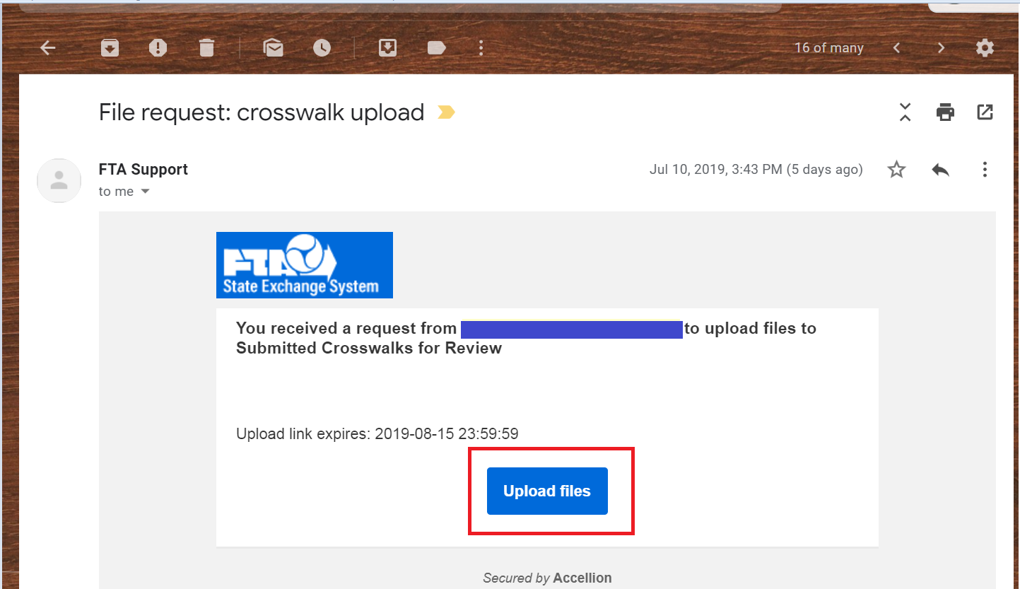

To upload they will simply need to drag the completed crosswalk file in or click on “select” to add the file then click on the Upload button.

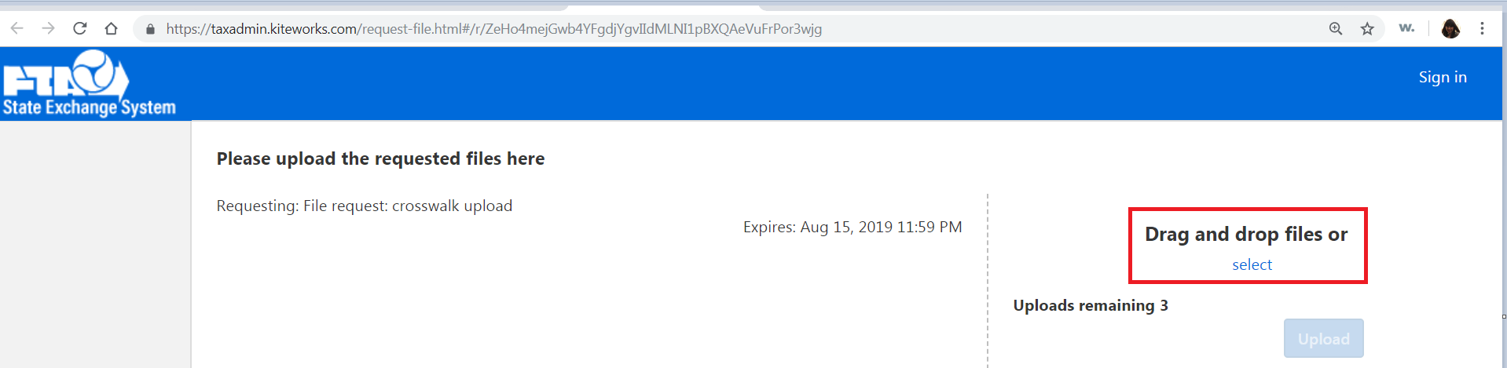

A working group will review the crosswalk and may have questions or suggestions. Completed crosswalks will be placed in a separate folder for download by the software companies and states.