**Developer Communication – April 22, 2021**

We want to communicate with our partners in the developer community on a couple of topics. This document is being posted to FTA SES and similar content will be sent to the NACTP listserv later today.

* Unemployment Compensation update
* Suspension of Business Rules related to TC4 for MEF

First, the unemployment compensation update. In essence, the bill did make the crossover to the Senate in time to still be considered and passed in this session. At last check (10:30 am on April 22nd), the bill is still in committee in the Senate. We have no indication on when the bill might be moved out of committee and get to the floor of the Senate. See snapshot of status below.

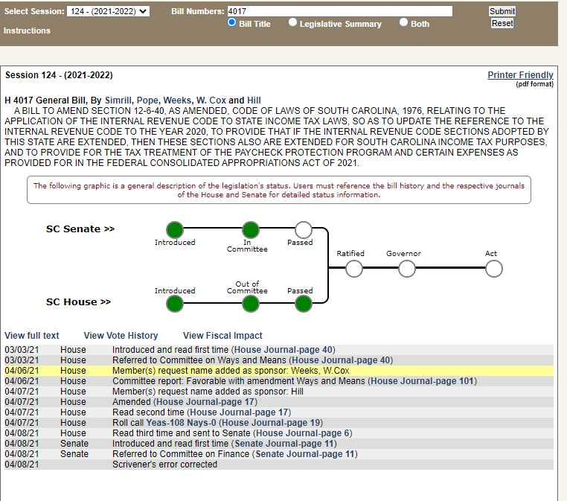

Until Conformity passes, the Unemployment Compensation should be added back for South Carolina. Our tax analysts advise that the addback should be included on Line e (other additions to income) of the SC1040 and NOT Line 1. See below snippet of SC1040.

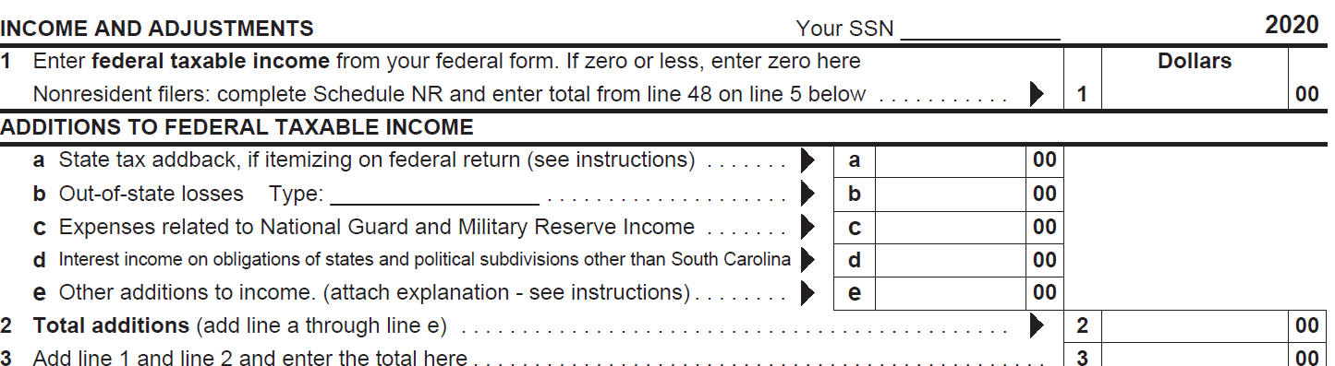

Our second topic is related to business rules that SCDOR added for TY2020 regarding TC4 and sub TC4 schedules/forms. We have heard your “cries in the wilderness”. These business rules will be suspended for all MEF tax types in an update occurring overnight April 22nd. To be on the safe side, do not unleash all of your TC4 related returns on us until after 8 am ET on April 23rd. The business rules being suspended based on the list posted to FTA SES are:

|  |  |  |  |  |  |
| --- | --- | --- | --- | --- | --- |
| 2020 MeF Business Rule Validation Messages | Error Code - 1040 | Error Code - 1041 | Error Code - 1065 | Error Code - 1120 | Error Code - 1120S |
| Schedule TC-4 not included for this return. | 0011 | 0011 | 0007 | 0009 | 0008 |
| Schedule TC-4P not included for this return. | 0012 | 0012 | 0008 | 0010 | 0009 |
| Schedule TC-4SA not included for this return. | 0013 | 0013 | 0009 | 0011 | 0010 |
| Schedule TC-4SB not included for this return. | 0014 | 0014 | 0010 | 0012 | 0011 |

For those developers who have put forth the effort to support these forms, SCDOR appreciates your efforts and your work will not be in vain. These rules will return, but are being suspended for now.

As always, SCDOR appreciates our partners in the developer community and your continued support!