- SUPREME COURT TODAY WORKFLOW use this

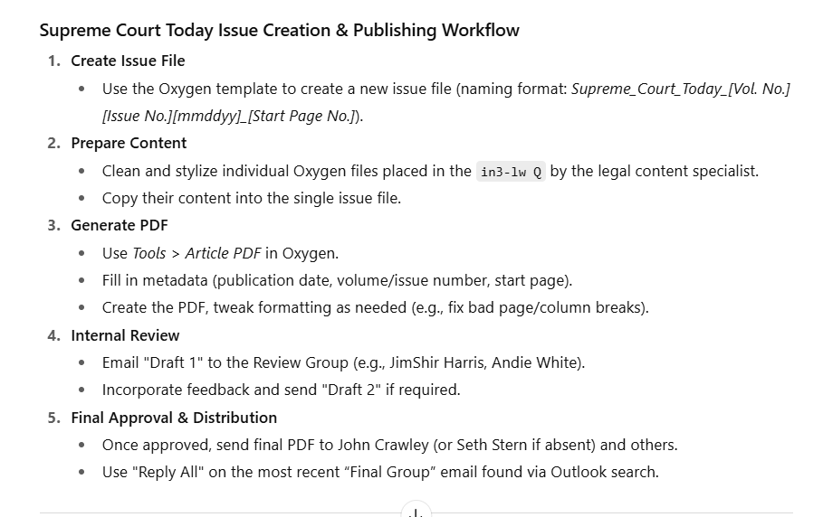

- Summary
✅ 1. Watch Training Videos (Total ~25 mins)
These provide key overviews of SCT production. Watch in order:
- Lunch & Learn Overview
Supreme Court Today: Overview
- Clean-Up Q Files
Clean-Up
- Creating and Generating PDF in Oxygen
Generating PDF
- Fixing Bad Breaks in Oxygen (Parts I & II)
Part I
Part II
- Emailing the Final PDF
Emailing

📋 2. Understand What SCT Is
- Weekly PDF newsletter linked from U.S. Law Week.
- Contains recent Supreme Court actions: orders, ORTOs, filings, etc.
- Published 49 weeks/year by Thursday. Production deadline: Wednesday noon–2 PM.
- New issues always begin on the next odd-numbered page from the last.

🗂 3. Before Production Day (Prep Work)
A. Gather Materials
- Legal content specialists add files to in3-lw Q.
- JIRA ticket is created (e.g., ECO-91632).
- Ticket includes:
  - Volume/Issue number
  - Publication date
  - Starting page number (next odd page after previous issue)
  - List/order of content sections

🧰 4. Prepare Oxygen Template
A. Clone the Template
- Go to BWIP > in3-lw Q.
- Clone Supreme_Court_Today_Template VOL_XX_XX_MM_DD_YY_PPPP.
- Rename:
Supreme_Court_Today_VOL_[VolNo]_[IssueNo]_[MM_DD_YY]_[StartPage]
(e.g., Supreme_Court_Today_VOL_92_50_07_04_24_3343)
B. Remove Unused Sections
Delete any story groups not used in this issue (e.g., ORTO, Oral Arguments if empty).

FOR INSTRUCTIONS: https://confluence.bna.com/display/BL/Supreme+Court+Today+Weekly+PDF
Copy FROM finished formatted file in done3-lw

If section is on the first page no need to include in the Index page number.
Preview in Editor’s mode to check for misspelled words
Check for State names Abbreviations

- Search on word “Clause.” Lowercase the word “clause” and any words describing which clause it is. “Due Process Clause” and other clauses that are uppercased should be “due process clause.”
- Search on word “Amendment.” Amendments over Ninth should NOT be spelled out. They should be e.g.,“14th” instead of “Fourteenth.” Amendments Ninth and under should be spelled out, e.g., “Fifth,” “Sixth.” Amendments and their numbers should be initial caps, Example: "Fifth Amendment," not "fifth amendment."

- Get rid of Line Breaks – Find Tags/Attributes to find Line breaks. Delete breaks.
- [8/4/2025] Do a search for ): with a space before the ): Delete space.
- Delete spaces between two section signs.
- Check the letter-case in the descriptors. Generally only the first word in the descriptor is capitalized. All others lower-cased:
However, the names of laws, agencies and proper names in descriptor should also be uppercased:
Note: No text - unless it is an acronym (Examples: SEC, ACA, NLRB) – should be in ALL CAPS.
If a Descriptor is missing:
Sometimes and entry will not have a descriptor in tags.
This is likely OK if the sentence “The ruling below addressed by this pro se petition will be summarized if and when the case is granted review.” is present. Otherwise the editors reviewing the PDF draft will let you know if there’s a problem.
- Names, Firms, Addresses Style:
Commas should come after name of petitioner {EXCEPT if Followed by "of"], after name of firm, between city state abbreviation. Retain comma after pro se
Note comma placement highlighted in yellow below, BUT, NO COMMA between filer name and "of" (See red arrow below):
Some firm names may have commas; others may not:
Example: Jordan Coyne Savits or Jordan, Coyne, Savits. Leave as spelled in address.
LLC, L.L.C., PA, P.A., PC, P.C.: Leave as spelled in Address
- Adding and correcting state abbreviations:
All filers' addresses should end with a state. Assume Washington is “D.C.,” New York is “N.Y.” etc.
DO NOT use 2-letter POSTAL style for abbreviations. Examples: AK, HI, MD, NY, MA, MO, NY, OH, UT
USE Bluebook style (https://www.law.cornell.edu/citation/4-500). Examples: Alaska, Exception: Calif. (not Cal., This applies to addresses only. Don't worry about case cites.), Colo., Ga., Md. , Mass., Mo., N.Y., Ohio, Utah.
States with names of six letters or less are spelled out: Alaska, Hawaii, Idaho, Kansas, Maine, Nevada, Ohio, Oregon, Texas, Utah

In Hearings Scheduled:
Make sure there is a space between the parens (put the space)
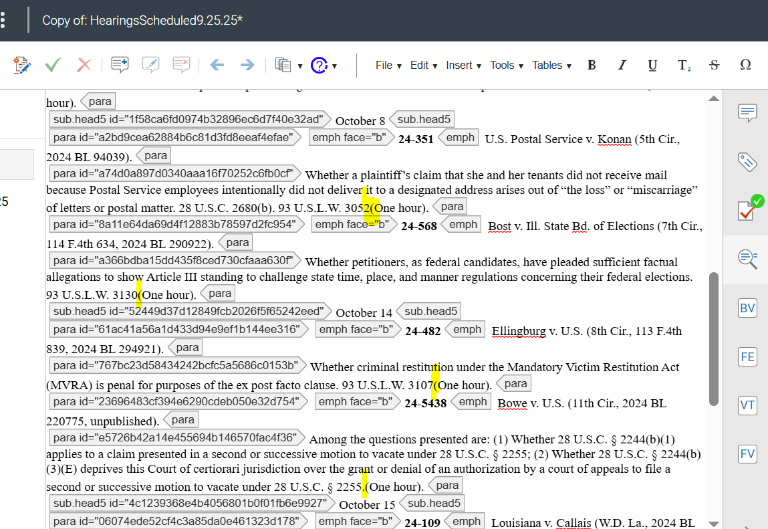

To preview:
Go to Actions then Click on create pdf
Service code:lw3-not then fill up Vol & Issue number
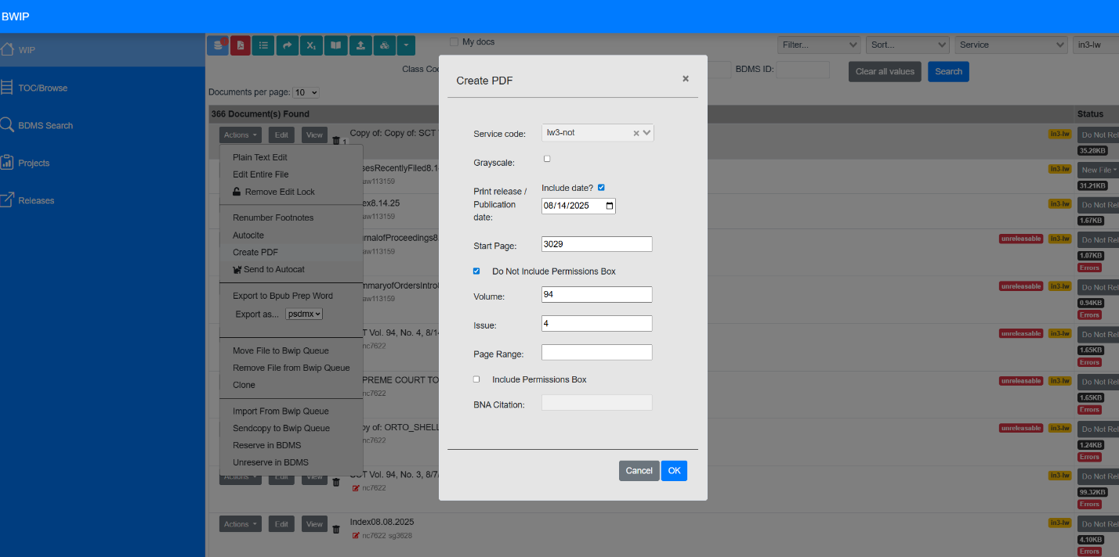

Save as draft 1
Change ticket status to Platform QA
Attach final pdf to ticket before closing
******************************************************************************

🧼 5. Clean Up Individual Files
Start from Index (last) and work backward.
A. Apply Clean-Up Rules (especially to "Recently Filed"):
- Fix punctuation (curly quotes/apostrophes, no ALL CAPS)
- Correct legal style (e.g., “Fifth Amendment,” not “fifth amendment”)
- Apply Bluebook state abbreviations
- Fix spacing, remove double spaces/line breaks
- Run spellcheck manually
B. Style Notes
- Firm names: keep original punctuation.
- Et als: remove from case names.
- Use <end.block justify="l"> tags to fix bad breaks in PDF.

📄 6. Build the SCT Issue File in Oxygen
A. Copy & Paste Clean Files
- Copy cleaned content (not the outermost pdm tags) into the appropriate story groups in your issue template.
B. Fix Front Page Box
- The Front Page Box goes under the first story group used.
- Remove any entries that:
  - Are on the first page
  - Are not in this week’s issue

🧾 7. Generate the PDF
- In Oxygen, go to: Actions > Create PDF
- Fill in:
  - Service: lw3-not
  - Pub date, start page, volume, issue
- Click OK
- Check for:
  - Bad column/page breaks
  - Unwanted banner on ORTOs (see Troubleshooting below)

✂️ 8. Fix Bad Breaks (if needed)
- Insert <end.block justify="l"> after problematic paragraphs to adjust layout.
- Focus on fixing:
  - Orphaned lines/headings
  - Blank columns/pages

💾 9. Save the PDF
Save TWO versions in:
\\pride1\jade_data\DealMaker\Supreme_Court_Today_Issues
- Draft: Section 3 [VolNo] [IssueNo] [Month_Day_Year]_DRAFT.pdf
- Final: Section 3 [VolNo] [IssueNo] [Month_Day_Year].pdf

📧 10. Email for Review
A. First Draft
Send to Review Group (JimShir, Andie, Prod Squad, etc.)
Email text:
Good morning. Draft 1 for Supreme Court Today [Vol. No.] [Issue No.] [Date] is attached.
B. After Revisions
- Save as _DRAFT 2 and final
- Reply to same thread confirming fixes made

📤 11. Email Final Version
Send to Final Group (John Crawley, Seth Stern, JimShir, etc.)
Email text:
Greetings. The PDF for Supreme Court Today [Vol. No.] [Issue No.] [Date] is attached.
- Attach final PDF
- Check that email sent successfully

📁 12. Final Steps
- Attach final PDF to JIRA ticket
- Move ticket to Platform QA
- Once John Crawley confirms it's posted (or even before), close the ticket

🛠 13. Troubleshooting
A. Too Much Content Error?
- Split ORTOs into a separate Oxygen file/PDF
- Use Adobe Acrobat Pro to merge:
  - Add ORTOs starting on next page number
  - Remove banner page
B. Clear Chrome Cache if “Generate Article PDF” fails

Checklist:

✅ 1. Watch Training Videos (Total ~25 mins)
These provide key overviews of SCT production. Watch in order:
- Lunch & Learn Overview
Supreme Court Today: Overview
- Clean-Up Q Files
Clean-Up
- Creating and Generating PDF in Oxygen
Generating PDF
- Fixing Bad Breaks in Oxygen (Parts I & II)
Part I
Part II
- Emailing the Final PDF
Emailing

📋 2. Understand What SCT Is
- Weekly PDF newsletter linked from U.S. Law Week.
- Contains recent Supreme Court actions: orders, ORTOs, filings, etc.
- Published 49 weeks/year by Thursday. Production deadline: Wednesday noon–2 PM.
- New issues always begin on the next odd-numbered page from the last.

🗂 3. Before Production Day (Prep Work)
A. Gather Materials
- Legal content specialists add files to in3-lw Q.
- JIRA ticket is created (e.g., ECO-91632).
- Ticket includes:
  - Volume/Issue number
  - Publication date
  - Starting page number (next odd page after previous issue)
  - List/order of content sections

🧰 4. Prepare Oxygen Template
A. Clone the Template
- Go to BWIP > in3-lw Q.
- Clone Supreme_Court_Today_Template VOL_XX_XX_MM_DD_YY_PPPP.
- Rename:
Supreme_Court_Today_VOL_[VolNo]_[IssueNo]_[MM_DD_YY]_[StartPage]
(e.g., Supreme_Court_Today_VOL_92_50_07_04_24_3343)
B. Remove Unused Sections
Delete any story groups not used in this issue (e.g., ORTO, Oral Arguments if empty).

🧼 5. Clean Up Individual Files
Start from Index (last) and work backward.
A. Apply Clean-Up Rules (especially to "Recently Filed"):
- Fix punctuation (curly quotes/apostrophes, no ALL CAPS)
- Correct legal style (e.g., “Fifth Amendment,” not “fifth amendment”)
- Apply Bluebook state abbreviations
- Fix spacing, remove double spaces/line breaks
- Run spellcheck manually
B. Style Notes
- Firm names: keep original punctuation.
- Et als: remove from case names.
- Use <end.block justify="l"> tags to fix bad breaks in PDF.

📄 6. Build the SCT Issue File in Oxygen
A. Copy & Paste Clean Files
- Copy cleaned content (not the outermost pdm tags) into the appropriate story groups in your issue template.
B. Fix Front Page Box
- The Front Page Box goes under the first story group used.
- Remove any entries that:
  - Are on the first page
  - Are not in this week’s issue

🧾 7. Generate the PDF
- In Oxygen, go to: Actions > Create PDF
- Fill in:
  - Service: lw3-not
  - Pub date, start page, volume, issue
- Click OK
- Check for:
  - Bad column/page breaks
  - Unwanted banner on ORTOs (see Troubleshooting below)

✂️ 8. Fix Bad Breaks (if needed)
- Insert <end.block justify="l"> after problematic paragraphs to adjust layout.
- Focus on fixing:
  - Orphaned lines/headings
  - Blank columns/pages

💾 9. Save the PDF
Save TWO versions in:
\\pride1\jade_data\DealMaker\Supreme_Court_Today_Issues
- Draft: Section 3 [VolNo] [IssueNo] [Month_Day_Year]_DRAFT.pdf
- Final: Section 3 [VolNo] [IssueNo] [Month_Day_Year].pdf

📧 10. Email for Review
A. First Draft
Send to Review Group (JimShir, Andie, Prod Squad, etc.)
Email text:
Good morning. Draft 1 for Supreme Court Today [Vol. No.] [Issue No.] [Date] is attached.
B. After Revisions
- Save as _DRAFT 2 and final
- Reply to same thread confirming fixes made

📤 11. Email Final Version
Send to Final Group (John Crawley, Seth Stern, JimShir, etc.)
Email text:
Greetings. The PDF for Supreme Court Today [Vol. No.] [Issue No.] [Date] is attached.
- Attach final PDF
- Check that email sent successfully

📁 12. Final Steps
- Attach final PDF to JIRA ticket
- Move ticket to Platform QA
- Once John Crawley confirms it's posted (or even before), close the ticket

🛠 13. Troubleshooting
A. Too Much Content Error?
- Split ORTOs into a separate Oxygen file/PDF
- Use Adobe Acrobat Pro to merge:
  - Add ORTOs starting on next page number
  - Remove banner page
B. Clear Chrome Cache if “Generate Article PDF” fails

********************************************************

✅ Supreme Court Today Production Checklist
📅 Before Production Day
- Watch/Review Training Videos
- Review JIRA ticket (volume, issue, date, start page, content order)
- Check Q folder for all needed files

🧰 Oxygen File Setup
- Clone Supreme_Court_Today_Template
- Rename Oxygen file: Supreme_Court_Today_VOL_[Vol]_[Issue]_[MM_DD_YY]_[StartPage]
- Remove unused story groups (e.g., ORTO, oral arguments if not included)

🧼 File Clean-Up (Start from Index and work up)
Repeat for each file:
- Fix punctuation (curly quotes, apostrophes, periods, dashes)
- Remove ALL CAPS (convert to sentence/title case)
- Remove “et al.” from case titles
- Correct spacing, line breaks, indentation
- Bluebook state abbreviations
- Style case names correctly
- Use <end.block justify="l"> tags to fix layout breaks
- Run spellcheck

📄 Build Full SCT Issue in Oxygen
- Copy/paste cleaned story content into appropriate story groups
- Confirm each story is inside <pdm:story-group> and <pdm:story>
- Remove unused content
- Edit Front Page Box:
  - Remove entries on first page or not in this issue
  - Confirm page numbers and headlines match

📄 Generate PDF
- Click Actions > Create PDF
- Fill in: lw3-not, pub date, start page, vol/issue numbers
- Confirm:
  - No banner pages (especially for ORTOs)
  - No bad breaks (widows/orphans/blank columns)
  - Pagination is correct

✂️ Fix Breaks If Needed
- Use <end.block justify="l"> after paragraphs
- Move long entries to next page/column
- Regenerate PDF after fixes

💾 Save Draft and Final PDFs
Save in \\pride1\jade_data\DealMaker\Supreme_Court_Today_Issues:
- Draft: Section 3 VOL ISSUE MM_DD_YYYY_DRAFT.pdf
- Final: Section 3 VOL ISSUE MM_DD_YYYY.pdf

📧 Email Draft for Review
- Send to Review Group (JimShir, Andie, etc.)
- Subject: “SCT Draft – Vol [#] Issue [#] [Date]”
- Attach Draft PDF
- Text:
Good morning. Draft 1 for Supreme Court Today Vol. [#] Issue [#] [Date] is attached.

📩 Address Review Comments
- Make requested edits
- Save updated PDF as _DRAFT 2
- Reply to same email thread with updated file

✅ Send Final Version
- Attach final PDF
- Email Final Group (John Crawley, Seth Stern, JimShir, etc.)
- Subject: “SCT FINAL – Vol [#] Issue [#] [Date]”
- Text:
Greetings. The PDF for Supreme Court Today Vol. [#] Issue [#] [Date] is attached.

📁 Close Out
- Upload final PDF to JIRA ticket
- Move ticket to Platform QA
- Confirm it's posted, then close ticket

🛠 Troubleshooting
- Too many pages? → Split ORTOs and merge in Adobe Acrobat
- Clear Chrome cache if PDF generation fails
- Check for incorrect fonts or margins

*************************************************
Instructions in Confluence Page:
- Created by Conway, Neal, last modified on Jun 02, 2025
1. I. Training Videos
The following Microsoft Stream training videos take about 25 minutes total to watch. Ignore any references to PDM as the Supreme Court Today is now produced in Oxygen.
Lunch & Learn - Video on Supreme Court Today:
https://web.microsoftstream.com/video/3fd50941-bb3a-482c-a47b-c4d897dbc385?list=studio
Producing Supreme Court Today: Clean-Up Q files
https://web.microsoftstream.com/video/fe156cdd-c535-4a9f-ab5b-6e8425cda5b3
Producing Supreme Court Today: Creating and Generating PDF in Oxygen
https://web.microsoftstream.com/video/6567fd5a-276d-4bd9-8225-b90603d86d98?list=studio
Producing Supreme Court Today: Fixing Bad Breaks in Oxygen Part I
https://web.microsoftstream.com/video/5d593e98-0423-4f34-9dc4-e52bd4526d8a
Producing Supreme Court Today: Fixing Bad Breaks in Oxygen Part II (Ignore Mentions of PDM)
https://web.microsoftstream.com/video/a0de54b7-d6a4-47eb-adc1-15e8ae106c10
Producing Supreme Court Today: Emailing:
https://web.microsoftstream.com/video/c3114beb-d149-4088-a293-3262327b989e
2. II. Description
2.1. A. What is Supreme Court Today?
Supreme Court Today (SCT) is a pdf linked from The United State Law Week. See an example issue. SCT publishes various actions by the court during the week before publication. SCT is published in volumes and issues. The volume number changes in July. The starting page of a new volume is always 3001. A new issue always begins with an odd page number, the next odd page number after the last page of the previous issue.
SCT is published no later than Thursdays 49 times a year. Holiday weeks are 1) Last week of July; 2) First week of September; 3) Last week of December (2021: Dec. 30).
2024 Publishing Holidays:
July 25 (Week of July 22)
Sept. 5 (Week of Sept. 2)
December 26 (Week of Dec. 23)
Not all sections that can appear in SCT will appear in each issue. For example, Opinions Relating to Orders and Rule 46 boxes are occasional while Recently filed and Index will be in every issue.
2.2. B. When is SCT produced?
SCT is produced on Wednesdays. The material for it should be gathered and processed by the legal content specialist or practice lead and put in the in3-lw Q in the days before publication.
By Wednesday morning, the legal content specialist or practice lead create a JIRA ticket (Example: https://jira.bna.com/browse/ECO-91632) for the issue and assign it to the Prod Squad team member.
The goal is to get the issue finished by Noon Wednesday, no later than 2 pm. Supreme Court events may impact this goal. If Wed. is a holiday, production may be pushed up to Tuesday.
2.3. C. Who produces SCT?
The material for individual sections is gathered and processed by Analysis (JimShir Harris, Andie White) and placed in the in3-lw Q.
Opinions Related To Orders (ORTOs), the lengthiest material when they appear (not always) in issues, are turned into annotated source files by ProdSquad and placed in the in3-lw Q.
When the finalized PDF is generated, the Prod Squad team member emails it to INDG News Director John Crawley and a list of others. John (or in his absence, Seth Stern) posts it on the U.S. Law Week site.
2.4. D. Sources of Information for Supreme Court Today
The following are some Supreme Court sources for data used in Supreme Court Today.
- To check Opinions Relating To Orders (ORTOs): https://www.supremecourt.gov/opinions/relatingtoorders/23 [You may have to change /24 to /25 etc.]
- To check orders and order lists of the Court: https://www.supremecourt.gov/orders/ordersofthecourt/23 [You may have to change /24 to /25 etc.]
- To check for Rule 46 Dismissals: https://www.supremecourt.gov/docket/docket.aspx [ Enter "Rule 46" in Docket Search]
2.5. E. What access do Prod Squad team members need?
Prod Squad team members must have the in3-lw Q. Templates are kept in the in the in3-lw Q and also the sec3-lw Q (but these may be out of date). The Q done3-lw is where old issues are archived and to be found.
2.6. F. What Software do Prod Squad team members need?
Team members will need Oxygen to edit files, assemble and publish a PDF. Team members will also need Adobe Acrobat Pro 2017 for the occasional to combine two pdfs into one.
2.7. G. How is the SCT PDF Produced?
From the Oxygen shell template (Supreme_Court_Today_OXYGEN_Template), the ProdSquad team member creates an issue copy (Supreme_Court_Today_[Vol. No.]_[Issue No.]_[mmddyy]_[Start Page No.], e.g., Supreme_Court_Today_90_7_09_09_21)_3061.
Then the team member cleans up and stylizes (See IV. Style & Clean-up below) the individual Oxygen files that the legal content specialist has placed in the in3-lw Q.
The team member then copies the text from the individual files into the single Oxygen issue file.
The team member then generates the PDF by selecting Tools/Article PDF, then filling in Publication date, start page, volume number, issue number, then clicking Create Article PDF.
The PDF may require tweaking and regeneration to eliminate bad breaks (i.e., headings as the last line on a column or page.).
Then the Prod Squad team member then emails a "Draft 1" to the Review Group (currently including JimShir Harris and Andie White, in addition to other Prod Squad team members. Do a search in Outlook for Supreme Court Today emails, the Reply All to the latest previous Review Group email.
JimShir and Andie will respond, saying the PDF is OK or they will point out fixes to be made. The Prod Squad team member makes the fixes then emails a "Draft 2."
When the pdf is approved for, it is emailed to John Crawley (in his absence, Seth Stern) at U.S. Law Week and a list of other recipients. Do a search in Outlook for Supreme Court Today emails, the Reply All to the latest previous Final Group email.(See VI. Emailing the PDF below).
2.8. H. What Content is Included in an SCT Issue?
The following table lists the various elements of SCT, their frequency of inclusion and the order in which they appear in the newsletter. The Story Groups refer to headings in the Oxygen template.
SCT Content Table
File | Frequency | Notes/Root Element/Tagging
Heading (Date, Vol No., Issue No.) | Always | Inserted in Create Article PDF Dialog window.
frontpagebox_[Issue Date_MM_DD_YY] | Always | Aside Tags - Nest under story group tag of first section used
Story Group: Oral Arguments
Arguments Scheduled*  Name: ArgumentsScheduled[mo].[dd].[yr] | Occasionally | Run this section about two weeks before that month's hearings are scheduled to start. Refer to the same issue number from the previous year to confirm. Contains questions presented./Journal Group tags
Story Group: Summary of Orders
SOO [Summary of Orders] Lead  Name:  SummaryofOrdersIntro[mo].[dd].[yr] | Usually | Run in any week that the Court issues orders granting or denying review or taking summary actions. During certain weeks of the term, the Court is on recess and no orders will be issued that require this section of the issue to be produced./Introduction Tags
Review Granted  Name:  ReviewGranted[mo].[dd].[yr] | Usually | This section is exported from SumDoc if there are any cases granted review in the past week./Docket History Group Tags
Summary Action  Name:  SummaryAction[mo].dd].[yr] | Usually | This section is exported from SumDoc if the Court took summary action in any cases in the past week./Docket History Group Tags
Review Denied  Name:  ReviewDenied[mo].[dd].[yr] | Usually | This section is exported from SumDoc if the Court denied review in any cases in the past week.
Story Group: Journal of Proceedings
Journal of Proceedings  Name:  JournalofProceedings[mo].[dd].[yr] | Usually | List of orders from the past week with links to the pdfs on the Court's site. If no orders were issues (when the Court is in recess), then we don't include this section.
Cases Argued**  Name:  CasesArgued[mo].[dd].[yr] | Occasionally | Runs a week after the end of the previous month's arguments. Built from a template using arguing attorney information from the Court's web site. / Annotated Source Tags
Story Group: Opinions Related to Orders (ORTOs)
Opinions Relating to Orders (ORTOs); (may be more than 1)  Name:  ORTO_[Party name]_[Docket_No.][Justice_last_Name] | Occasionally | Keep regular watch for these on the Court's web site. Should be ticketed to Echo Prod Squad ASAP to allow prep time and also noted in Teams chat. Prod Squad creates the file and Content and Analysis includes it in the JIRA ticket for the week. / Annotated Source Tags
Story Group: Cases Docketed
Rule 46 Box  Name:  rule46box[mo].[dd].[yr] | Occasionally | Keep daily watch for Rule 46 dismissals for Tracker purposes. This content in the PDF is entered manually using a template by content and analysis. / Aside Tags
Arguments Calendar***  Name: ArgumentsCalendar[mo].[dd].[yr] | Occasionally | Add this section as soon as possible after the Court releases its argument schedule for a given month. This is usually months beforehand. Exported from SumDoc.
Cases Recently Filed  Name:  CaseRecentlyFiled[mo].[dd].[yr] | Always | Exported each week from SumDoc. We keep track of this using the SCT spreadsheet and note immediately when cases are added to an issue. / Docket History Group Tags
Index (lw3ix)  Name:  Index.[mo].[dd].[yr] | Always | List of docket numbers of included cases granted/denied review, summarily decided, and recently filed. Produced using a template file and a command that adds in information from the relevant files you've already created. / Notification Finding Aids 97 with Notification Index Tags Nested
3. III. Preparing:
3.1. A. The SCT Ticket
Here is an example of the ticket that the legal content specialist creates: ECO-91632 - Vol. 89, No. 31; 3/4/21 Done
The ticket should include:
- The Volume Number
- Issue Number
- Thursday Publication Date
- Starting page number.* The Prodsquad Team Member will have to add this.
- A list of all the sections that will be in included in the issue in the order that they should appear, starting with the front page box, ending with the index.
*To get the starting page number of the new issue, get the last page number of the last issue on this page: https://www.bloomberglaw.com/product/blaw/bloomberglawnews/us-law-week?tab=SUPREME_COURT_TODAY.
Find the PDF link here:
The first page number of the new issue should be the next ODD page number up from the last page of the last issue. You will not enter the page number until you are at Tools/Create Article PDF stage.
4. IV. Style & Clean-up
VIDEO: Producing Supreme Court Today: Clean-Up Q files
https://web.microsoftstream.com/video/fe156cdd-c535-4a9f-ab5b-6e8425cda5b3
It is recommended that you start with the last file (Index) that will be in the issue and work up to the first file (frontpage box). These clean-up instructions begin with the last file (index)
4.1. A. Index (usually named something like "SCT_Index_[mm][dd][yy]"), the “Cases Summarized” file
The sections (not all may appear) should be in this order
- Review Granted
- Summary Action
- Review Denied
Cases in each of above three sections should be in numerical order by year and matter number within the section (e.g., cases with “20-“ before cases with “21-“, numbers 20-097 before 20-255)
Should look like this, no spaces before or after dash:

4.2. B. Recently Filed
Should be named something like "RecentlyFiled12_18_23"
“Recently Filed” is the longest section in the newsletter and requires the most clean-up. The following clean-up instructions for “Recently Filed” apply to all similar sections of Supreme Court Today.
- Get rid of double spaces. Do a find/replace. Replace double spaces with single
- Replace prime marks (straight apostrophes) with curvy apostrophes. ’ Copy this curvy apostrophe: ’ Paste in Replace Bar. Don’t use “Replace all.” Use “Replace” and check before it replaces.
- Replace straight quotes with curvy quotes “” In opening quote, place cursor to the right of straight quote. Type ". On closing quote, place cursor to left of closing quote. Type ". Delete straight quote. Don’t use “Replace all.” Use “Replace” and check each instance before replacing.
- Search on word “Clause.” Lowercase the word “clause” and any words describing which clause it is. “Due Process Clause” and other clauses that are uppercased should be “due process clause.”
- Search on word “Amendment.” Amendments over Ninth should NOT be spelled out. They should be e.g.,“14th” instead of “Fourteenth.” Amendments Ninth and under should be spelled out, e.g., “Fifth,” “Sixth.” Amendments and their numbers should be initial caps, Example: "Fifth Amendment," not "fifth amendment."
- Get rid of Line Breaks – Find Tags/Attributes to find Line breaks. Delete breaks.
- Delete spaces between two section signs.
- Check the letter-case in the descriptors. Generally only the first word in the descriptor is capitalized. All others lower-cased:
However, the names of laws, agencies and proper names in descriptor should also be uppercased:
Note: No text - unless it is an acronym (Examples: SEC, ACA, NLRB) – should be in ALL CAPS.
If a Descriptor is missing:
Sometimes and entry will not have a descriptor in tags.
This is likely OK if the sentence “The ruling below addressed by this pro se petition will be summarized if and when the case is granted review.” is present. Otherwise the editors reviewing the PDF draft will let you know if there’s a problem.
- Names, Firms, Addresses Style:
Commas should come after name of petitioner {EXCEPT if Followed by "of"], after name of firm, between city state abbreviation.
Note comma placement highlighted in yellow below, BUT, NO COMMA between filer name and "of" (See red arrow below):
Some firm names may have commas; others may not:
Example: Jordan Coyne Savits or Jordan, Coyne, Savits. Leave as spelled in address.
LLC, L.L.C., PA, P.A., PC, P.C.: Leave as spelled in Address
- Adding and correcting state abbreviations:
All filers' addresses should end with a state. Assume Washington is “D.C.,” New York is “N.Y.” etc.
DO NOT use 2-letter POSTAL style for abbreviations. Examples: AK, HI, MD, NY, MA, MO, NY, OH, UT
USE Bluebook style (https://www.law.cornell.edu/citation/4-500). Examples: Alaska, Exception: Calif. (not Cal., This applies to addresses only. Don't worry about case cites.), Colo., Ga., Md. , Mass., Mo., N.Y., Ohio, Utah.
States with names of six letters or less are spelled out: Alaska, Hawaii, Idaho, Kansas, Nevada, Texas, Ohio, Utah, Maine
- Run Spellcheck Tool
Under Tools Pulldown, click Check Spelling. Spellcheck will flag all proper names, legal terms, abbreviations etc. Just click “Ignore all.” There will be misspellings.
Ignore Latin or French legal terms. Examples: cert, forma pauperis, per curiam, pro se, vacatur, stare decisis, coram nobis, voir dire. Often preceded by Latin prepositions “de,” “ex,” “per,” “pro,” “inter”.
Examples of suspicious-looking names to check:
ConocoPhillips (Should there be a space between Conoco and Phillips?); adidas (Yes, its official name is lowercased)
“Norcross + Judd” actually uses plus sign instead of &
A real example of a name to check: “Johnathon.”
Docket for 20-918
Title: In Re Johnathon Kelly, Petitioner
Docket search https://www.supremecourt.gov/docket/docket.aspx

4.3. C. Other Sections
The clean-up instructions for Recently Filed apply less so to all other sections. In shorter sections you can just eyeball the text for misspellings etc. The following are things to watch out for in specific sections.
4.3.1. 1. Arguments Scheduled

Make sure there's a space before the parens, highlighted above, enclosing the time limit
4.3.2. 2. Oral Arguments Journal
The following shows where commas should be placed:

4.3.3. 3. Opinions Relating to Orders (ORTOs)
Before inclusion in Supreme Court Today, ORTOs must be processed from pdfs published on the Supreme Court web site. See Confluence Instructions: Supreme Court Today: How To Process Opinion Related To Order (ORTO) (https://confluence.bna.com/pages/viewpage.action?pageId=1665728672 for instructions on processing ORTOs.
A) Make sure Et Als are removed from case names.
Insert a line break element to put the Case No. and Date on one line.
B) Headers such as I, II, A, B should be in p tags, justified center:
4.3.4. 4. Cases Carried Over/Oral Arguments Scheduled Sections
These sections may sometime have consolidated cases. There should be no hard para returns between these. Put in Line breaks:

5. V. Creating/Generating Oxygen PD
Video: Producing Supreme Court Today: Creating and Generating PDF in Oxygen
https://web.microsoftstream.com/video/6567fd5a-276d-4bd9-8225-b90603d86d98?list=studio
5.1. A. Copy/rename the template.
In BWIP My Services/in3-lw Q:

- Find Template Supreme_Court_Today_Template VOL_XX_XX_MM_DD_YY_PPPP
In Actions pulldown, select Clone:

You have to refresh BWIP and reselect in3-lw Q to see “Supreme_Court_Today_Template VOL_XX_XX_MM_DD_YY_PPPPP
Open the copy of the template, you will see at the top, the title of the doc in Name tags surrounded by ignore tags:

This tagging is new to the SCT template. It is how BWIP picks up the unique name of the document, enabling us to identify the document in the BWIP Q. The ignore tags will prevent this name from publishing in the PDF.
Change the “Copy of” name to “Supreme_Court_Today_VOL_[XX]_[XX]_[MM]_[XX]_[YY]_[PPPP],” filling in current Vol., issue, Date, starting page.
When you save and close, doc name should appear in the BWIP with name, EXAMPLE: “Supreme Court Today Vol_92_50_07_04_24_3343” This is the shell into which you will paste all the sections.
This template has story-group headers (See SCT Content Table above) for all possible sections that may be included in the newsletter.
Since not all sections will be included in every issue, you can remove story groups that you will not need. For example, if there are no Hearings Scheduled or Argued Cases Awaiting Decision, you can remove the Oral Argument story group. If there are no Opinions Relating to Orders, you can remove that story group.
There will always be a Recently Filed and Index so the issue will always include the Cases Docketed story group.
5.2. B. The Front Page Box (“Inside Supreme Court Today”)
The Front Page Box (“Inside Supreme Court Today”) is nested inside the first story group you are using. For example, if the first Story Group used used Summary of Orders, the Inside Supreme Court Today "aside" tags are nested right under the opening story group tag like this:

The Front Page Box does not list the content of the first page. The first section to be listed in the Front Page Box is the the first section starting on an inside page. Example: If the first section starting on an inside page is Opinions Relating to Orders, then ORTO is the top toc entry.
Delete all TOC entries for sections that are not included in the particular issue of SCT.
5.3. C. Copying Text From Individual Files Into Issue File.
Do not select the outmost pdm module tags of a file. These are obsolete. Select the next tag the inside pdm module tags.

Since the Summary of Orders is the first story group in this issue, the Front Page Box in its aside tags is nested right under the Summary of Orders name tag:

Delete TOC entries from Inside Supreme Court Today (Front Page Box) for any sections that appear on the front page. The first TOC entry should befor the first section that starts on a secondary page.
Also delete TOC entries for any section that is not included in a particular issue, often Rule 46 dismissals and ORTOs.
Since the summary of Orders starts on the front page, We are going to delete the SOO Toc entry in the Front page box:

5.4. D. Generating The PDF in Oxygen
When you have copied/pasted all the text:
- Close file
- Under Actions pulldown, click "Create PDF"
You will get this dialog box, very similar to the one in WebQ:
- Make sure Service is set to lw3-not.
- Enter pub date, start page, Volume, issue numbers (all highlighted above). You may have to click on "Do Not Include Permissions Box" to fill in Volume /Issue.
- Click OK
5.5. E. Fixing Bad Breaks
12/21/2023: We are currently not using end block tags to fix bad breaks in Oxygen as Oxygen does not work like Arbortext in stretching paragraphs.
Videos: Producing Supreme Court Today: Fixing Bad Breaks in Oxygen Part I
https://web.microsoftstream.com/video/5d593e98-0423-4f34-9dc4-e52bd4526d8a
Producing Supreme Court Today: Fixing Bad Breaks in Oxygen Part II (Ignore Mentions of PDM)
https://web.microsoftstream.com/video/a0de54b7-d6a4-47eb-adc1-15e8ae106c10
It is unlikely that the first time you generate the PDF it will have no bad breaks. You may even have big blank spaces between text. You fix these by adding End Block, Justified Left <end.block justify="l"> tags in strategic places. In my experience, you can solve any break or spacing issue by adding enough <end.block justify="l"> tags. You may not be able to eliminate all bad breaks. Just concentrate on the worst breaks.
Example locations of End Block tags:
Here <end.block justify="l"> was placed after closing docket history tag of a case in Recently Filed:

Bad Break Example 1: Unacceptable last word, highlighted yellow, in an ORTO jumped to top of right column. Solution: Fixed by inserting End Block tag after paragraph marked by red arrow.

Bad Break Example 2: Unacceptable placement of header at bottom of column. Solution: Insert <end.block justify="l"> (Red Arrow) after closing tags of ORTO.

Bad Break Example 3: Acceptable if you can't fix or fixing it makes things worse elsewhere. Only three lines at bottom of column; bulk of text in next column. Solution: Insert <end.block justify="l"> tag after closing tags (red arrow) of Case 20-673.

Bad Break Example 4: Space at bottom of page. Try to eliminate. Solution: This was solved by inserting five <end.block justify="l"> tags at various spots throughout the Recently filed section.

Bad Break Example 5: Acceptable. Ideally "Environment" etc. should be at the top of p. 3128. If it is the only bad break in the pdf, and fixing it does not cause a problem farther down, insert an <end.block justify="l"> after the closing "docket history" tag of the case above.

5.6. F. Saving The PDF.
Save the PDF to this folder: \\pride1\jade_data\DealMaker\Supreme_Court_Today_Issues. Save two versions, one a draft and one a final file name. The draft should be named Section 3 [Vol. No.][Issue No.][Month_Day_Year]_DRAFT. Example: Section 3 90 9 September 23 2021_DRAFT. Also save it as the final file name that you will put it in the email. Example: Section 3 90 9 September 23 2021. You will email the draft to the reviewers. When the reviewers answer with fixes, save the file as _DRAFT 2 and also as the final file name.
6. VI. Emailing the PDF
Video: Producing Supreme Court Today: Emailing:
https://web.microsoftstream.com/video/c3114beb-d149-4088-a293-3262327b989e
Here is a sample of the initial email to be sent to reviewers:

Review Group Email recipients as of 12/21/2023:
- JimShir Harris
- Andie White
- Neal Conway
- LaShaun Wye
- Paul Stelter
- Erin Murphy
- John Jones
- Michelle Powers
- Chloe Fells
- Prod Squad Team Member Producing SCT
- Report-To of Prod Squad Team Member Producing SCT
Text should read:
"Good morning. Draft 1 for Supreme Court Today [Vol. No.][Issue No.][Month_Day_Year] is attached."
Attach the DRAFT file.
The reviewers will either say it looks good or most likely have some fixes. After making the fixes, save the file as Draft 2 and also again as the final file name, attach it to a response email, point out that the fixes have been made and send it again.
If fixes have been made and both reviewers have responded, you need not wait for anyone to check the fixes. Email the final version with all fixes to the following recipients in the U.S. Law Week group.
Final Group mail recipients as of 12/21/2023:
- Thomas Taylor
- John Crawley
- Seth Stern
- JimShir Harris
- Andie White
- Neal Conway
- LaShaun Wye
- Paul Stelter
- Erin Murphy
- John Jones
- Michelle Powers
- Chloe Fells
- Prod Squad Team Member Producing SCT
- Report-To of Prod Squad Team Member Producing SCT
Text should read:
Greetings. The PDF for Supreme Court Today [Vol. No.][Issue No.][Month_Day_Year] is attached.
Make sure that the final version with fixes is attached. Send. Check in Sent folder that it has gone. With this step you are done. Attach the PDF to the JIRA ticket and put in Platform QA. After John Crawley sends the email that SCT has been posted (You do not need to wait for John to send email), you can close the ticket.
7. VII. Troubleshooting & Graphics
- Generate Article PDF with PRINCE results in this error message:

Solution: If you are using the Chrome browser, clear cache, close out browser, restart.
- Create Article PDF yields error message like this:

This was caused by too much content in the newsletter. This occurred in the Vol. 90, No. 15, 11/04/21 issue.
The solution is to separate the Opinions Related to Orders into their own Oxygen file/PDF, retain all the other material in the original Oxygen file,

Supreme_Court_Today_Vol_90_15_11_04_21_3127_ORTO_NoHead is the Arbotext file with only the ORTOs. The top looks like this:

Note: It has a Story Group at the top followed immediately by an End Page, Justify L Tag. This pushes the beginning of the ORTOs to the second page so there is no green banner/vol./issue/date stuff at the top. There is also no Front Page Box. It will look like the ORTO pdf is a continuation of the PDF with all the other material. Without the End Block Tag, the ORTO pdf looks like this, which you don't want:

The is how the pdf generates when you add the empty Story Group and the End Page, Justify L tag.

You open the pdf in Adobe Acrobat Pro 2017 and use Organize Pages to delete the blank page with the banner.

This is what you get when you delete the blank banner page.

Note: The starting page of this ORTO pdf is the next number up (can be even or odd) from the last page of the Part 1 PDF. In this case the ORTO starting page was 3127. The starting page of the Part 1 PDF was 3119. The last page of the Part 1 PDF was 3126. In order to get 3127, I had to make the start page of the ORTO pdf number 3126. When it generated, 3126 was the number of the blank page with the banner. When I deleted that page with Adobe Acrobat Pro 2017/Organize Pages, the start page was 3127. So all I needed to do is use Adobe Acrobat Pro 2017/Organize Pages to attach the part beginning with p. 3127 to the first part of the newsletter ending with 3126. As you regenerate PDFs after making corrections, make sure start page number is right in

Remember, in this example issue, Part 1 starts with 3119, but part 2 with the ORTOs starts with 3126.
I named the first part of the PDF (containing all the material but the ORTOS)
Section 3 90 15 November 4 2021_Part_1.pdf
I named the second part with the ORTOS
Section 3 90 15 November 4 2021_Part_2
I used Adobe Acrobat Pro 2017/Organize Pages/Insert/From File to add the ORTOs part (highlighted in yellow) to the first part.

Save the PDF as instructed in Part V. F above.
2. Graphics
Once in great while, a graphic may need to be included. This example is a map of Alabama that was included by the Supreme Court in an Opinion Related to Order in Vol. 90, 28, 2/10/2022 issue (done-3lw Q: Supreme_Court_Today_VOL_90_28_02_10_22_3235):

This was the Oxygen coding for that image. Note that the horizontal scope was set to a column ("news-col").

Supreme Court Today Clean Up Process Summary:

General Recommendation
- Start with the last file (Index) in the issue and work backward to the frontpage box.

4.1 Index File ("Cases Summarized")
- File name usually: SCT_Index_[mm][dd][yy]
- Sections should appear in this order:
  - Review Granted
  - Summary Action
  - Review Denied
- Within each section, list cases numerically by year and case number (e.g., 20-097 before 20-255).
- Format dashes with no spaces before or after.

4.2 Recently Filed
- File name format: RecentlyFiled[mm]_[dd]_[yy]
- Most time-intensive section.
- Clean-up tasks:
  - Double spaces → Single
  - Straight apostrophes (') → Curly (’)
  - Straight quotes (") → Curly (“ ”) (manually, check each)
  - Lowercase all uses of "clause" (e.g., "due process clause")
  - Amendments:
    - 1st–9th: Spell out (e.g., "Fifth Amendment")
    - 10th and above: Use numerals (e.g., "14th Amendment")
    - Capitalize “Amendment” and number
  - Remove line breaks and extra spaces between section signs (§§)
  - Descriptors: Only capitalize the first word, unless it’s a proper name or agency
  - NO ALL CAPS, unless an acronym (e.g., SEC, ACA)
Names & Addresses:
- Comma placement:
  - After petitioner name, firm name, city
  - No comma before “of” in firm names
- Preserve firm name spelling and punctuation (e.g., LLC vs. L.L.C.)
- Add or correct state abbreviations:
  - Use Bluebook style, not postal codes
  - Spell out states with 6 letters or fewer (e.g., Texas, Utah)
  - Examples: N.Y., Calif., Mass., Colo., Ga., Ohio
Spellcheck
- Use spellcheck tool but ignore flagged:
  - Proper names
  - Latin/French legal terms (e.g., cert, pro se, per curiam)
- Double-check odd names (e.g., “Johnathon,” “adidas,” or “Norcross + Judd”)

4.3 Other Sections
- Apply Recently Filed clean-up rules lightly, use judgment based on length/complexity.
4.3.1 Arguments Scheduled
- Ensure space before parentheses with time limit.
4.3.2 Oral Arguments Journal
- Check commas for correct placement.
4.3.3 Opinions Relating to Orders (ORTOs)
- Process via Supreme Court PDFs and follow Confluence instructions.
- Tasks:
  - Remove “et al.” from case names
  - Put case number and date on one line
  - Use centered paragraph tags for section headers (I, II, A, B, etc.)
4.3.4 Cases Carried Over / Oral Arguments Scheduled
- For consolidated cases, no hard returns; use line breaks instead.

Checklist Version:
✅ General Workflow
- Start with last file (Index) and work upward to the frontpage box

✅ 4.1 Index File (e.g., SCT_Index_[mm][dd][yy])
- Confirm sections appear in this order:
  - Review Granted
  - Summary Action
  - Review Denied
- Sort cases numerically by year and docket number
- Format dashes with no spaces before/after (e.g., 20-255)

✅ 4.2 Recently Filed (e.g., RecentlyFiled12_18_23)
🔤 Text Formatting
- Replace all double spaces with single spaces
- Convert straight apostrophes (') to curly apostrophes (’)
- Convert straight quotes (") to curly quotes (“ ”) manually
- Lowercase "clause" and any identifying words (e.g., “due process clause”)
📜 Amendment Formatting
- 1st–9th → spell out (e.g., “Fifth Amendment”)
- 10th+ → use numerals (e.g., “14th Amendment”)
- Capitalize “Amendment” and number
🧹 Clean-up
- Remove line breaks (find and delete tags/attributes)
- Remove spaces between two section signs (§§)
- Fix descriptor letter-case:
  - Only first word capitalized
  - Proper names/agencies stay capitalized
- Ensure no ALL CAPS, except acronyms (e.g., SEC, NLRB)
🏢 Names & Addresses
- Use comma after:
  - Petitioner name (unless followed by “of”)
  - Law firm name (unless followed by “of”)
  - City name before state
- Retain firm punctuation (e.g., LLC, P.A., Jordan Coyne Savits)
- Ensure all addresses end with a Bluebook-style state abbreviation
  - Use full names for 6-letter-or-less states (e.g., Texas, Utah)
  - Use abbreviations like N.Y., Calif., Colo., Mass.
✅ Spellcheck
- Run spellcheck tool (Tools > Check Spelling)
- Click “Ignore All” for:
  - Legal terms (e.g., cert, forma pauperis, per curiam)
  - Proper names and abbreviations
- Manually verify unusual or suspicious name spellings (e.g., “Johnathon,” “adidas”)

✅ 4.3 Other Sections (Lighter Clean-up)
4.3.1 Arguments Scheduled
- Ensure space before parenthesis containing time limit
4.3.2 Oral Arguments Journal
- Check comma placement around firm names, cities, etc.
4.3.3 ORTOs (Opinions Relating to Orders)
- Remove et al. from case titles
- Ensure case number and date appear on one line
- Apply centered paragraph tags to headers (I, II, A, B)
4.3.4 Cases Carried Over / Oral Arguments Scheduled
- For consolidated cases, use line breaks (not paragraph returns)

