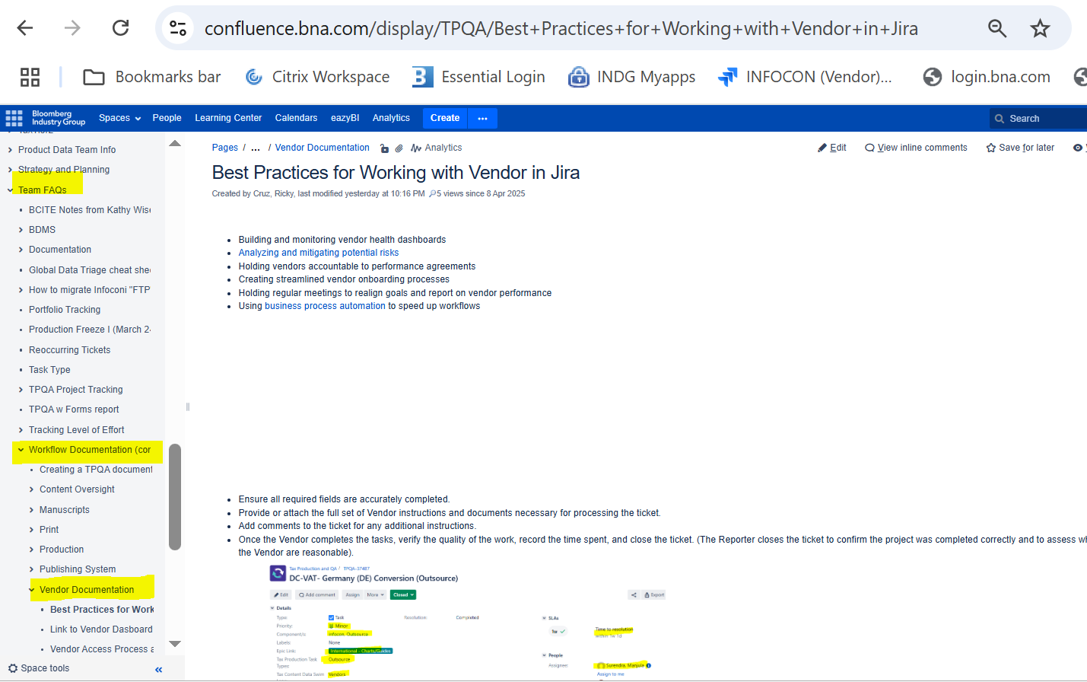

To add new content click on create and the new document will appear under Vendor Documentation.
- Open Vendor Documentation
- Then click on Create (You need to open the title where you want the new document to fall into)
