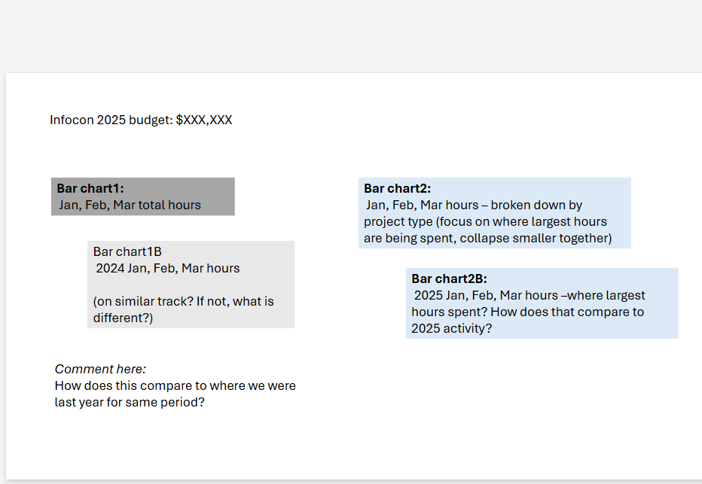

EXCEL VENDOR DASHBOARD IN SHARED DRIVE:
Infocon_Dashboard.xlsx
https://bna.sharepoint.com/:x:/r/sites/Pride4_Bna4_Data_TaxAccounting/_layouts/15/Doc.aspx?sourcedoc=%7B997FEE73-E703-4B98-AD0E-A15CD06E87EC%7D&file=Infocon_Dashboard.xlsx&action=default&mobileredirect=true

https://bna.sharepoint.com/sites/Pride4_Bna4_Data_TaxAccounting/Shared%20Documents/Forms/AllItems.aspx?id=%2Fsites%2FPride4%5FBna4%5FData%5FTaxAccounting%2FShared%20Documents%2FGROUPS%2FTax%26Accounting%2FOperations%2FProduction%2FWorkflow%20and%20Process%2FTracking%2FVendors%2FInfocon&viewid=5955958b%2D7c95%2D45af%2Dbb4b%2Da8e995ab6ab7

