- Copy Info.unit start values from the JIRA ticket attachment into the notepad file that you created

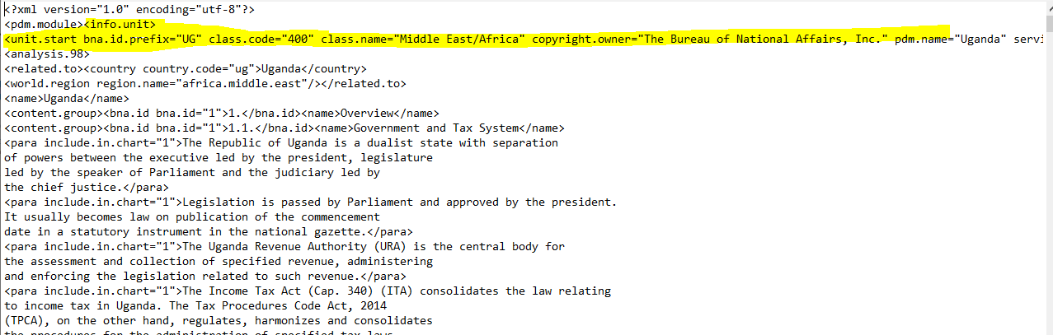

- Refer to the attached Country Code list (VAT NAVIGATOR GTG Country Code.pdf) to fill up the country code value and (VAT/GTG World Region Names and Related to Tags) for the related to and World region name attributes.

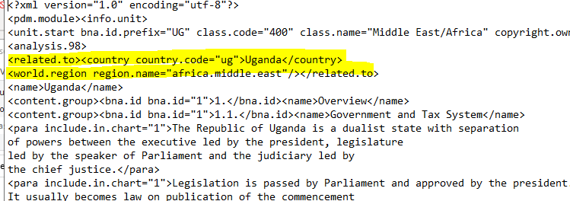

- Convert body of document using the VAT/GTG sample documents and the link to as reference.
Notes:
- For VAT chart paragraphs are highlighted in turquoise in the Word file and tagged as <para include.in.chart="1"></para> and the rest are regular <para></para>s
VAT:
In the Word file:

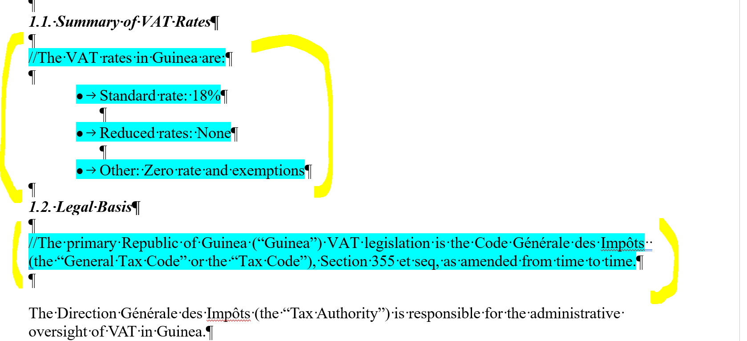

In the converted file:

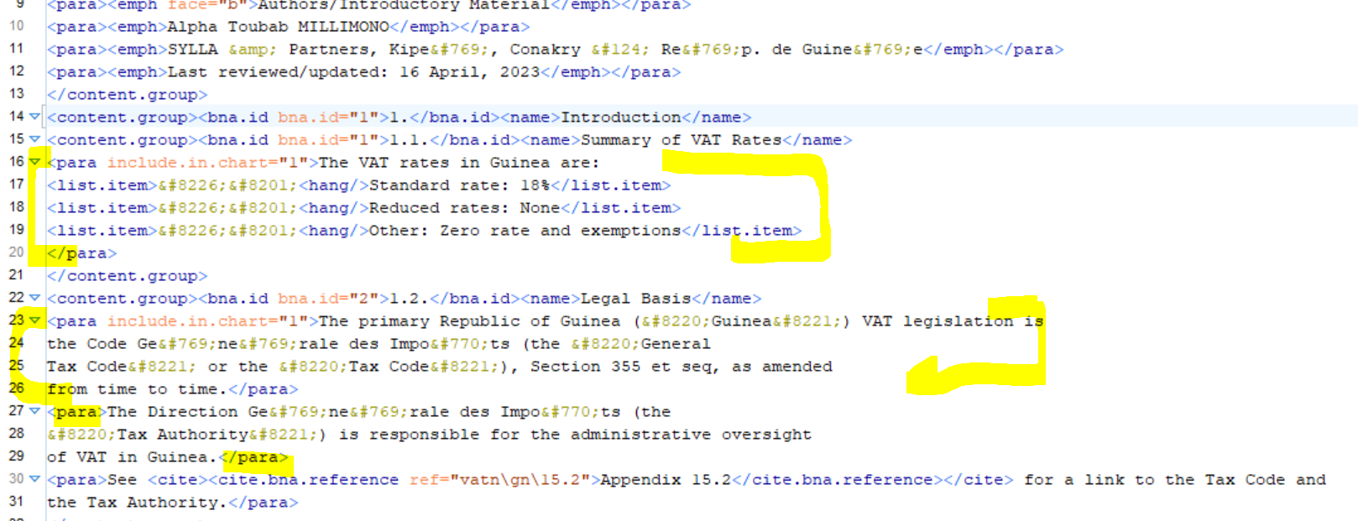

GTG:
In the Word file:
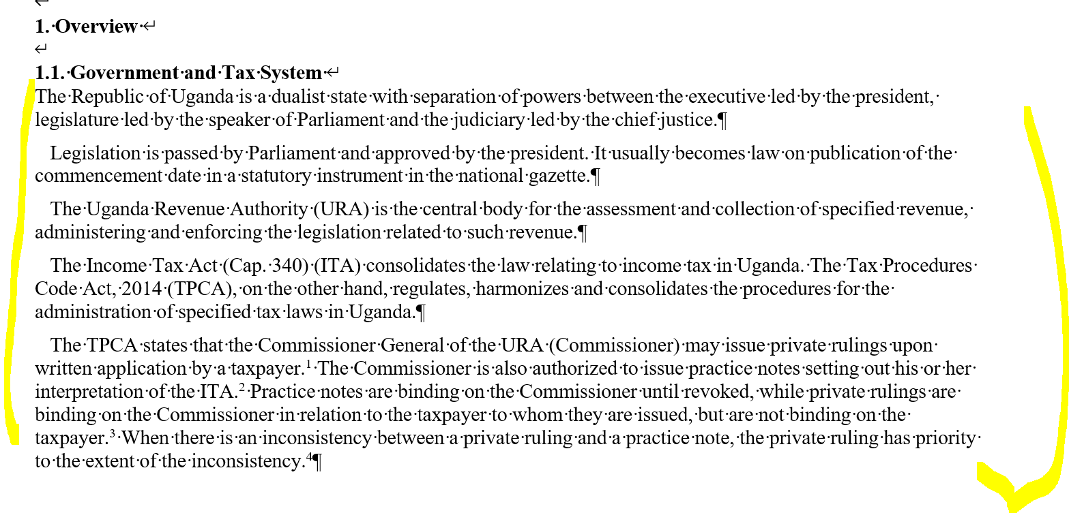

In the converted file:

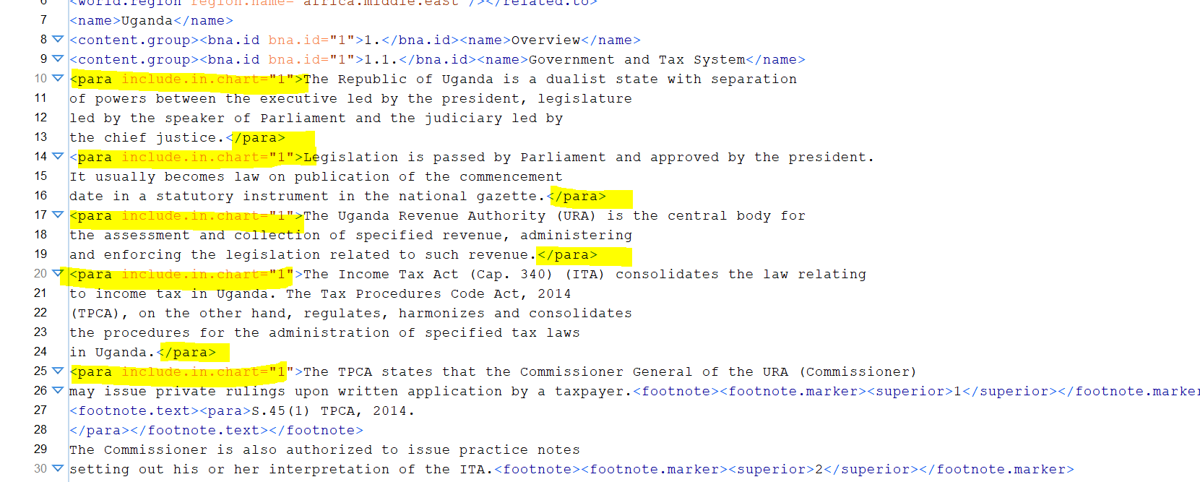
- Content.groups are nested and should be tagged accordingly.

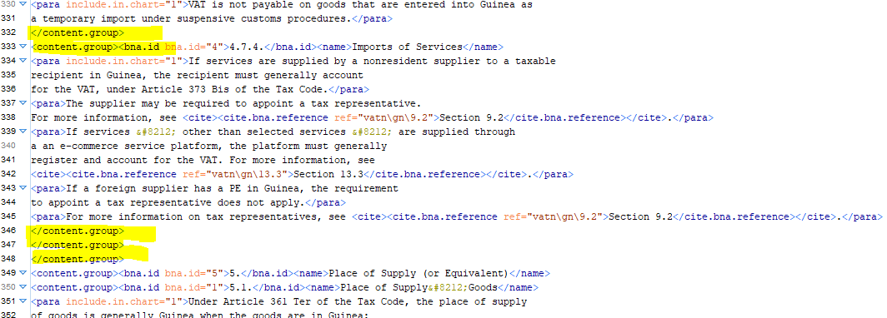

- Fill up bna.ids and make sure that they have the appropriate values:
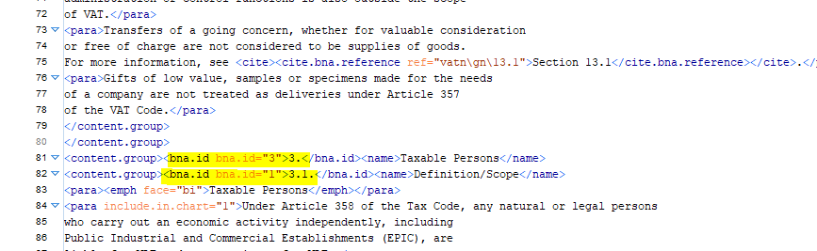
- Bullet items are tagged as <list.item>&#8226;&#8201;<hang/>

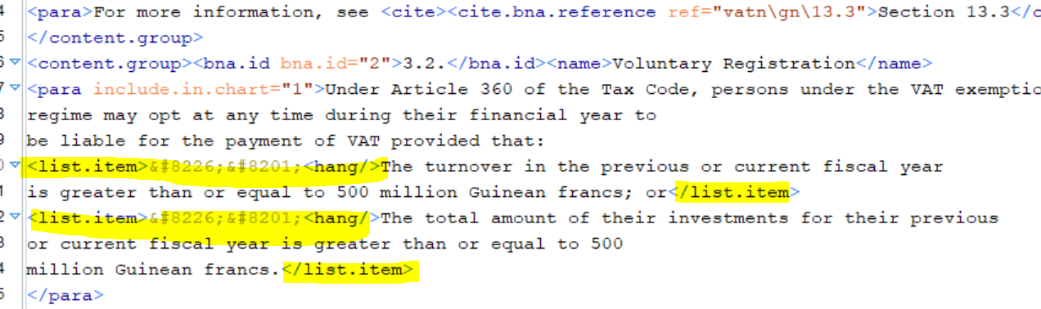

- Tag Appendix and Sections as <cite.bna.reference>:
<cite><cite.bna.reference ref="vatn\gn\15.2">Appendix15.2</cite.bna.reference></cite>
<cite><cite.bna.reference ref="vatn\gn\4.7.2">Section 4.7.2</cite.bna.reference></cite>

- Tag URLs as cite.urls:

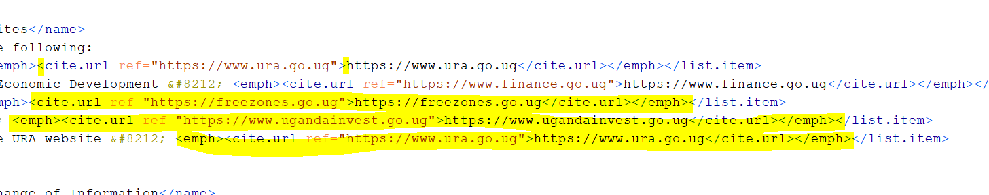

Refer to the attached file (Special Characters And Entities.docx) for the Special Characters/Entities that are to be used in converting the Word file to XML:

Sample of Special Characters & Entities:

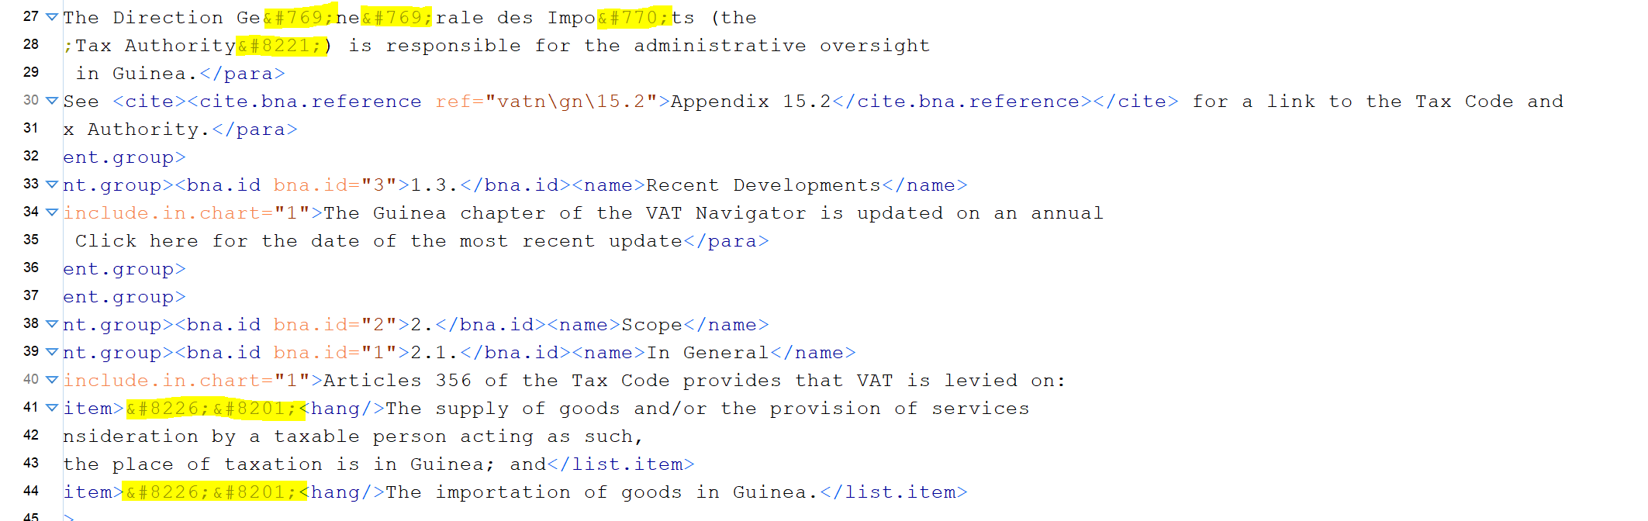

Finally, review to make sure tagging is correct for the ff:

<related.to>-- Correct country code?
<para include.in.chart>
<content.group> check nesting
<bna.id> check attributes
<list.item>
<cite.bna.reference>
<cite.url>
Special characters/entities

