VAT/GTG WORKFLOW

OVERVIEW
- Claire Tarrant’s team notifies TPQA of a file that is ready to be processed through an INTX ticket.
- TPQA acknowledges receipt of the file in the INTX ticket.
- Shawne/Ricky M. creates a TPQA TICKET for Infocon and attaches the word file for conversion/tagging.
- Infocon processes the file then returns the completed document to Shawne/Ricky M.
- Shawne/Ricky M reviews and inserts the completed document to a file in BWIP then changes the status to ready for approval/notifies Analyst that the file is ready for review and approval.
- Analysts review file in BWIP then approves and releases/post.

SAMPLE INTX TICKET:

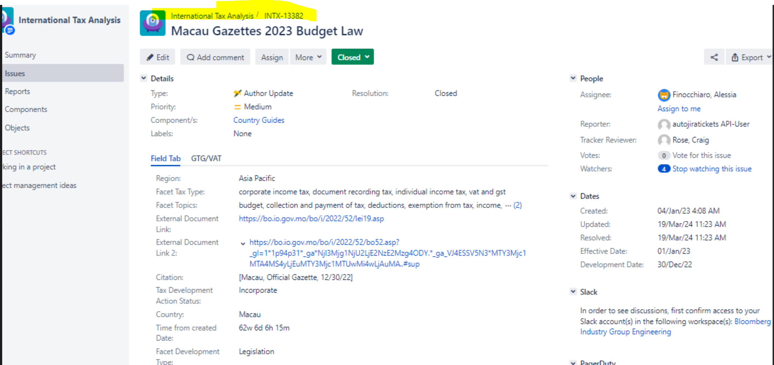

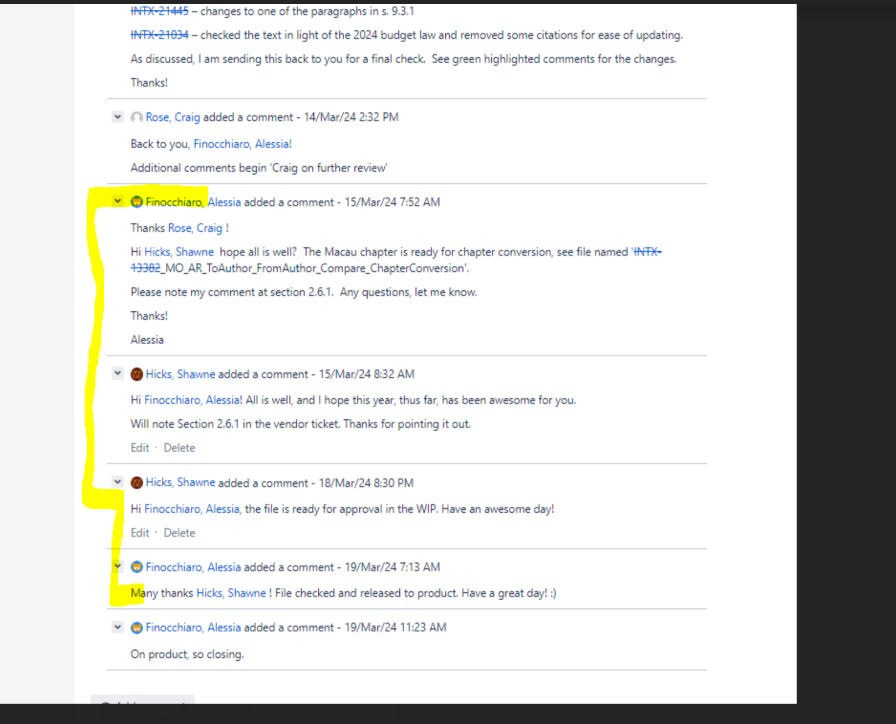

SAMPLES OF TPQA TICKET

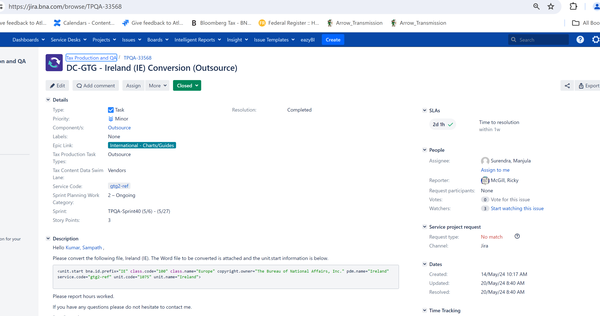
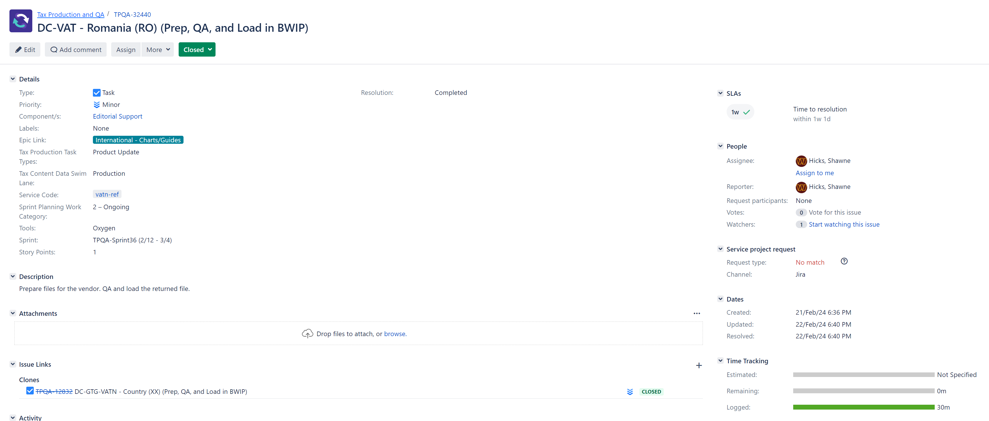

EXCERPT OF SAMPLE WORD FILE FOR CONVERSION/TAGGING

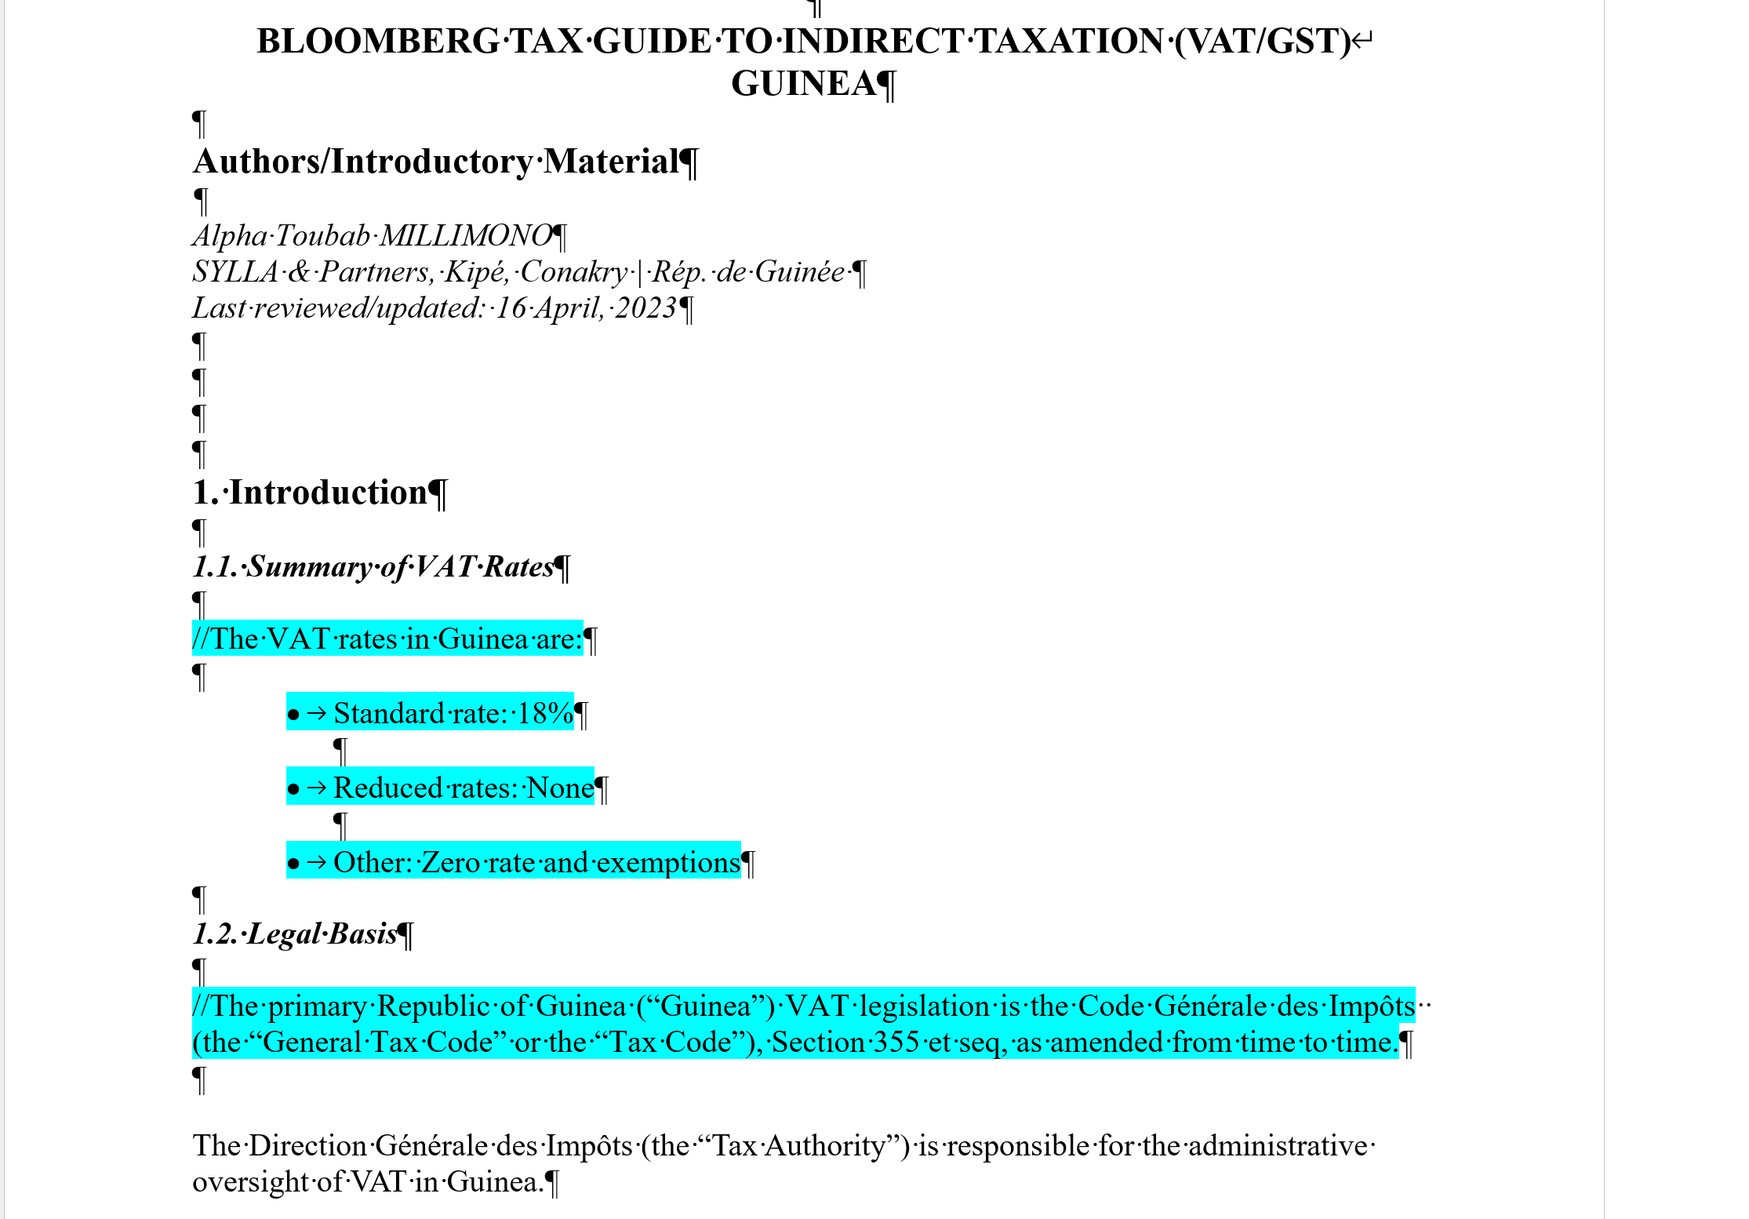
EXCERPT FROM A SAMPLE COMPLETED DOCUMENT

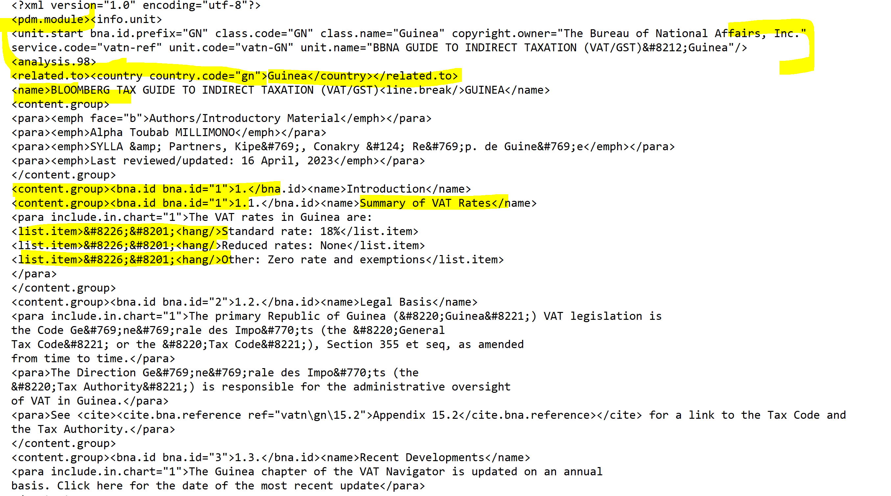

EXCERPTS FROM INFOCON PROCESSING INSTRUCTIONS

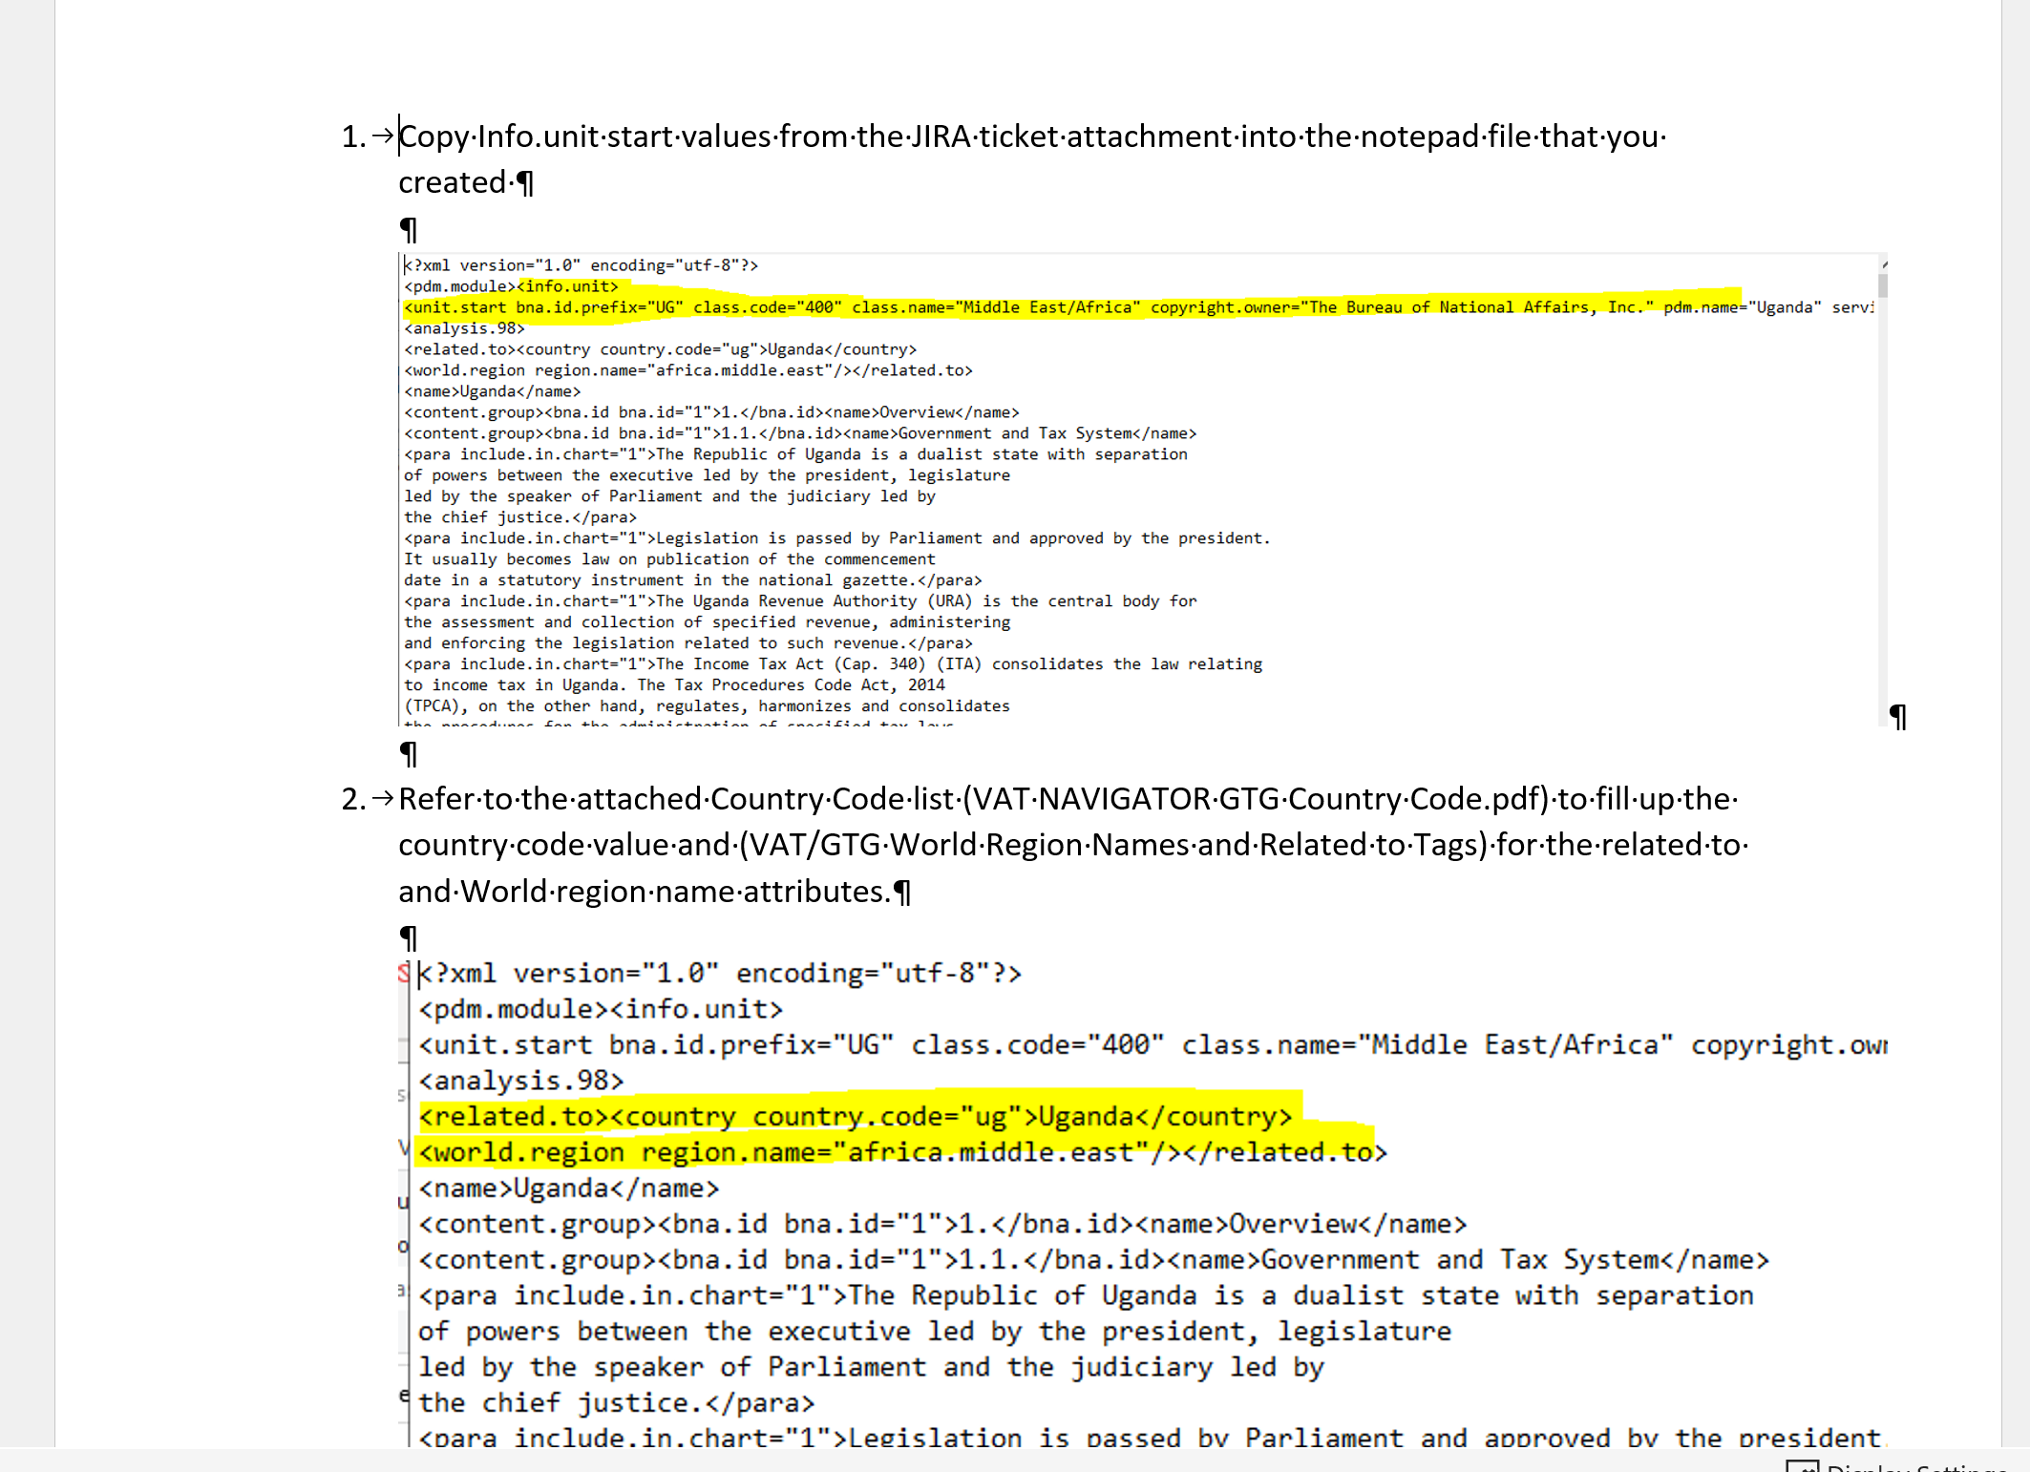

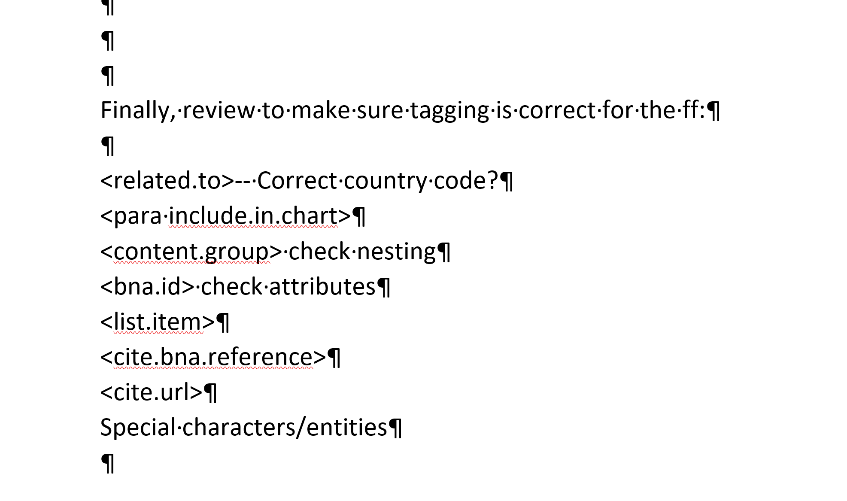

VAT SERVICE QUEUE IN BWIP
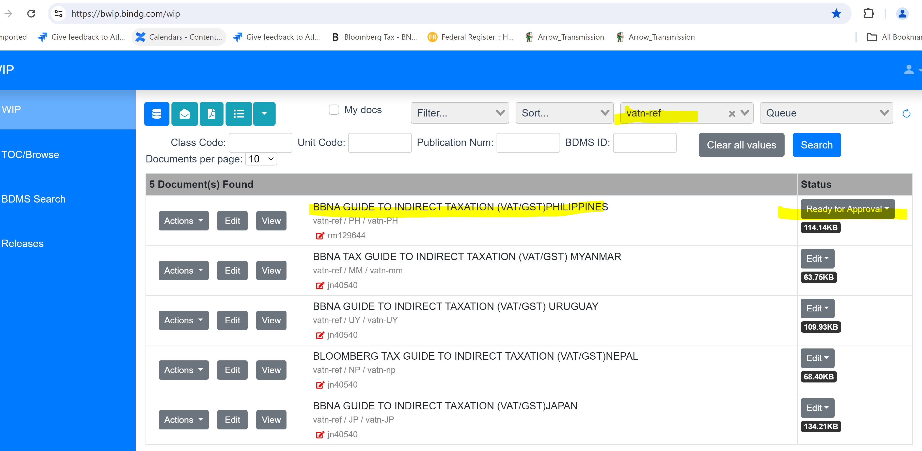

GTG SERVICE QUEUE IN BWIP

