Update Code Sections

Confluence page for Updating Code sections
https://confluence.bna.com/display/TPQA/Legislation+and+Code+Updating

Go to Chapter III

Summary
- Get Code sections affected list (excel file)
- Get pdf file from Congress .gov.
- Search for section in Column c ex. 401(a)(67) in pdf file [search for division or title first]

Additional Notes:
- No need to put Division & Title in Background, only required in History
- Use “substitute” instead of “strike” & “insert"

To look for the Code Section file in BWIP

3 things that need to be Updated
- Code Section

Look for the Bill section in Column A of Code List Excel file

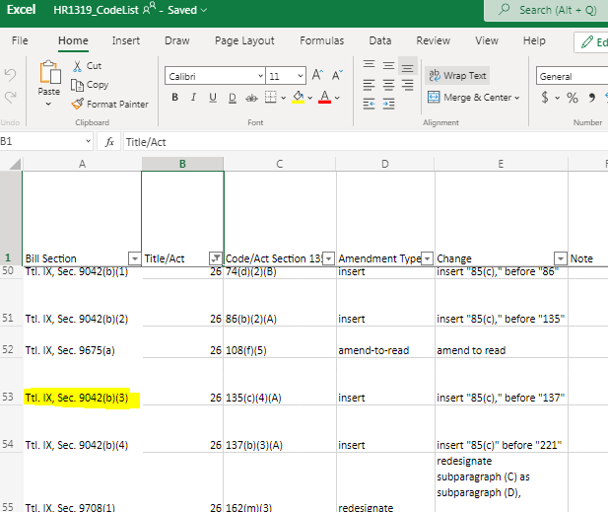

Search for the Bill section in the pdf

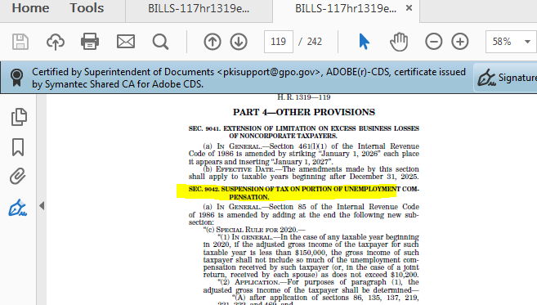
Search for the Code section in column C

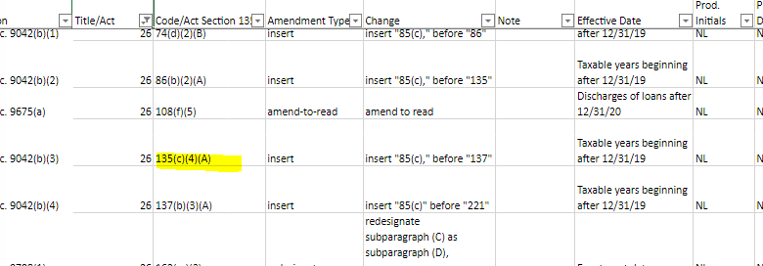

Then go down further in the pdf and search for the Code section indicated in column C of the Excel Sheet to get the instruction and text needed to update the code section.

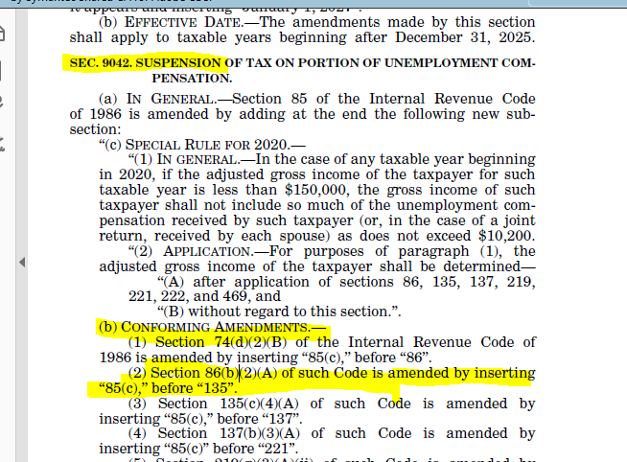

Follow instructions to checkout the file for the Code Sections that needs to be updated below.
Note:
Use ___ if there is no PUB. L. yet ex.
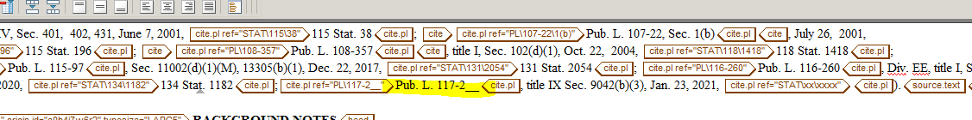

Then update the code section in arbortext

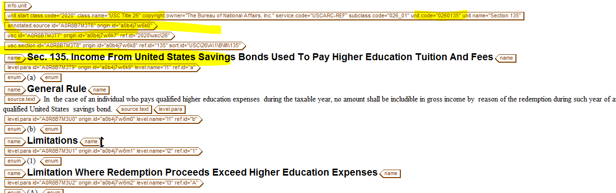

then

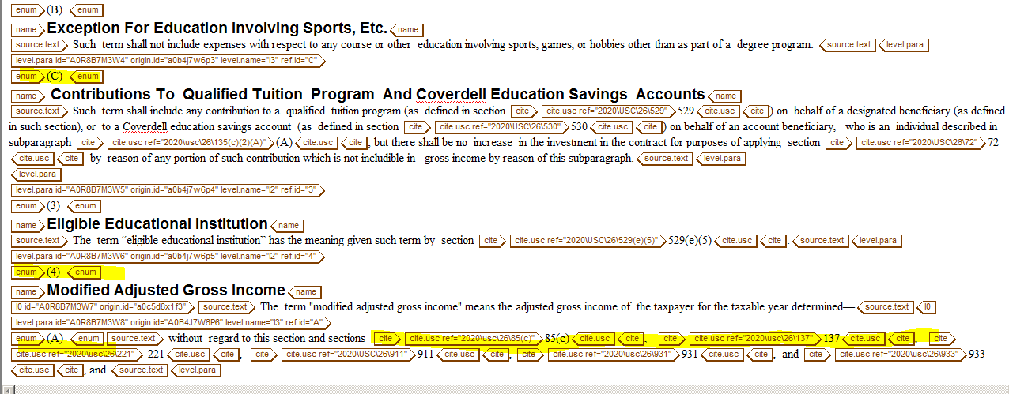

- History

Go further down on the Arbortext file and update the history – (this appears above the Background Notes)
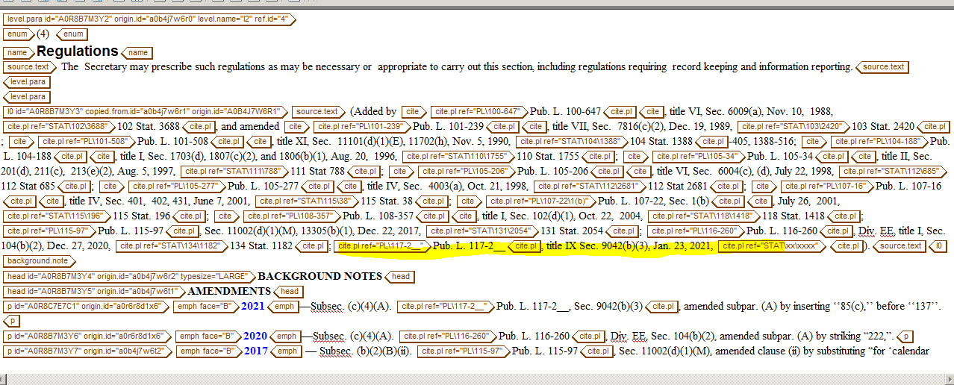

- Update Background Notes/Amendments

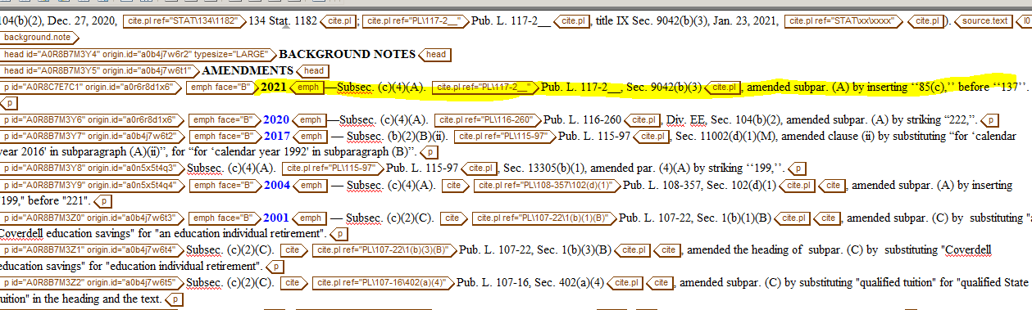

To look for the Code Section file in BWIP
1.Check out the file in BWip (usc-ref, 026_usc). The files are grouped based on the Code section number. For example, 026_00_usc has the files for Code sections 1-99, 026_01_usc has files for Code sections 100-199.

To look for the Code Section file in PDM
EX.
Update the following Code sections for HR 5444: Sec. 6015, 7602, 7802.

- Checkout files in pdm2
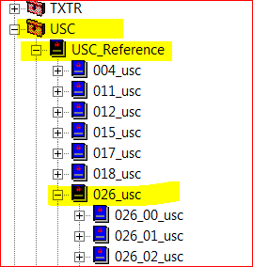

SEC 6015

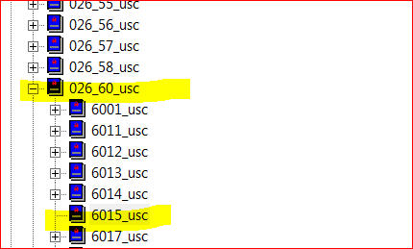

SEC 7602
- 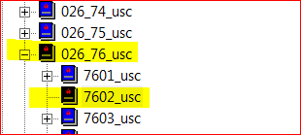

SEC 7802

- 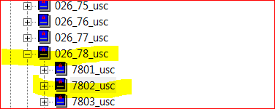

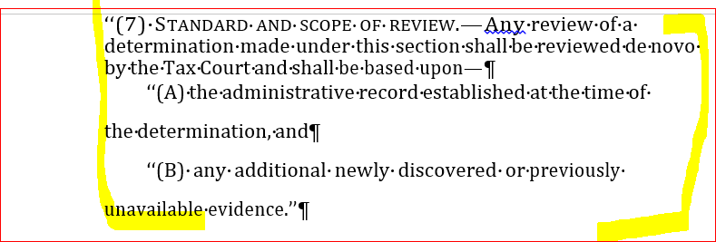

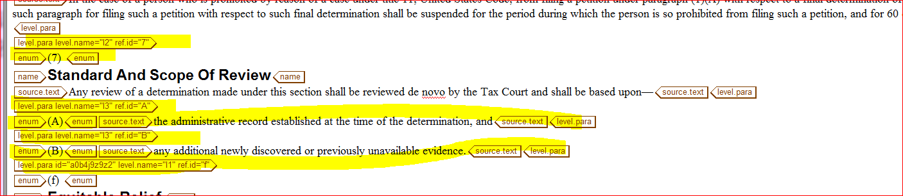

Amending Code Sections

B. AMENDED CODE SECTION
1.Check out the file in BWip (usc-ref, 026_usc). The files are grouped based on the Code section number. For example, 026_00_usc has the files for Code sections 1-99, 026_01_usc has files for Code sections 100-199.
2. Before starting to update a Code section, check the effective date. If the effective date is delayed (effective on a date later than the enactment date), there will need to be two versions of the affected language (current and future).
3. Find the language in the Code file that needs to be updated. If there is not a delayed effective date, change the language following the Act language instructions. Note that in headings/names, the first letter of each word is capitalized and there is no period or dash at the end.
4. If there is a delayed effective date, add an Editor’s Note to the existing language that needs to be amended. This will be the “current” version. Use the edno tag, p tag. The Editor’s Note immediately follows the Section name, subsection name, paragraph name, etc., as applicable. Inside the edno/p tags, add the following language (you do not need to add “Editor’s Note:”):
Sec. XX, before amendment by Pub. L. No. 117-yy, Sec. zz, is effective for [add effective date – determine this by looking at the effective date for the amendment].
Here’s an example:
25D(a) Allowance Of Credit
Editor's Note: Sec. 25D(a), below, before amendment by Pub. L. 114-113, Div. P, Sec. 304(a)(1), is effective before Jan. 1, 2017.
In this example, the effective date of the new provision is "on or after Jan. 1, 2017". We need to change "on or after" to "before".
To create the “future” version, in the Code section file, copy the affected part of the Code language plus the Editor’s Note and paste immediately after the “current” version of the language. In the Editor’s Note, change “before amendment” to “after amendment” and change the effective date.
Here’s an example:
25D(a) Allowance Of Credit
Editor's Note: Sec. 25D(a), below, after amendment by Pub. L. 114-113, Div. P, Sec. 304(a)(1), is effective on or after Jan. 1, 2017.
After amending the Editor’s Note, amend the Code section language as directed by the Act.
5. After making all changes to the Code section language, go to the “History” section of the file, which is immediately before the BACKGROUND NOTES section. Add the Public Law information at the end of the History section. This includes the Public Law number, title number (if any), all Act sections that directly amended the Code section, the enactment date, Stat. cite. You generally will not be able to add the Public Law number, date or Stat. cite when initially updating the file.
Example: (Aug. 6, 2002, Pub. L. 107-210, title II, Sec. 201(a), 116 Stat. 933; amended by Pub. L. 108-311, title IV, Sec. 401(a)(2), Oct. 4, 2004, 118 Stat. 1166; Pub. L. 110-172, Sec. 11(a)(5), Dec. 29, 2007, 121 Stat. 2473; Pub. L. 111-5, div. B, title I, Sec. 1899A(a)(1), 1899C, 1899E(a), 1899G(a), title III, Sec. 3001(a)(14), Feb. 17, 2009, 123 Stat. 115; Pub. L. 111-144, Sec. 3(b)(5)(A), Mar. 2, 2010, 124 Stat. 42; Pub. L. 111-344, title I, Sec. 111(a), 113, 115(a), 117, Dec. 29, 2010, 124 Stat. 3611; Pub. L. 112-40, title II, Sec. 241, Oct. 21, 2011, 125 Stat. 401; Pub. L. 113-295, Div. A, title II, Sec. 209(j)(3), Dec. 19, 2014, 128 Stat. 4010.)
6. Next, update the BACKGROUND NOTES section in two places. First update the AMENDMENTS section. At the top of the AMENDMENTS section, add the year in bold (unless it is already there) and then explain the amendment, following the style used by other amendments. If more than one amendment was made in a year (even if by different Acts), do not add the year for each entry – it only goes with the first entry. Add the amendment explanations in the order that they appear in the Code language (e.g., amendments to subsec. (a), then amendments to subsec. (b), etc., regardless of the order they appear in the Act language). If an Act section amends the entire subsection, paragraph, etc., the entire language of that subsection, paragraph, etc. (before amendment) needs to be placed in the Amendments section so that subscribers can see what it was before amendment.
Example:
2015 - Subsec. (b)(1)(B). Pub. L. 114-27, Sec. 407(a), amended subpar. (B) by substituting “before January 1, 2020” for “January 1, 2014”.
Subsec. (e)(1)(J). Pub. L. 114-27, Sec. 407(d)(1), amended subpar. (J) by substituting “insurance. For purposes of” for “insurance if the eligible individual was covered under individual health insurance during the entire 30-day period that ends on the date that such individual became separated from the employment which qualified such individual for—
“(i) in the case of an eligible TAA recipient, the allowance described in subsection (c)(2),
“(ii) in the case of an eligible alternative TAA recipient, the benefit described in subsection (c)(3)(B), or
“(iii) in the case of any eligible PBGC pension recipient, the benefit described in subsection (c)(4)(B).
“For purposes of”.
Subsec. (e)(1)(J). Pub. L. 114-27, Sec. 407(d)(2), amended subpar. (J) by substituting “insurance (other than coverage enrolled in through an Exchange established under the Patient Protection and Affordable Care Act” for “insurance”.
Subsec. (g)(11)-(13). Pub. L. 114-27, Sec. 407(b), amended subsec. (g) by redesignating par. (11) as par. (13) and by adding new par. (11) and (12).

7. After the AMENDMENTS section, add the effective date information. If there are no other previous amendments for the year, add the heading EFFECTIVE DATE OF 20__ AMENDMENT(S). If there is only one amendment, then do not use "amendments" instead use "amendment". In the paragraph below the heading, add the effective date information following the style of other EFFECTIVE DATES. The effective date information can also include special rules and transition rules. If there is already a heading for the year, add the new effective date information immediately below the heading.
Example:
EFFECTIVE DATE OF 2015 AMENDMENTS
Amendments by Pub. L. 114-27, Sec. 407, effective for coverage months in taxable years beginning after December 31, 2013, except for the amendment by Sec. 407(d)(2), which is effective for coverage months in taxable years beginning after December 31, 2015.
Section 407(f)(3) of Pub. L. 114-27 provided the following transitional rule:
“(3) TRANSITION RULE.—Notwithstanding section 35(g)(11)(B)(i) of the Internal Revenue Code of 1986 (as added by this title), an election to apply section 35 of such Code to an eligible coverage month (as defined in section 35(b) of such Code) (and not to claim the credit under section 36B of such Code with respect to such month) in a taxable year beginning after December 31, 2013, and before the date of the enactment of this Act—
“(A) may be made at any time on or after such date of enactment and before the expiration of the 3-year period of limitation prescribed in section 6511(a) with respect to such taxable year; and
“(B) may be made on an amended return.”

8. When you are finished updating the file, tag any cites to other Code sections or partial cites to the Code section you are in. If you have added the Public Law number, run the command acta, which will tag the Public Law cites. If you have not added the Public Law number, do NOT run acta.

C. REPEALED CODE SECTION
1.Check out/open the applicable file. At the end of the name of the Code section, add [Repealed].
2. After the <name> information add an Editor’s Note stating that the Code section was repealed. Depending on the Act language, you will use either “repealed” or “struck”.
Example: Editor's Note: Pub. L. 113-295, Div. A, Sec. 221(a)(2), struck Sec. 30, effective on December 19, 2014.
3. Update BACKGROUND NOTES. (1) Update the history section by adding the Public Law information at the end. This includes the Public Law number, the Act section that repealed the Code section, the enactment date. You generally will not be able to add the Stat. cite when initially updating the file. (2) Update the AMENDMENT section by adding the year in bold and then explain the amendment, following the style used by other amendments. If more than one amendment was made in a year (even if for different Acts), do not add the year for each line – it only goes with the top entry. (3) After the AMENDMENTS section, add the heading EFFECTIVE DATE OF REPEAL and then add the repeal effective date information immediately below the heading.
Example:
EFFECTIVE DATE OF REPEAL
Section 102(d) of Pub. L. 101-234 provided that:
‘(1) In general. — Except as provided in this subsection, the provisions of this section (repealing section 1395i-1a of Title 42, The Public Health and Welfare, enacting provisions set out as notes under section 6050F of this title and section 1395t of Title 42, and repealing provisions set out as a note under section 1395i-1a of Title 42) shall take effect January 1, 1990.
D. ALL FILES
1.Run autocite – selecting Federal Public Laws to tag the Public Law cites – after the Public Law number has been added.
2. Store the file.
3. In BWiP, change the status to "Mark for Approval".
3. Once the file has been updated, update the spreadsheet and notify QA team that the file has been updated and pulled.
4. QA team will review and reply with changes needed or will make the changes.

Overall Process:
- Production team amends 26 USC files in BWIP (USC-REF)
- Use Code Section Affected List spreadsheet to track file progression and alert QA when file is ready.
- Don’t publish Code files to BTAX until I give the word.
- When file is ready, James and I will QA.
- QA makes small edits to the file if needed. (note in spreadsheet.)
- QA will send back to Production if more extensive edits are required. (note in spreadsheet.)
- When approved, QA will note in spreadsheet.
- PL numbers added when available.

Anatomy of Code section: 4 parts
- Language: Amend language according to the provision in the Act language PDF. (I’ll send a link to everyone when we have language)
- History: Add the History at the end of the language example: (…..; Pub. L. 117-___, Div. X, title X, Sec. XXX, Aug. ___, 2022.)
- BNOTE: Add the amendment portion and don’t forget the 2022 heading:
example: 2022 - Subsec. (e)(1)(C). Pub. L. 117-___, Div. X, title X, Sec. XXX(x)(x) amended subpar. (C) by substituting “sections 23 and 25D” for “sections 23, 25D, and 1400C”.
- BNOTE: Add Effective date and don’t forget the heading, “Effective Date of 2022 Amendment” or “Amendents”
example: EFFECTIVE DATE OF 2022 AMENDMENT
“Amendment by Sec. 104(c) of Pub. L. 117-___, effective for taxable years beginning after December 31, 2022.”

Delayed Effective Date Protocol: Sample, Sec. 4672(a)(2)(B), by PL 117-58

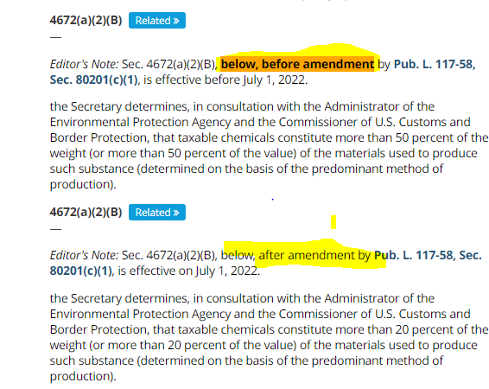
****
BACKGROUND NOTES
AMENDMENTS
2021—Subsec. (a)(2)(B). Pub. L. 117-58, Sec. 80201(c)(1), amended subpar. (B) by substituting “20 percent” for “50 percent” each place it appeared.

EFFECTIVE DATE OF 2021 AMENDMENT
Amendment by Pub. L. 117-58, Sec. 80201 is effective on July 1, 2022.

****

Redesignated Example: Sec. 5002(b), by PL 103-465

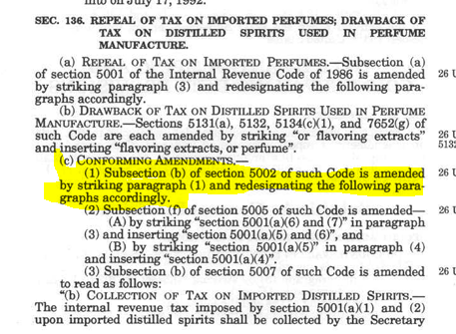

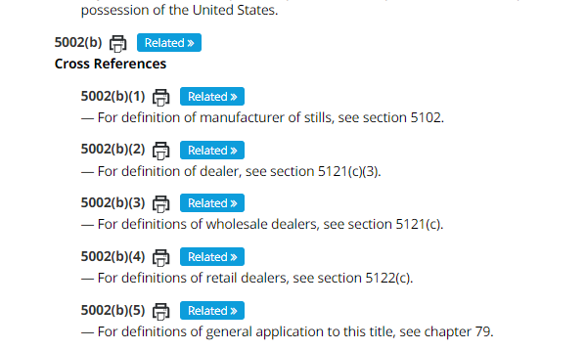

1994--Subsec. (b). Pub. L. 103-465, Sec, 136(c), struck par. (1) and redesignated pars. (2) - (6) as pars. (1) - (5), respectively. Before it was struck, par. (1) read as follows:
“(1) For definition of wine gallon, see section 5041(c).”

EFFECTIVE DATE OF 1994 AMENDMENT
Amendment by Pub. L. 103-465 effective January 1, 1995.

****

