Update Code Sections
NOTE: Use 135-test, 86-test, 222-test & 219-test in rc3974-comp as samples

4 things that need to be Updated
- Update Code Section
- History (usually the Bill Section- Column A is used in the language)
- Amendments
- Effective date

Follow instructions to checkout the file for the Code Sections that needs to be updated below.

1.Check out the file in BWip (usc-ref, 026_usc). The files are grouped based on the Code section number. For example, 026_00_usc has the files for Code sections 1-99, 026_01_usc has files for Code sections 100-199.

Note
- PL. no, 2. Statute & 3. Enactment Date usually comes later and most of the time it’s not yet available yet available when we’re updating the Code Sections. The Code sections are updated again when it’s available.
- The effective date in the Excel Sheet is not the Enactment date. Effective dates can go back . The effective date usually appears after the end of the Code section that needs to be updated not the End of the BILL or Pdf.
- The Enactment date is the date the President signs the Bill. The Enactment date, statute and PL. No. comes in at the same time.
Use PL. 117-__ (2 underscores) when the Pl. no is not yet available and no need to put Statute tags

Confluence page for Updating Code sections
https://confluence.bna.com/display/TPQA/Legislation+and+Code+Updating
Go to Chapter 3

Summary
- Get Code sections affected list (xml file)
- Get pdf file from Congress .gov.
- Search for section in Column C ex. 401(a)(67) in pdf file [search for division or title first]

- Code Section

Look for the Bill section in Column A of Code List Excel file

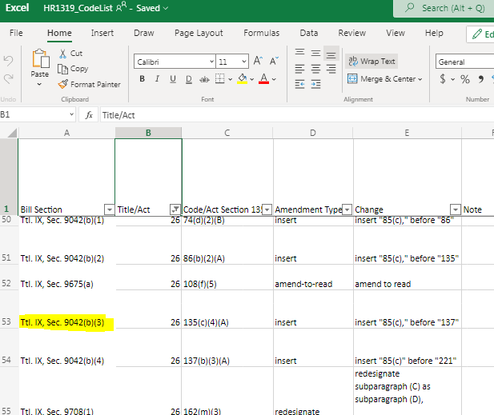

Search for the Bill section in the pdf

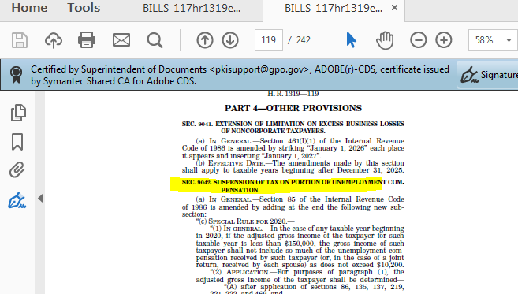
Search for the Code section in column C

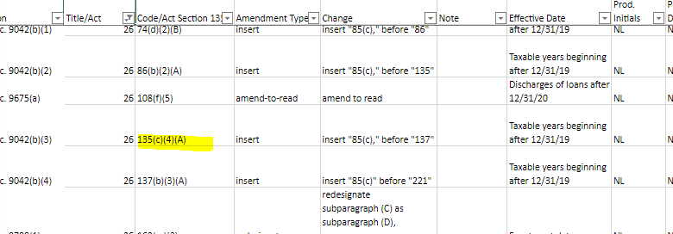

Then go down further in the pdf and search for the Code section indicated in column C of the Excel Sheet to get the instruction and text needed to update the code section.

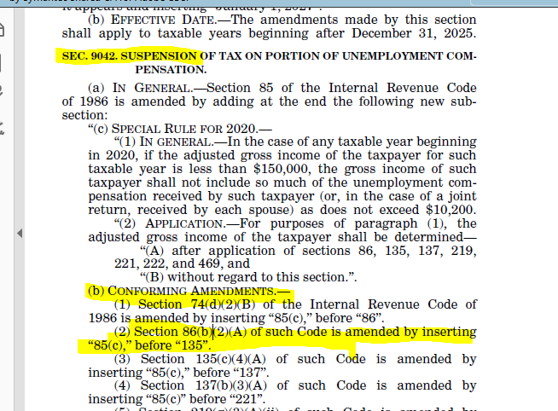

Note:
Use ___ if there is no PUB. L. yet ex.
P.L. 117-__

---------------------------------------

Then update the code section in arbortext

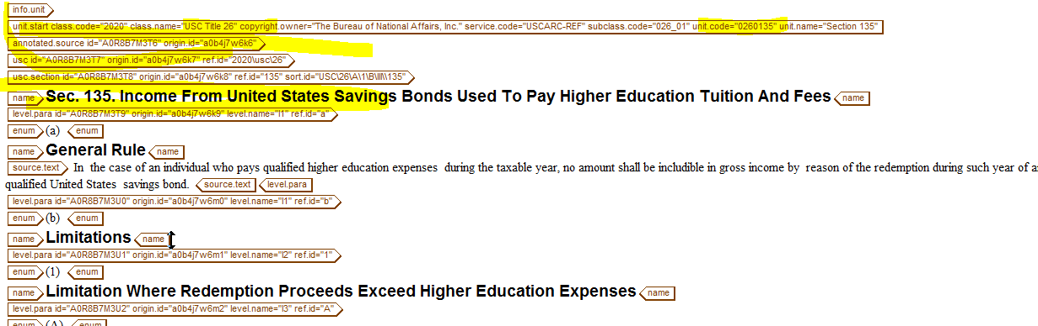

then

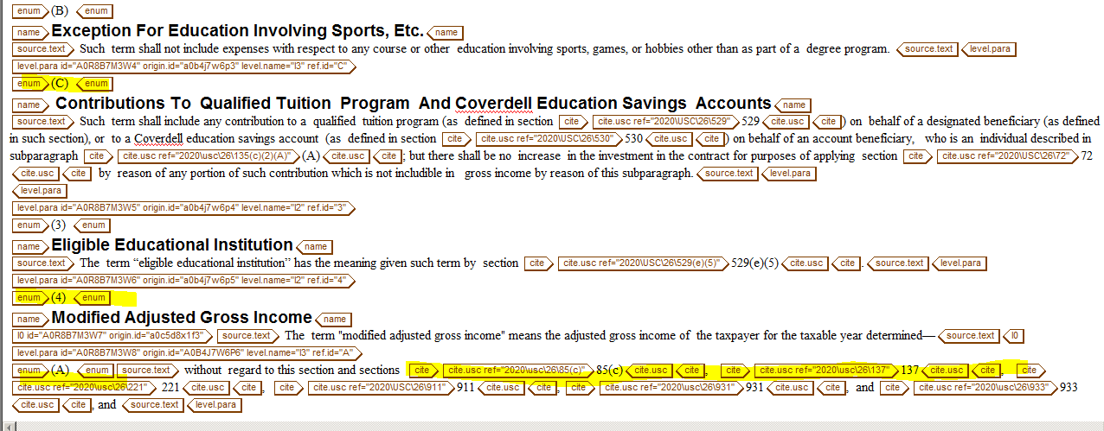

- History

Go further down on the Arbortext file and update the history – (this appears above the Background Notes) Usually data from Column A is used in the history

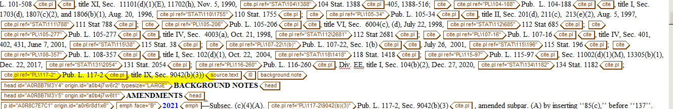

- Update Background Notes/Amendments
To determine if the update is a par, subpar, clause or subclause refer to previous entries below ex. subpar. A, clause (ii) .
In the example below amended subpar A is taken from Subsec (c)(4)(A).

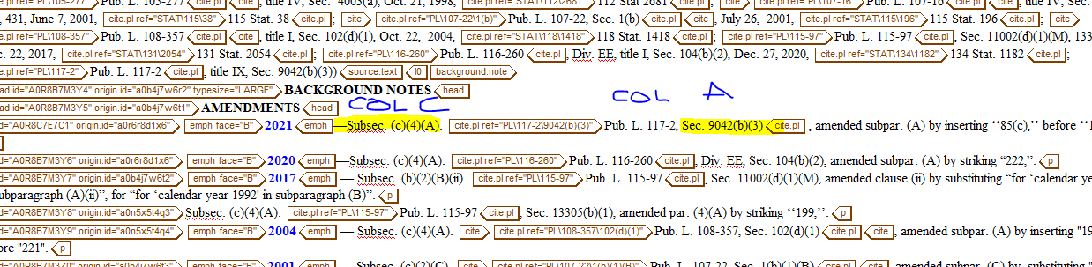

Update Effective Date

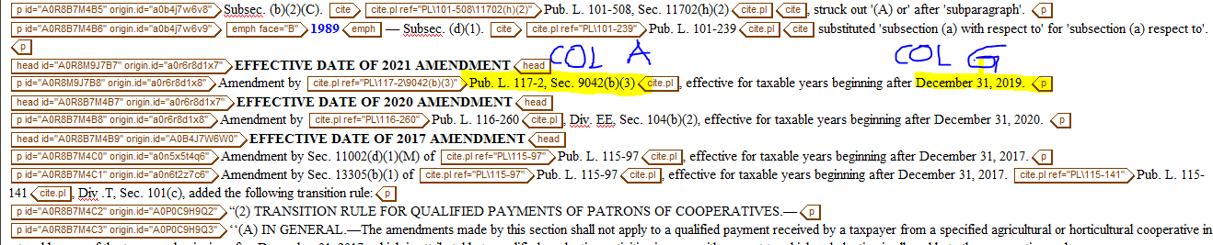

To look for the Code Section file in PDM
EX.
Update the following Code sections for HR 5444: Sec. 6015, 7602, 7802.

- Checkout files in pdm2
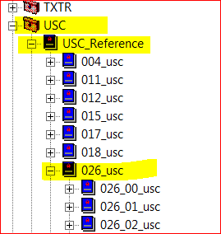

SEC 6015

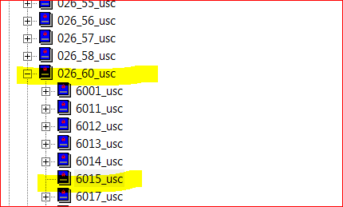

SEC 7602
- 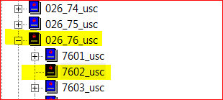

SEC 7802

- 