To make corrections (Phase 1)
Pdfs are in
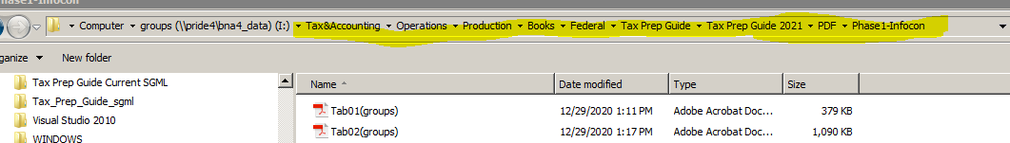

Sgml file is in TXPG_edit pool
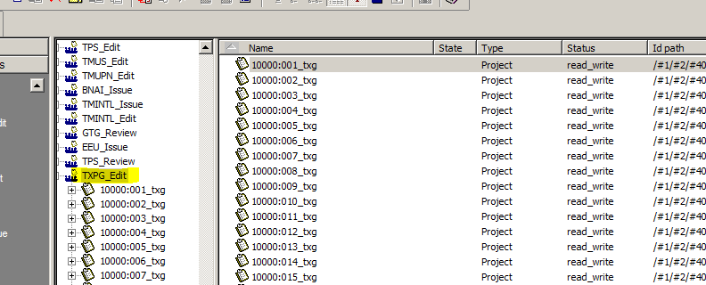
After making corrections
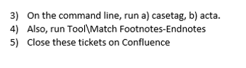

Sending the files to Infocon

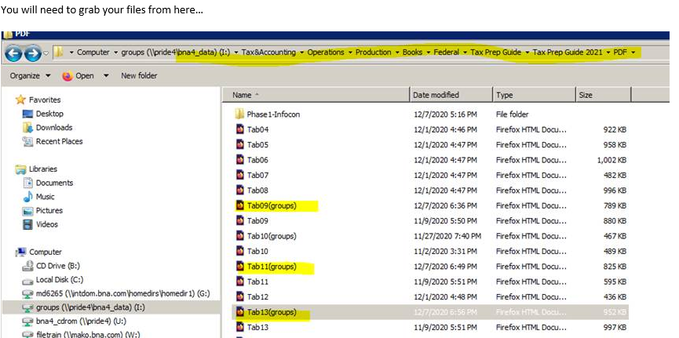

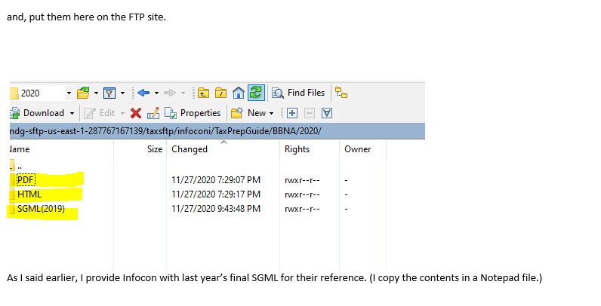

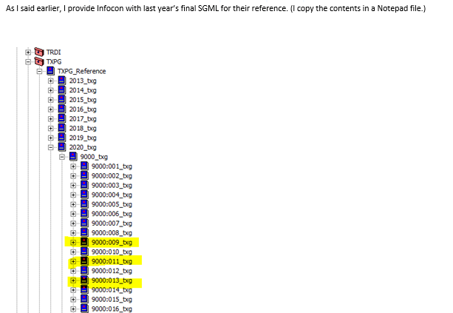

For unit.start values for this Tab, and other Tabs to come, please refer to the table below:

TAB NUMBER | Bna.id.prefix | Class.code | Class.name | Subclass.code | Unit.code | Unit.name
1 | 10000 | 10000 | Form 1040 | 2020 | 001 | Name of Tab
2 | 10000 | 10000 | Form 1040 | 2020 | 002 | Name of Tab
3 | 10000 | 10000 | Form 1040 | 2020 | 003 | Name of Tab
4 | 10000 | 10000 | Form 1040 | 2020 | 004 | Name of Tab
5 | 10000 | 10000 | Form 1040 | 2020 | 005 | Name of Tab
6 | 10000 | 10000 | Form 1040 | 2020 | 006 | Name of Tab
7 | 10000 | 10000 | Form 1040 | 2020 | 007 | Name of Tab
8 | 10000 | 10000 | Form 1040 | 2020 | 008 | Name of Tab
9 | 10000 | 10000 | Form 1040 | 2020 | 009 | Name of Tab
10 | 10000 | 10000 | Form 1040 | 2020 | 010 | Name of Tab
11 | 10000 | 10000 | Form 1040 | 2020 | 011 | Name of Tab
12 | 10000 | 10000 | Form 1040 | 2020 | 012 | Name of Tab
13 | 10000 | 10000 | Form 1040 | 2020 | 013 | Name of Tab
14 | 10000 | 10000 | Form 1040 | 2020 | 014 | Name of Tab
15 | 10000 | 10000 | Form 1040 | 2020 | 015 | Name of Tab
16 | 10000 | 10000 | Form 1040 | 2020 | 016 | Name of Tab
17 | 10000 | 10000 | Form 1040 | 2020 | 017 | Name of Tab
18 | 10100 | 10100 | Form 1120 | 2020 | 001 | Name of Tab
19 | 10200 | 10200 | Form 1120S | 2020 | 001 | Name of Tab
20 | 10300 | 10300 | Form 1065 | 2020 | 001 | Name of Tab
21 | 10400 | 10400 | Forms 1041, 706, and 709 | 2020 | 021 | Name of Tab
22 | 10600 | 10600 | Employee Benefits | 2020 | 001 | Name of Tab
23 | 10500 | 10500 | Forms 940 and 941 | 2020 | 001 | Name of Tab
24 | 10700 | 10700 | Business Topics | 2020 | 001 | Name of Tab
25 | 10700 | 10700 | Business Topics | 2020 | 002 | Name of Tab
26 | 10700 | 10700 | Business Topics | 2020 | 003 | Name of Tab
27 | 10700 | 10700 | Business Topics | 2020 | 004 | Name of Tab
28 | 10700 | 10700 | Business Topics | 2020 | 005 | Name of Tab
29 | 10700 | 10700 | Business Topics | 2020 | 006 | Name of Tab
30 | 10700 | 10700 | Business Topics | 2020 | 007 | Name of Tab
31 | 10700 | 10700 | Business Topics | 2020 | 008 | Name of Tab
32 | 10700 | 10700 | Business Topics | 2020 | 009 | Name of Tab
33 | 10700 | 10700 | Business Topics | 2020 | 010 | Name of Tab
34 | 10700 | 10700 | Business Topics | 2020 | 011 | Name of Tab

Receiving files from Infocon

Files received from Infocon are located in:
Infocon uploads the file into the FTP under the folder "/infoconi/TaxPrepGuide/Infocon/2020".

After receiving the files-
Store, review (pdf & SGML)and send back comments the update Jira tickets in the confluence page.

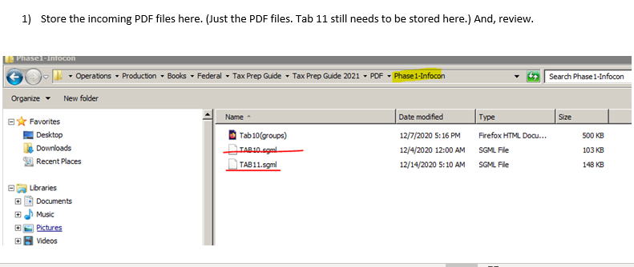
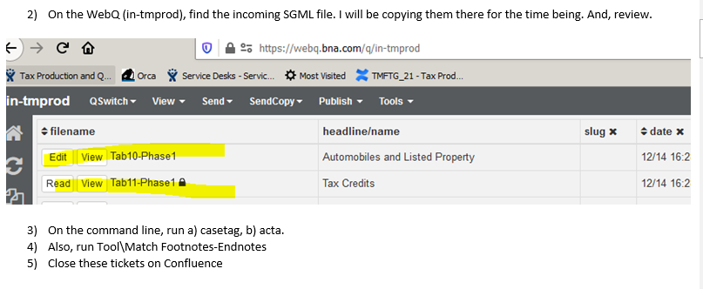

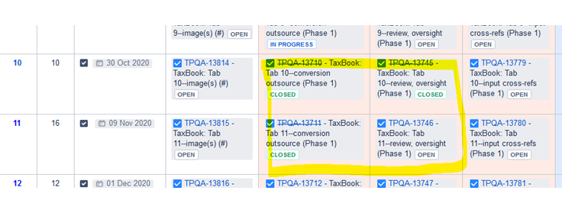

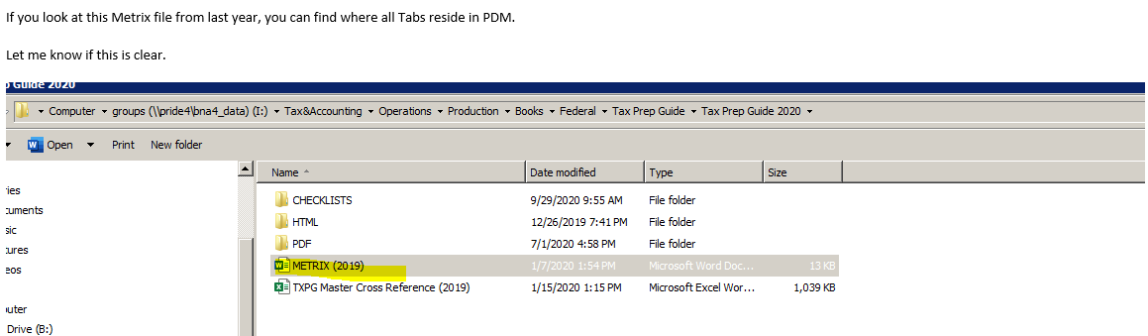

Where to find SGML files from Infocon in the Edit Pool

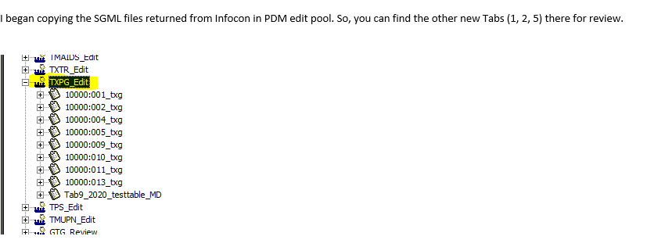

Search for the following in the pdf (should be highlighted)

Unit name no “TAB number”
&minus to replace hypens in computations
Cite reference tagging
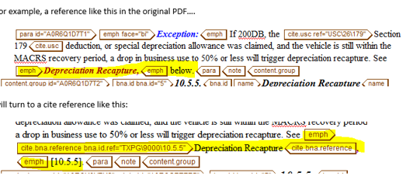

1. page
2. previous column
3. Next column
4. Tab
5.below
6. the following pages
7. above (not all – only if referenced to another chapter)
8. page reference
9. Text page

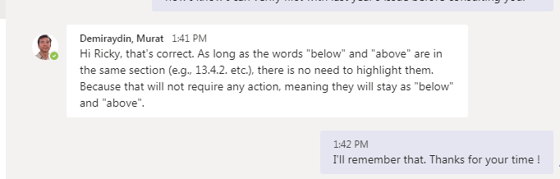
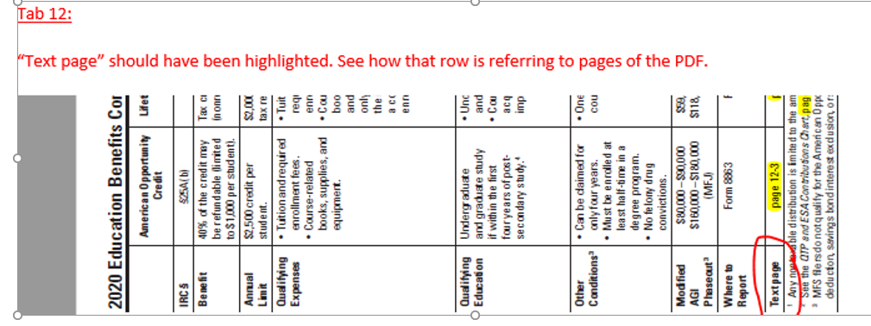

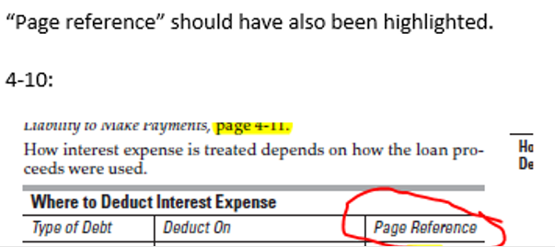

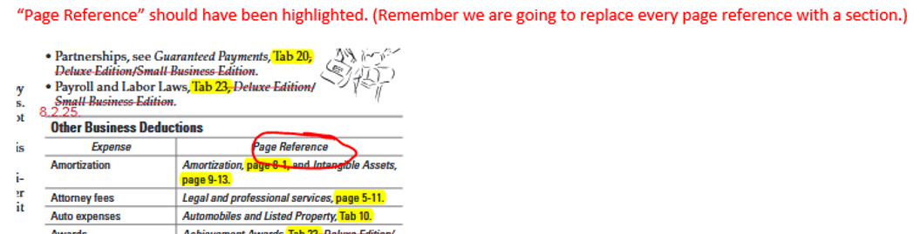

Check for the following in the SGML file (compare with previous year’s Issue in BTAX to verify highlighted terms and formatting of Tables

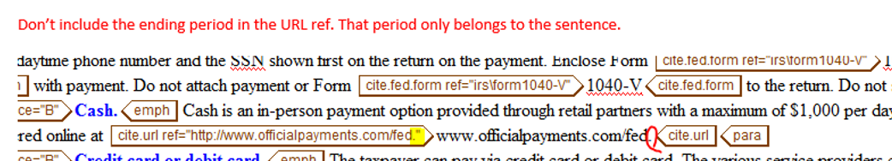

Check for content group nesting and list.item

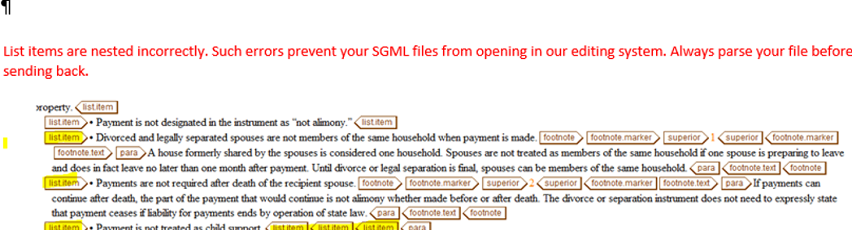

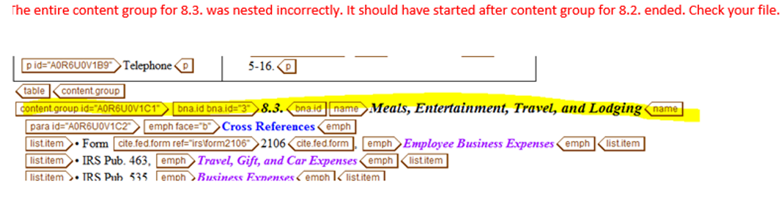

For Tables in SGML file check for
Frame, alignment (Figures should be right aligned), row and column separators, underscore single (rule for fraction, formulas and equations)

Ignore Frames- TOP BOT for tables

Note: use underline (not underscore) if the number has an underline and row at the same time

For TAB 17 tag only Federal forms (For Infocon)
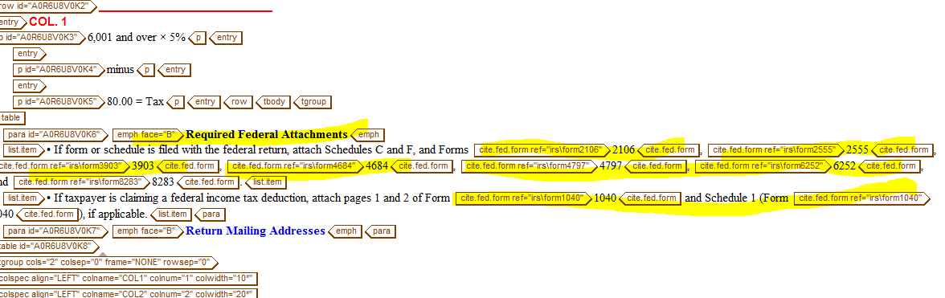

Phase 2

Sending files to infocon

Get files from here:

PDF
*Files are basically the same files (also where the phase I files were stored) that was reviewed and corrected from phase I and renamed from groups to new groups)
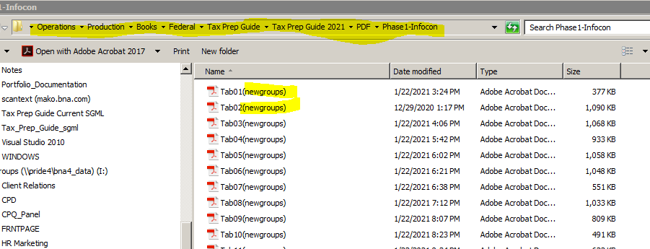

Then copy to FTP site to send to Infocon
groups (phase 1) & newgroups (phase 2)

Murat, Shawne and Nina are still in the process of reviewing the schedule and will give their input by the end of the day. The creation of the prototype is included in the Set up/Create the page view task which is scheduled on the first week of January but will be moved earlier as soon as we received the first batch of files for the 2nd Phase from Infocon. It was placed on the first week of January to provide extra time in case we or Infocon are short staffed during the holidays. The team has the impression
that the project will be finished earlier and I will adjust the starting dates once we know how long it will take Infocon to finish at least the first batch of the 2nd Phase. According to Murat the project was completed between the first and 2nd week of February although we’ve been publishing the Forms individually as we finish. In the new workflow we have the option to release individually or one time because of the test mode. Our concern is that if we release the files individually, the links to other tabs will link to a tab that hasn’t been updated yet. Anyway, let us know which way you prefer and I’ll reflect it on the schedule.

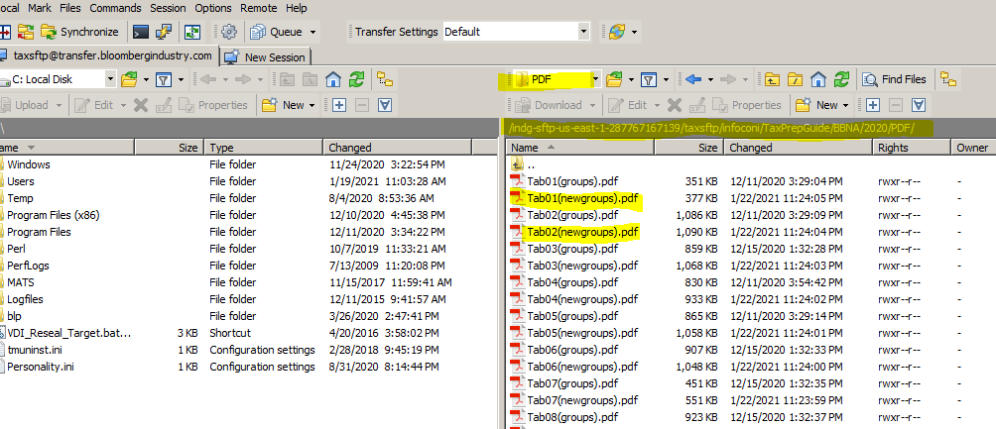

Get SGML files from PDM in TXPG_Edit
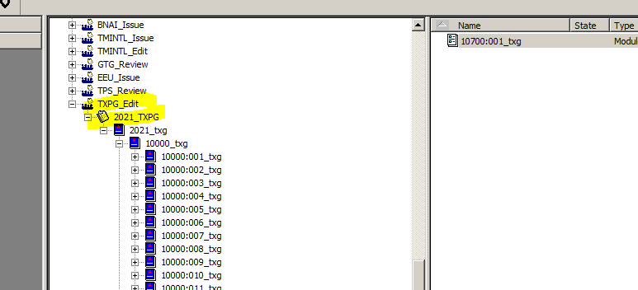

Then copy to FTP site here:

