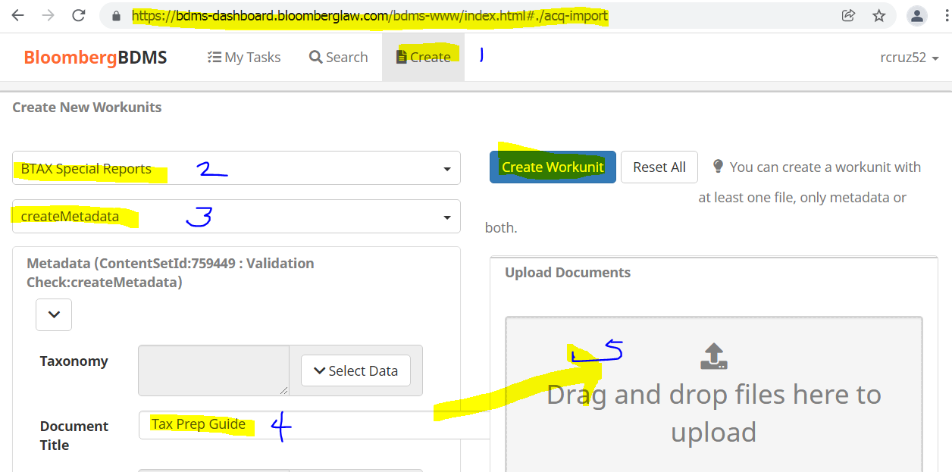

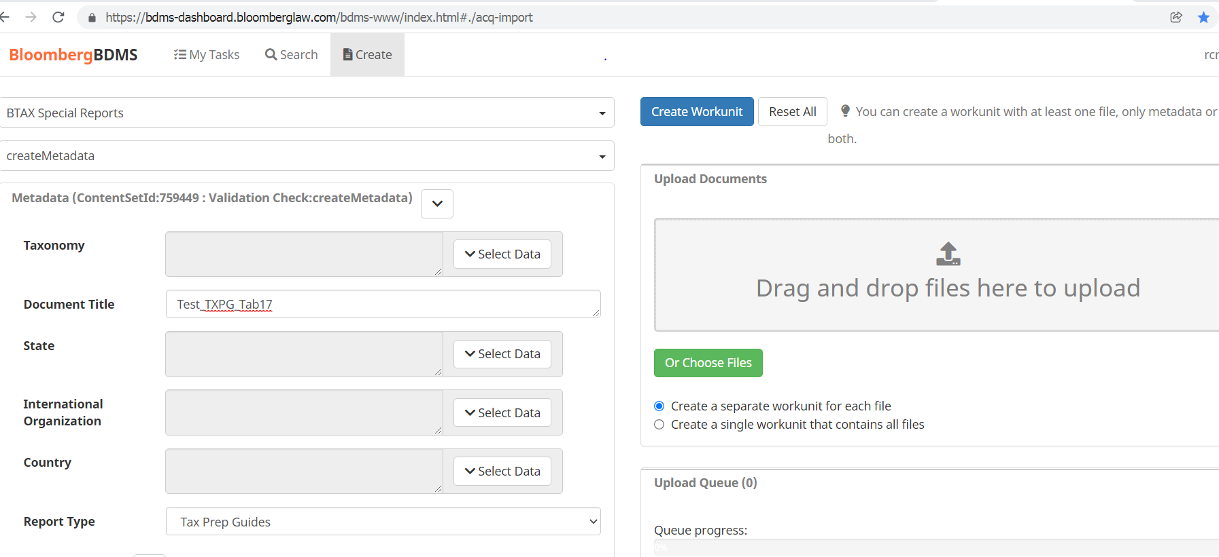

To Search for a File

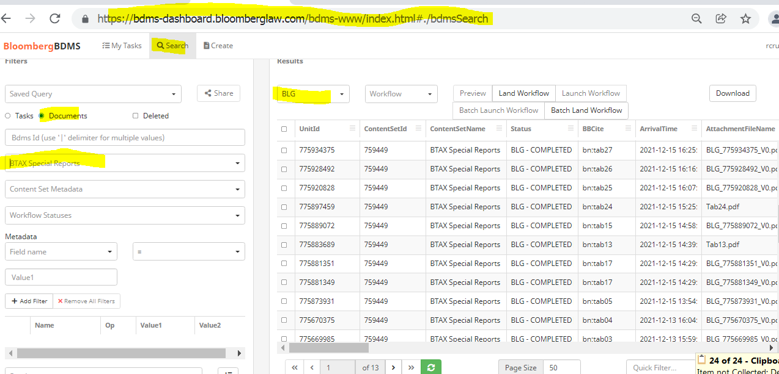

To Update a file in BDMS
Go to :
https://confluence.bna.com/display/TAX/PDF+Upload+Tool?preview=/1011254791/1311932718/PDF%20upload--replace%20existing_2021.09.09.docx

