TABLES, CHARTS & LISTS COLLECTION WORKFLOW

- Update or create a TCL document upon request from Analysts on JIRA
Sample ticket: https://jira.bna.com/browse/TPQA-28107

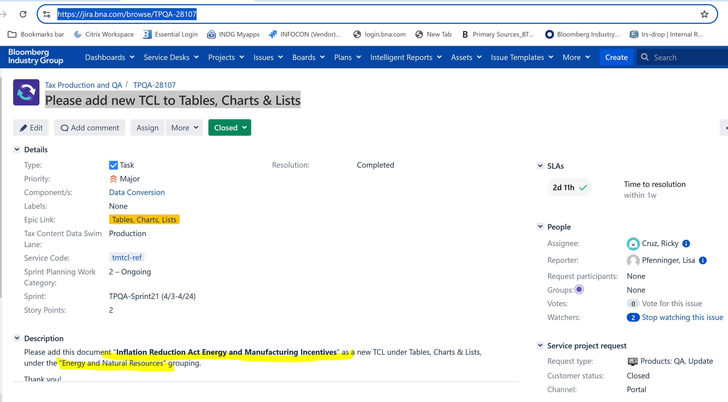

- Locate & checkout file to be updated from BWIP or create a new document when requested

IN BWIP:

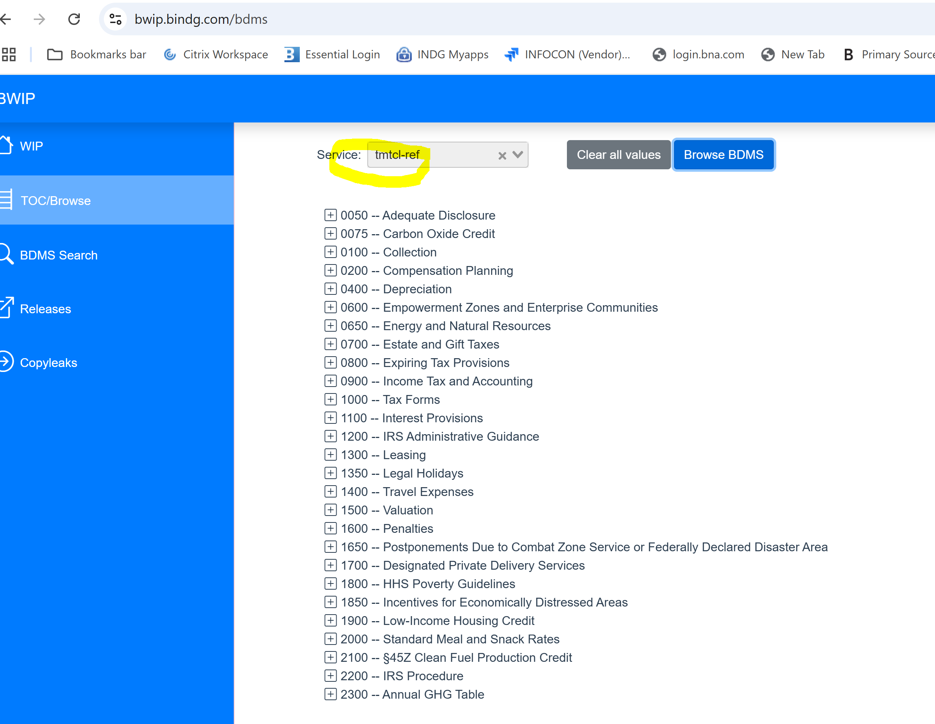
__________________________________________________________________________

- (FOR NEW TCL) Convert attachment(s) to word rtf file then send to bwip 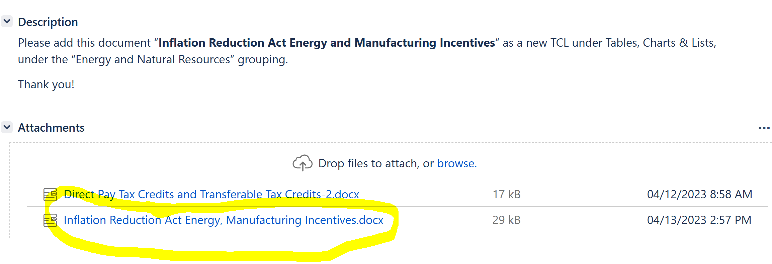
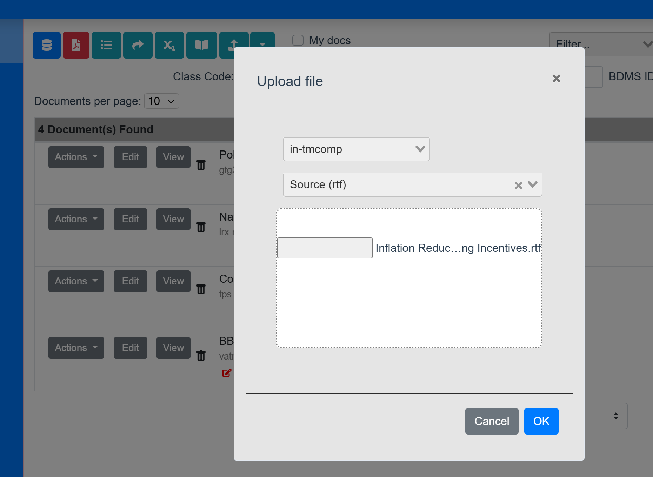

6. Format table in BWIP and insert to a dummy file with Info unit tags

_______________________________________________________________________
For TCL file to be updated

1. If URL is not indicated in the ticket, search in BTAX by copying the title and going to BDAT.

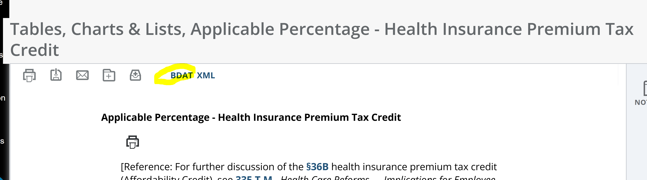

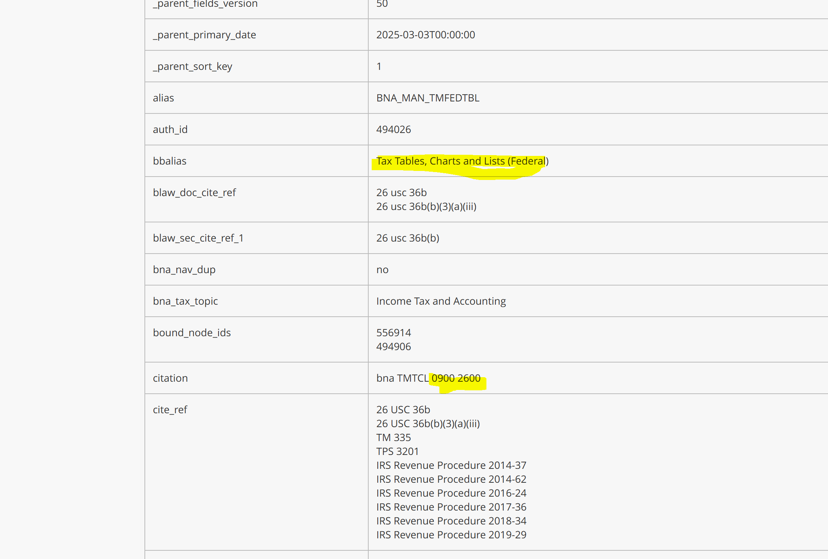

Locate existing document in BWIP
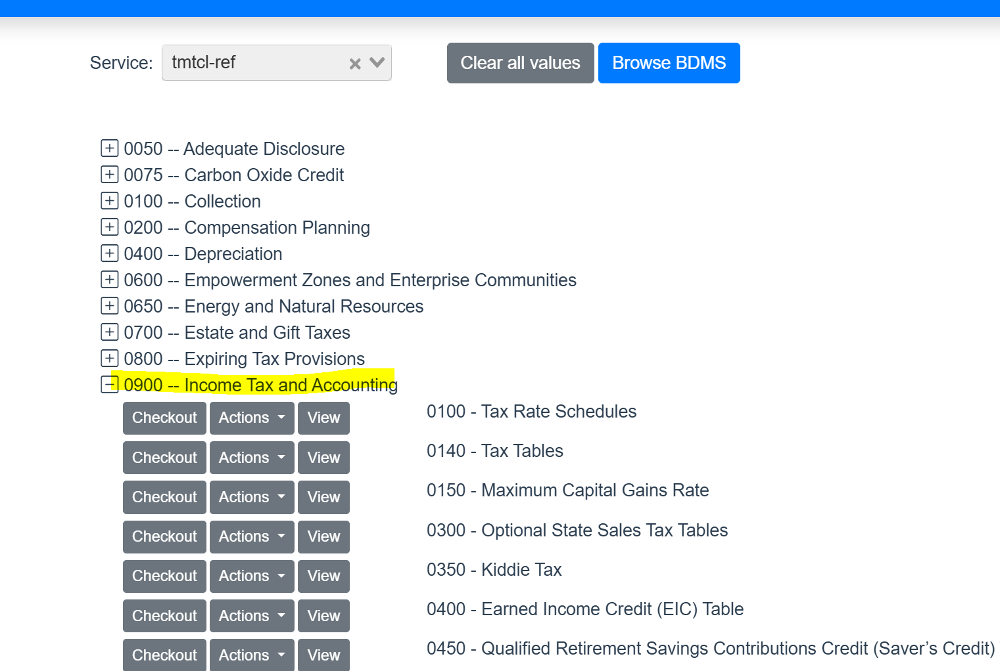

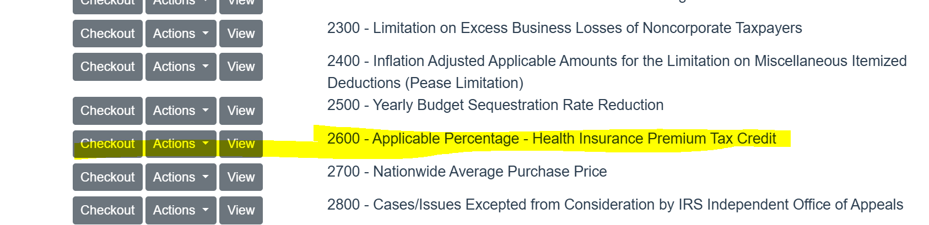

- Checkout file and make necessary updates.

