TAX COURT RULES UPDATING INSTRUCTIONS

TAX COURT RULES UPDATING involves going through 3 files, 2 for reference and 1 file where the updates are to be made:
- Tax Court Rules Amended March 2023.pdf
b. Tax Court Rules Notice March 2023.pdf
c. ctr_ref_0001_Rules_1-3.docx, ctr_ref_0002_Rules_10-13.docx, etc.

- From the NOTICE file (Tax Court Rules Notice March 2023.pdf) determine the RULES the Rules that were amended and needs to be updated:
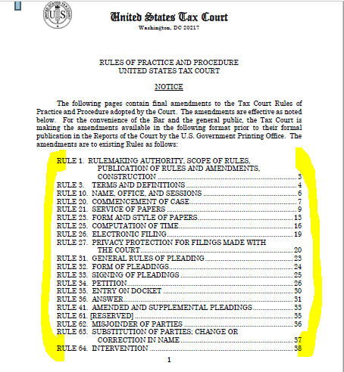

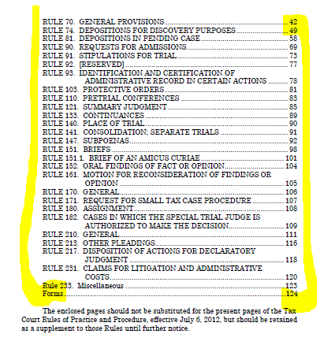

- On the Notice file (Tax Court Rules Notice March 2023.pdf) search for the page containing the Rules’ amended text & Notes.

Example:

FOR RULE 1

Rule 1 is in page 3, Rule 3 is in page 4, and so forth:
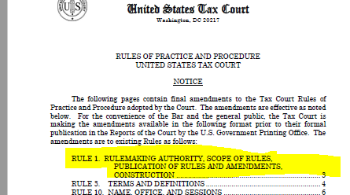

And going to page 3:
The top portion contains text that was amended and the lower part the Notes section (not all amended Rules include Notes).
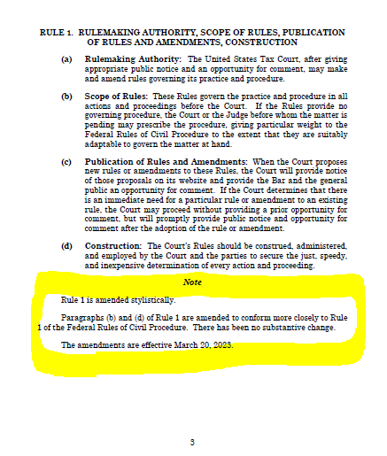

- Copy the Note section and insert at the bottom of the corresponding Rule .docx file, in this case – ctr-ref_0001_Rules_1-3.docx. [if there is no Note section proceed to step 5 & if there is an existing one delete it and replace with the new version]

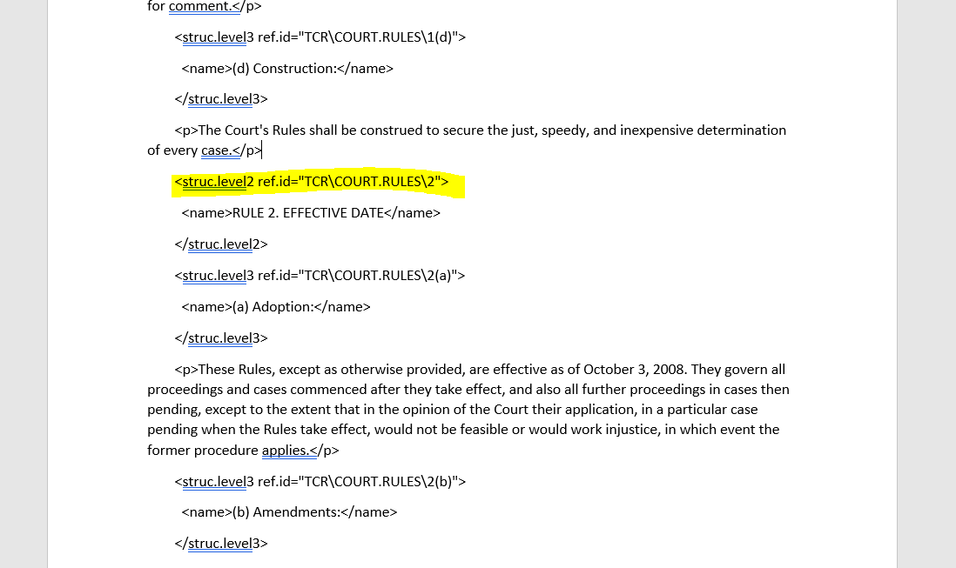
Insert Note Section here

- After inserting the text, tag following the sample below:
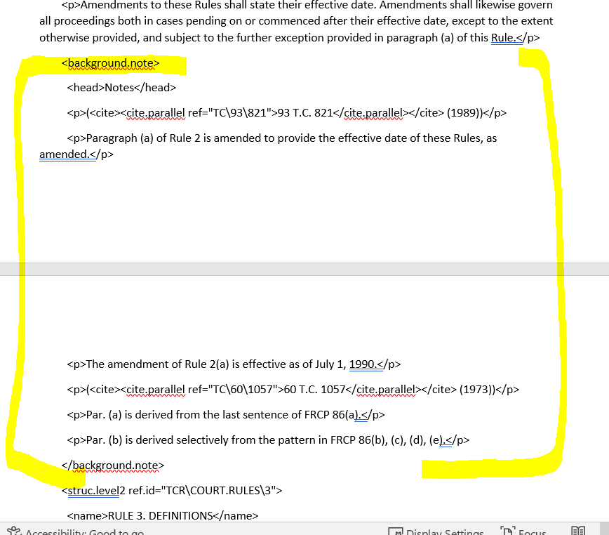

- After inserting and tagging the Note section go to the Tax Court Rules Amended March 2023.pdf file and extract the corresponding text and update the top part of ctr-ref_0001_Rules_1-3.docx:

Text to be extracted and inserted:
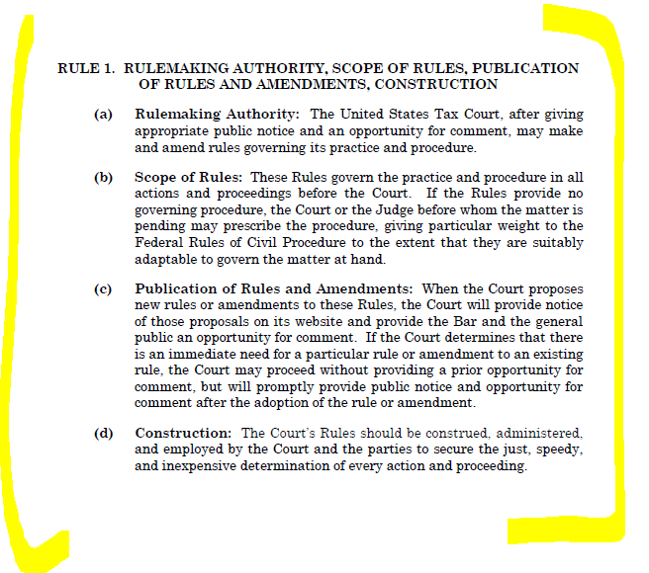

Text in ctr-ref_0001_Rules_1-3.docx that needs to be updated after inserting the Note section:

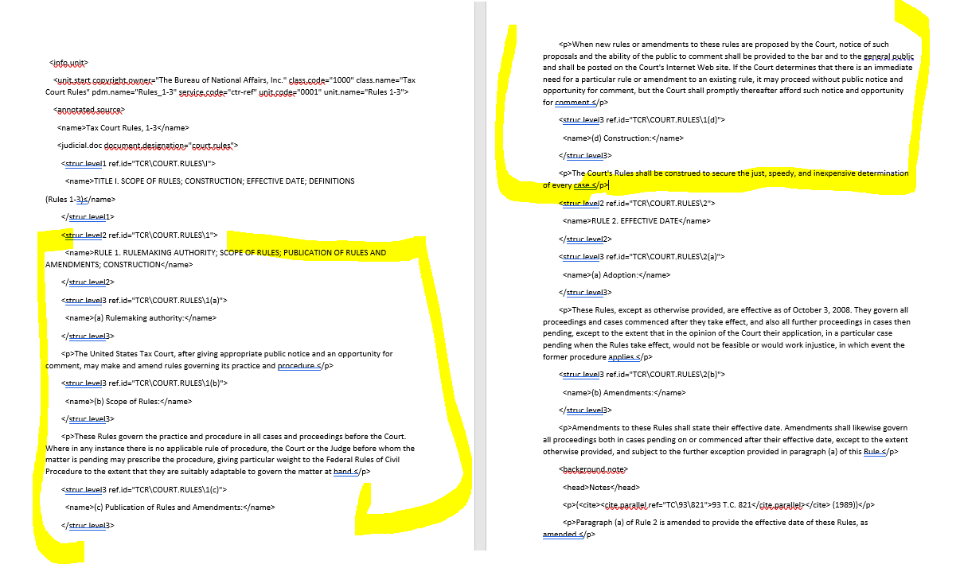

- You can either edit/update the text using the Tax Court Rules Amended pdf file as reference or insert the extracted text to the docx. file and follow existing tagging.

The text that needs to be updated showing in the top portion of the Notice may look the same as the one appearing in the Amended pdf but there might be minor updates that are not readily noticeable. On the safe side we prefer the version from the Amended pdf file as it is the final copy that is on the IRS web site.

