SEARCH & REPLACE <para include.in.chart=”1” with <list.tiem> tags

In PTE
- Do a Control H (this step will replace the <para include.in.chart=”1” with <list.item> tags to <list.item>

Type <para include.in.chart="1" id=".*?><list.item> in the search box &
<list.item> in the replace box then click on replace all
Note : Make sure you click on the Regular expression tab (encircled in blue) before clicking on replace all.

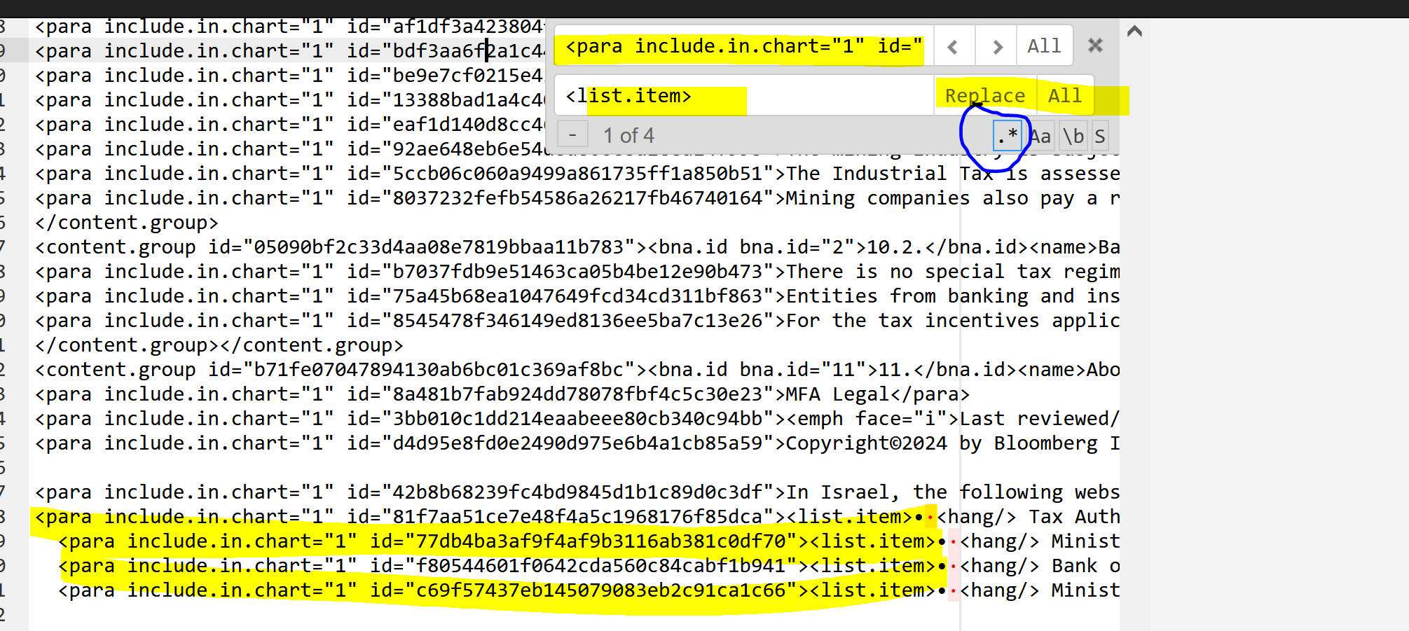

The file will look as shown below after the search and replace process:

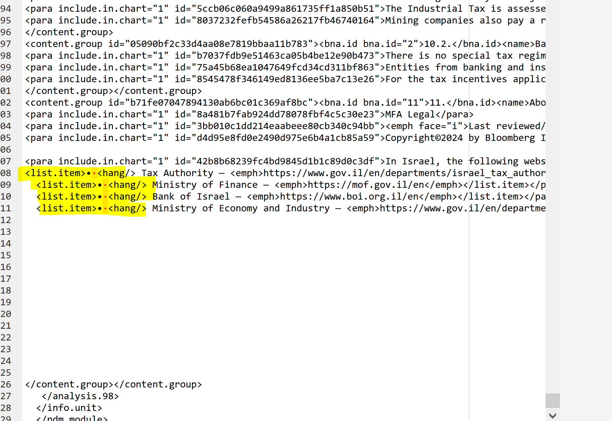

TO DELETE PARAGRAPH IDS

If you need to get rid of the paragraph ids do a search & replace by
typing<para include.in.chart="1" id=".*?> in the search box &
<para include.in.chart="1"> on the replace box then click on replace all

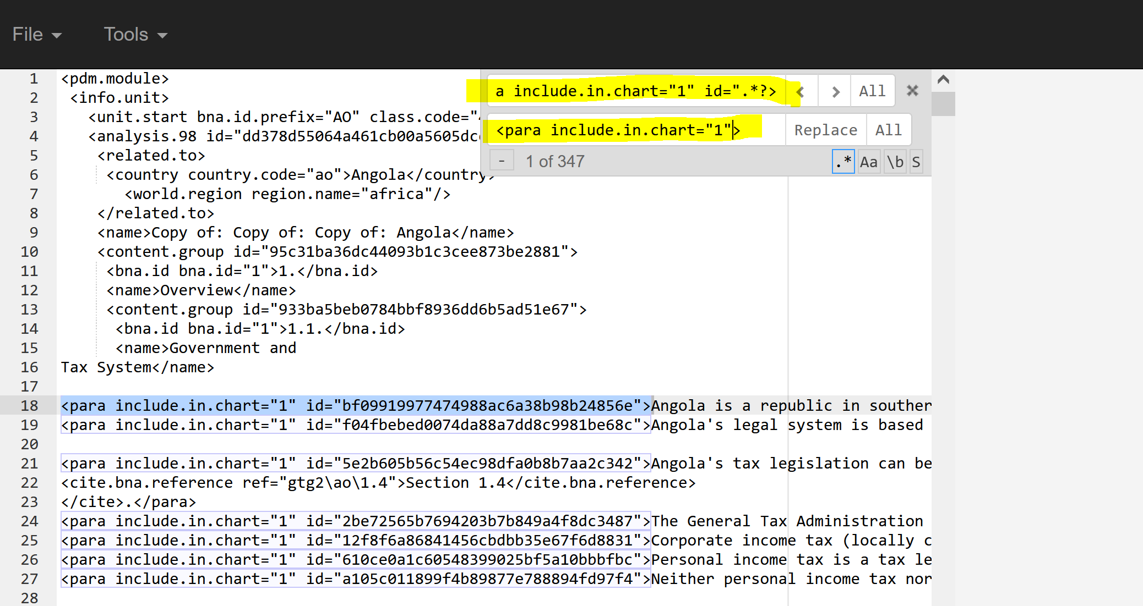

The file will look as shown below after the search and replace process:

