SENDING PO, COVER PAGE, & PORTFOLIO FINAL PDF TO PRINTER (GASCH)/PULL MAILING LIST/PRINT FULFILLMENT SCHEDULE

- SEARCH FOR PORTFOLIOS TO BE PRINTED IN JIRA (RECENTLY CREATED SD TICKETS):
Use Jira search -- project = SD AND status in (Open, "In Progress", "Work Queue") AND "Epic Link" = TPQA-33024 AND created >= -3w
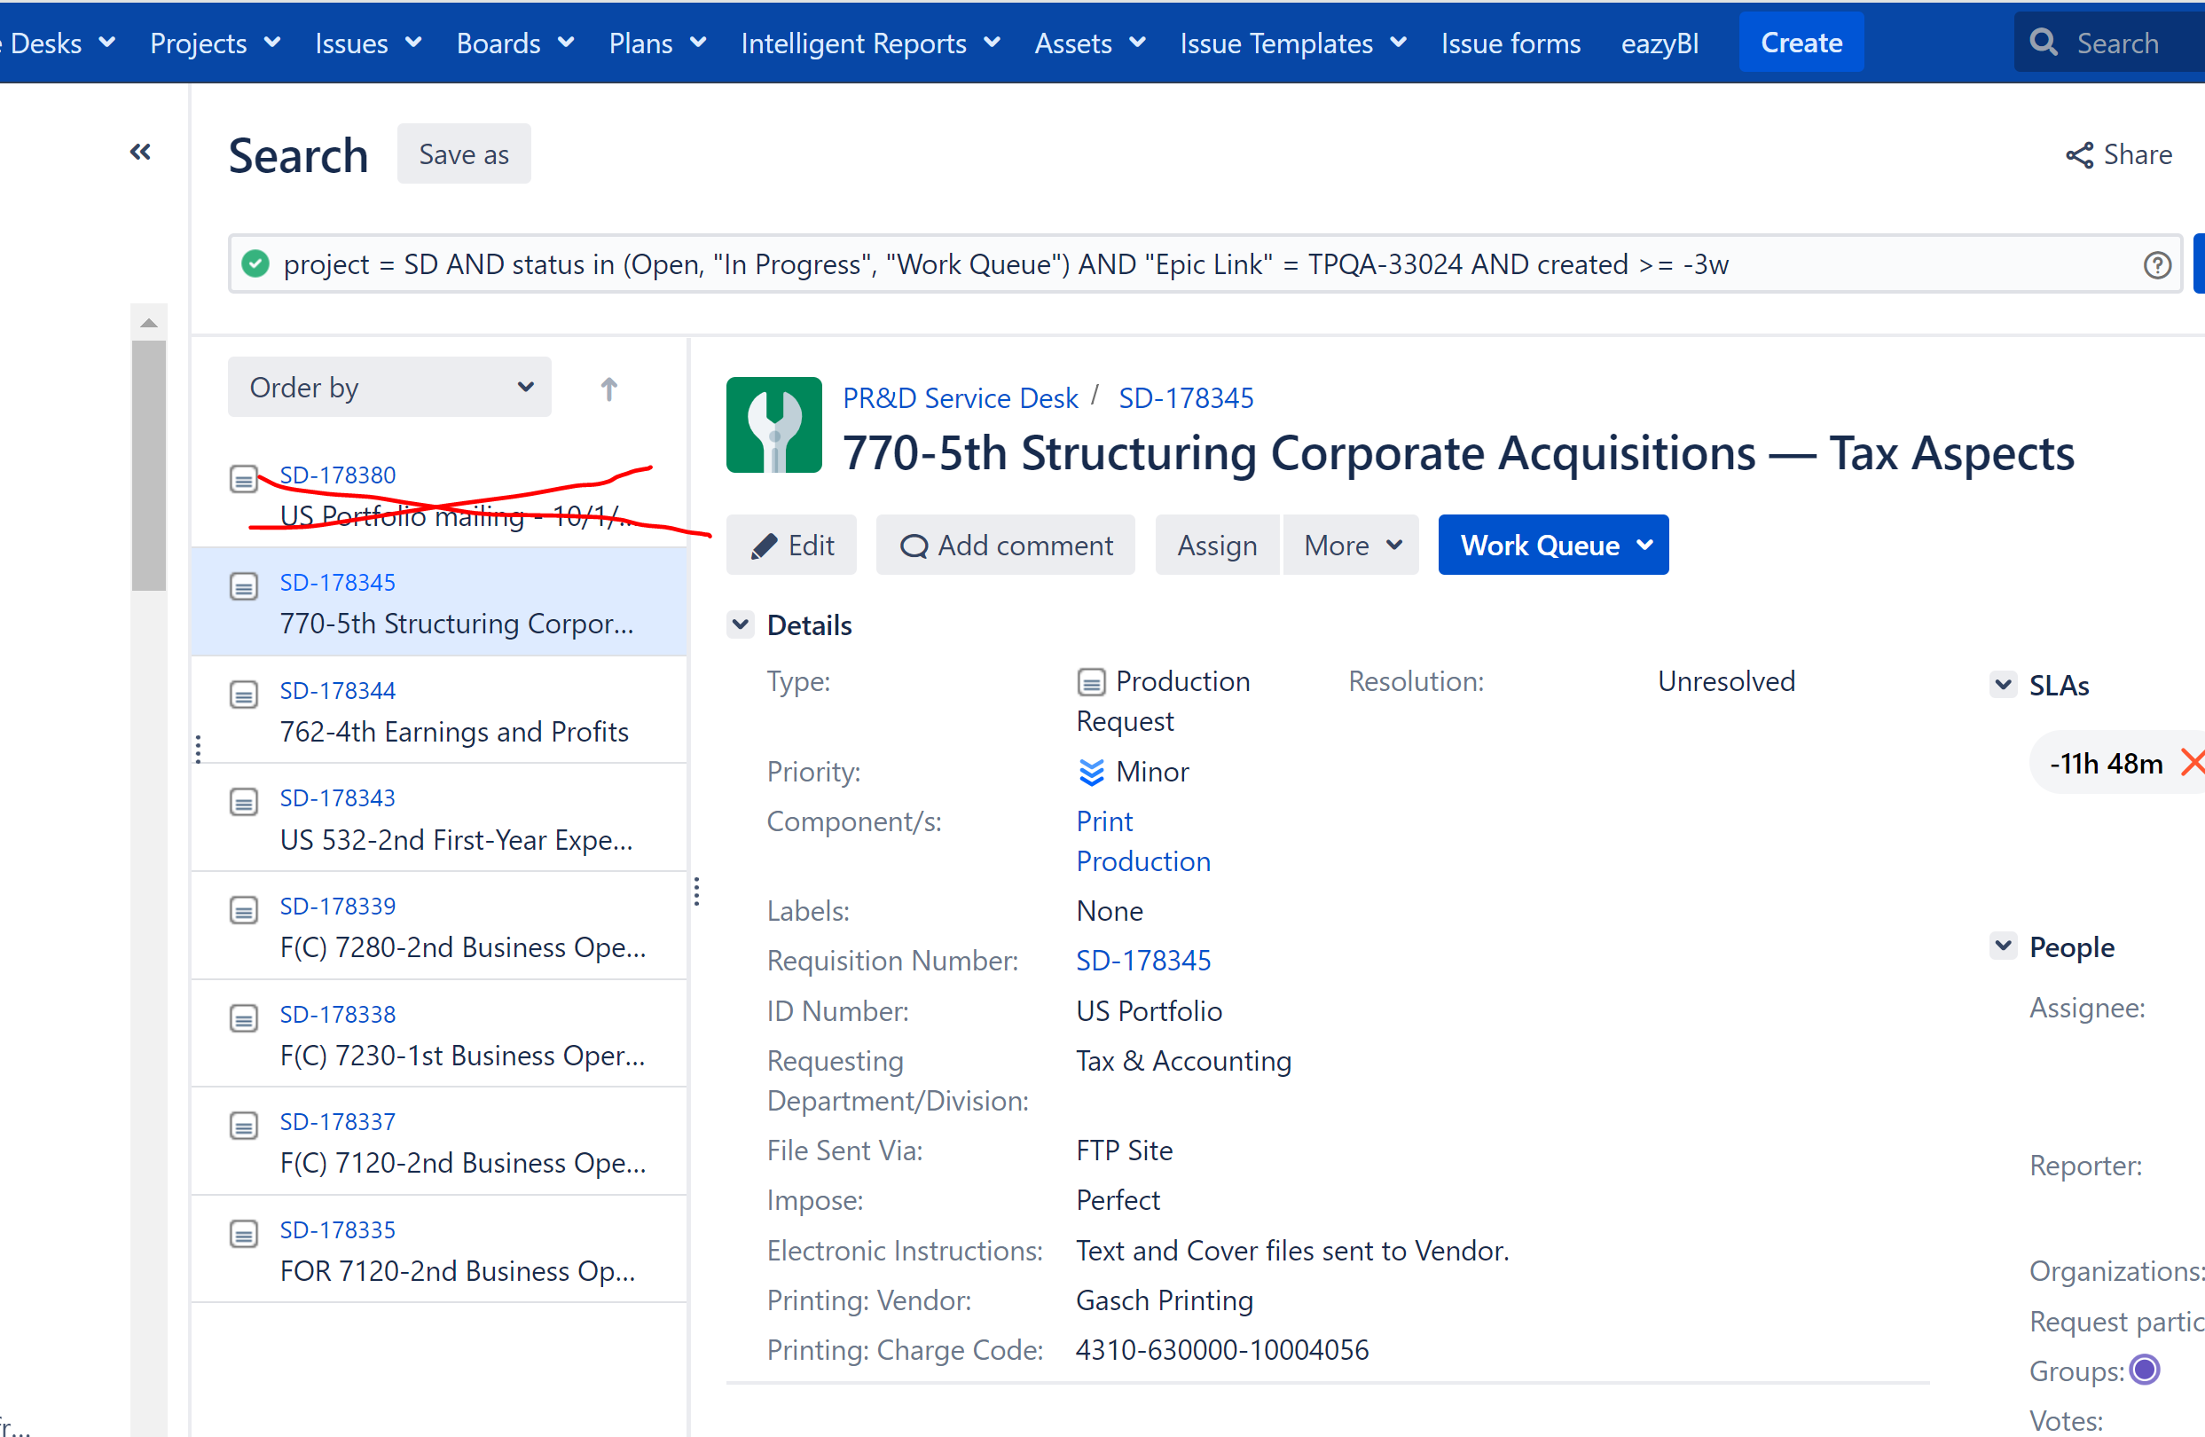

- INSTRUCTIONS ON HOW TO FILL UP FORM:
https://confluence.bna.com/display/TPQA/2%29+Upload+Composed+File+to+Print+Vendor

- URL FOR FORM TO FILL UP:
https://gaschprinting.com/send-a-file/

- SAVE PO TO FOLDER IN:

https://bna.sharepoint.com/sites/Pride4_Bna4_Data_TaxAccounting/Shared%20Documents/Forms/AllItems.aspx?OR=Teams%2DHL&CT=1727109962281&clickparams=eyJBcHBOYW1lIjoiVGVhbXMtRGVza3RvcCIsIkFwcFZlcnNpb24iOiI0OS8yNDA4MTcwMDQyMSIsIkhhc0ZlZGVyYXRlZFVzZXIiOmZhbHNlfQ%3D%3D&id=%2Fsites%2FPride4%5FBna4%5FData%5FTaxAccounting%2FShared%20Documents%2FGROUPS%2FTax%26Accounting%2FOperations%2FProduction%2FProjects%2FPortfolios%2FPrint%2DProduction%2F8%2E%202024%20Portfolio%20Orders&viewid=5955958b%2D7c95%2D45af%2Dbb4b%2Da8e995ab6ab7

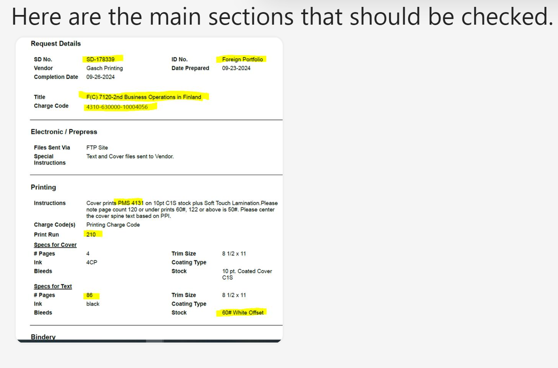

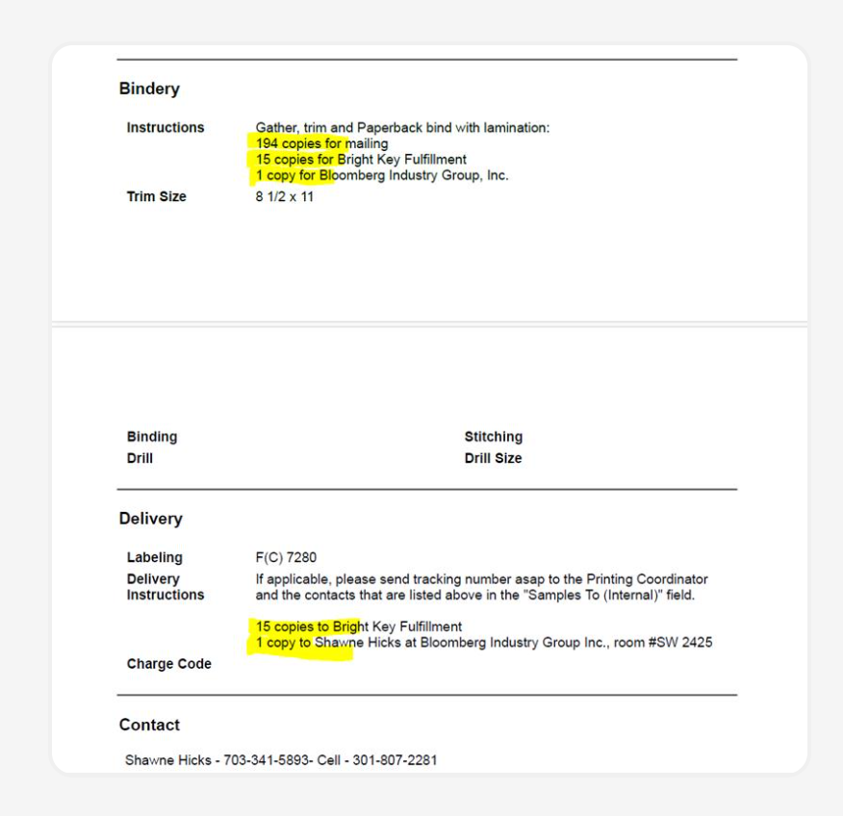

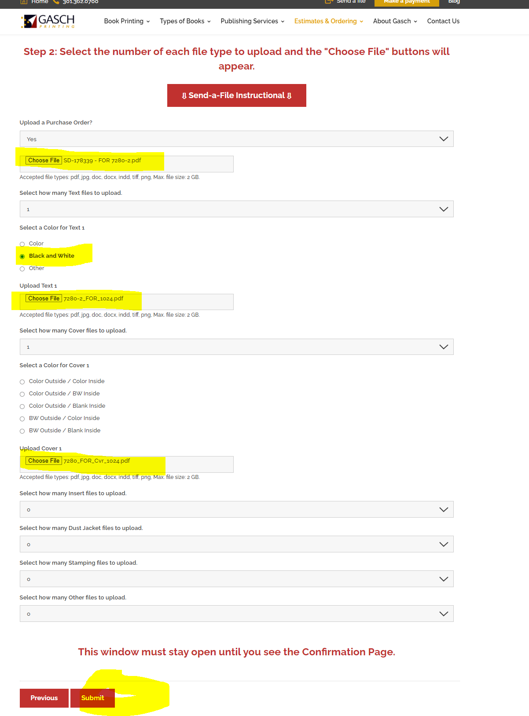

PULL MAILING LIST (SAP) INSTRUCTIONS–
- CHECK WHAT SERIES WILL BE PRINTED BY LOOKING AT THE PRINT FULFILLMENT SCHEDULE (e.g., US, Foreign, or EGT.
PRINT FULLMENT SCHEDULE
https://confluence.bna.com/pages/viewpage.action?pageId=1734950328

- THEN:
https://confluence.bna.com/pages/viewpage.action?pageId=1741455919

