Prop. Reg. Instructions
New Prop. Reg. -- REG-108054-21. -- https://jira.bna.com/browse/TPQA-28544
DC_Prop REG: RG_108054-21_Official -- https://jira.bna.com/browse/TPQA-28562
INFOCON (Vendor) Dashboard -- https://jira.bna.com/secure/Dashboard.jspa?selectPageId=117800
- James V. / Paula creates a Jira ticket when a new Prop. Reg. (advance version) is released by the IRS
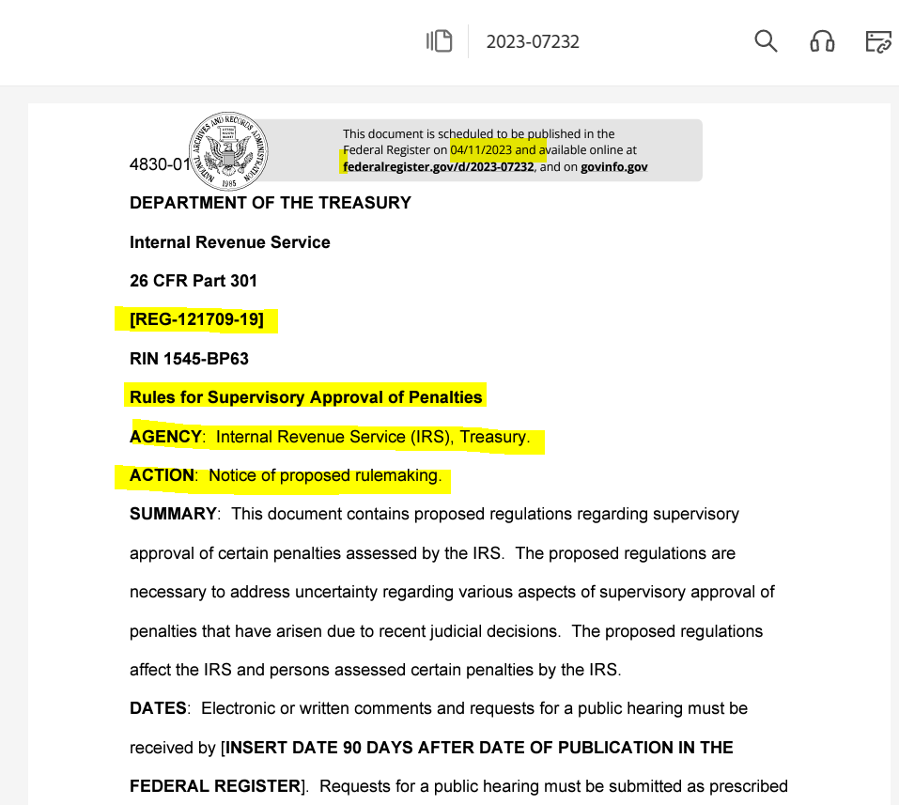

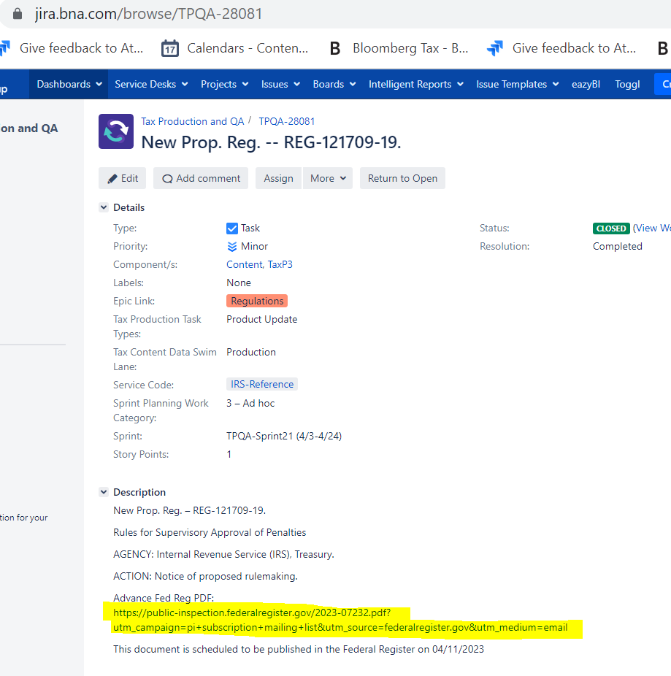
2--Title
5--URL link to advance pdf
Publication Date to Federal Register
1--Document Number
4--Action
3--Agency

The Jira ticket contains the Prop. Reg. No., Title, Agency, Action, URL link to the advance pdf, and the date the document is to be published in the Federal Register.

***Make sure, when copying and pasting from the Federal Register document, whether the advance version, or the official PDF version, to replace a copied hyphen with a keystroke/keyboard hyphen. Do NOT use a copy and paste hyphen, as it will make the BWIP document ineffective (for the attribute fields). For instance “REG-122319-22” – make sure there are keystroke/keyboard hyphens for the attribute fields in BWIP. ***

- Next step is to create a file for the new Prop. Reg. by going to WEBQ in the legtemplates-tmprod directory and copy Prop._Reg. Template file into your personal queue.

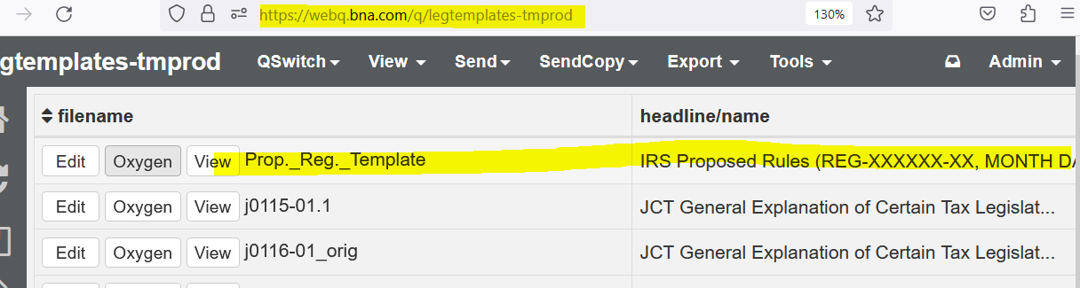

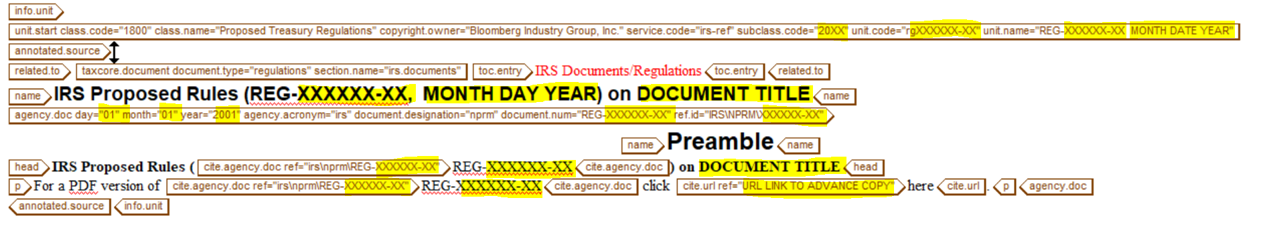

- Fill up the highlighted entries using the information from the Jira ticket and the advanced pdf.

Note: Prop. Reg. documents comes in different versions, and this should be indicated in the Unit code (Document number plus a -01, -02, or -03 extension e.g. reg121709-19-01, rg121709-19-02 etc. following on what extension has been used on prior documents.)

- Completed file should be similar to the file below:

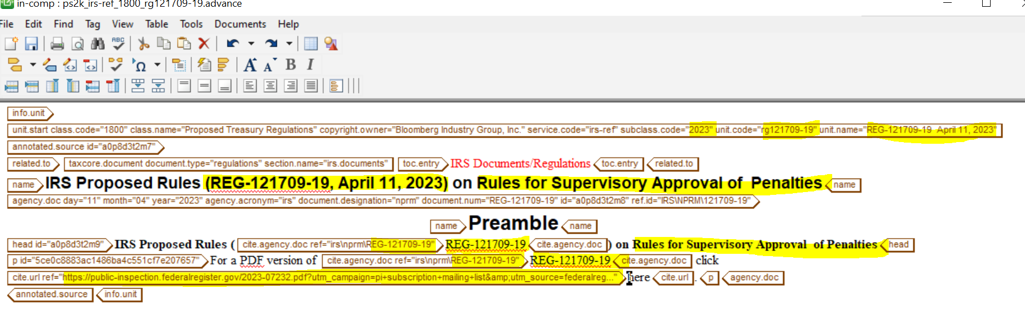

Agency Doc field:
rg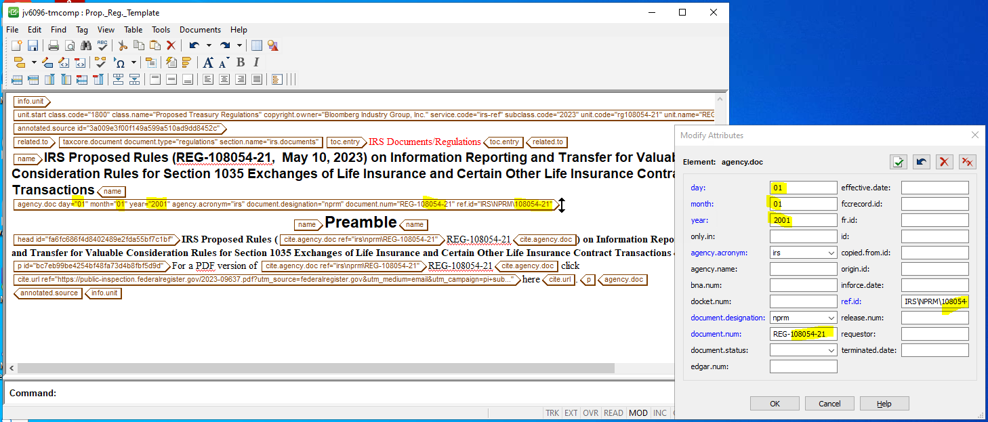

Sample of unit tags of a Prop. Reg. Hearing Document:
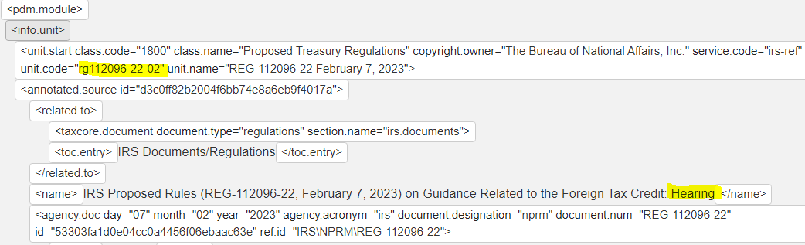

Sample of unit tags of a Prop. Reg. Correction Document:
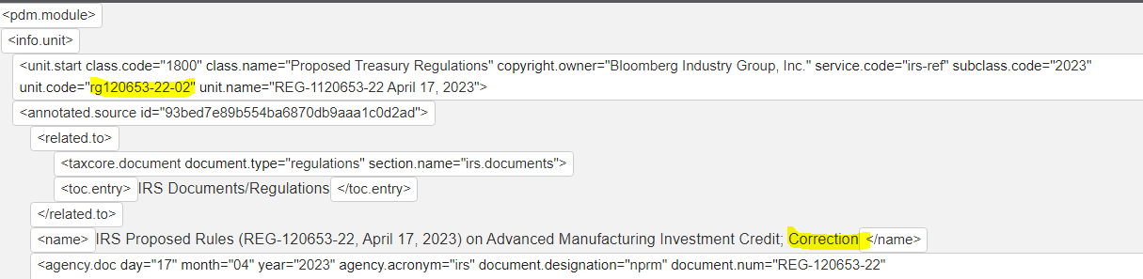

To be able to see the attributes, much the same was as unformatted, and what would be seen in F7, use the expansion below, for “full tags and attributes”.

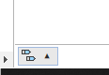
Click “full tags and attributes”

- Once you are done with the file in Oxygen, rename the file in WebQ before sending it to BWIP. Use the UNIT CODE as the File Name. (Close the file before renaming it in WebQ.)
Sometimes when renaming, if you have copied and pasted from somewhere else, such as the Fed Reg PDF, the hyphen might not be recognized in the Rename file part, and it will give an Invalid Name error. So just replacing what looks like a regular hyphen with a keyboard hyphen should work to be able to correctly rename the file.

- Click on the R in the left panel: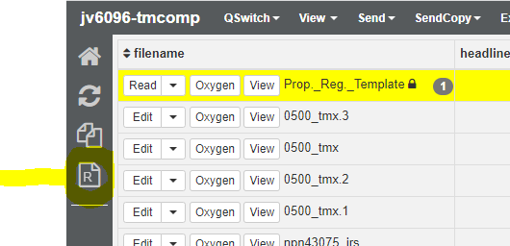

Lowercase, no hyphen:
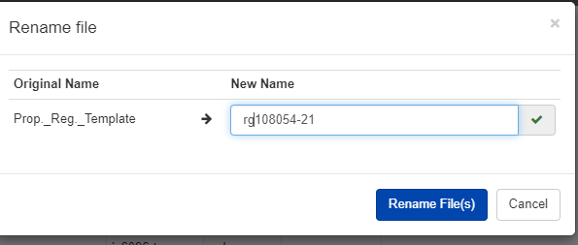
If locked, highlight, and use TOOLS, unlock:
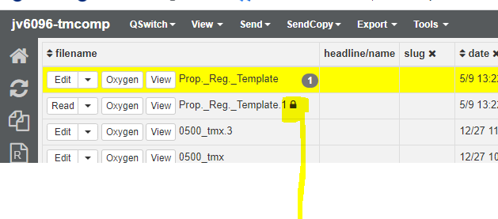

- Send the file in WEBq to BWIP.
a. Highlight the file in WEBQ and in The EXPORT drop down menu click on
to BWIP: 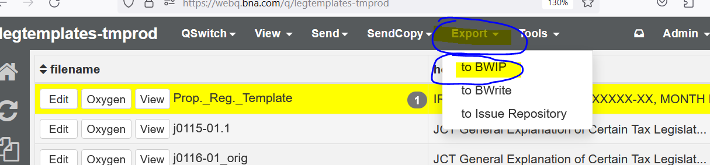

If for some reason you need the file back after sending to BWIP, use this command to get the file back:
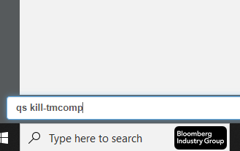
This is where it will end up:
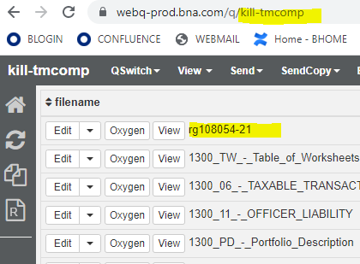

- When the file in in the WIP directory in BWIP highlight the file and click on the Actions drop down menu and click on Mark for Release: 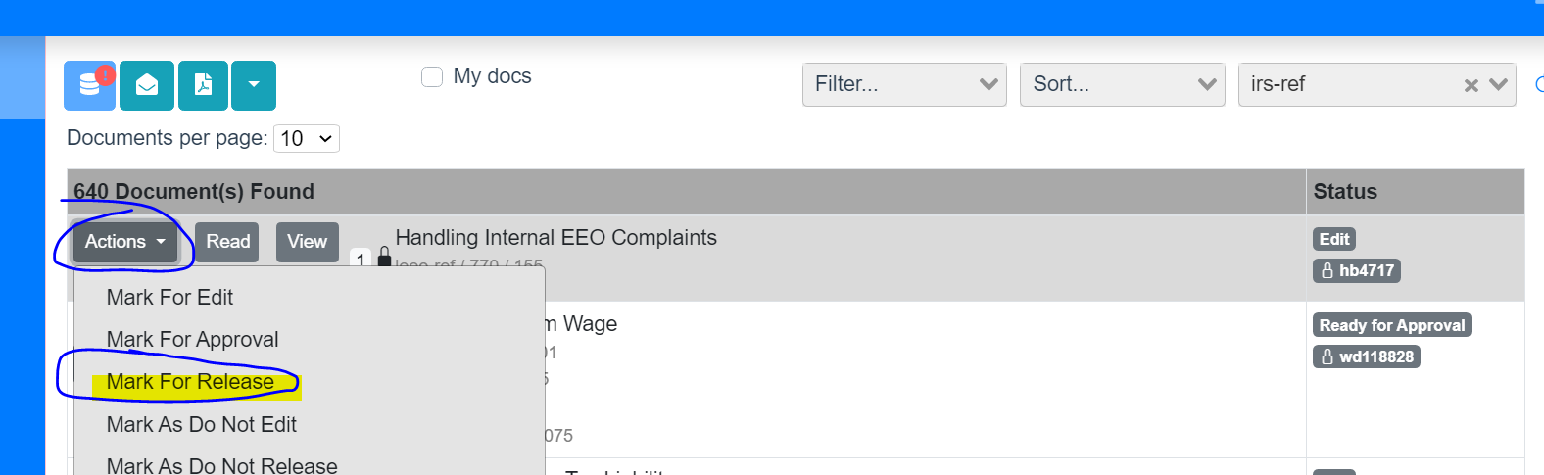
- Click on the Release icon to post in BTAX:

Click to post the file in BTAX
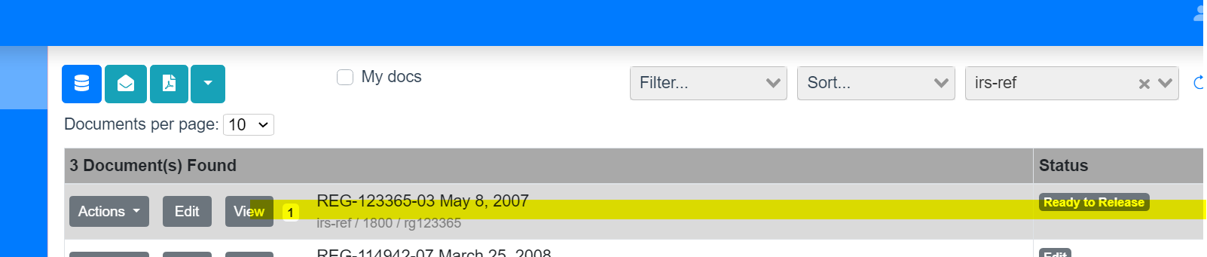
- Once the Official version (copy published in the Federal Register) is available send the pdf file to Infocon for conversion to full text.
- Create a JIRA ticket and attach the Official Fed Reg document pdf and also the info unit codes with tagging from the advance version file.
Name the Official Fed Reg PDF starting with “rg_” and for the ones that are exceptions, such as a Hearing or a Cancellation, etc., make sure to add the “-02”
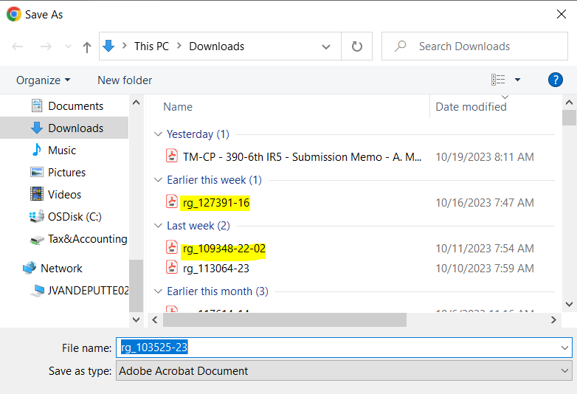
(DC_Prop REG: RG_108054-21_Official -- https://jira.bna.com/browse/TPQA-28562 )
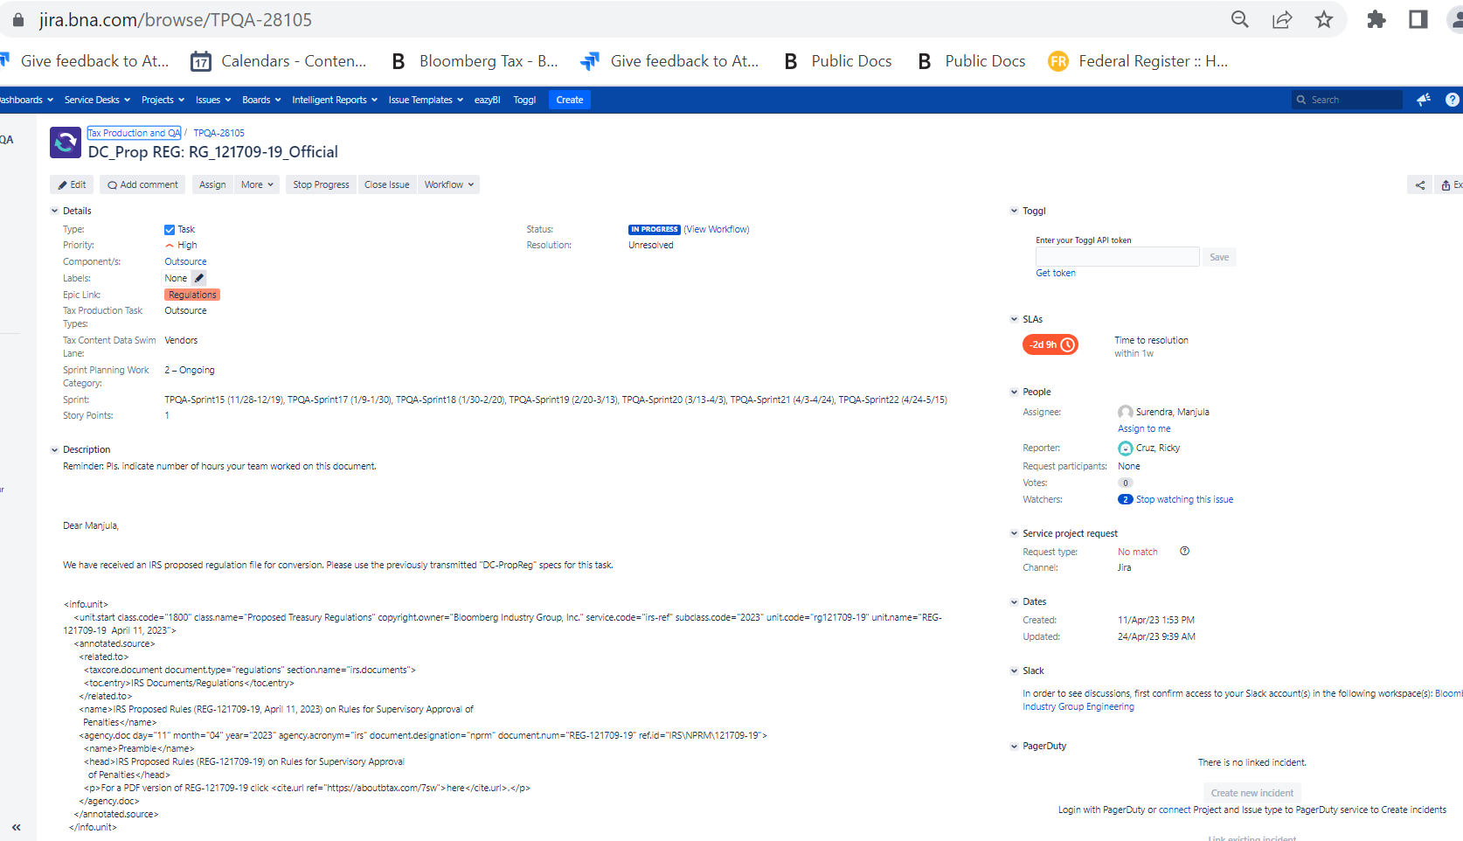

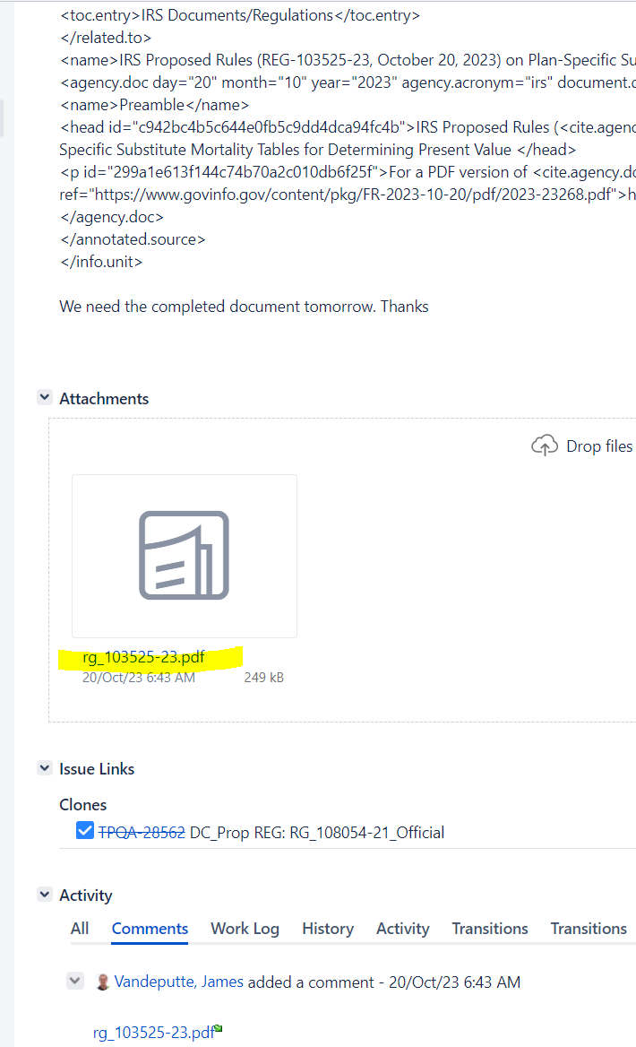

- Upon receipt of completed file from Infocon insert the text to the file with the link to the advance copy in BWIP.
- Checkout the file
- Edit in Oxygen in WIP
- Release in BWIP

Inserting the converted text from Infocon:

Save the sgml file (in your personal directory) from the attached sgml file in the Vendor ticket e.g.,:

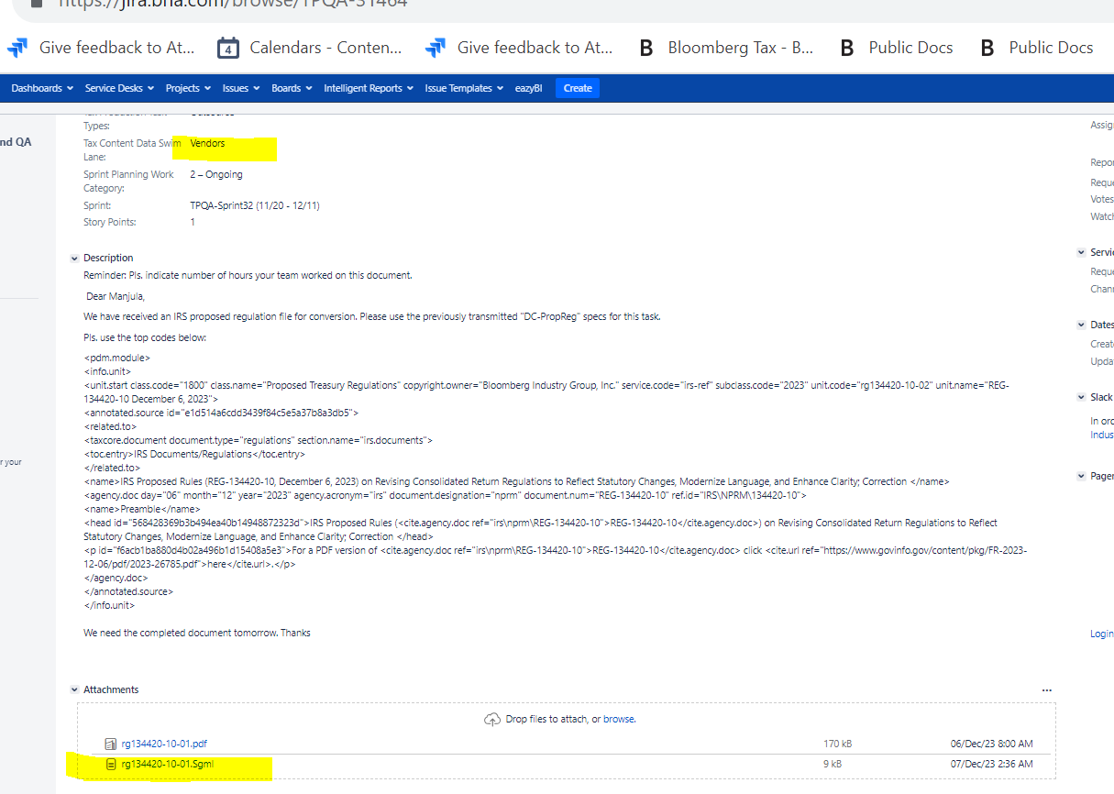

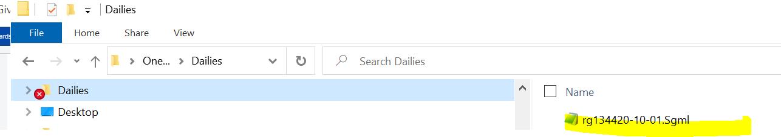

2. Open the file in Notepad then click on Edit, Select All, then Edit Copy

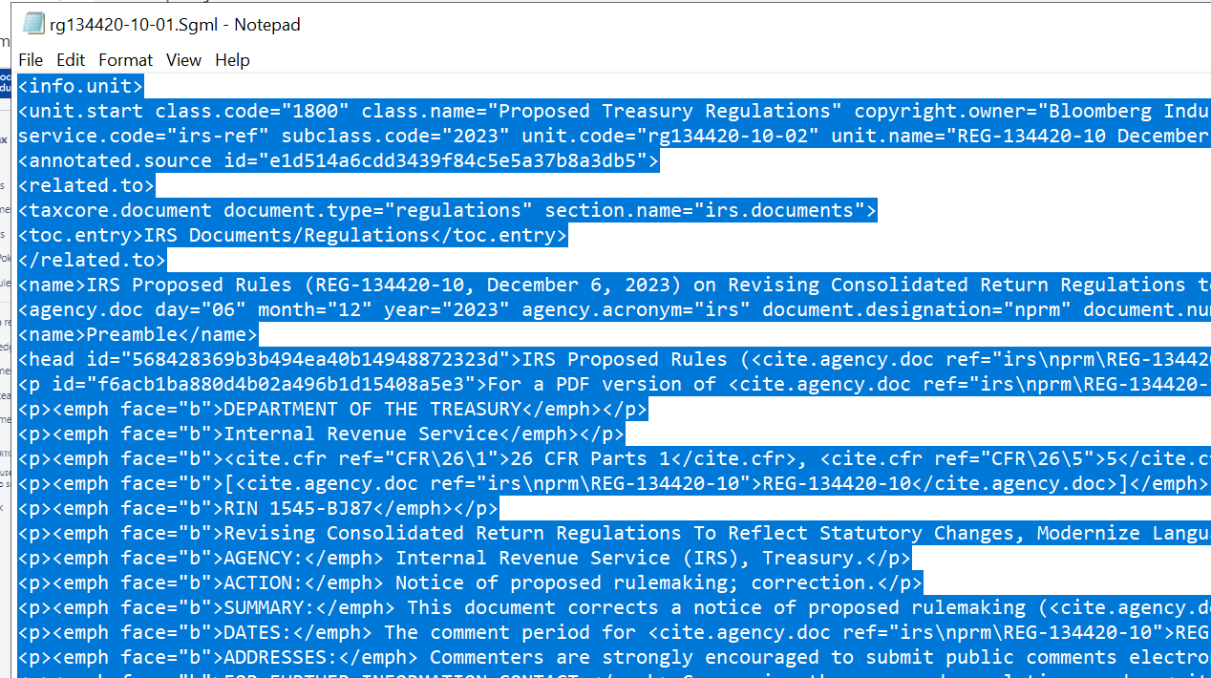

In WebQ qs to in-comp and open Prop_Reg_Template_Blank by clicking on Edit:
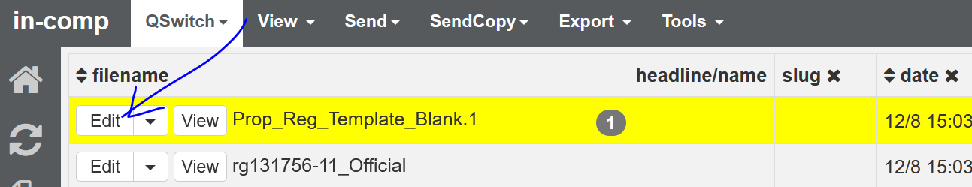

Delete contents of the file by doing a right click and Select All then delete

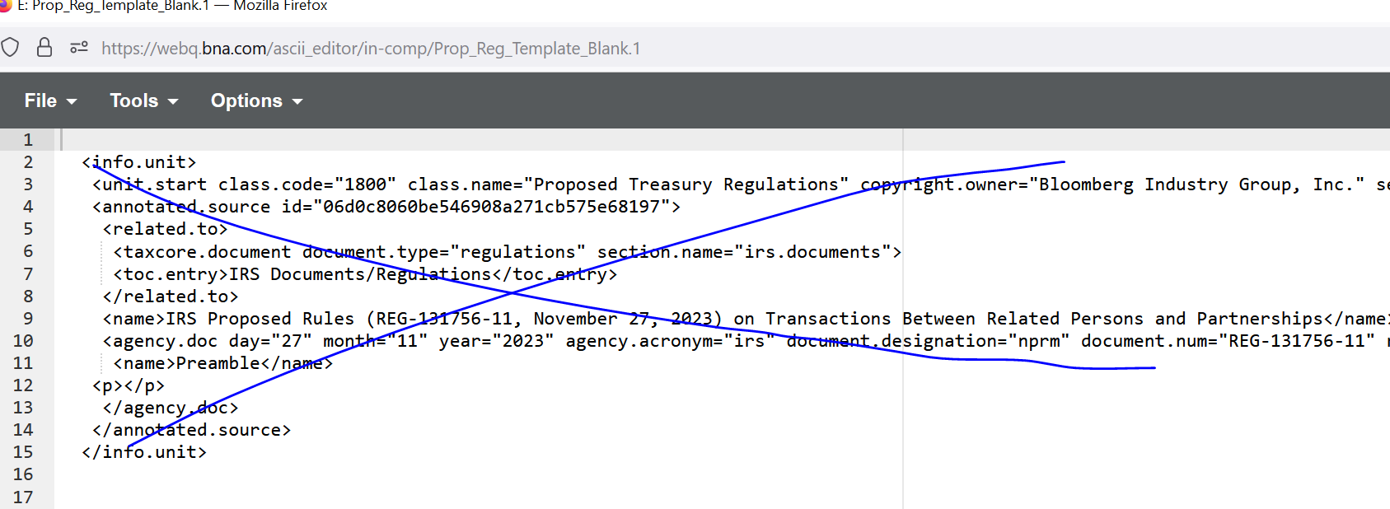

After deleting the contents Paste the highlighted text from the SGML in Notepad
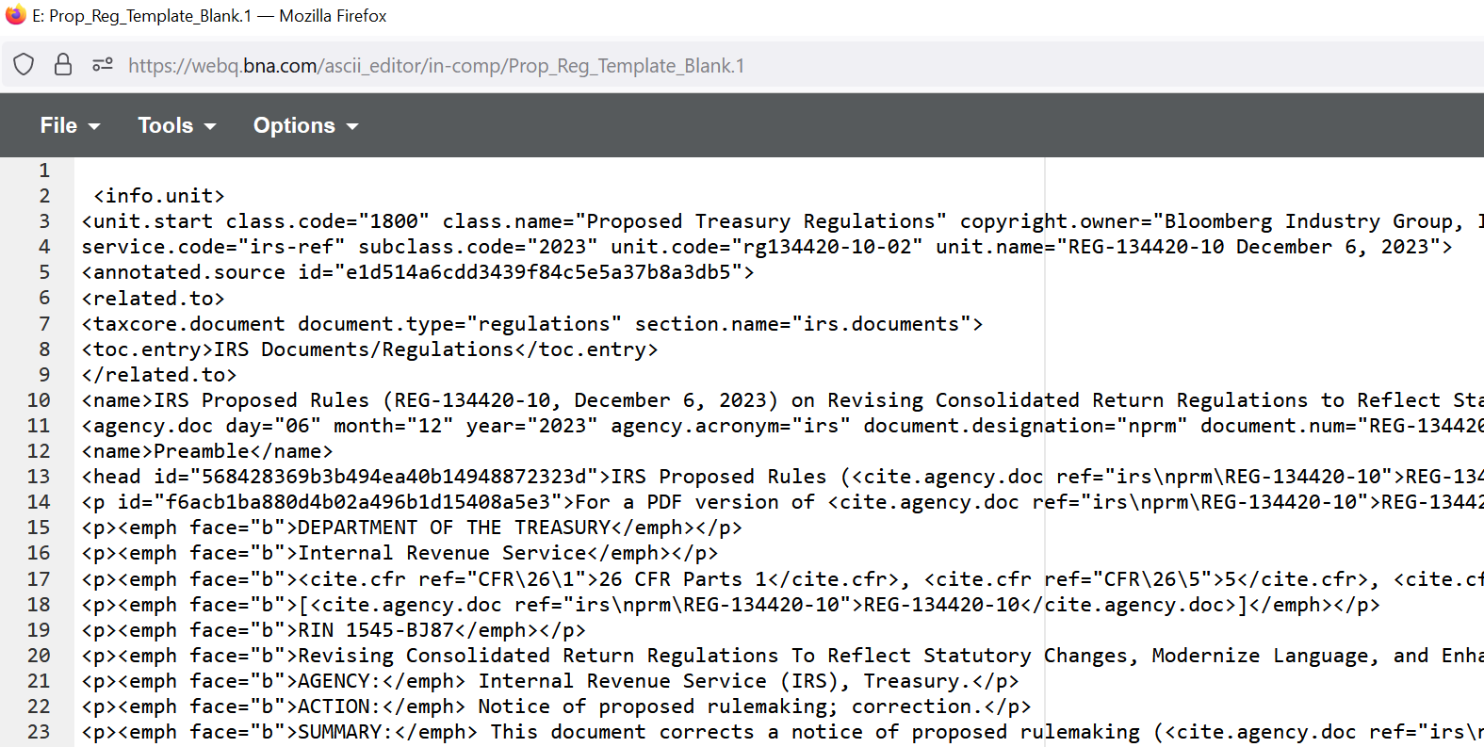

Then click on tools Assign EINS:
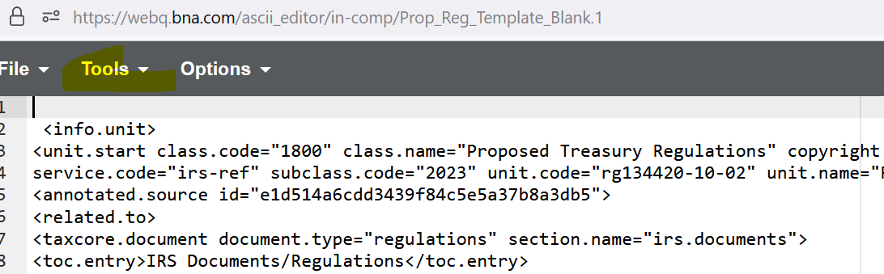

Click on file then save, then open in Oxygen Edit:
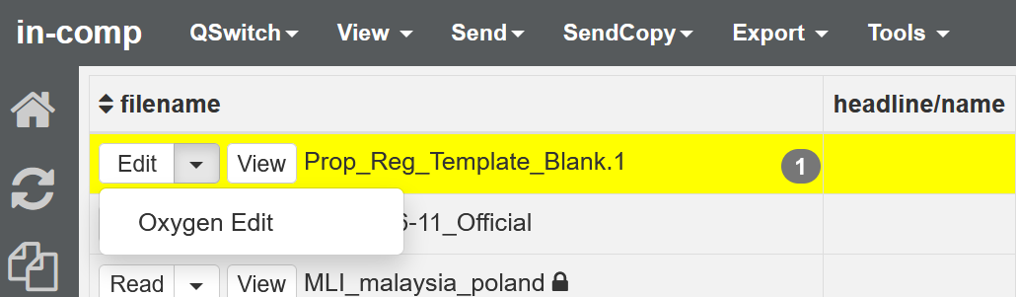

In Oxygen click on the 3 dots and edit as XML:
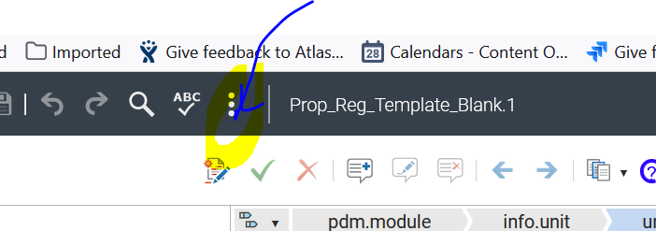

Tis is how it will look like in the xml editor:

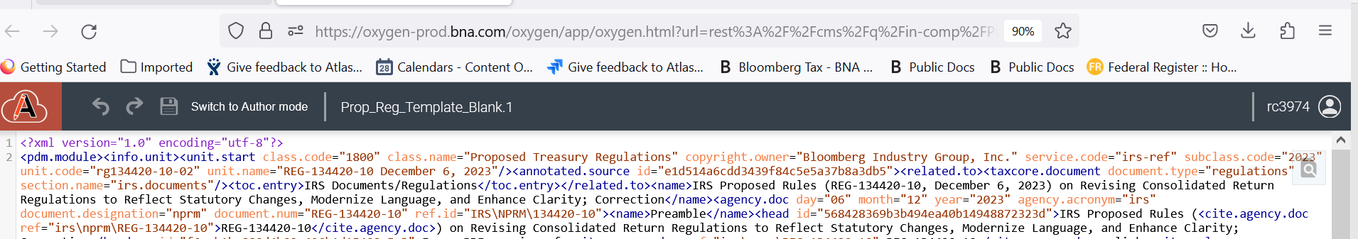

In BWIP, checkout the file from irs-ref Service collection:

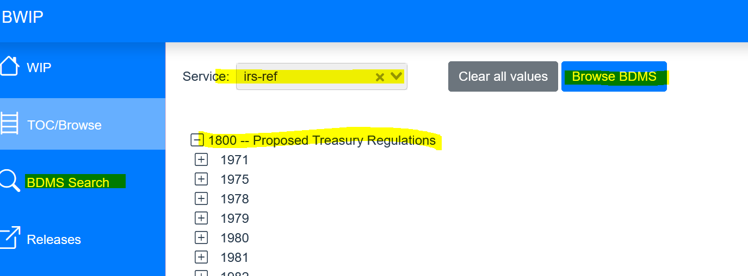

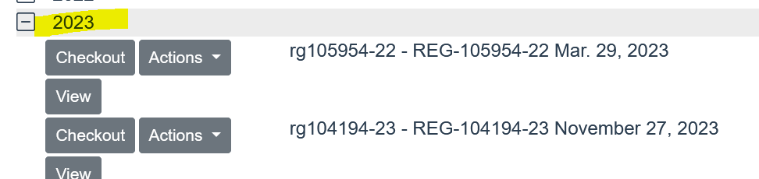

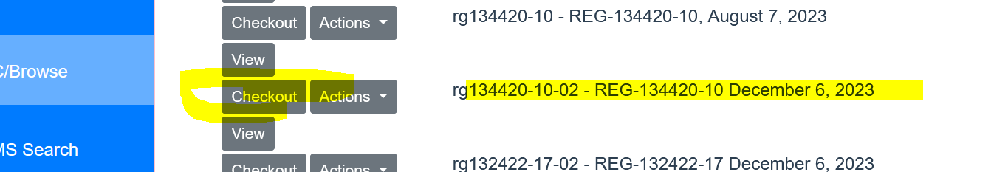

Edit the file in WIP:

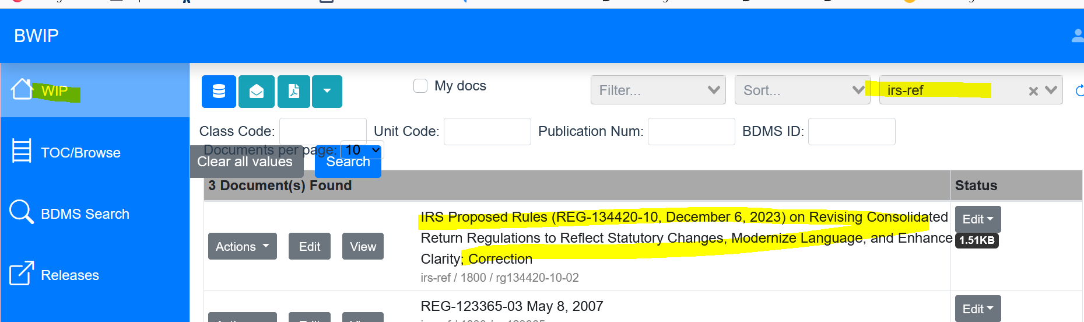

Click on the 3 dots and edit as XML

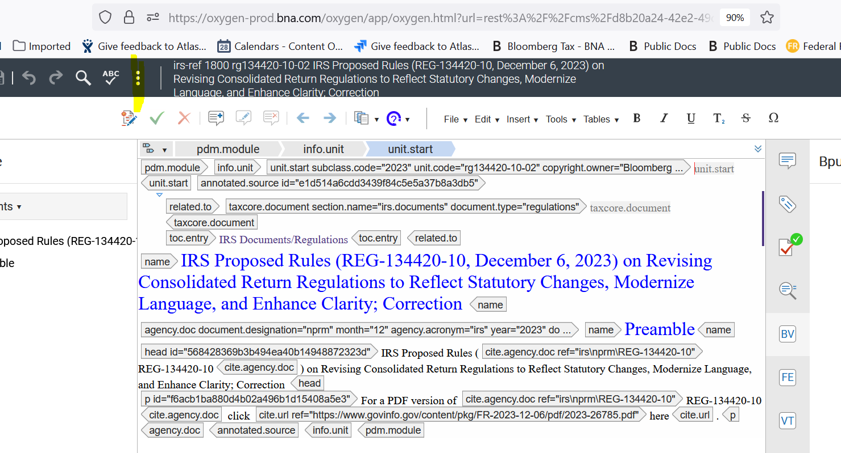

Delete the contents and paste the copied text from the Prop. Reg. Template file:

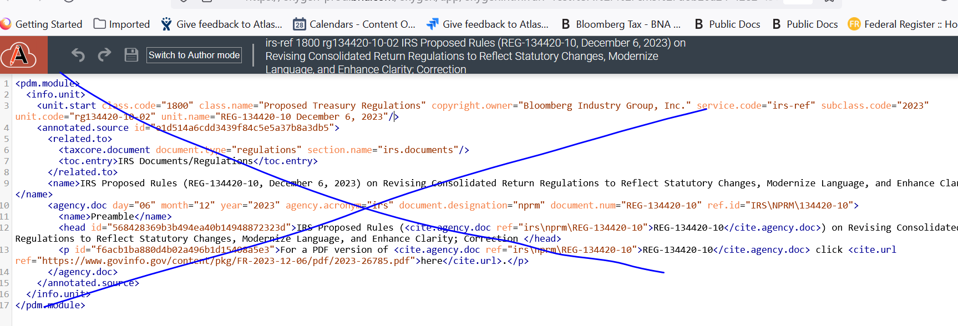

Once pasted delete the <?xml version tag at the top of the pasted text

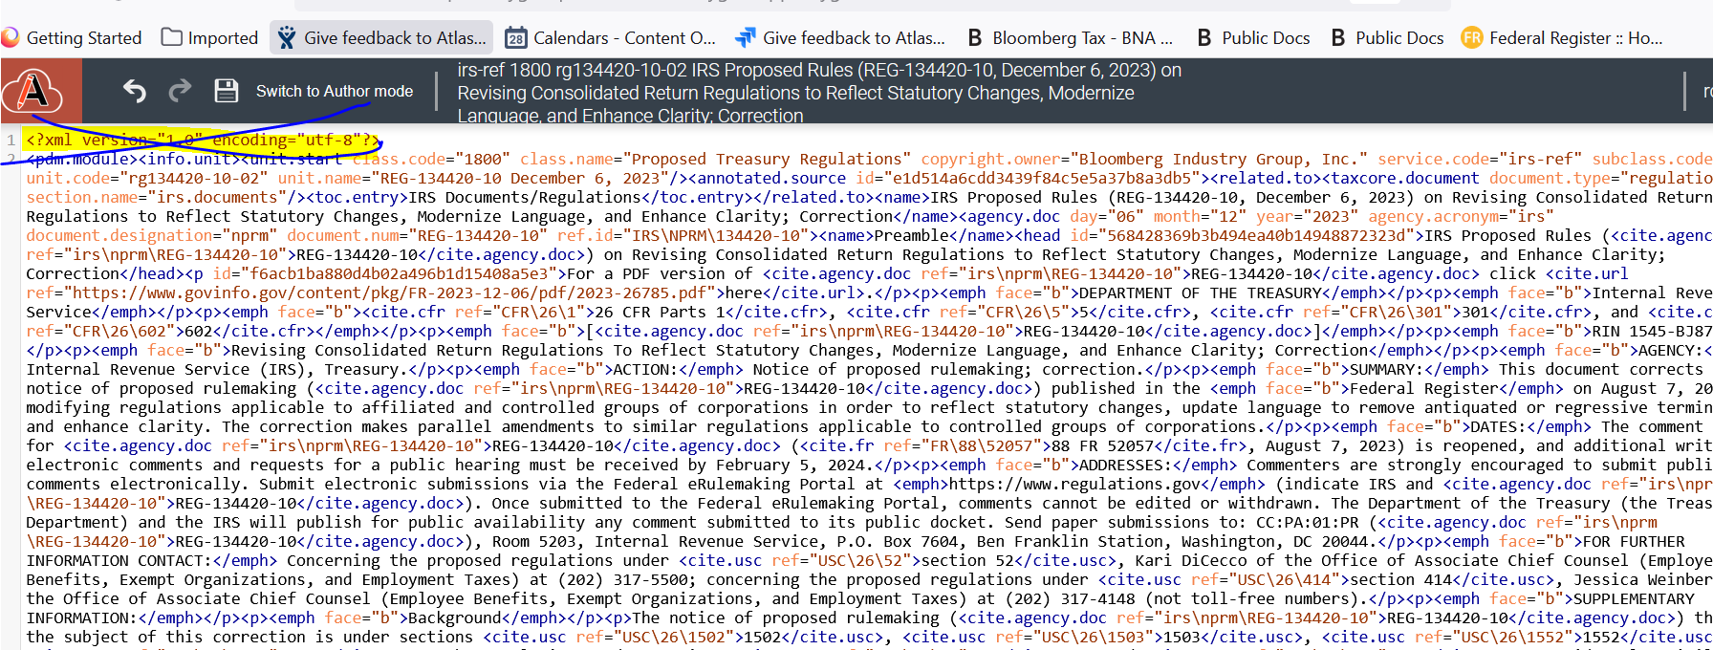

Switch to the author mode and save and close.

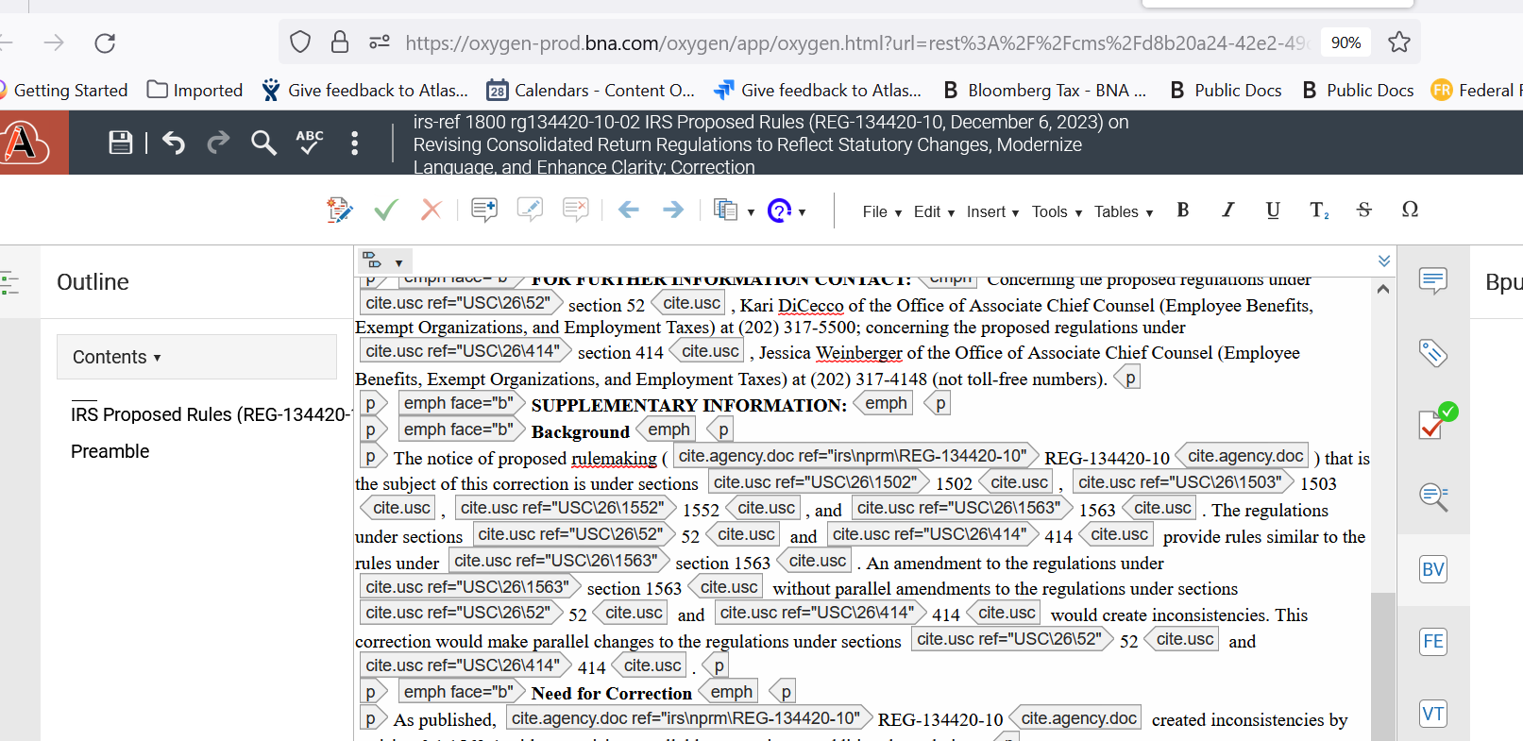

Release the file in BWIP:

