Draft Proposed Regulation (Prop. Reg.) Conversion Instructions for Innodata

In the Jira ticket the Pdf file to be converted is attached along with the Info Unit Tag (Top codes) be to used.

e.g.,

Info unit Tags sample:
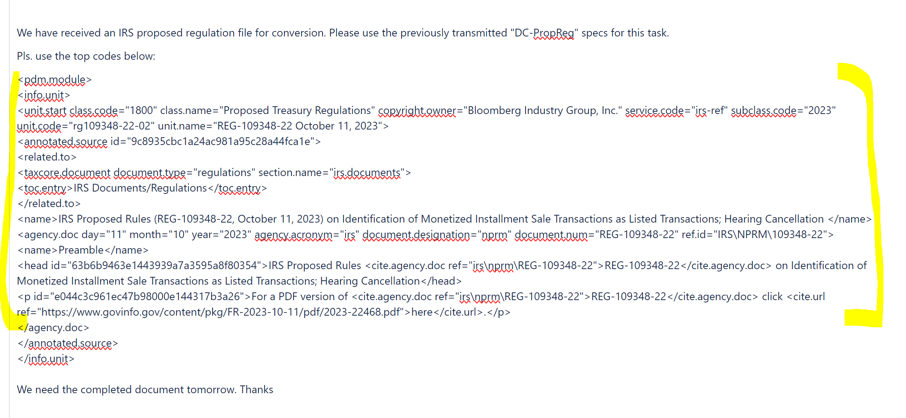

Prop Reg Pdf file for Conversion sample:
Text to be converted are highlighted in the Sample.
Search for the Reg Number in the pdf file to determine the which Regulation to extract and convert (e.g., REG-109238-22 in the sample file). File usually starts with “DEPARTMENT OF THE TREASURY” and ends with “BILLING CODE…”.

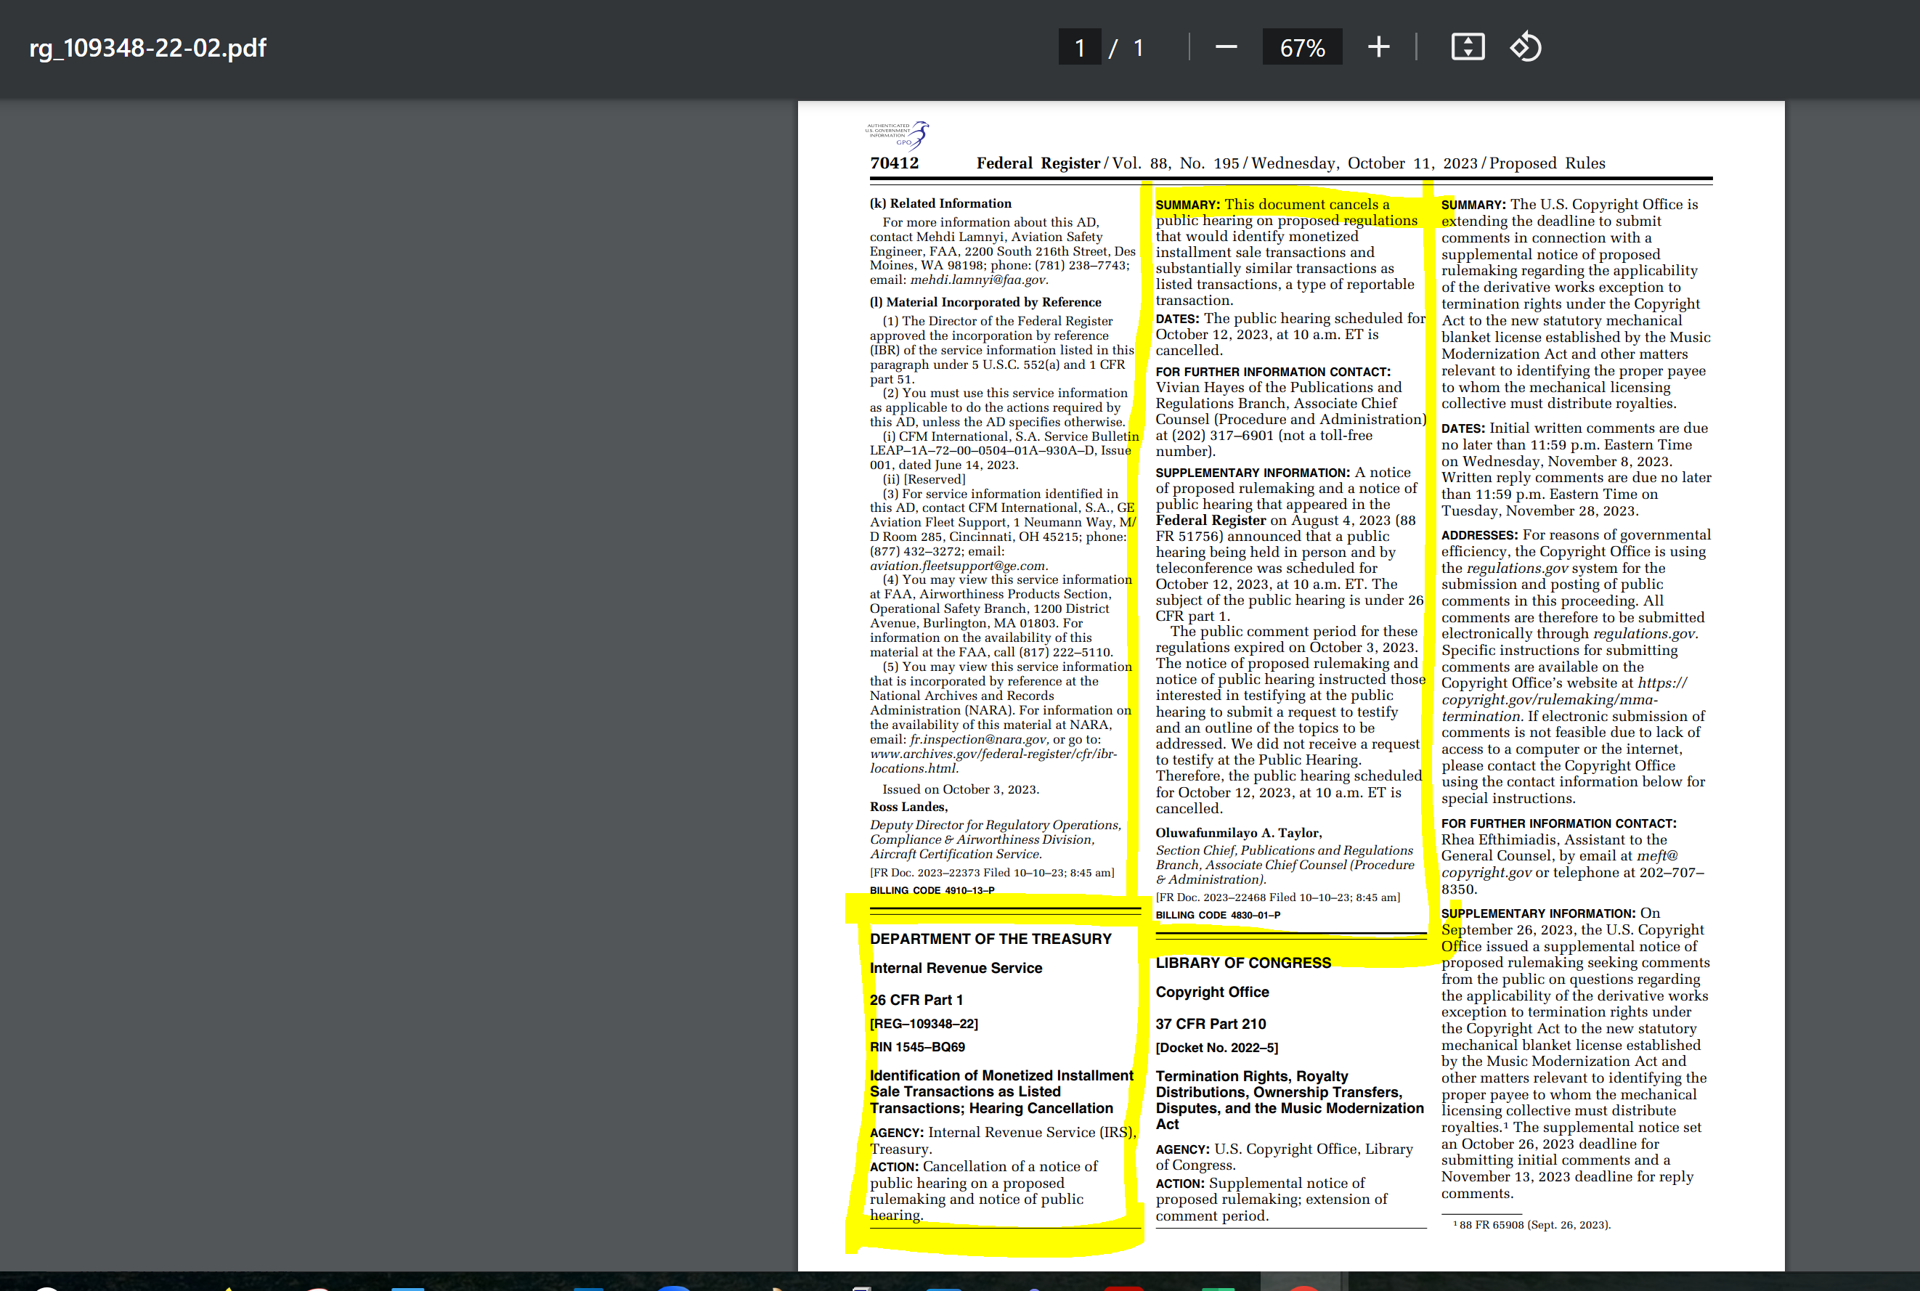

Converted text Sample

<pdm.module>
<info.unit>
<unit.start class.code="1800" class.name="Proposed Treasury Regulations" copyright.owner="Bloomberg Industry Group, Inc." service.code="irs-ref" subclass.code="2023" unit.code="rg109348-22-02" unit.name="REG-109348-22, October 11, 2023"/>
<annotated.source>
<related.to>
<taxcore.document document.type="regulations" section.name="irs.documents"/>
<toc.entry>IRS Documents/Regulations</toc.entry>
</related.to>
<name>IRS Proposed Rules (REG-109348-22, October 11, 2023) on Identification of Monetized Installment Sale Transactions as Listed Transactions; Hearing Cancellation</name>
<agency.doc day="11" month="10" year="2023" agency.acronym="irs" document.designation="nprm" document.num="REG-109348-22" ref.id="IRS\NPRM\REG-109348-22">
<name>Preamble</name>
<head>IRS Proposed Rules <cite.agency.doc ref="irs\nprm\REG-109348-22">REG-109348-22</cite.agency.doc> on Identification of Monetized Installment Sale Transactions as Listed Transactions; Hearing Cancellation</head>
<p>For a PDF version of <cite.agency.doc ref="irs\nprm\REG-109348-22">REG-109348-22</cite.agency.doc> click <cite.url ref="https://www.govinfo.gov/content/pkg/FR-2023-10-11/pdf/2023-22468.pdf">here</cite.url>.</p>
<p>
<emph face="b">DEPARTMENT OF THE TREASURY</emph>
</p>
<p>
<emph face="b">Internal Revenue Service</emph>
</p>
<p>
<emph face="b">
<cite.cfr ref="CFR\26\1">26 CFR Part 1</cite.cfr>
</emph>
</p>
<p>
<emph face="b">[<cite.agency.doc ref="irs\nprm\REG-109348-22">REG-109348-22</cite.agency.doc>]</emph>
</p>
<p>
<emph face="b">RIN 1545-BQ69</emph>
</p>
<p>
<emph face="b">Identification of Monetized Installment Sale Transactions as Listed Transactions; Hearing Cancellation</emph>
</p>
<p><emph face="b">AGENCY:</emph> Internal Revenue Service (IRS), Treasury.</p>
<p><emph face="b">ACTION:</emph> Cancellation of a notice of public hearing on a proposed rulemaking and notice of public hearing.</p>
<p><emph face="b">SUMMARY:</emph> This document cancels a public hearing on proposed regulations that would identify monetized installment sale transactions and substantially similar transactions as listed transactions, a type of reportable transaction.</p>
<p><emph face="b">DATES:</emph> The public hearing scheduled for October 12, 2023, at 10 a.m. ET is cancelled.</p>
<p><emph face="b">FOR FURTHER INFORMATION CONTACT:</emph> Vivian Hayes of the Publications and Regulations Branch, Associate Chief Counsel (Procedure and Administration) at (202) 317-6901 (not a toll-free number).</p>
<p><emph face="b">SUPPLEMENTARY INFORMATION:</emph> A notice of proposed rulemaking and a notice of public hearing that appeared in the <emph face="b">Federal Register</emph> on August 4, 2023 (<cite.fr ref="FR\88\51756">88 FR 51756</cite.fr>) announced that a public hearing being held in person and by teleconference was scheduled for October 12, 2023, at 10 a.m. ET. The subject of the public hearing is under <cite.cfr ref="CFR\26\1">26 CFR part 1</cite.cfr>.</p>
<p>The public comment period for these regulations expired on October 3, 2023. The notice of proposed rulemaking and notice of public hearing instructed those interested in testifying at the public hearing to submit a request to testify and an outline of the topics to be addressed. We did not receive a request to testify at the Public Hearing. Therefore, the public hearing scheduled for October 12, 2023, at 10 a.m. ET is cancelled.</p>
<p>
<emph face="b">Oluwafunmilayo A. Taylor,</emph>
</p>
<p>
<emph>Section Chief, Publications and Regulations Branch, Associate Chief Counsel (Procedure &amp; Administration).</emph>
</p>
<p>[FR Doc. 2023-22468 Filed 10-10-23; 8:45 am]</p>
<p>
<emph face="b">BILLING CODE 4830-01-P</emph>
</p>
</agency.doc>
</annotated.source>
</info.unit>
</pdm.module>

Conversion Instructions

- Open a Blank Document in Word
- Insert Info unit tags from JIRA ticket
- Open Pdf file using Word and save as a .doc or rtf file
- Click on the Select all on the Select drop down menu
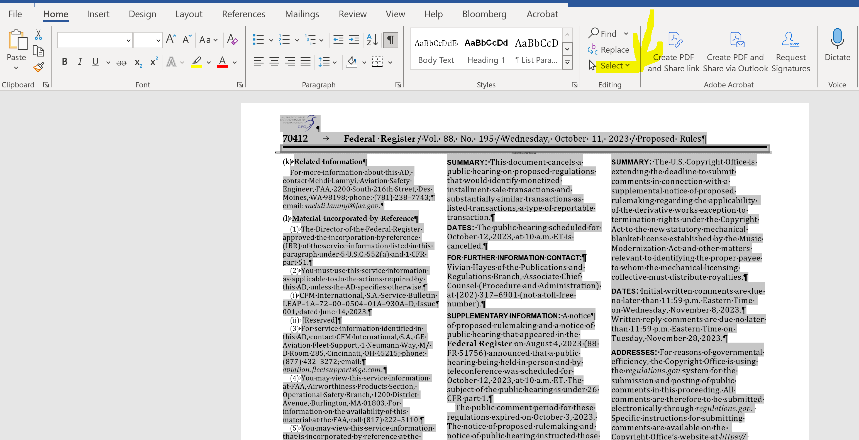

- Open pdf or rtf file, click on Layout then on the drop down menu click on one column
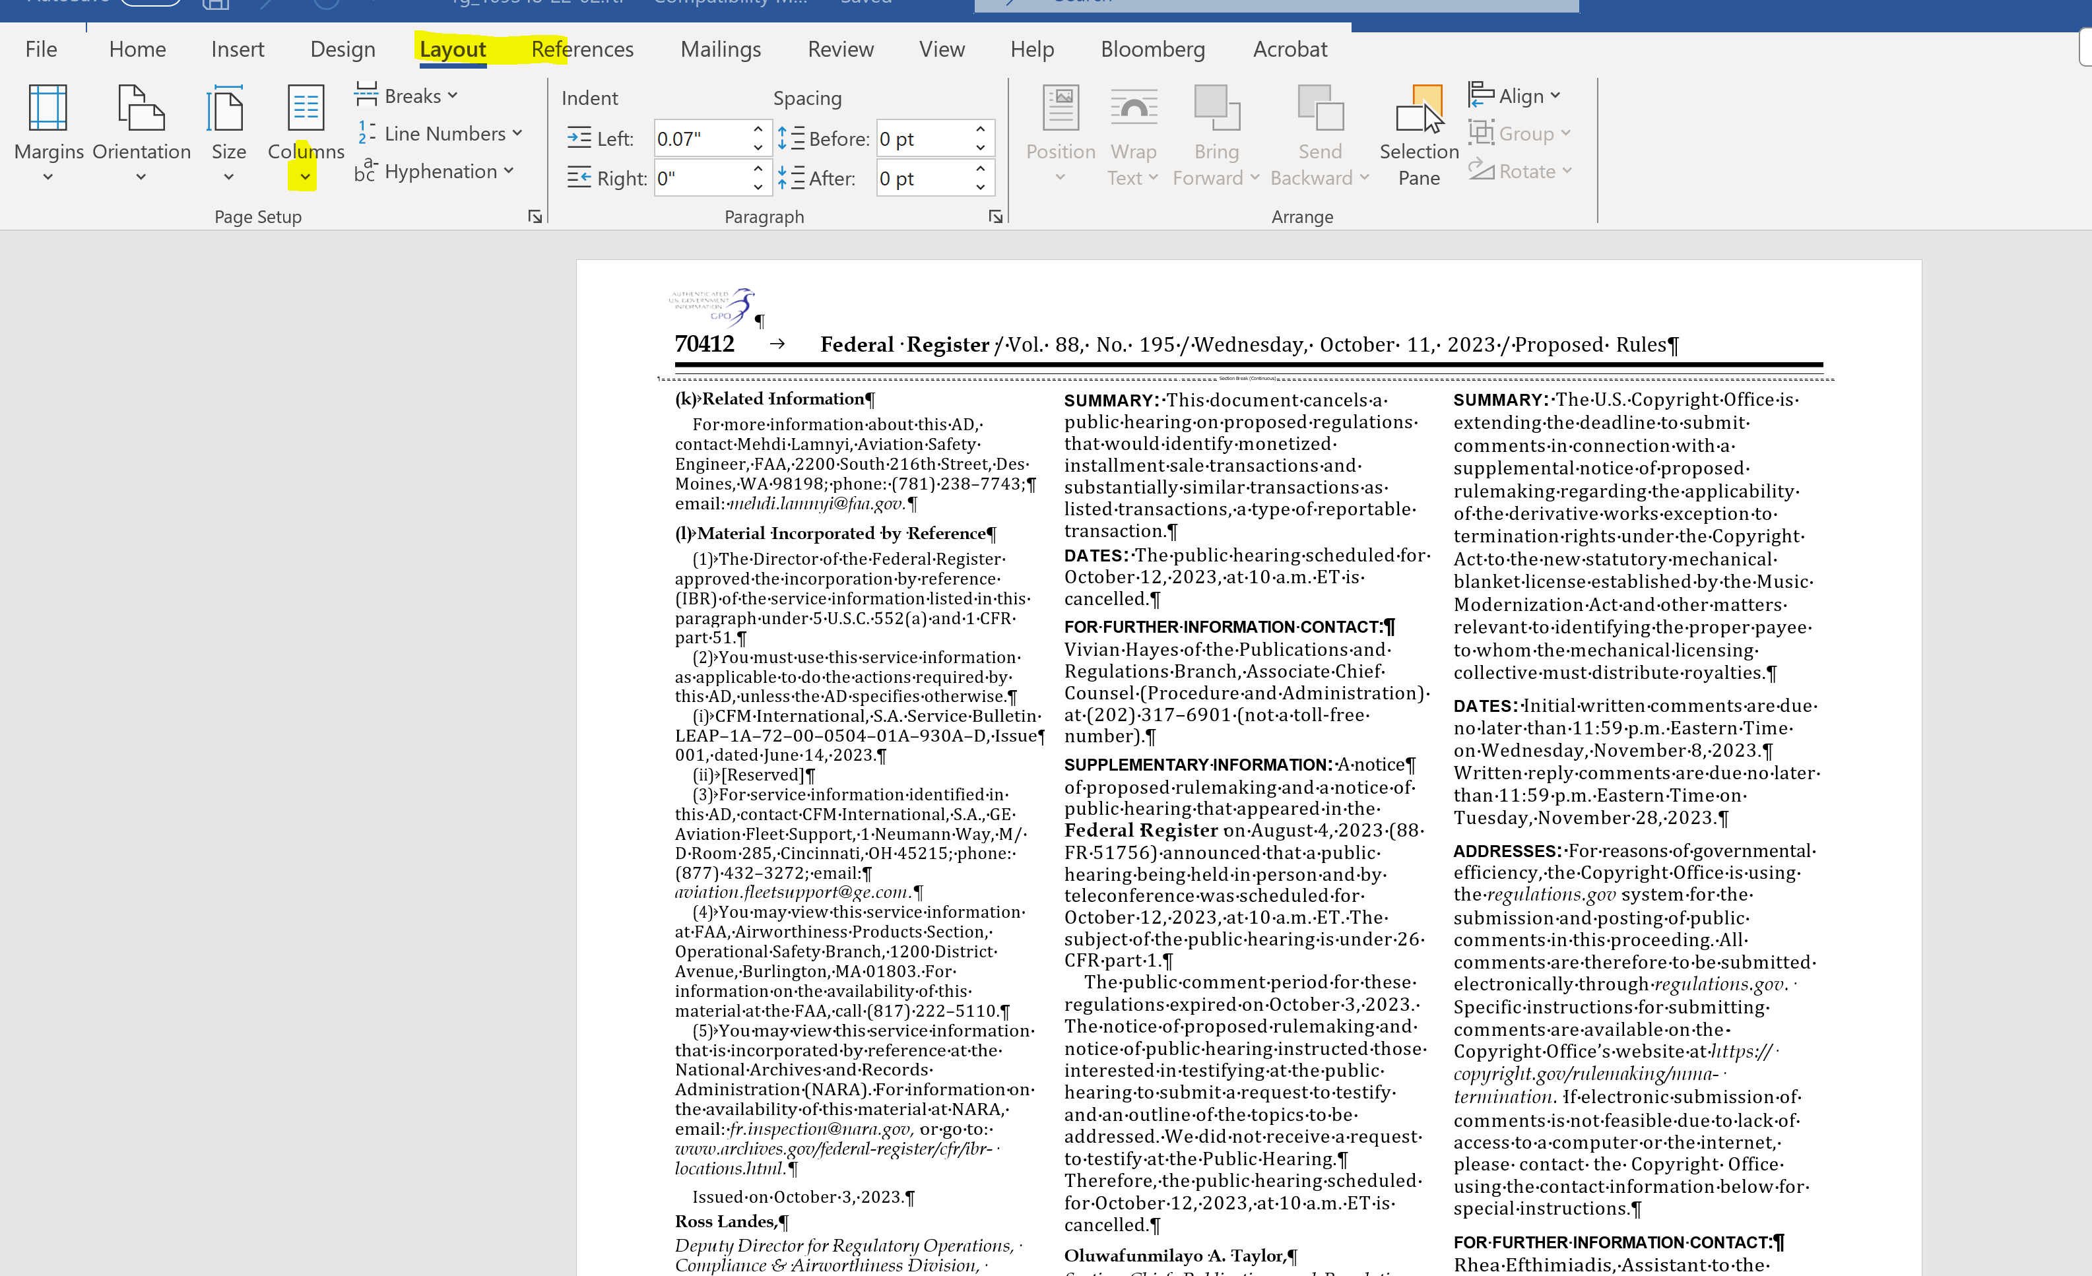

Text will change to one column format, extract required text and clean file by getting rid of extraneous text, section breaks, column break, headers and footer and unnecessary paragraph and line breaks.
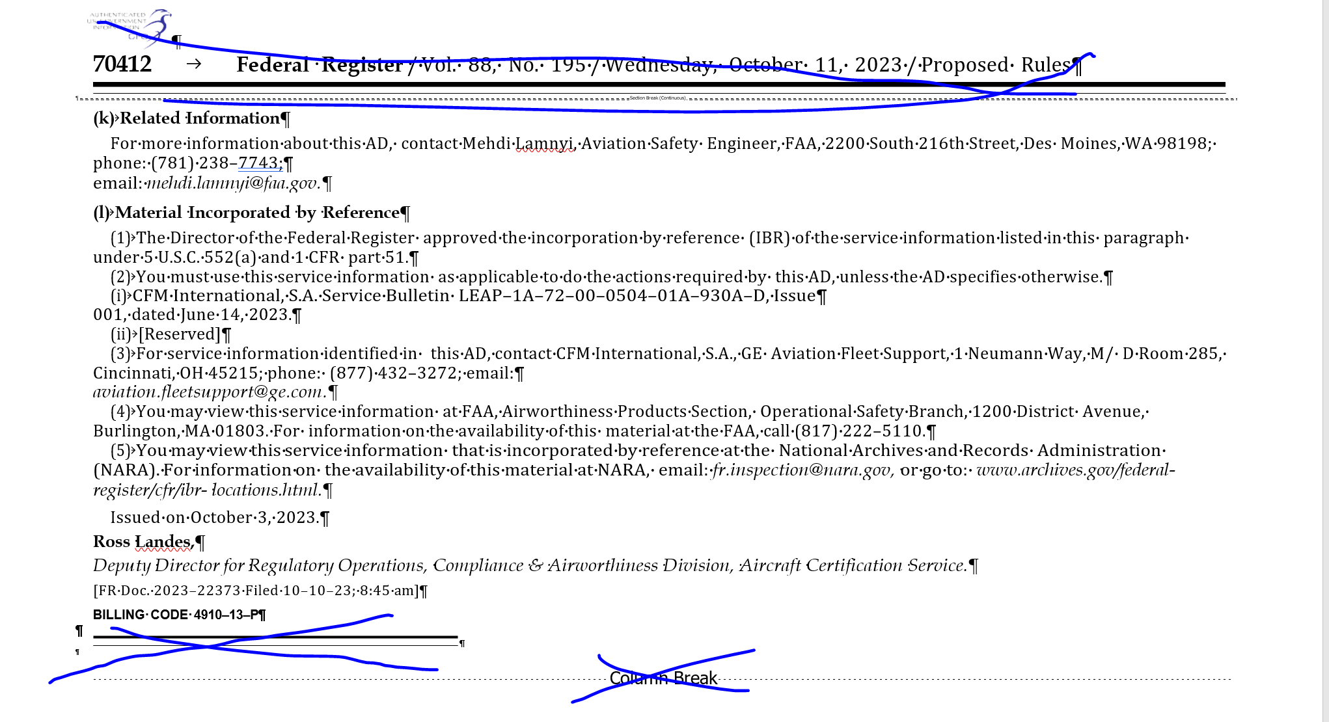

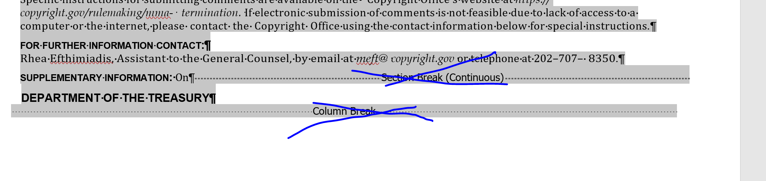

After cleaning the file select all and use Arial typesize 9 as the font and it should look like this:
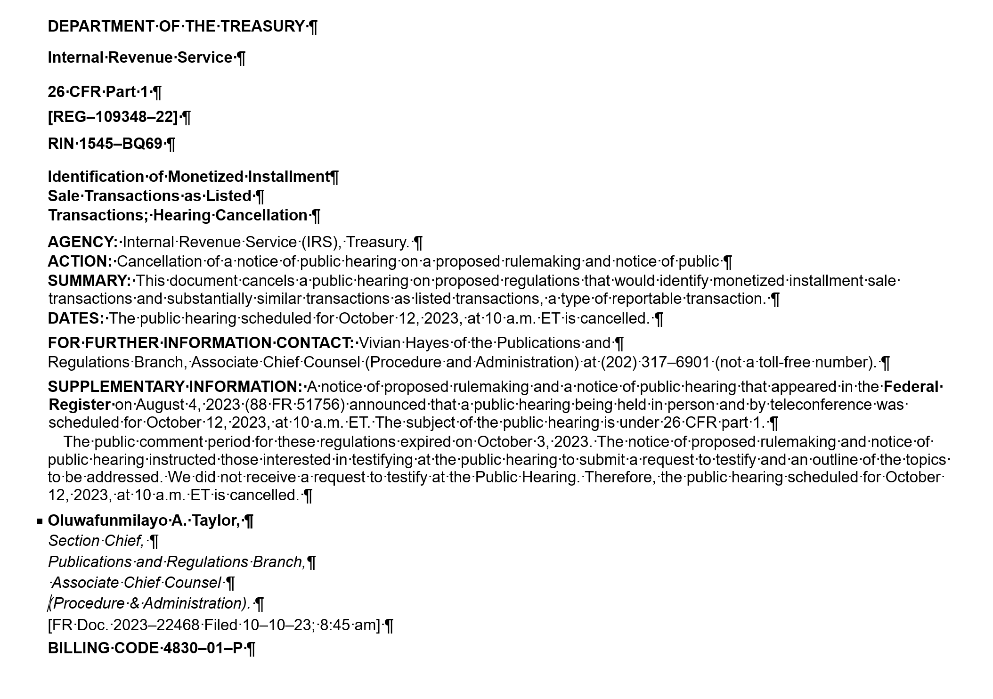

Then start tagging headings with <head></head>
Words in bold with <emph face-“b”></emph>
Paragraphs with <para></para>
Also, tag cite cfr and cite agency doc
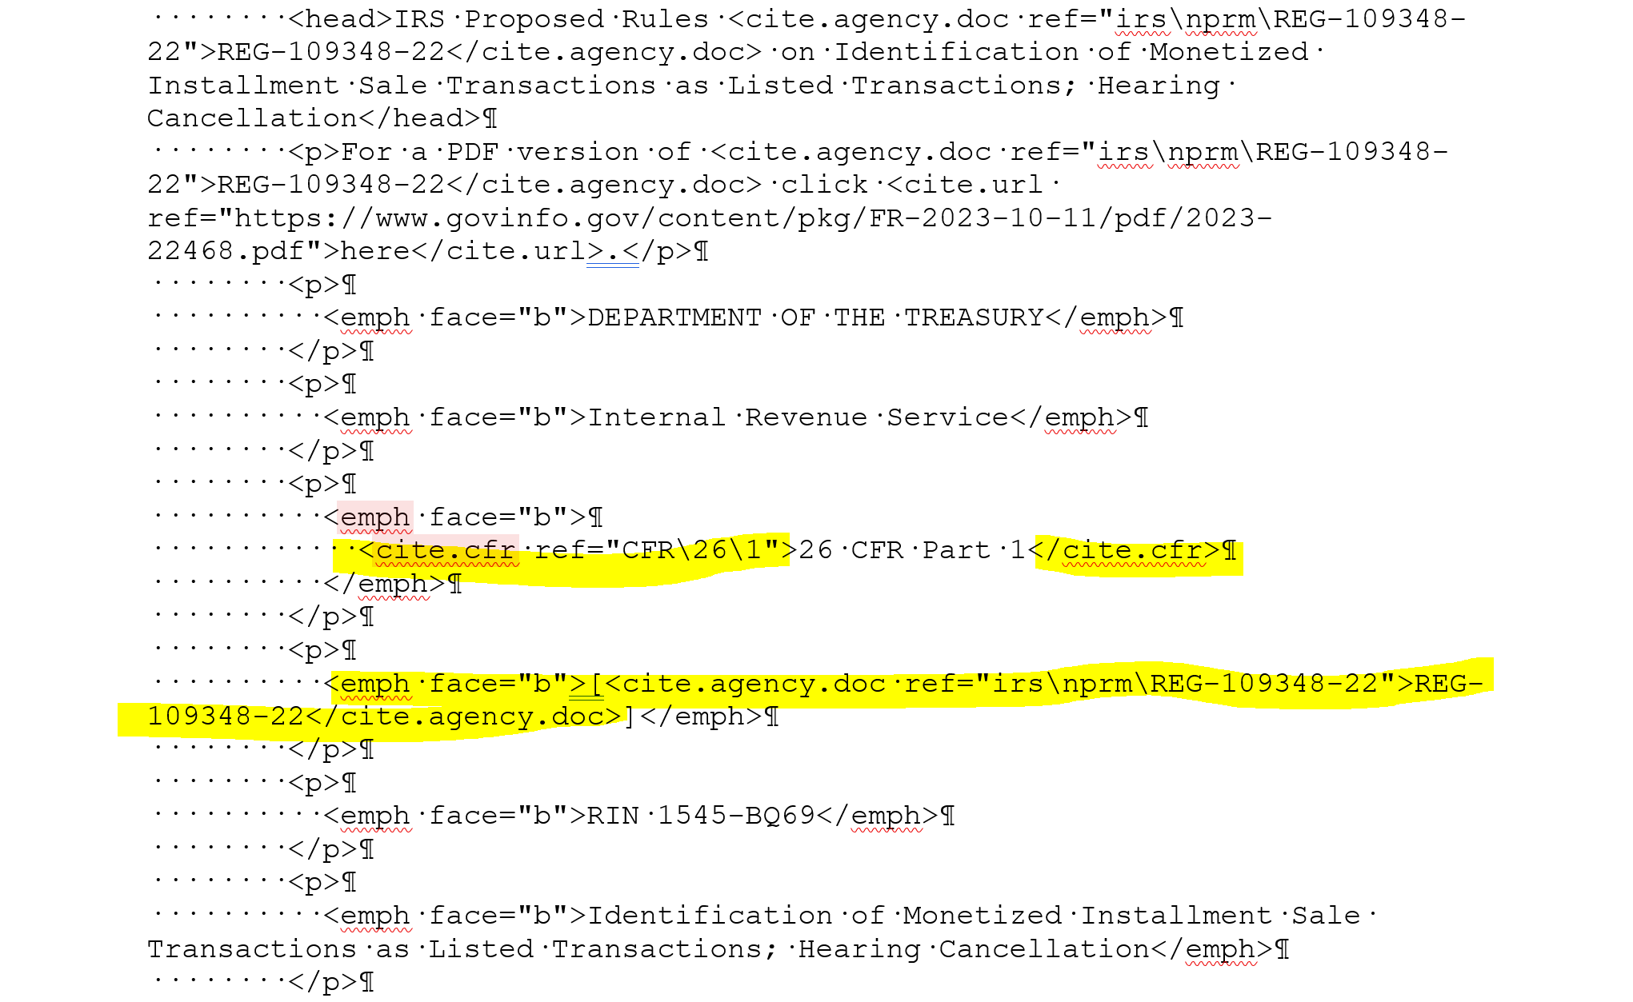

After completing the tagging, paste in a blank Notepad and name the file REG-_______ (e.g., REG_123456-01).
Attach to the JIRA ticket and notify TPQA staff that it is completed and indicate number of hours worked.

