LEGISLATIVE HISTORY

To search for Prior Version

in summary:
Log on to BTAX, Federal and go to the relevant Code section. Click on the Versions icon on the right rail. Find the version amended immediately preceding the Public Law you are working on. Note that the Public Law you are working on might not be the most recent Public Law to amend the Code section. Click on “View Codified Text” to bring up the text of this version.
For example, if you are creating a legislative history file for Code Sec. 118 as amended by PL 117-58, you would select the version amended by PL 115-97 and click on “View Codified Text” under the heading for PL 115-97.

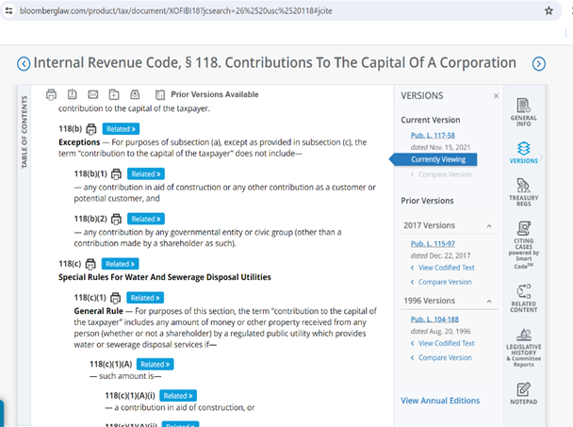
Copy the text starting with the section number/title through the end of the Code section language. Do not copy text appearing after the line rule. Save the file and follow the same steps for each Code section amended by the Public Law.

If it’s a new Code section, then there won’t be any prior version. Just put “None” for the prior version

Detailed instructions:

- Go to BTAX – https://www.bloomberglaw.com/product/tax/page/page_federal
- THEN CLICK ON federal ICON
- in go to primary source document CHOOSE Internal Revenue Code in the drop down menu
- then key section number (Example: section 117)
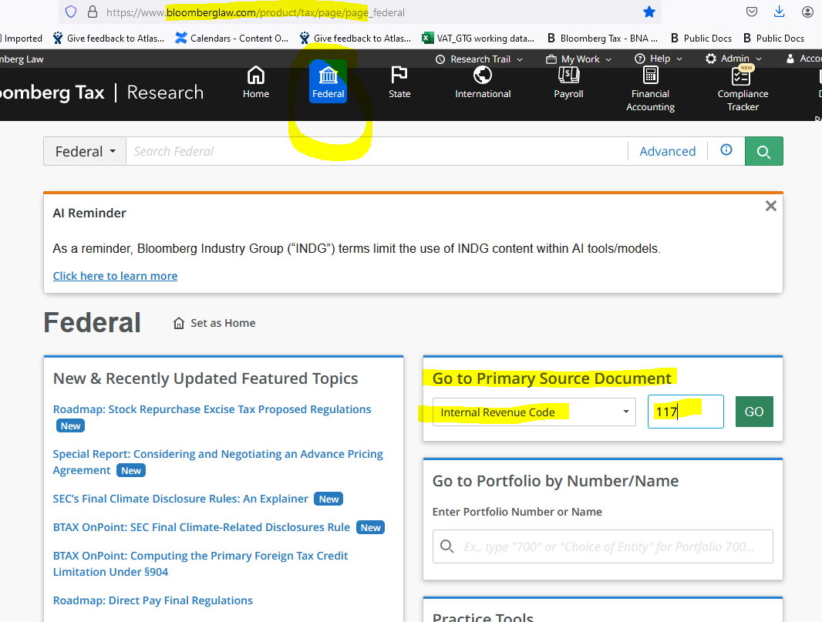

- on the right panel Click on Versions
Under Prior Versions choose the first entry (there might cases wherein there are multiple prior versions but the first entry is usually the latest prior version)
- then click on Codified Text

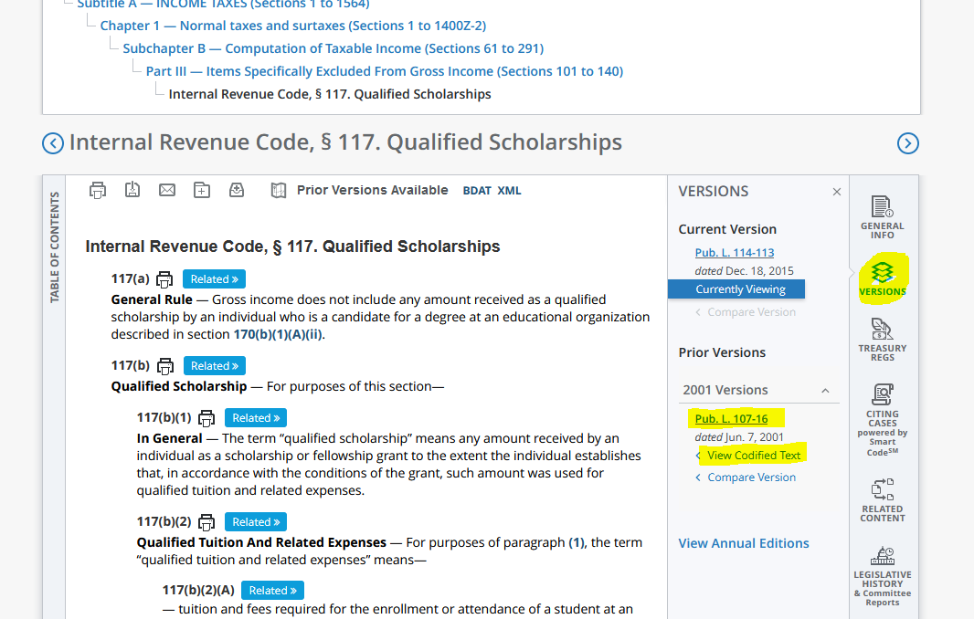

Go to Prior Version – Codified text
copy text only before the line
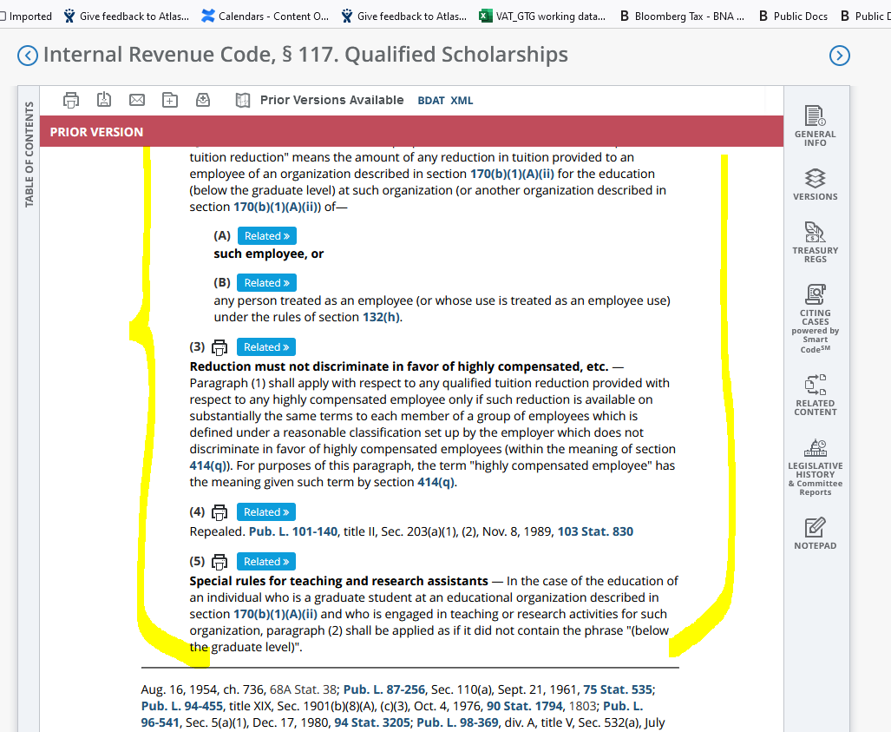

to check if you have the right version:

go to the current version History at the bottom of the Page Just Before Background Notes
(Note: Generally prior versions don’t have Editor’s note)

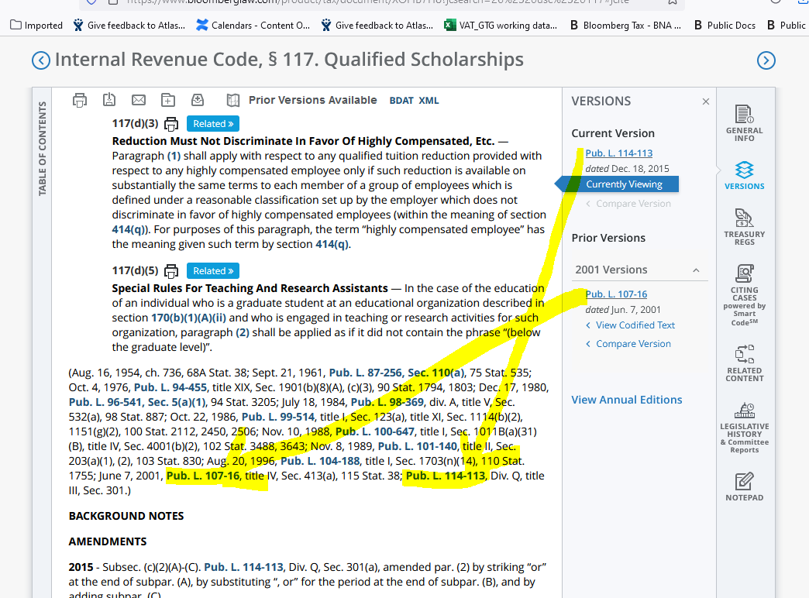

IN the sample above the current version is pub. l. 114-113 & THe prIOR VERSION IS PUB. L. 107-16. The last Pub. L. entry is the current version and the one before that is the prior version. (IN CASES WHERE THEY DO NOT MATCH SEND US AN EMAIL OR LEAVE A note IN THE JIRA TICKET).

In instances wherein the PUBic law is not the latest that affected the code section use the one before it.

in the example below if we are working on pl 117-44 amending code section 9508 (note that PL 117-44 is not the most recent Pubic law to amend Code section 9508, pl 117-58 is the latest then PL117-52)
in this case we use the pl 116-159 which is the version immediately preceding PL 117-44.

And if were are working on PL 117-52 we will use the codified text for pl 117-44 .

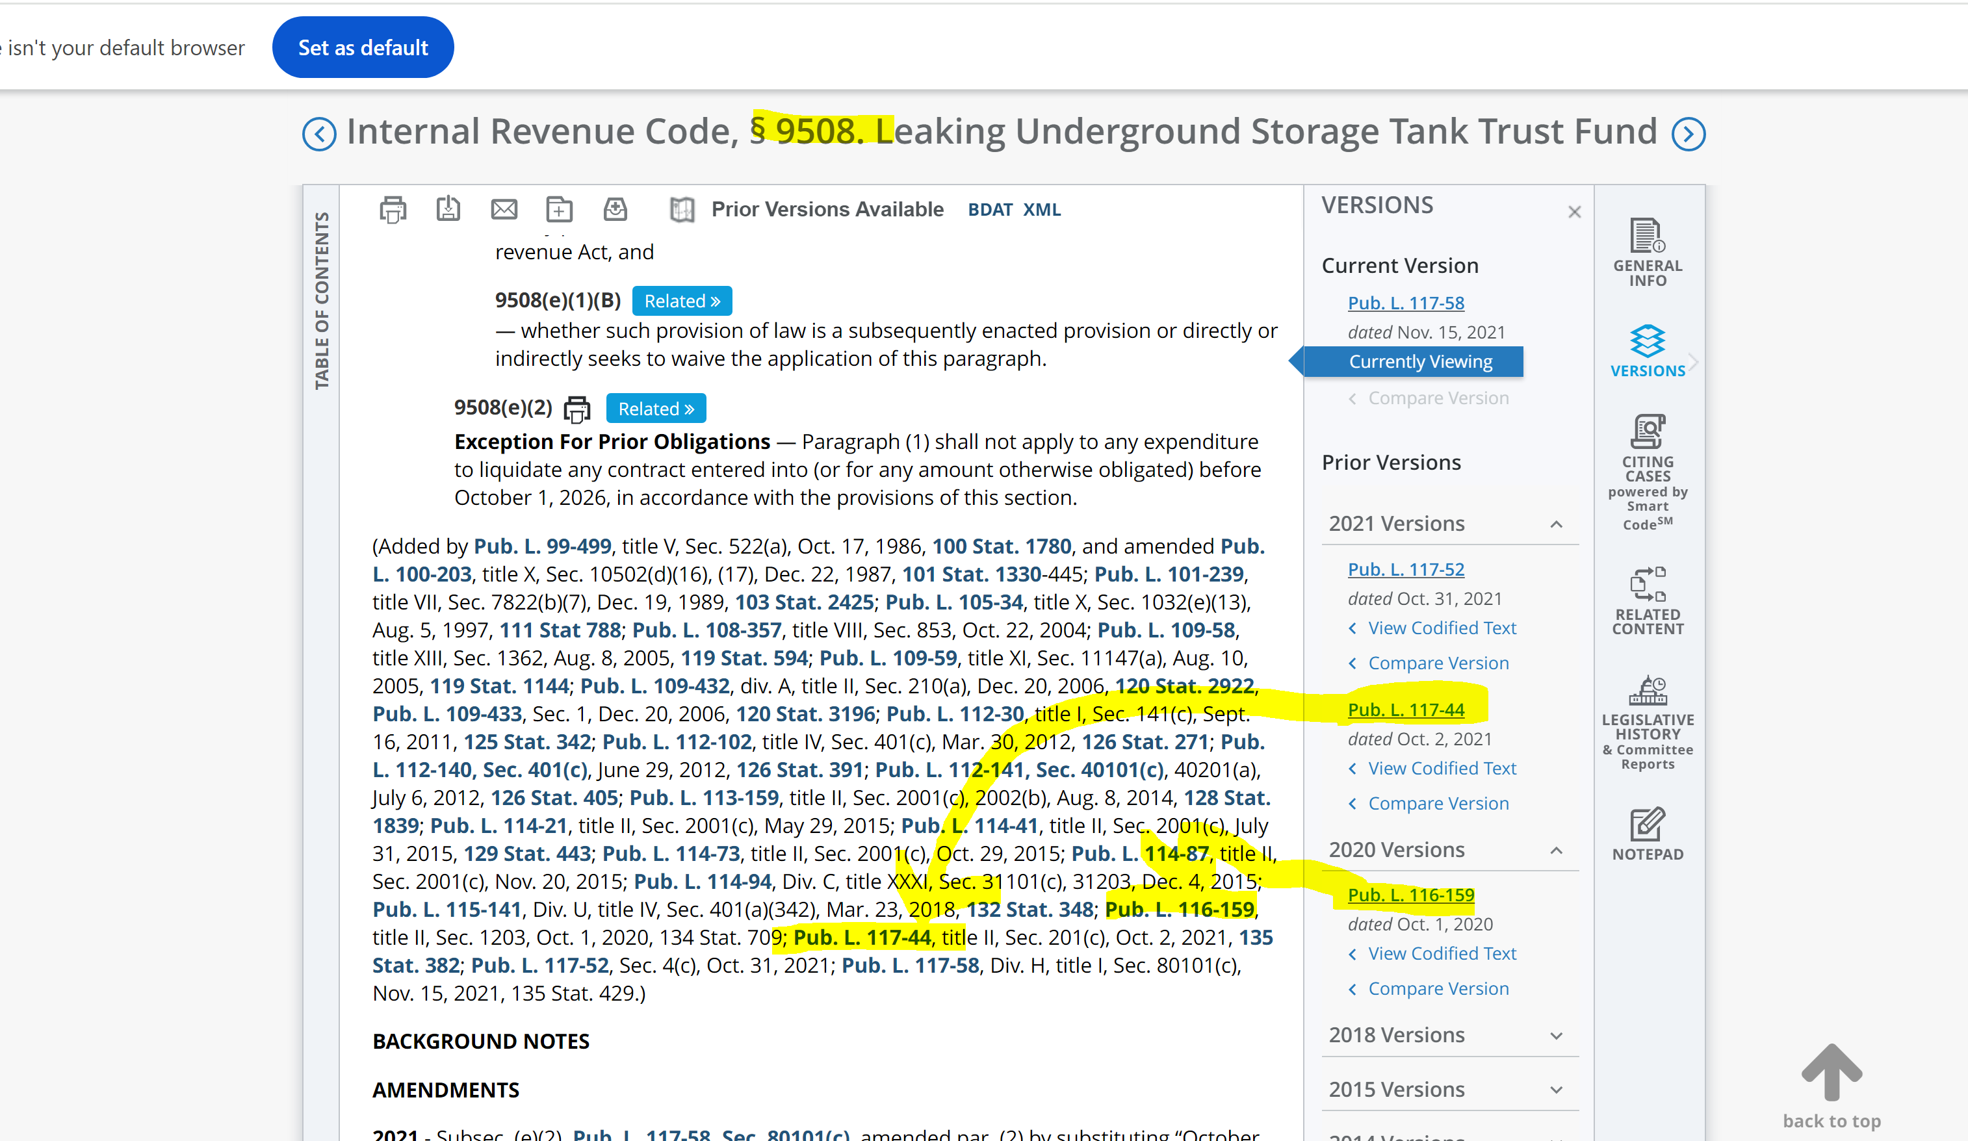

SAMPLE EXCERPT OF PRIOR LAW OF CODE SETION 117 as it appears in BTAX (unformatted)

26 U.S.C. § 117. Qualified scholarships
(a)Related
General rule —
Gross income does not include any amount received as a qualified scholarship by an individual who is a candidate for a degree at an educational organization described in section 170(b)(1)(A)(ii).
(b)Related
Qualified scholarship —
For purposes of this section—
(1)Related
In general —
The term "qualified scholarship" means any amount received by an individual as a scholarship or fellowship grant to the extent the individual establishes that, in accordance with the conditions of the grant, such amount was used for qualified tuition and related expenses.
(2)Related
Qualified tuition and related expenses —
For purposes of paragraph (1), the term "qualified tuition and related expenses" means—
(A)Related
tuition and fees required for the enrollment or attendance of a student at an educational organization described in section 170(b)(1)(A)(ii), and
(B)Related
fees, books, supplies, and equipment required for courses of instruction at such an educational organization.
(c)Related
Limitation
(1)Related
In general —
Except as provided in paragraph (2), subsections (a) and (d) shall not apply to that portion of any amount received which represents payment for teaching, research, or other services by the student required as a condition for receiving the qualified scholarship or qualified tuition reduction.
(2)Related
Exceptions —
Paragraph (1) shall not apply to any amount received by an individual under—
(A)Related
the National Health Service Corps Scholarship Program under section 338A(g)(1)(A) of the Public Health Service Act, or
(B)Related
the Armed Forces Health Professions Scholarship and Financial Assistance program under subchapter I of chapter 105 of title 10, United States Code.
(d)Related
Qualified tuition reduction
(1)Related
In general —
Gross income shall not include any qualified tuition reduction.
(2)Related
Qualified tuition reduction —
For purposes of this subsection, the term "qualified tuition reduction" means the amount of any reduction in tuition provided to an employee of an organization described in section 170(b)(1)(A)(ii) for the education (below the graduate level) at such organization (or another organization described in section 170(b)(1)(A)(ii)) of—
(A)Related
such employee, or
(B)Related
any person treated as an employee (or whose use is treated as an employee use) under the rules of section 132(h).
(3)Related
Reduction must not discriminate in favor of highly compensated, etc. —
Paragraph (1) shall apply with respect to any qualified tuition reduction provided with respect to any highly compensated employee only if such reduction is available on substantially the same terms to each member of a group of employees which is defined under a reasonable classification set up by the employer which does not discriminate in favor of highly compensated employees (within the meaning of section 414(q)). For purposes of this paragraph, the term "highly compensated employee" has the meaning given such term by section 414(q).
(4)Related
Repealed. Pub. L. 101-140, title II, Sec. 203(a)(1), (2), Nov. 8, 1989, 103 Stat. 830
(5)Related
Special rules for teaching and research assistants —
In the case of the education of an individual who is a graduate student at an educational organization described in section 170(b)(1)(A)(ii) and who is engaged in teaching or research activities for such organization, paragraph (2) shall be applied as if it did not contain the phrase "(below the graduate level)".

COPY, paste, Format text, combine into single file, & attach to Jira ticket
Copy/paste each code section excerpt out into a single Word file, code sections in numerical order (see attached sample)
Clean up text so that it matches attached sample, e.g.:
- heading text, following sample
- font (Avenir Next P for BBG, 9pt)
- flush left
- no extra paragraph returns between paragraphs
- bold text as in sample
- text pulled up to follow heading, separated by hyphen, as in attached sample (Prior Law – Secs combined and formatted_sample.docx)
Attach combined file to ticket

