To search for Prior Version

Go to BTAX -federal
in primary source documents key section number
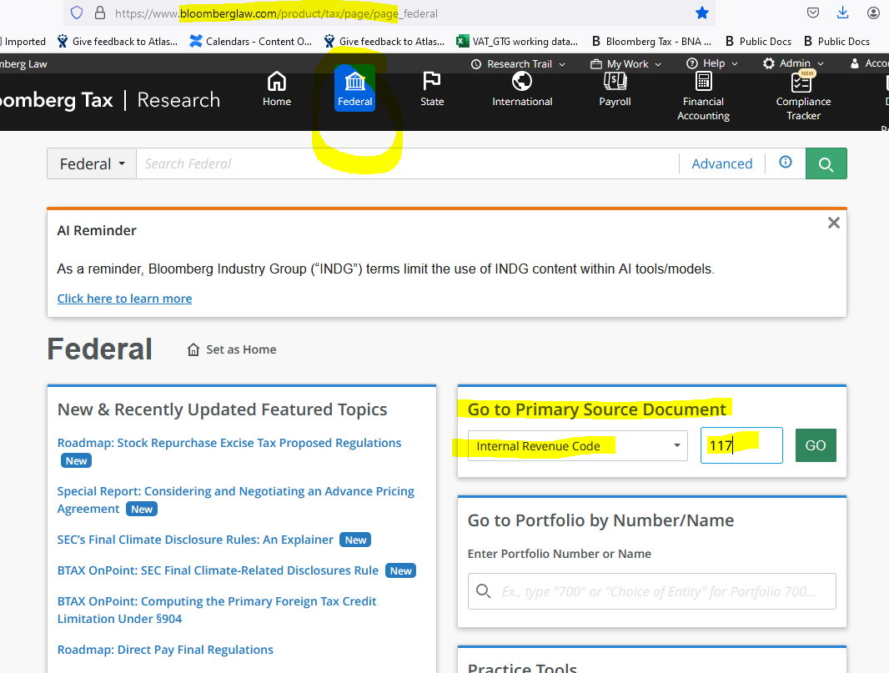

Click on Versions
Under Prior Versions choose the first entry
then click on Codified Text

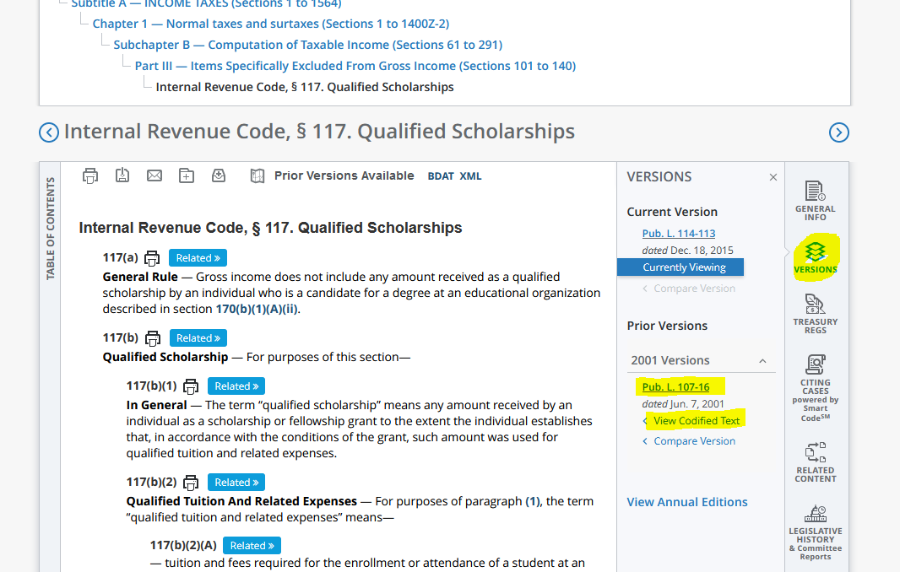

Go to Prior Version – Codified text
copy text only before the line

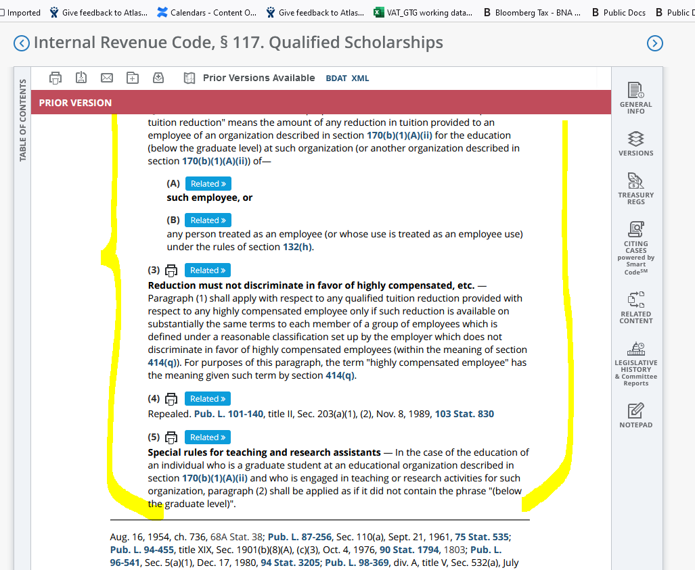

to check if you have the right version:

go to the current version History at the bottom of the Page Just Before Background Notes
(Note: Generally prior versions don’t have Editor’s note)

