EXAMPLE Email to Gasch & Brightkey ( to be sent around the time Portfolio Compose pdfs are being done)
Note: don’t forget to put an”A” after the portfolio number if it’s a replacement on both emails to Gasch & Brightkey (as of March 2025)

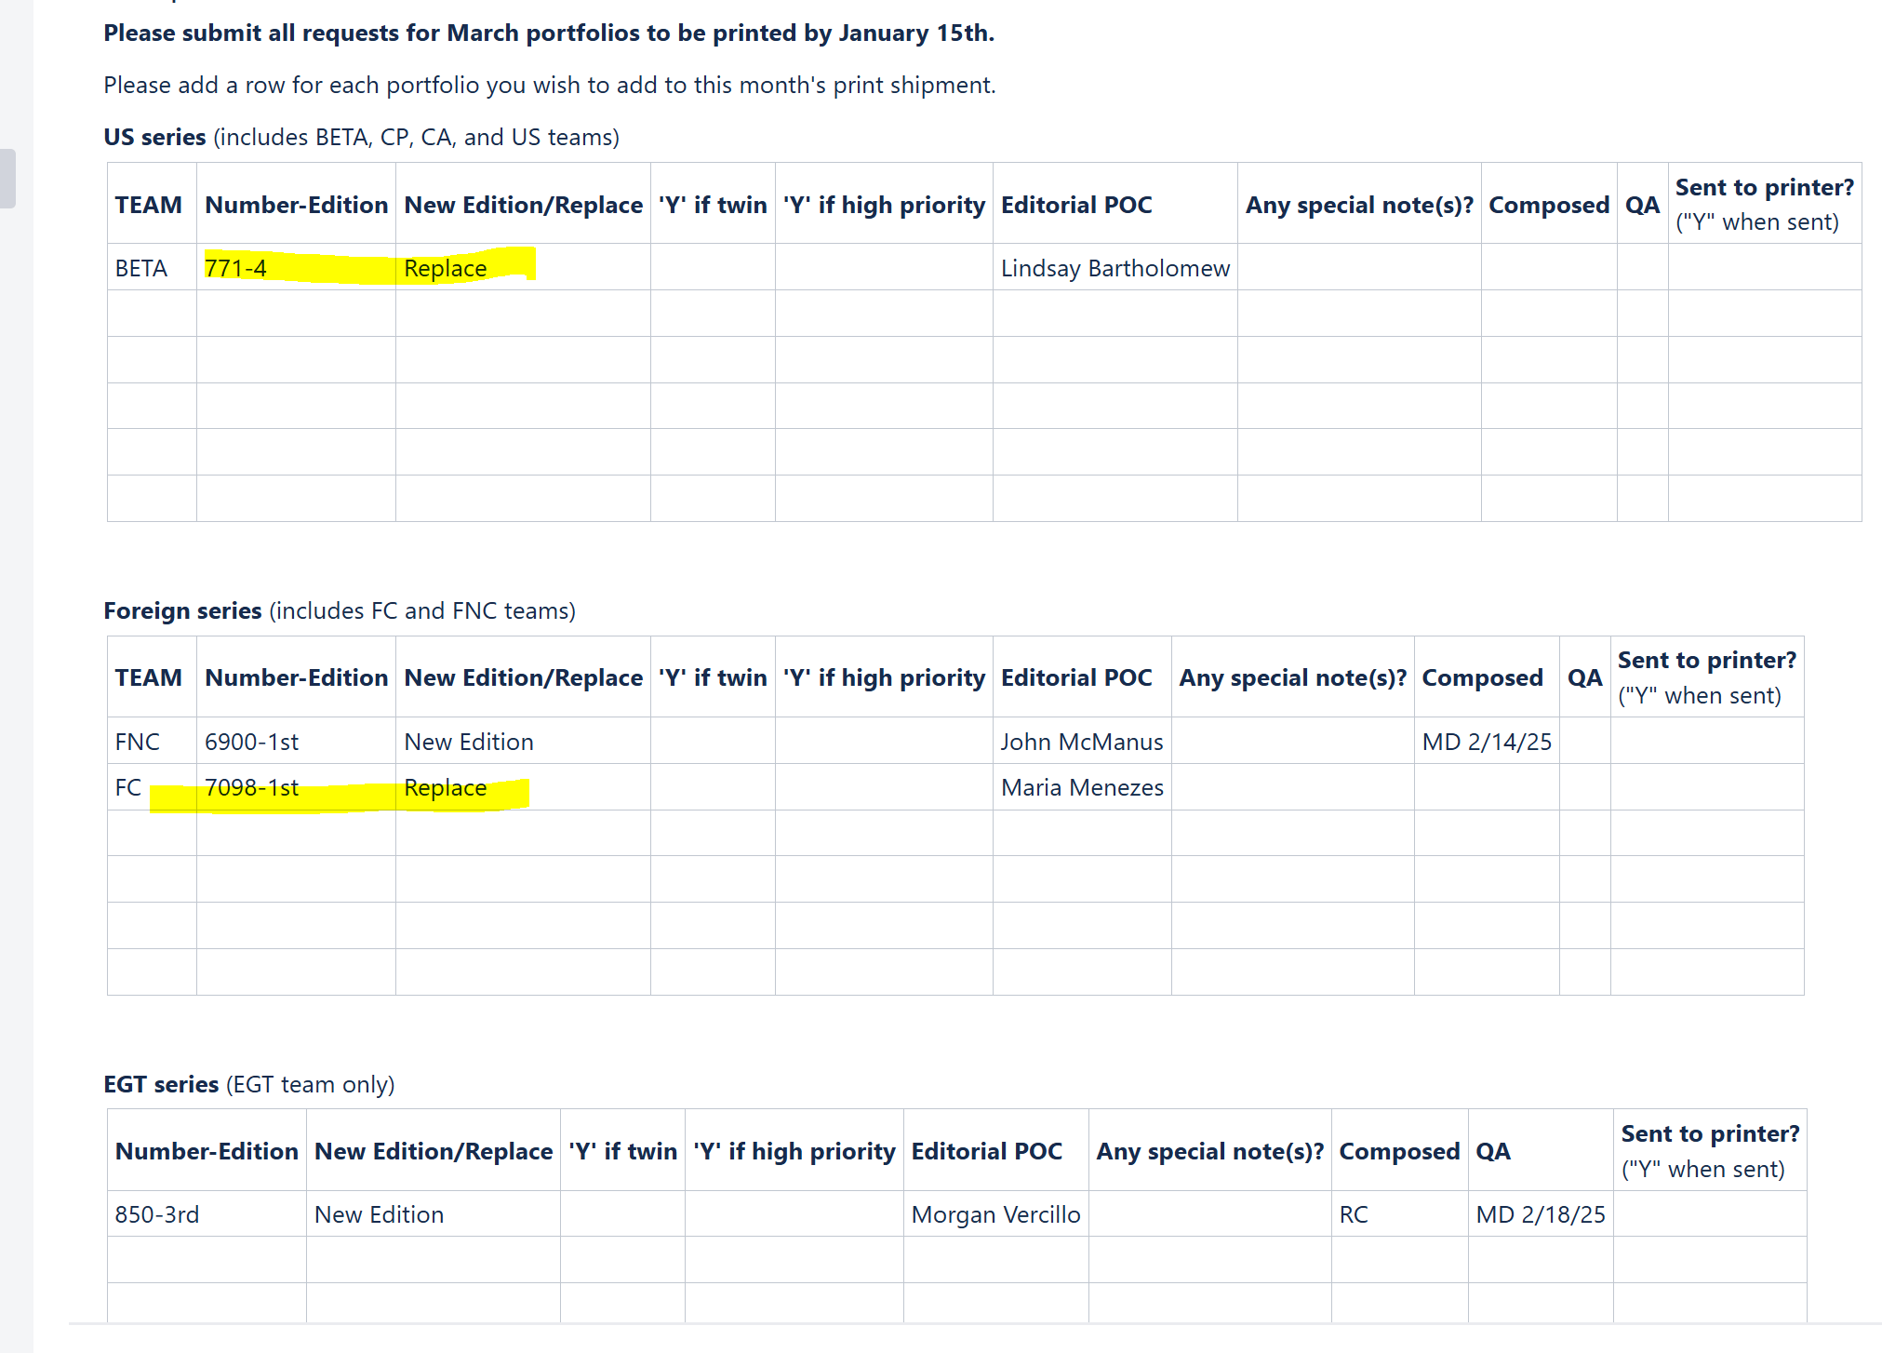

- Example Email to Gasch
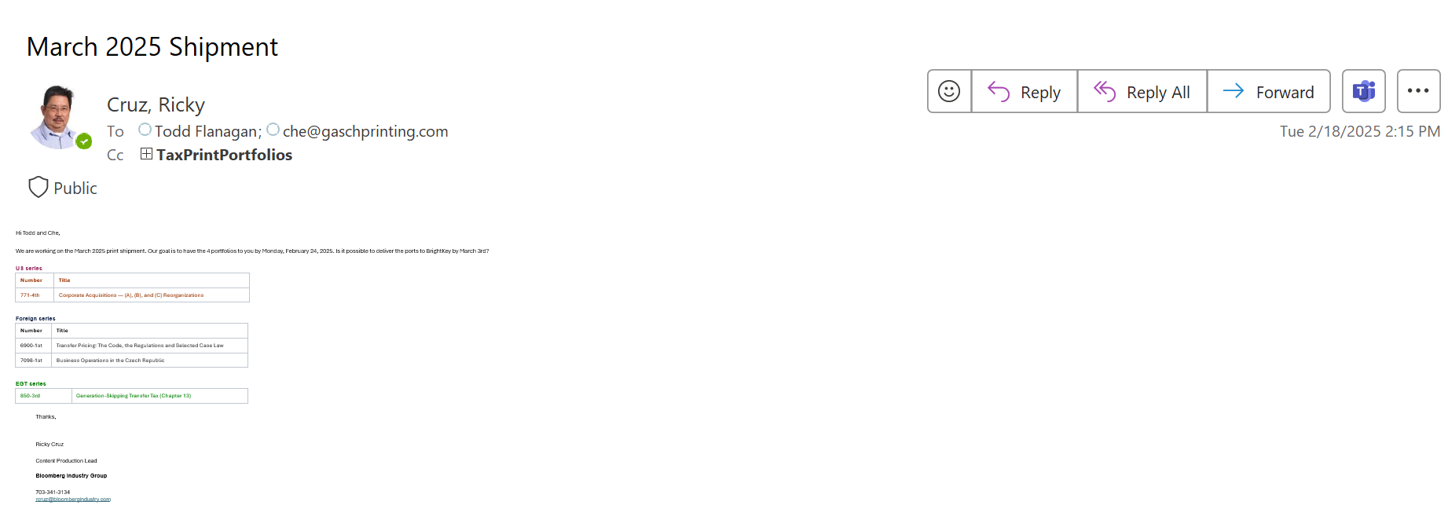

2.
