Practical Guidance
Note:
4 tickets that we have to make changes to
- Reclassification ticket (production ticket) assign to yourself Change Workflow to Platform QA after everything is done and Ping Michelle (even numbered tickets) or Dan (odd numbered tickets) for Ready for QA)
- Origin ticket
- Ex-paywall ticket
- Autocomplete ticket – assign to yourself (Change workflow to Production then to Uploading when done)
Label needs to added only on the 3 tickets (Autocomplete excluded)
Summary
- Get Production ticket and assign, make changes to resource .type, Document title (if necessary) and Label (in the end change Workflow to Platform QA)

https://confluence.bna.com/pages/viewpage.action?pageId=1771737102

- Check out file and make changes and post (to check if changes were posted click on link to document in the Prod ticket.
- Get Origin ticket ,
make changes to Resource Type, Title and Label,
link Origin ticket to Production ticket ( Search for Origin ticket by copying DOC ID TO SEARCH)
Get Ex-paywall ticket, make changes to Resource Type, Title and Label
In the origin ticket search for the ex-pay wall ticket by searching at the relates to link in the Origin ticket
- Go to Anthology and make changes
https://bbnaanthology.bloomberglaw.com/anthology/clients/BLAW/products/BALL/autocomplete_datasets/101/autocomplete_entries#81815

Copy title from Production Ticket to search in Anthology
then update
field (Title if necessary)
Field Desciption –Change Timeline to Overview
Then click on save changes to publish
After Publishing in Anthology
Check link in original Ticket if changes were made

- Get AutoComplete ticket and change Workflow to Publishing after changes were made
Search for AutoComplete ticket here:
https://jira.bna.com/browse/ECO-248432
Copy Title in Search

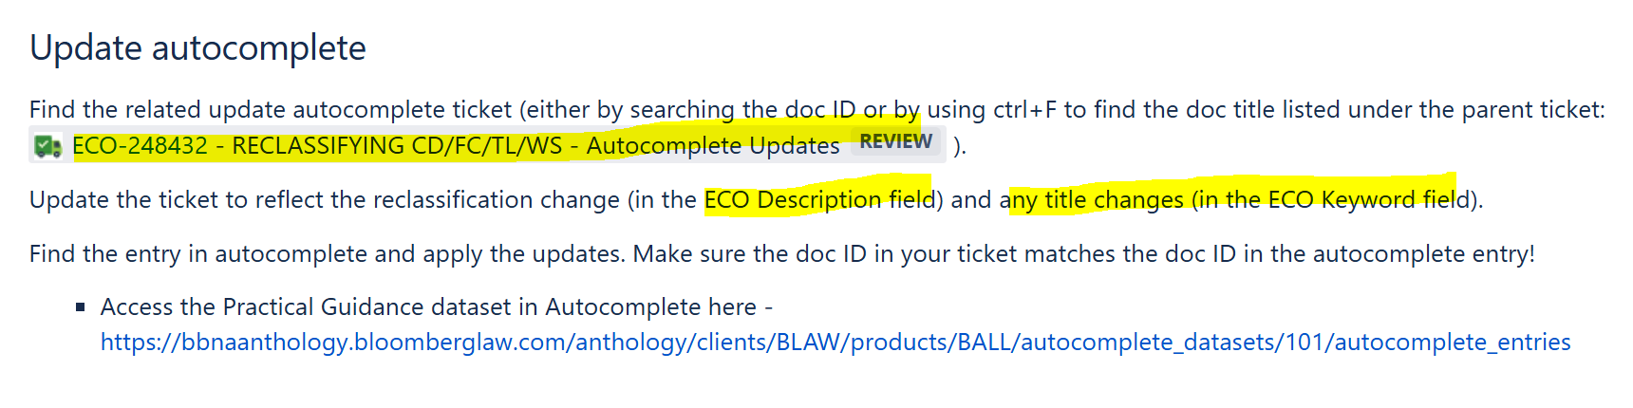
Make changes to ECO Keyword: (Title if necessary)
ECO Description: Change entry Timeline to Overview (eg.; Merger Timeline to Merger Overview)
**************************************************************************************
Instructions:
In the production ticket
If there is a change name make changes to unit name tag too.
- On the production ticket change
- Workflow to Production
- Resource Type
- Document title(if needed)
- Label

- Checkout and make changes to the file
- Change Resource type
- Name ,(Title if needed) also change in unit info tag.
- Search for the Origin ticket
To search for origin ticket copy doc id the paste to search IN JIRA
Origin ticket has a darker shade:
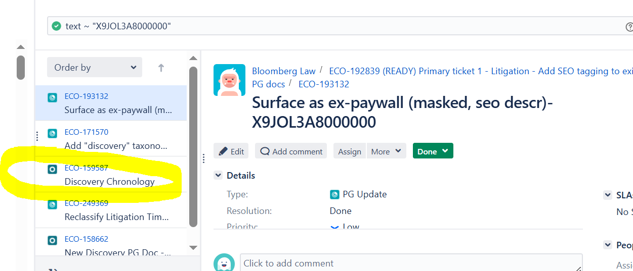

- Link ticket to origin ticket
Copy Origin ticket no and paste to More>Link in the Production ticket
Use relates to(In linking)
In the Origin ticket
Change Resource type & Title (if needed)- add Label

In the origin ticket search for the ex-pay wall ticket by searching at the relates to links
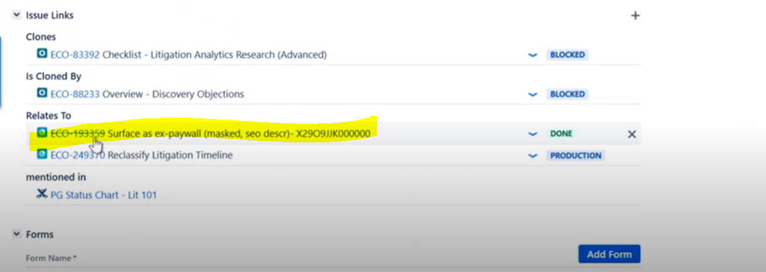

- In The ex paywall ticket change Resource type & (Title if needed) and Label

- In Anthology
Copy title from Production Ticket to search in Anthology
then update
field (Title if necessary)
Filed Desciption –Change Timeline to Overview
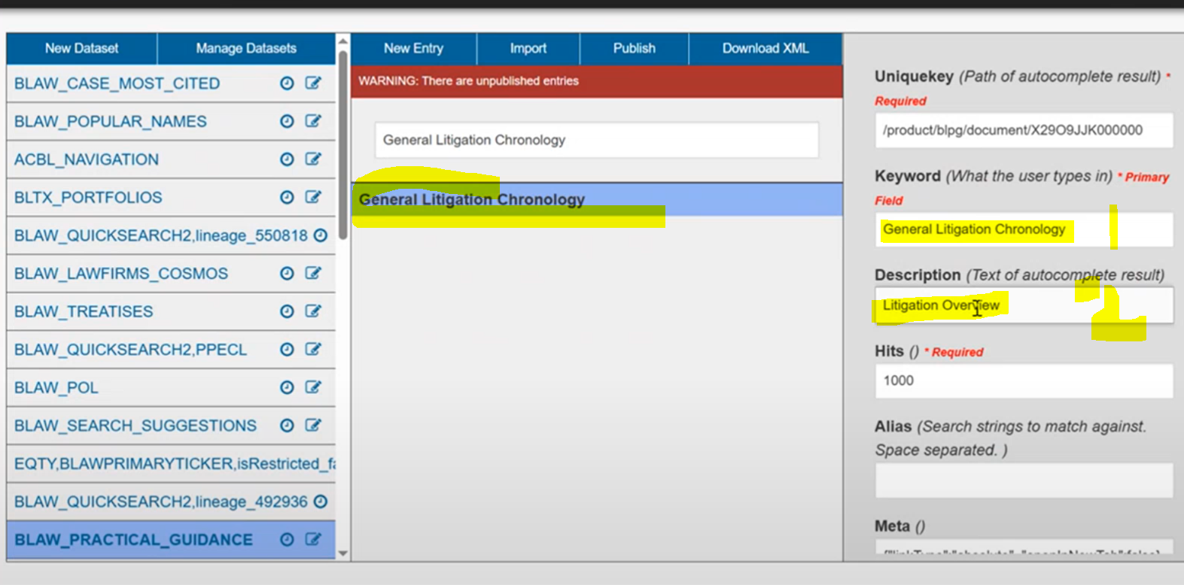

Then click on save changes
- Go to Autocomplete ticket
Search for AutoComplete ticket here:
Make necessary changes then change workflow from Production to Uploading

After completing the tasks:
Change Workflow in the production Ticket from Production to Platform QA
The ping Michelle (even)or Dan(odd): ready for QA in the Production ticket.

Check in 2 days --Timeline should be Overview when you search for the tltle in BLAW:
