Skip to end of metadata
- Created by Demiraydin, Murat, last modified on Feb 23, 2018
Go to start of metadata
How to convert manuscripts from Word to SGML format.
- 1Software Requirements
- 2Overview
- 3Opening Manuscript in Template
- 4Applying Macros
- 5Reviewing and Troubleshooting Your Document
- 6Dividing Portfolio
- 7Sending Chapters to BPub
- 8Opening Chapters in WebQ

Software Requirements

- Word 2013 or later.
- Latest BPub Prep Template installed for Word. See these instructions for installation.

Overview

A Word-based template called BPub Prep is used to convert manuscripts form Word to SGML format, and to send the tagged files to the WebQ. This template provides several built-in macros to tag and add styles to different components (headings, list items, examples, etc.) in a manuscript. The template is a work in progress. This documentation focuses on Detailed Analysis (DA) chapters only. Converting other portions of a manuscript, such as Worksheets, are not described here.

Opening Manuscript in Template

- Start Word.
- Click File > New > CUSTOM
- Click BPub_Prep
- In Choose Document Type dialog box, select Chapter (analysis.98) under Portfolio. (This opens an empty document with info.start attributes on top that are going to be filled in later.)
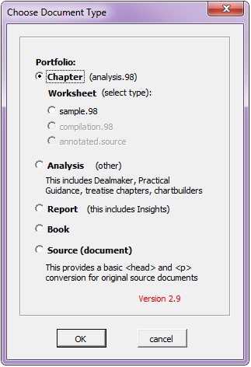
- Place your cursor between Document and the paragraph symbol.
- Press Enter twice.
- Click BCleanup&Prep tab.
- Click Insert File.
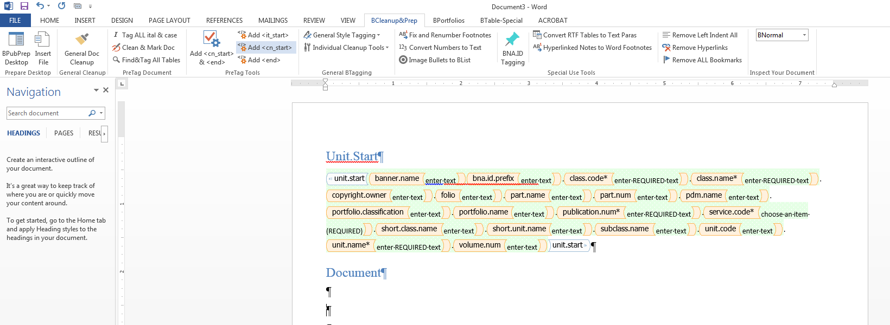
- Locate your manuscript file in your drive and insert it in your document.
- Remove all front matter including the title page, portfolio description, table of contents as well as table of worksheets and worksheets at the end. The manuscript should begin with Chapter I heading.
- Click Convert Numbers to Text. (This ensures “soft” numbers in numbered lists and headings turned to “hard” (unchanging) numbers.)
- Click Image Bullets to BList. (This converts image-type bullets to BList style.)

Applying Macros

Now you may start running the macros in the following order to clean up, and tag your manuscript. Wait for one macro to finish before you start the next one.
- Click General Doc Cleanup.
- Click Tag ALL ital & case. (This button identifies and changes any regular italic text and case names to BPub styles.)
- Click Clean & Mark Doc. (This macro will perform several clean-up tasks.)
- Click Find&Tag All Tables. (You will have to further modify, clean up your tables in the WebQ.)
- You are done using BCleanup&Prep tab. Now select BPortfolios tab.
- Click Tag Hds & Special Ps. (When completed, this macro will have tagged heading levels 1 through 4, and special paragraphs such as comments, examples.)

Reviewing and Troubleshooting Your Document

Currently, the template is not flawless, and requires manual intervention post-tagging. Although it applies most Bstyles correctly, it still misidentifies certain text elements and tags them incorrectly. It is time now to review the whole document and reassign the correct styles where needed.
Using View tab, you can determine whether the headings are leveled correctly in the Navigation pane on the left (BHead1, BHead2, etc.). The center column displays styles assigned to each item. Majority of your paragraphs should be tagged with BNormal.
Right mouse click offers a shortcut menu, where you can choose Validate Styles to check the entire document for valid styles.
Some of the most common errors in tagging:
- Numbered list items tagged as BHead2 or BHead4.
  - Go to BPortfolios tab
  - Select the erroneous list items
  - Select BList_orig# > BList_orig (or another)
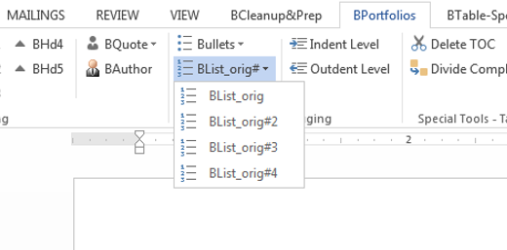
- Roman numeral list items tagged as BNormal:
  - Select the erroneous list items
  - Change the style to BList_orig (or another)
At any time, OpenStyles macro (under BPortoflios tab) can be used to view and apply the entire collection of valid styles.
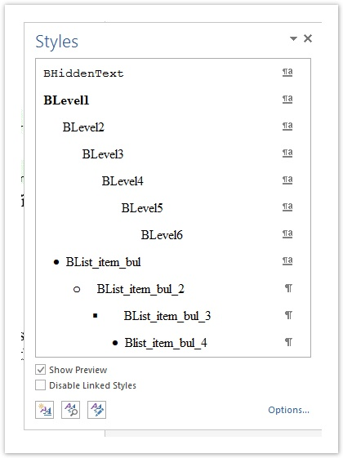

Dividing Portfolio

- Click Divide Complete Portfolio under BPortfolios tab.
- Specify the default Unit.Start values:
  - bna.id.prefix: portfolio number
  - class.code: A
  - portfolio.classification: retrieve this value from previous edition
  - portfolio.name: full portfolio title
  - publication.num: portfolio number and revision (e.g., 324-4th)
  - service code: select one from list
  - You may leave other attributes intact
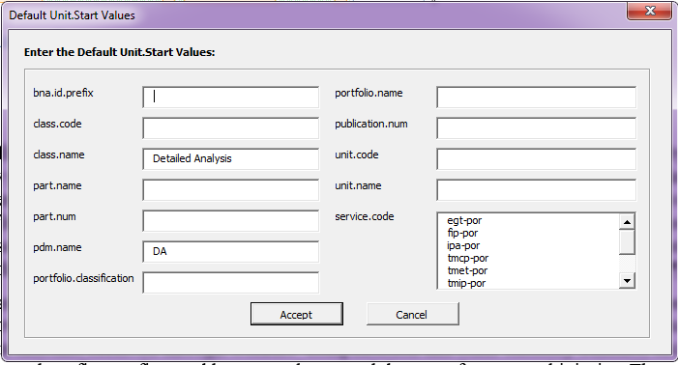
- Press Accept

Your portfolio will be broken into individual chapters where each chapter will be appended a unit.start on top. When dividing completes, Word will close and your divided chapters will be copied in Documents folder on your computer.

Sending Chapters to BPub

- Locate your individual files on your computer, and open the first chapter.
- Specify further values for Unit.Start:
  - unit.code: chapter number
  - unit.name: chapter title
- Right click on your mouse and select Send to Bpub.
  - Give a name to your file
  - Select queue in-tmprod
  - Press Accept.
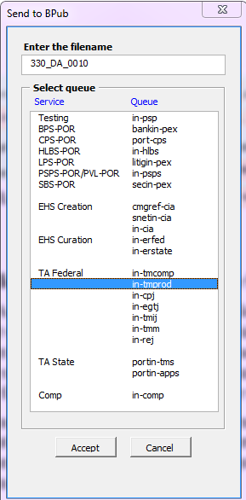
- Repeat the process for each chapter.
Note: If you receive an error while sending files to BPub, contact Sally Baird.

Opening Chapters in WebQ

All your chapters have now been sent to a designated queue (in-tmprod) in the WebQ. You can open them and perform any further editing, such as formatting tables and inserting images.

