Portfolio Print Workflow –(once the Composed Portfolio pdfs finished final QA sending files to Gasch can start after that send the Mail Memos
https://confluence.bna.com/display/TPQA/Portfolio+Print+Replacement+Workflows
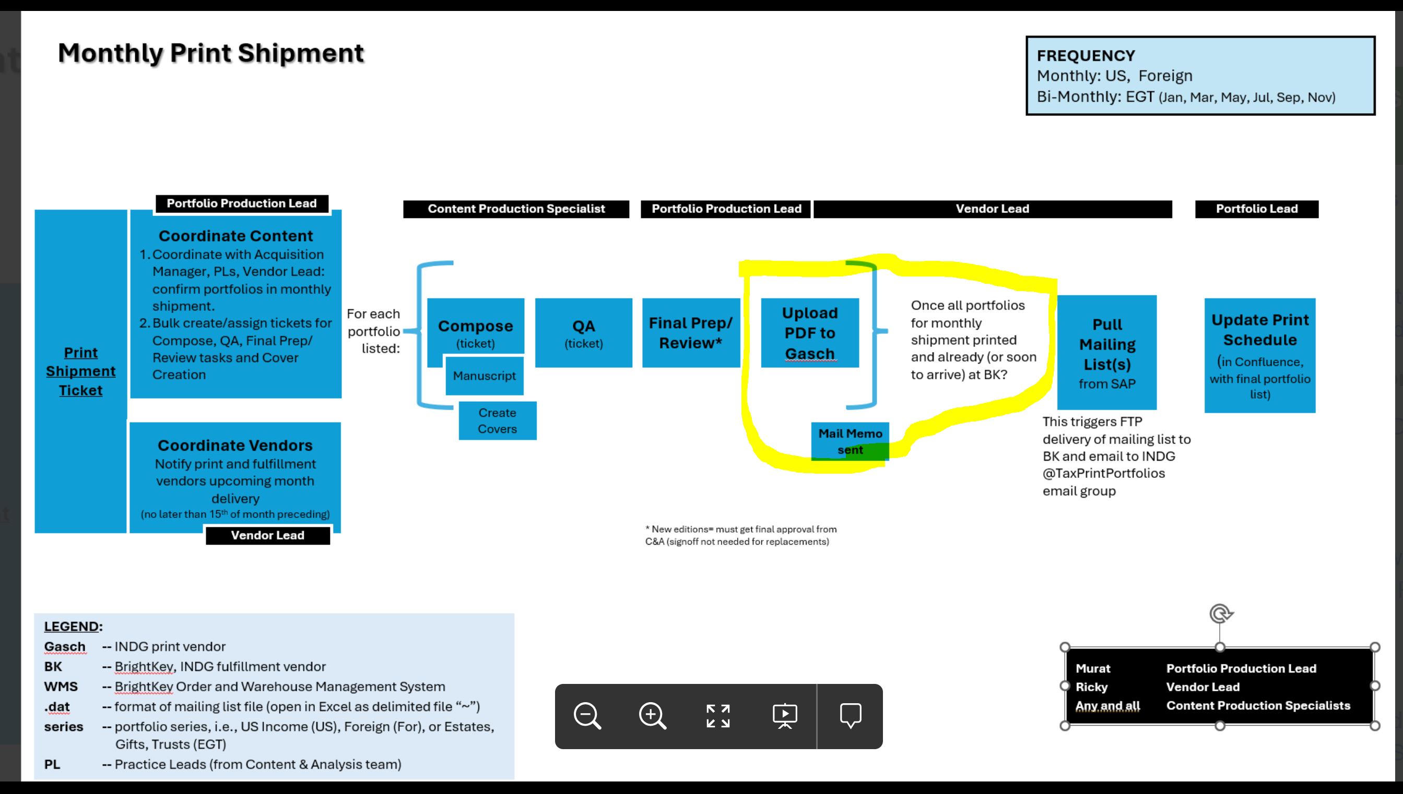
- Final Prep/Preview of Portfolio pdf
- Upload Composed Pdf to Print Vendor(Gash) - https://confluence.bna.com/pages/viewpage.action?spaceKey=TPQA&title=2%29+Upload+Composed+File+to+Print+Vendor
- Prepare and send Mail Memo
https://confluence.bna.com/pages/resumedraft.action?draftId=1741460742&draftShareId=c8a32d7c-e2f9-4690-a155-5c2ea1664cb2&

Summary
- Upload Composed pdf to Vendor
- Prep and send Mail Memo

