PORTFOLIO COMPOSITION NOTES

- TOOLS >REASSIGN ALL EINS>STRIP COPY HISTORY>RENUMBER FOOTNOTES
- search for reserve to delete reserved footnotes
- EDIT ATTRIBUTES> CHANGE FOLIO NUMBER
- FOR TABLES – INSTEAD OF END BLOCK USE END PAGE (ED BLOCK DOESN’T WORK ON TABLES) AFTER END ROW TAG. headings on tables should not be hypenated if possible
- FOR TOO MUCH SPACING BETWEEN TEXT ON FOONOTES USE LINE BREAK JUSTIFY =L ONLY IN PRINT. TRY ON A COUPLE OF WORDS FIRST THEN ADJUST TO MAKE IT FIT (FOR LONG URLS AND REGULATION & SECTIONS
- .CHECK LINE BREAK BETWEEN AUTHORS ON TITLE PAGE
- FONT ON DISCLAIMER SHOULD BE 9 PTS (IF IT’S ON A PARA, DELETE PARA & CREATE A ONE ROW TABLE WITH A FONTSIZE OF 9 PTS.
- CHECK CHAPTERS ON TOC FIRST TO SEE IF THERE ARE DUPLICATE CHAPTERS
- CHECK HEIRARCHY & level of indent(ALTERNATE NUMBER & LETTERS [I,A,1,a,(1),(A),(I),(A),(I)]
- Check indents on paras
- for creating tocs for twins make sure the info unit tag for the portfolio you are creating is on top

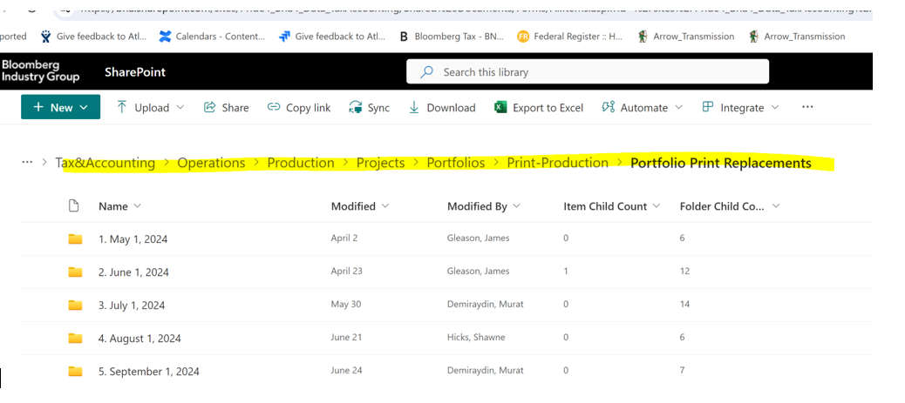

FOR REPLACEMENT- USE THIS LANGUAGE: RETAIN THE EDITION NUMBER BUT CHECK IN BTAX
THIS IS ONLY A REPLACEMENT SO IT RETAINS EDITION NUMBER (FOR NEW EDITION THE edition number changes and th language includes discard the previous edition)


FOR THE DISCLAIMER- TYPESIZE =9 ONLY WORKS AT THE P LEVEL
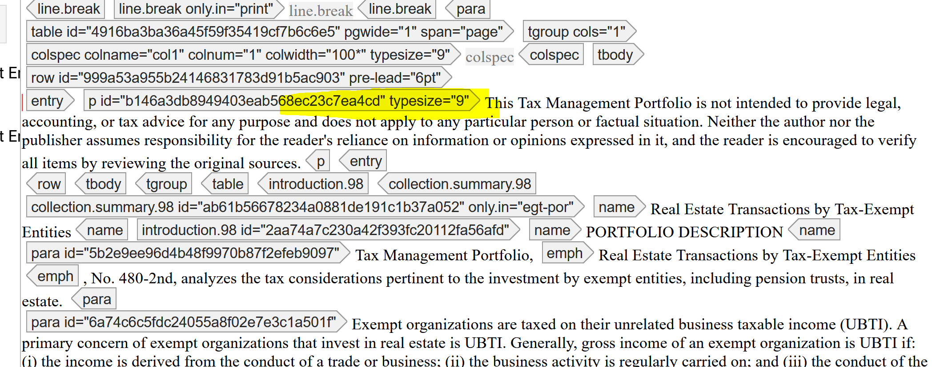

For covers Replacements will have “a” OR additional LETTER  ON THE SPINE :

Link to qa notes:
https://confluence.bna.com/display/tpqa/qa

For citations (there should be no period or double comma after closing parenthesis): 

