Partial VAT/GTG Conversion Using the Email Gateway

- Open file in Word and replace Manual Linebreak with Paragraph Character

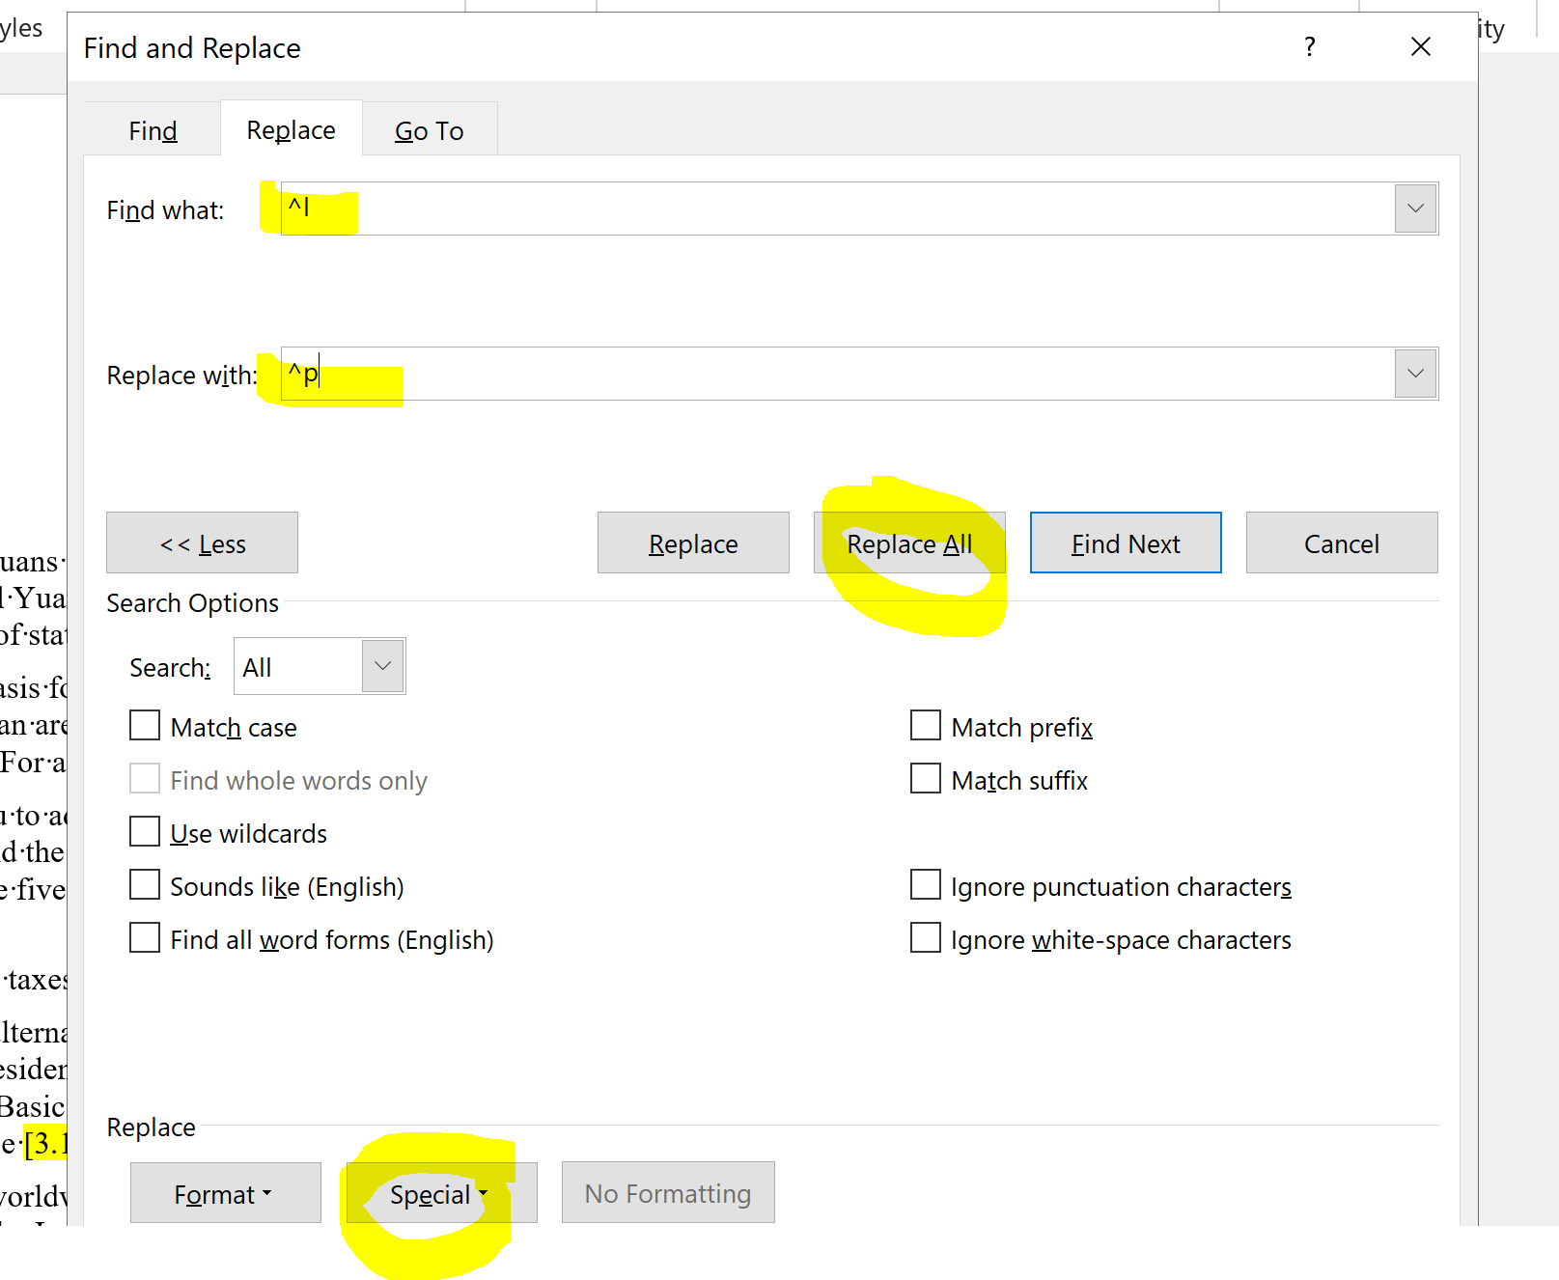

File will look like this originally:
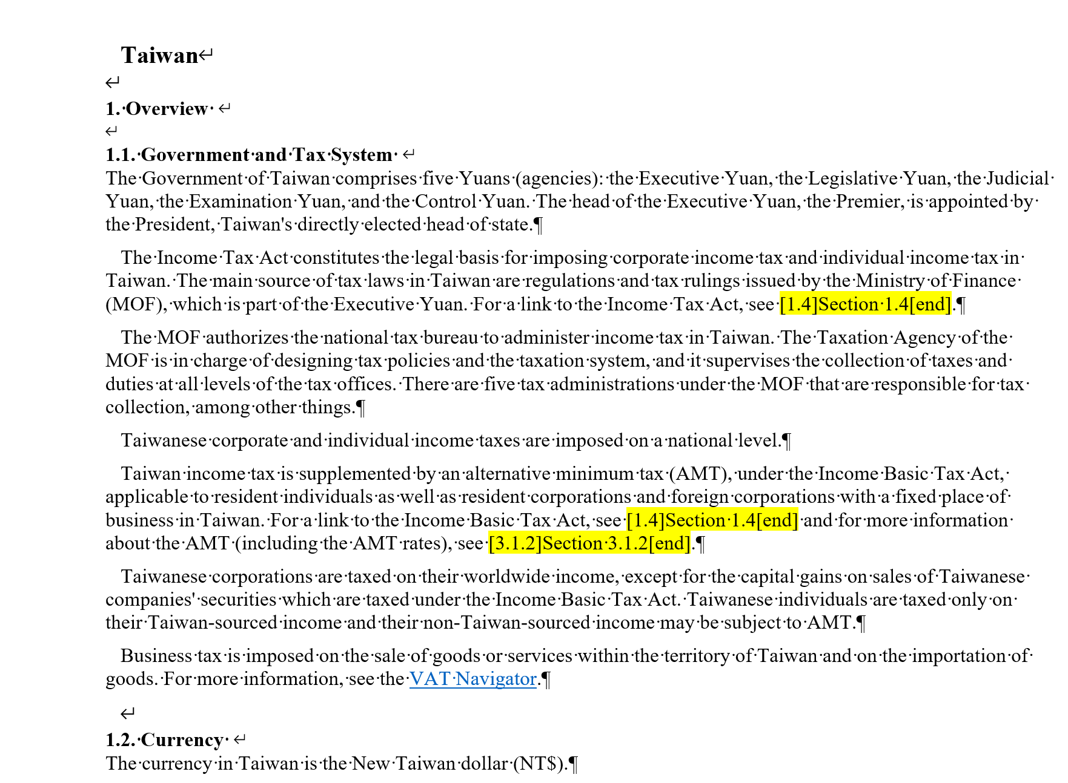

To this:

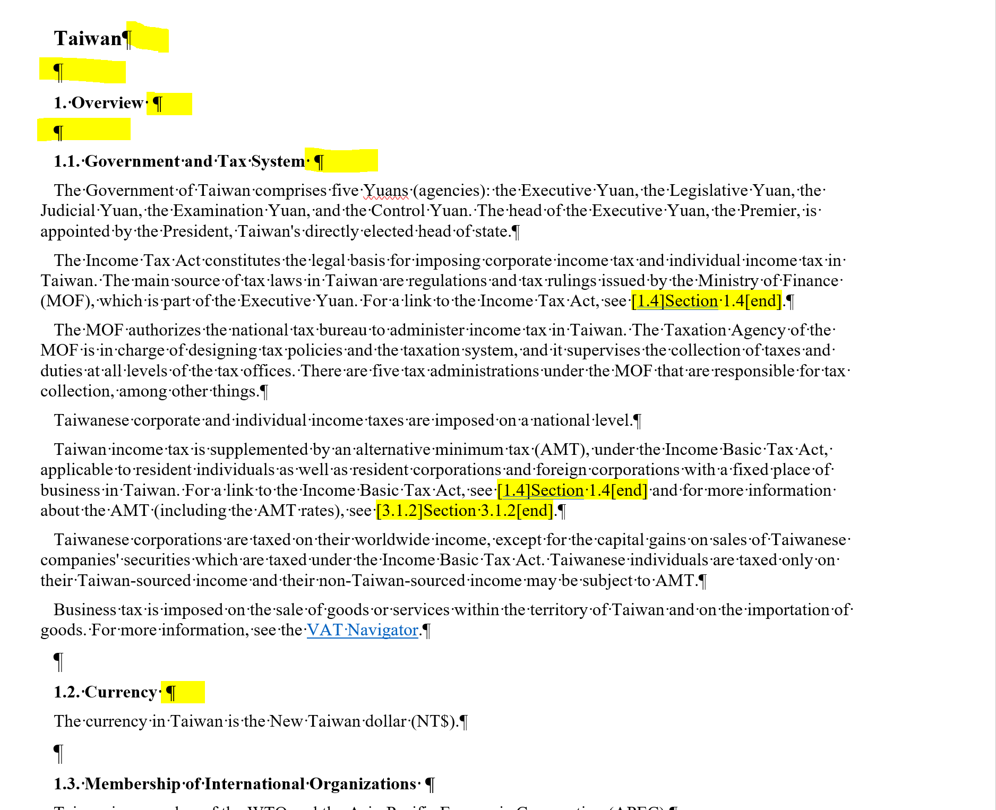

- Replace the Bullets with ###$$$ : 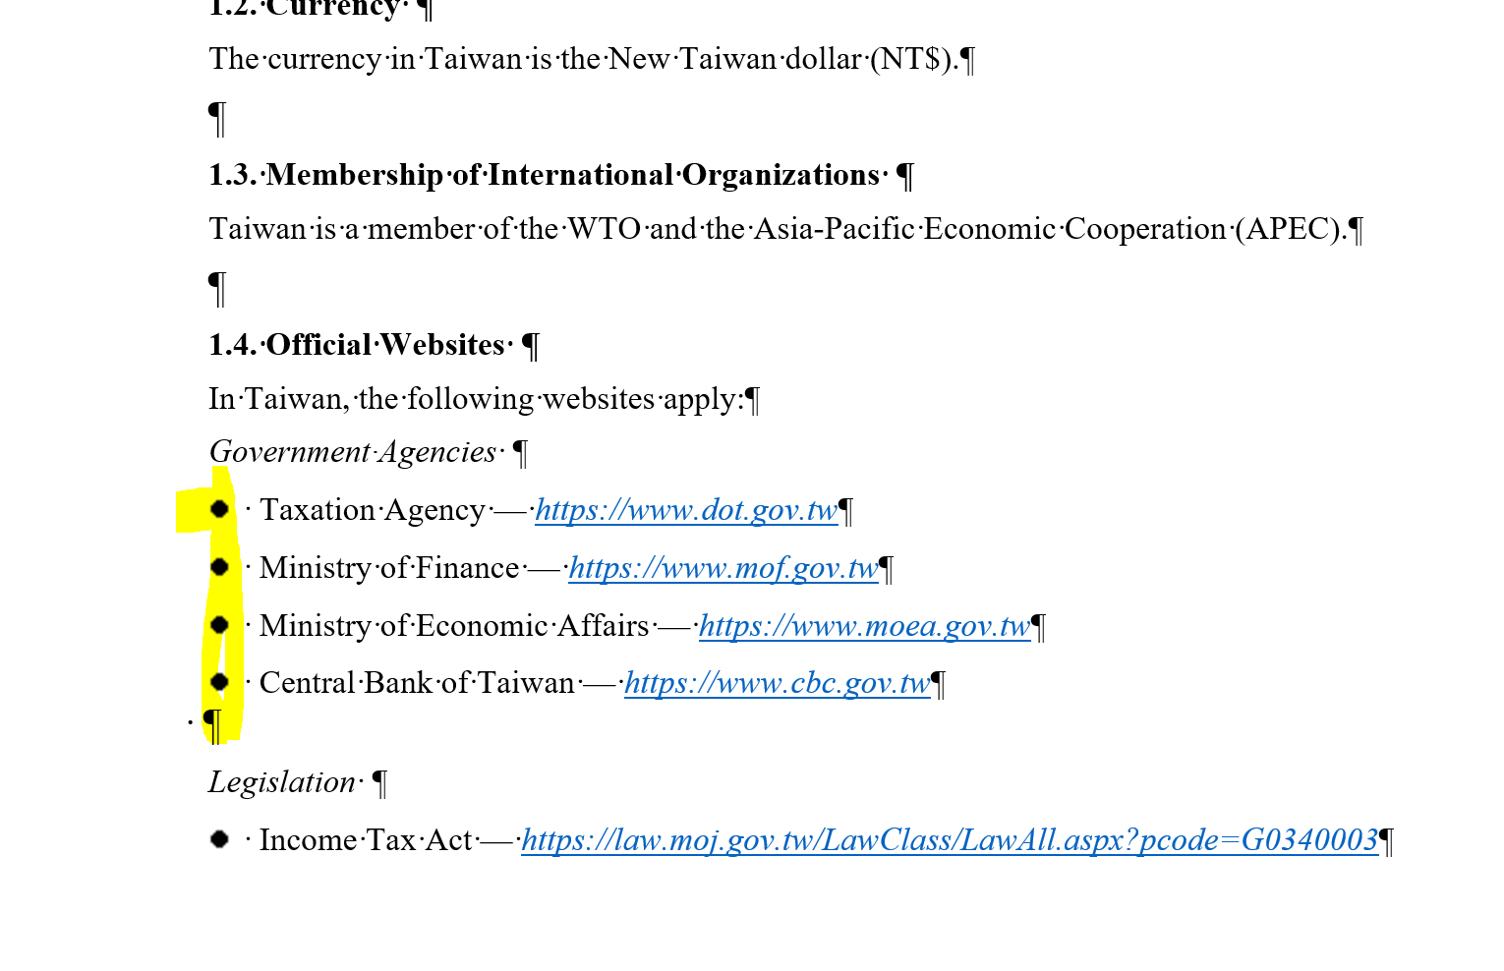
Use Control F to bring up the Find menu

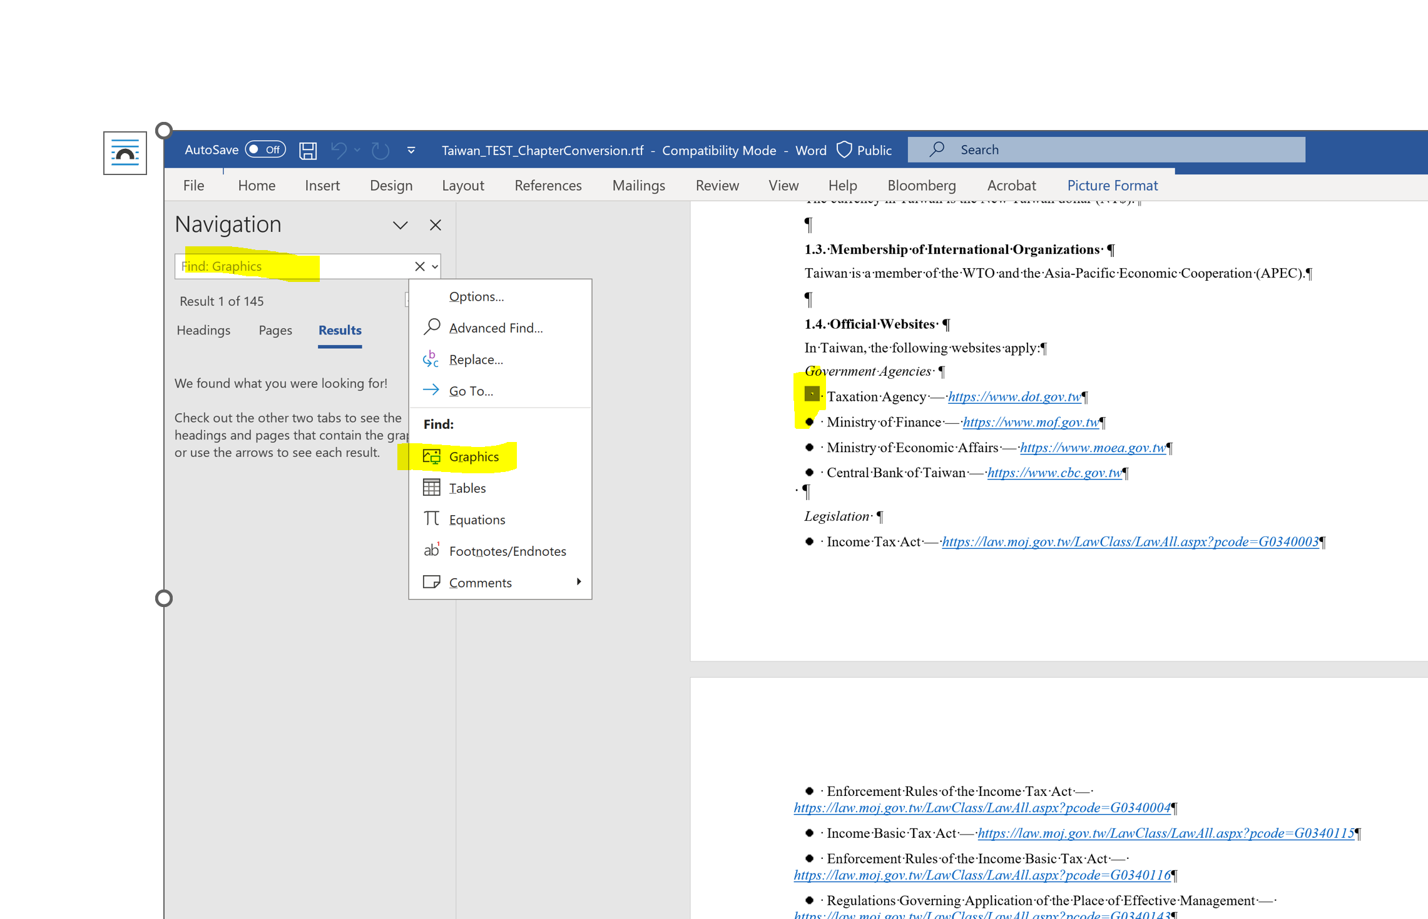

Then click on Home>Replace then type ###$$$ on the Replace with line and retain the ^g on the Find what line (the “^g “was generated when the search for graphics was executed.

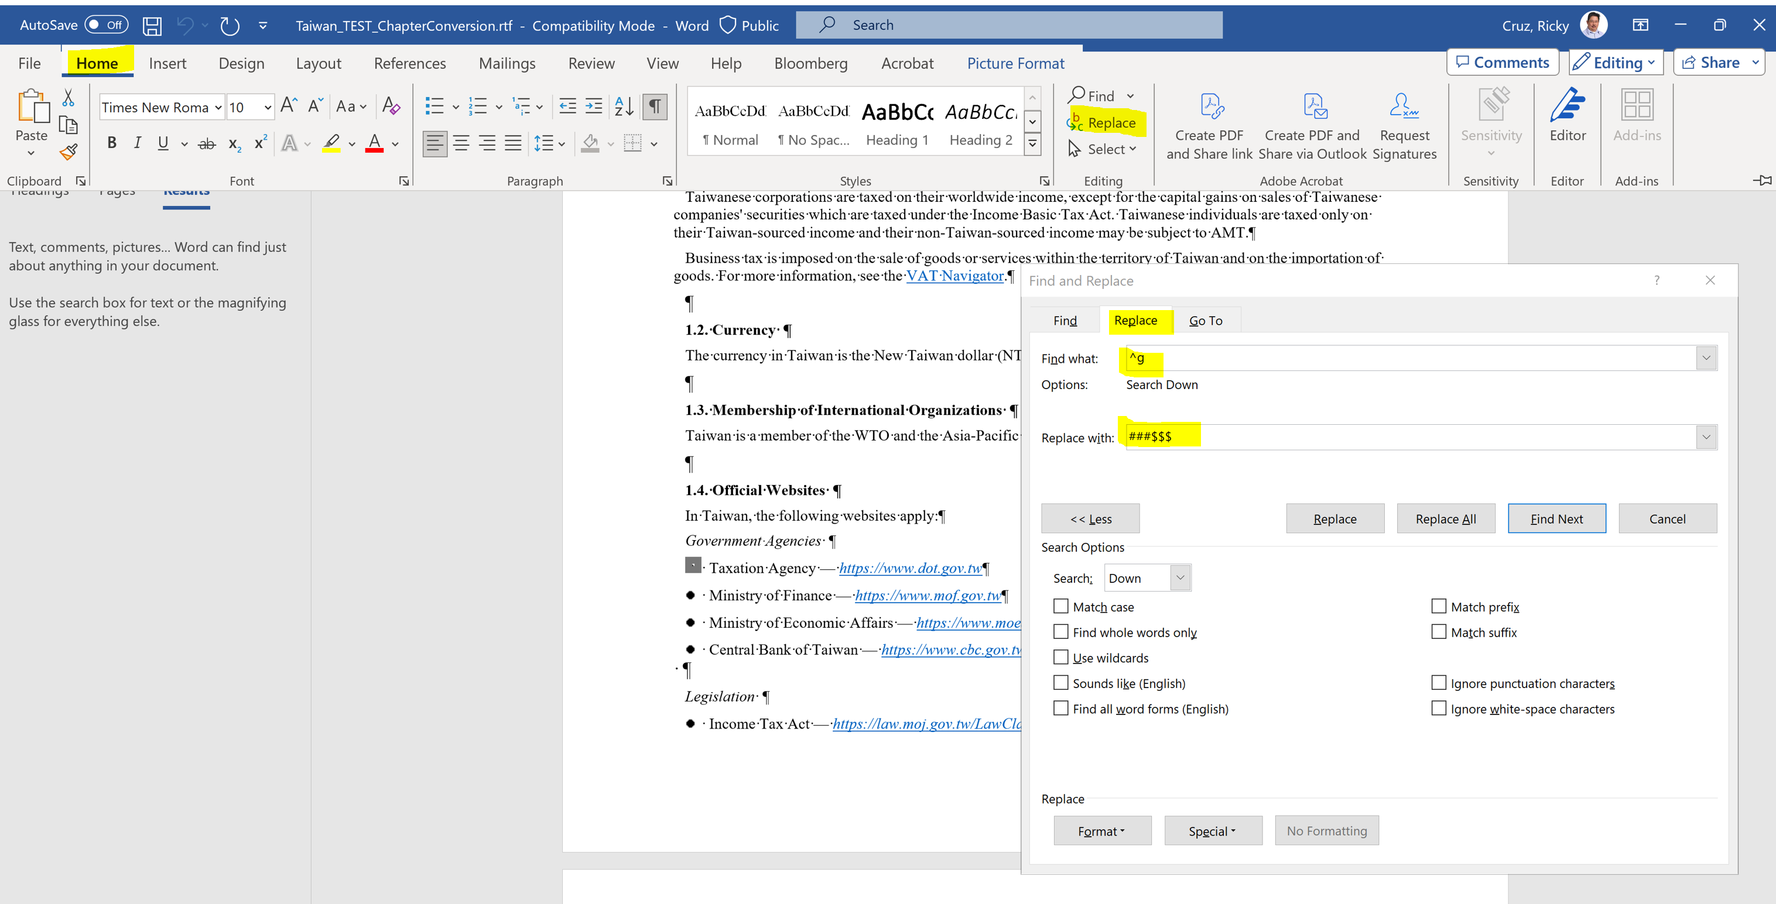

Then click on replace all and the document will look like what is shown below:

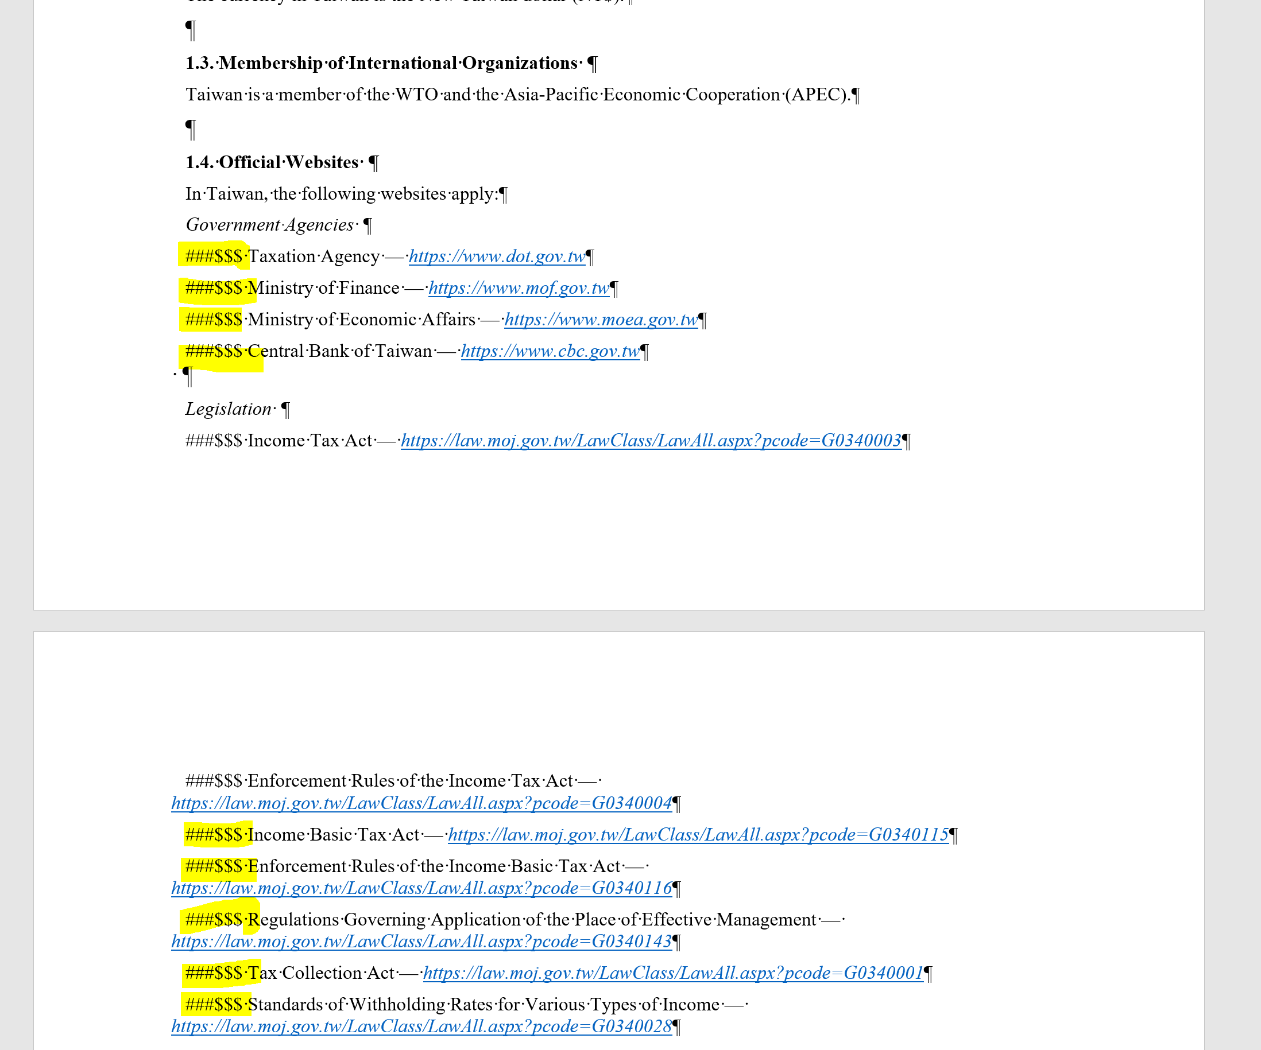

After the replacement save the document as an RTF File:

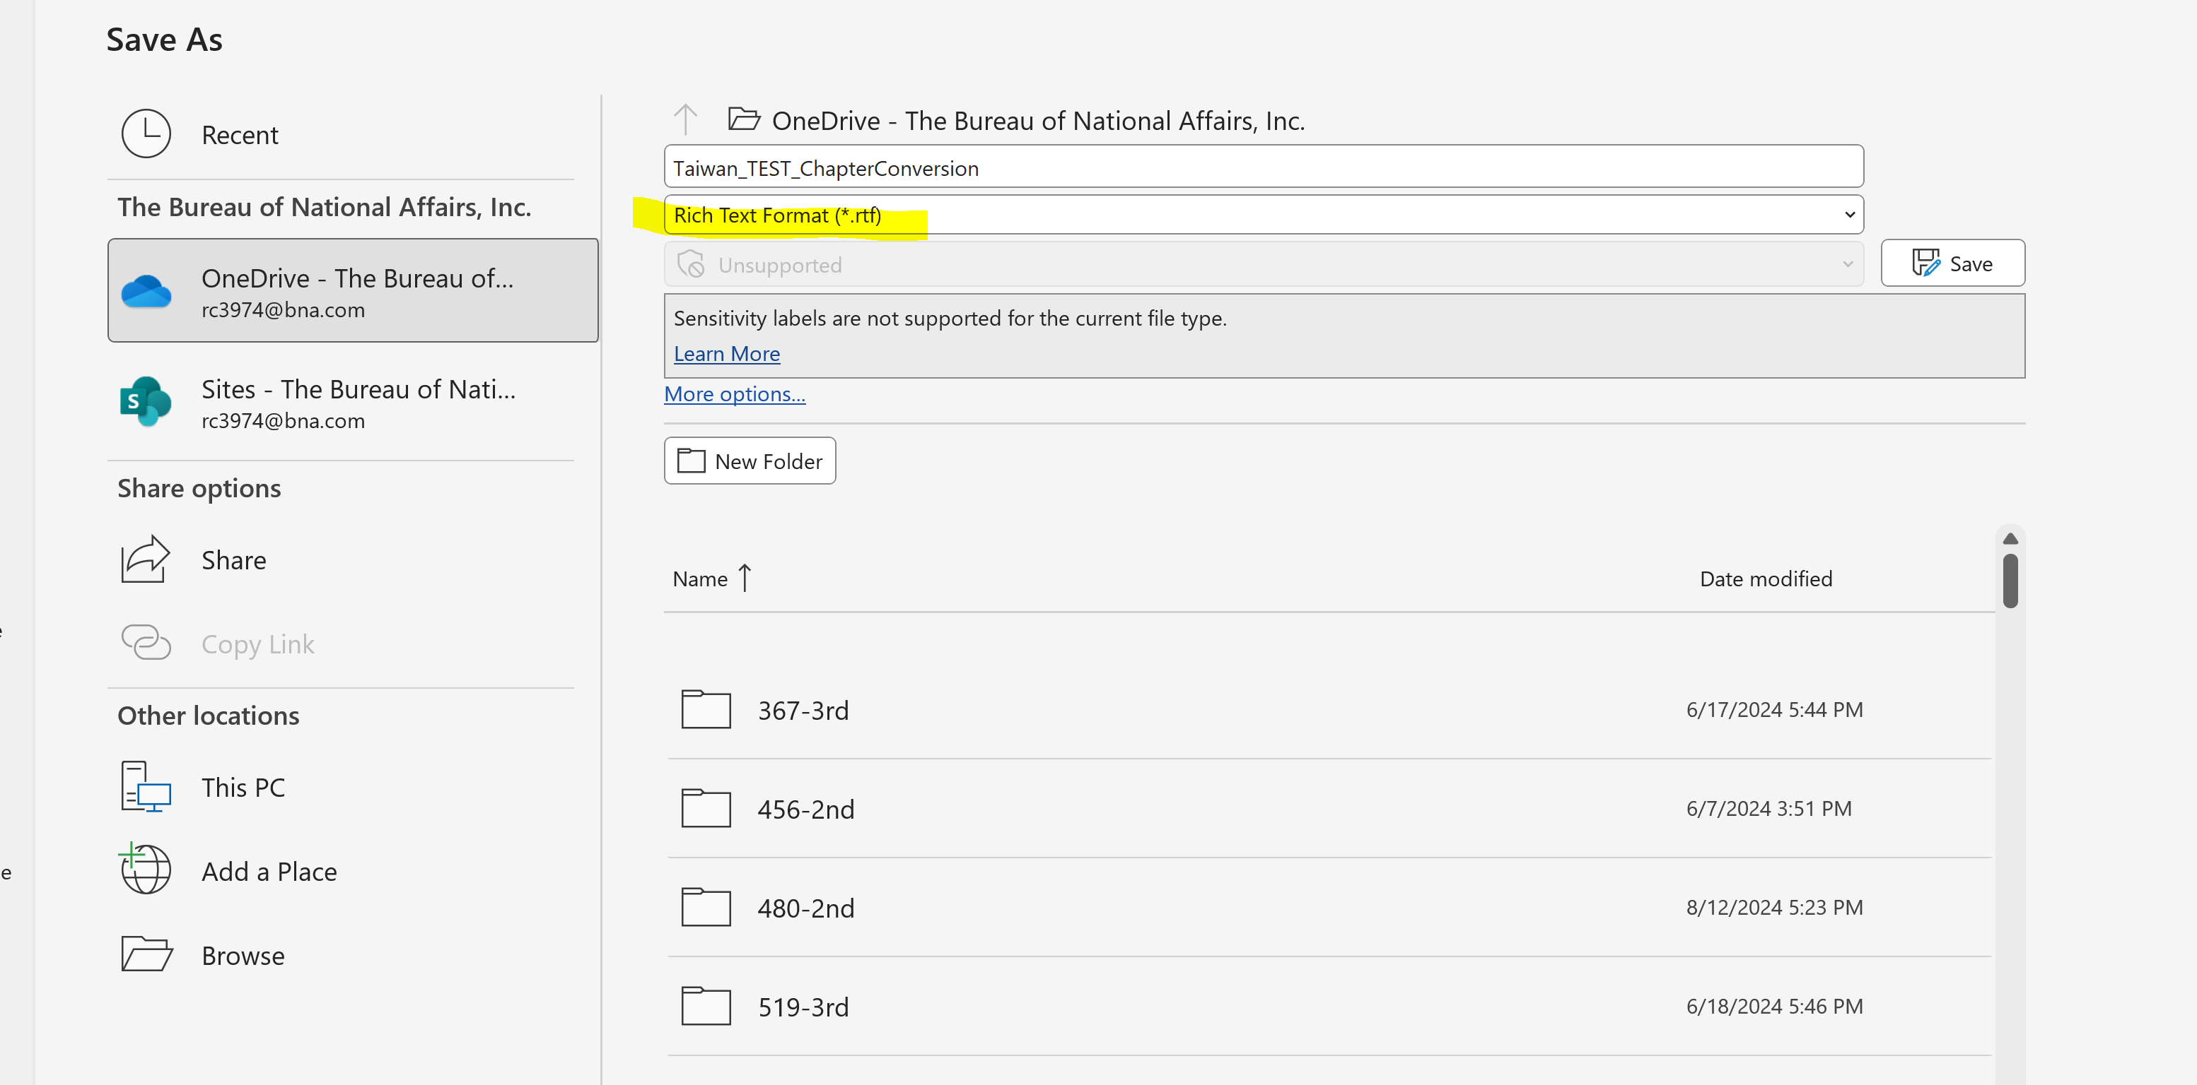

Using the Email Gateway send the file to BWIP

- Create Message following the sample below:
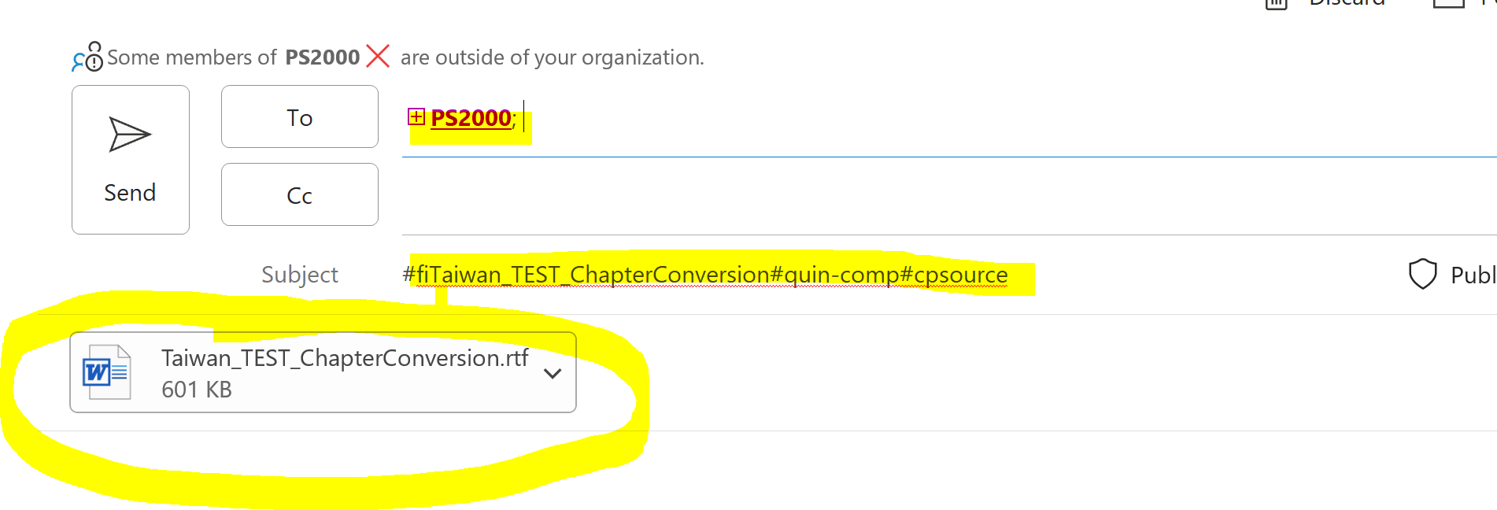
- Message should be addressed to: PS2000
- On the Subject line type: #fiFILENAME#quin-innodata#cpsource
Note: There should be no spaces on the filename. Underscore can be used instead of spaces. A blank space within the filename will cause the transmission to fail.
You can either send the file to the in-comp or in-innodata queue.

- Attach the RTF file then click on send.

In BWIP locate the Actions drop down menu and select Plain Text Edit

This will open the file with the basic p, emph, & footnote tagging and will look like this:

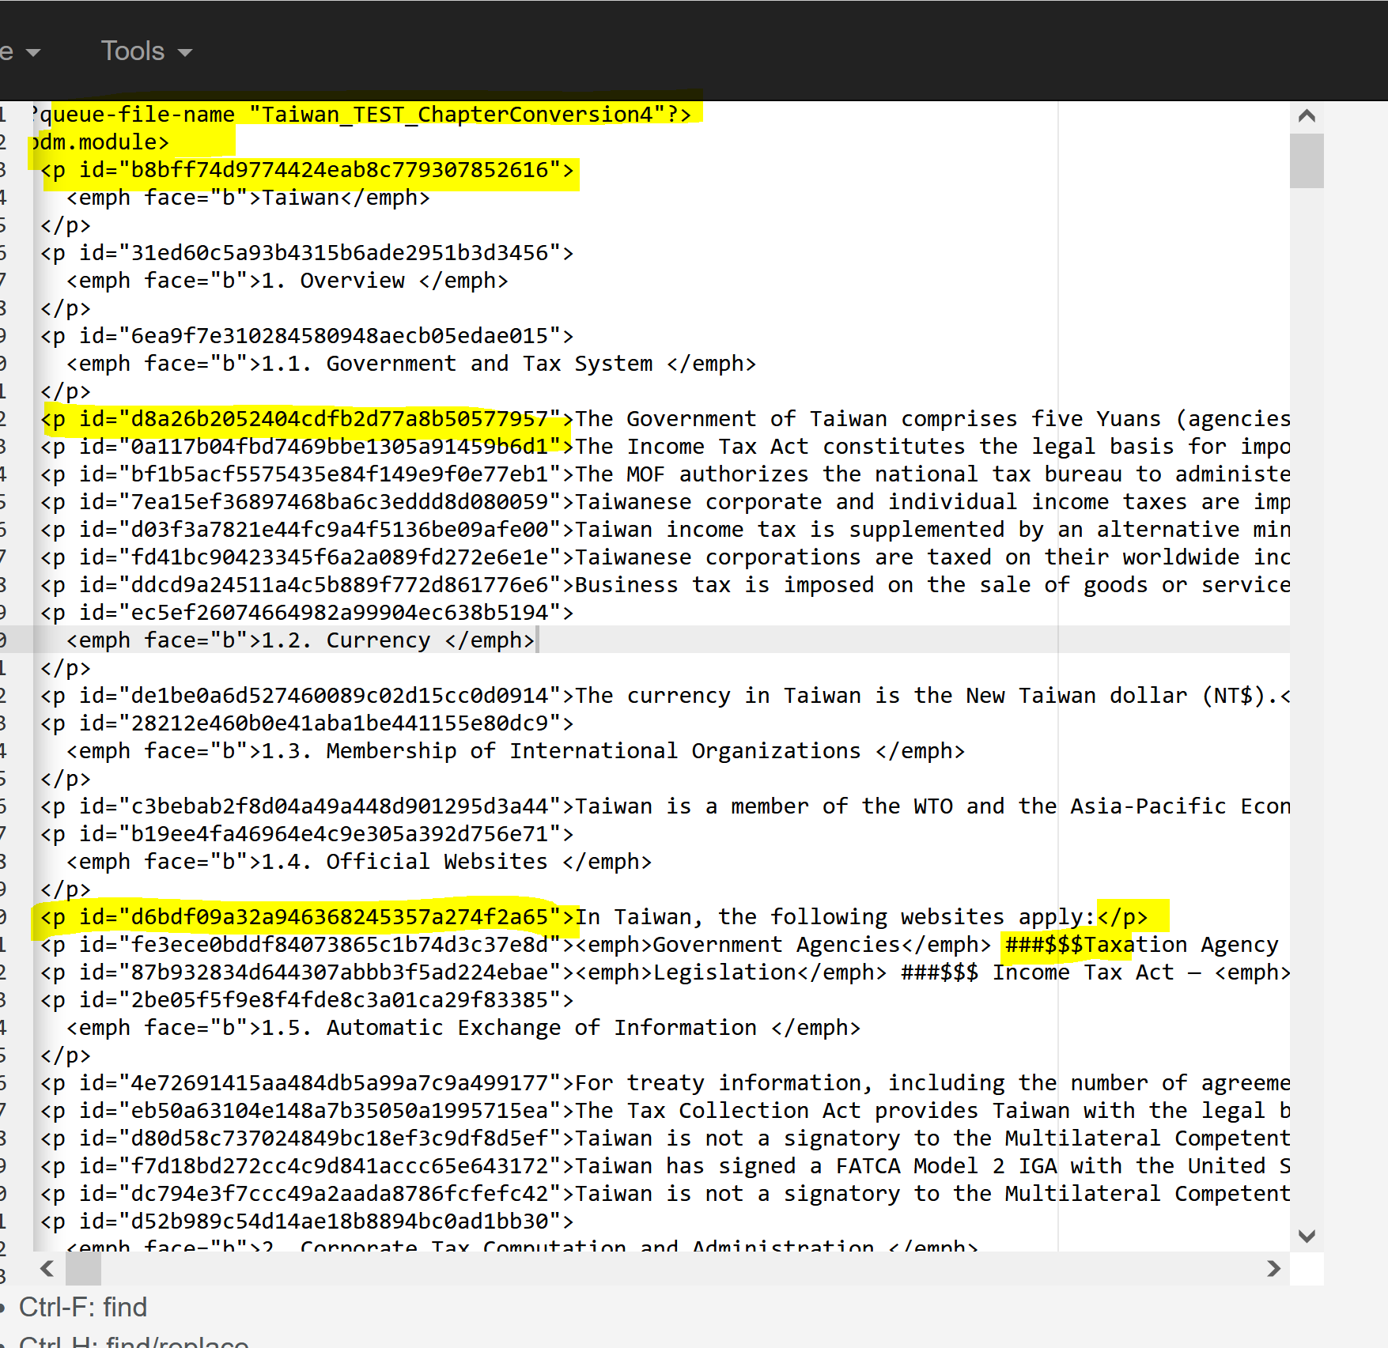

Press Control H to Find and Replace and key the characters below, this will change the <p tags with ID numbers to <para include.in.chart=”1”>
