PREX INSTRUCTIONS IN WORKPLACE (RICKY_TEST):

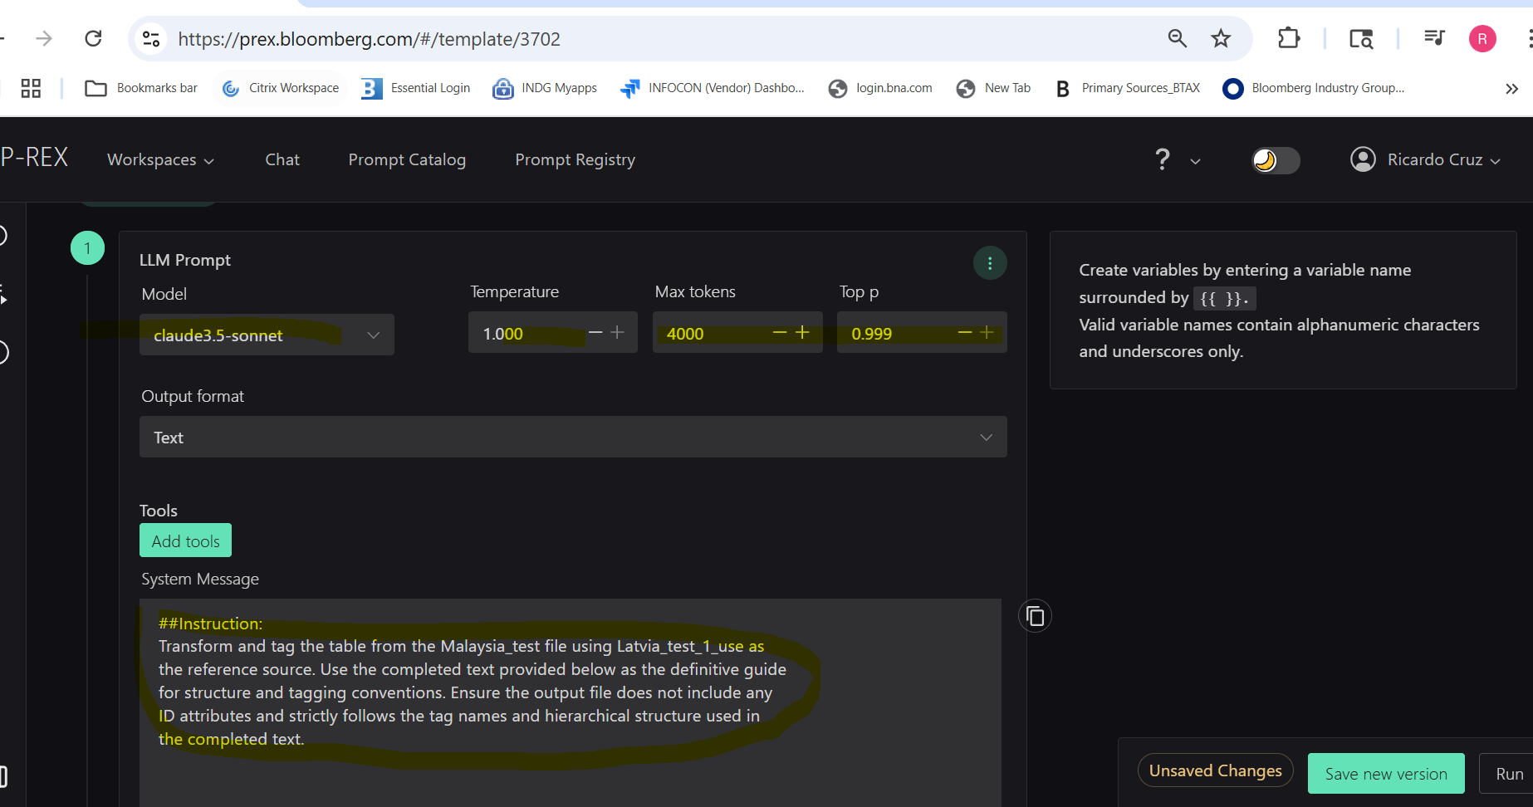

##Instruction:
Transform and tag the table from the Malaysia_test file using Latvia_test_1_use as the reference source. Use the completed text provided below as the definitive guide for structure and tagging conventions. Ensure the output file does not include any ID attributes and strictly follows the tag names and hierarchical structure used in the completed text.

PREX INSTRUCTIONS IN CHAT

Instruction: Convert the input test file (Jordan_test) into XML format using the content from Latvia_test_1_use as the data reference and adhering to the XML structure, tag naming conventions, and formatting rules specified in Latvia_XML_use. Ensure that all document ID attributes are omitted in the output.
Jordan_ test.
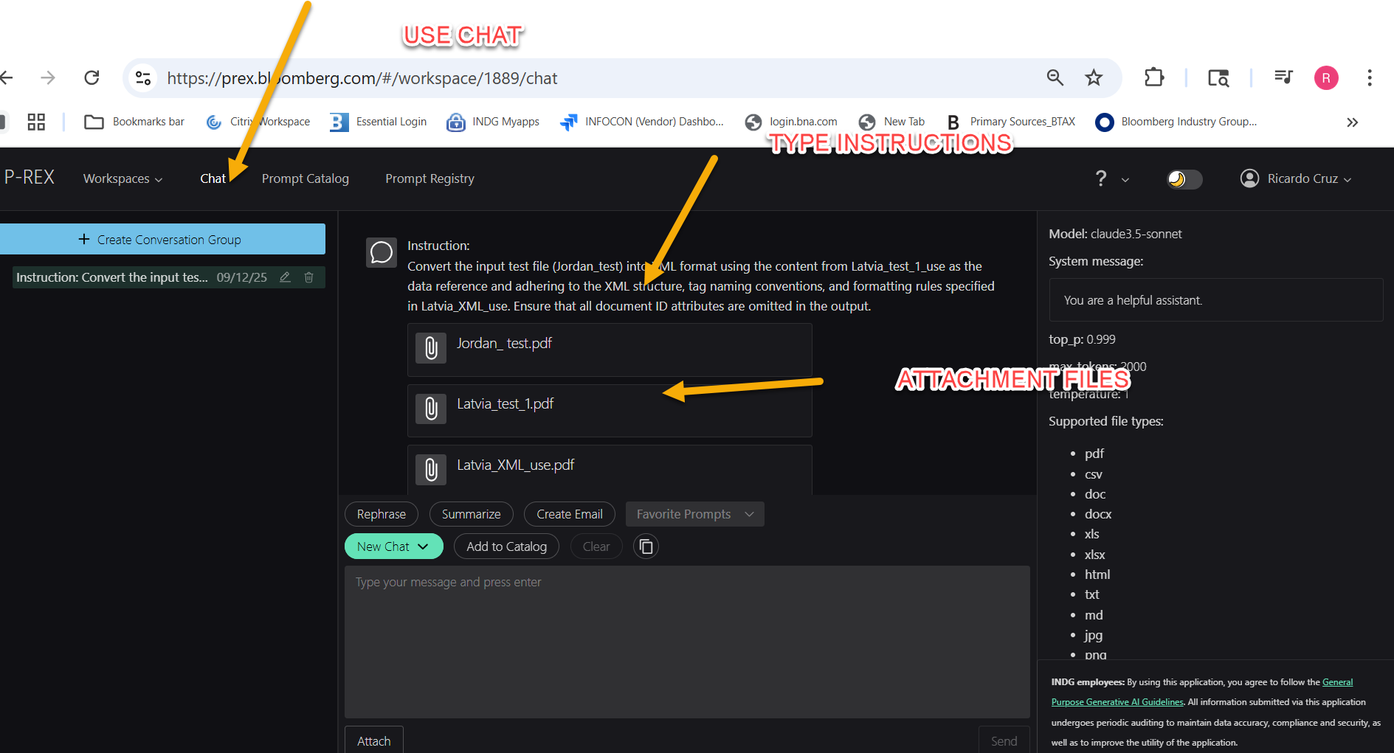

PREX RESPONSE:
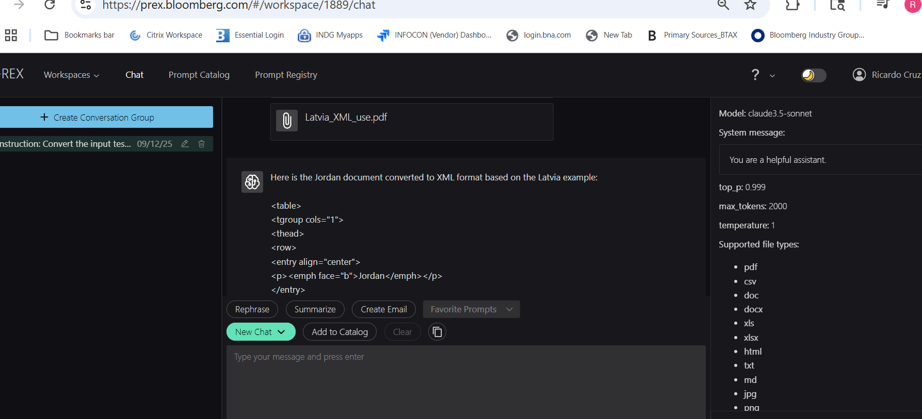

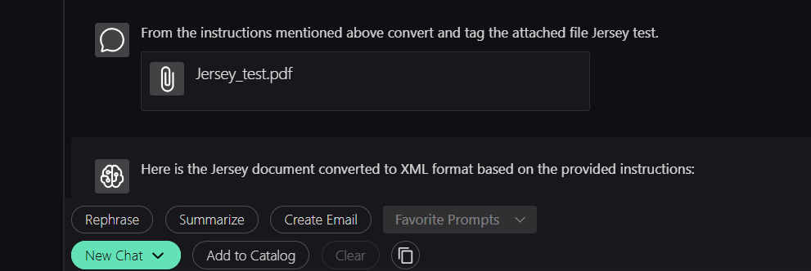

Note use: From the instructions mentioned above convert and tag the attached file Liechtenstein_test

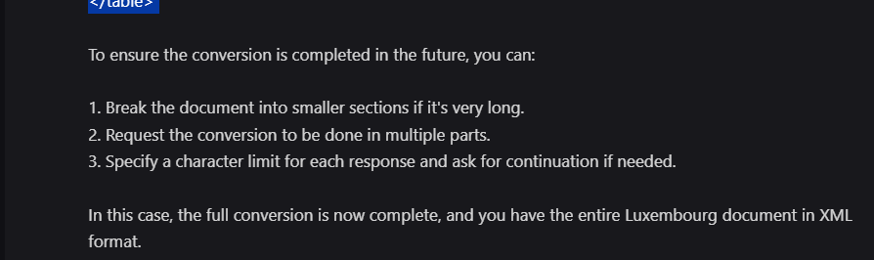

The optimal character limit can vary depending on the specific AI system being used, but a good general guideline is to aim for around 2,000 to 4,000 characters per response. This range typically ensures that: 1. The response is comprehensive enough to include a substantial amount of information. 2. It's not so long that it risks being cut off or incomplete. 3. It's easier to manage and review the output in manageable chunks. For very long documents like the Luxembourg example, you might want to request the conversion in multiple parts, each part staying within this 2,000 to 4,000 character range. This approach allows for a balance between completeness and manageability. If you're working with a system that has a known, specific character limit, it's best to stay about 10-20% below that limit to account for any potential overhead or formatting that might be included in the response. Remember, when dealing with long documents or complex conversions, it's always a good practice to review the output carefully and request any missing parts or clarifications as needed.

PREX STRUCTURE FOR WORKPLACE
<analysis> <related.to> <country country.code="LV">Latvia</country> </related.to> <name>Latvia</name> <content.group> <bna.id bna.id="1">1.</bna.id> <name>Country-by-Country Report</name> <content.group> <bna.id bna.id="1">1.1.</bna.id> <name>Law/Regulations</name> <para include.in.chart="1"> <cite.url ref="https://likumi.lv/ta/en/en/id/292196-regulations-regarding-country-by-country-report-of-multinational-enterprise-group">Cabinet Regulation No. 397</cite.url> </para> </content.group> <content.group> <bna.id bna.id="2">1.2.</bna.id> <name>Effective Date</name> <para include.in.chart="1">Fiscal years beginning on or after January 1, 2016.</para> </content.group> <content.group> <bna.id bna.id="3">1.3.</bna.id> <name>Filing Threshold</name> <para include.in.chart="1">In general, Latvian MNE groups with consolidated group revenue of €750 million or more in the preceding fiscal year.</para> </content.group> <content.group> <bna.id bna.id="4">1.4.</bna.id> <name>Local Filing</name> <para include.in.chart="1">A Latvian subsidiary may be required to file a CbC report if certain conditions are met.</para> </content.group> <!-- Additional content groups for other sections --> </content.group> <content.group> <bna.id bna.id="2">2.</bna.id> <name>Public Country-by-Country Report</name> <content.group> <bna.id bna.id="1">2.1.</bna.id> <name>Law/Regulations</name> <para include.in.chart="1"> <cite.url ref="https://www.vestnesis.lv/op/2023/187.1">Income and Income Tax Disclosure Act</cite.url> </para> </content.group> <content.group> <bna.id bna.id="2">2.2.</bna.id> <name>Effective Date</name> <para include.in.chart="1">Financial years beginning on or after June 22, 2024.</para> </content.group> <!-- Additional content groups for other sections --> </content.group> <!-- Additional content groups for Master File, Local File, etc. --> </analysis>

Instruction: Convert the input test file (Maldives__test) into XML format using the content from Latvia_test_1_use as the data reference and adhering to the XML structure, tag naming conventions, and formatting rules specified in Latvia_XML_use. Ensure that all document ID attributes are omitted in the output.

Please convert and tag the attached file Brazil_Table.docx, using Spain_table.docx as the source file and Spain_XML_test.docx as the output file reference. Do not include document IDs in the output. If the document is too long, split Brazil_Table.docx and the output into multiple parts to make the conversion possible. Specify the number of output files created and use the same tagging as Spain_XML_test.docx in the output file.

If any errors occur, please identify the source of the error and provide instructions on how to fix it.

