PDF Book Creation and Quality Assurance Process
Created by: Ravulapalli, Vijay
Last Modified: April 23, 2025

Purpose and Overview:
Every year, PDFs of updated books are created and provided to authors or companies who have allowed publication on the website. This PDF replaces the previous print edition and serves as an electronic or printable version without needing website access.

Task 1: Exporting Chapters from BWIP
- Identify the Book:
Determine the book to be processed using the Service Code (e.g., "EMP-Book" for Employment at Will).
- Search the Book:
In BWIP (Book Workflow and Information Portal), go to the TOC/Browse tab, enter the Service Code, and select "Browse BDMS."
- Export Chapters:
Use the "export to bpub prep word" option from the Actions dropdown to export each chapter individually as Word documents. Repeat this for all chapters.
- Fix Export Errors:
  - Tables nested inside paragraph tags <p> cause export failures—move tables outside these tags.
  - Nested long quotes inside other long quotes also cause errors—contact the author for help fixing these.
  - If files don’t open due to errors, fix them in BWIP before continuing.
- Save Files:
Place all chapter Word files in the "raw" folder located at \\wideaccess\bpub_arbortext\jade_data\data\ProductSupport\DataAdministration\Books\3. Source and Analysis\PDF Creation.

Task 2: Editing Individual Chapters
- Remove Book Summaries:
Delete any introductory summaries at the beginning of chapters.
- Correct Section Headings:
Fix section headings that are incorrectly placed inside summary tags and adjust their styles.
- Fix Footnotes in Summaries:
Move footnotes from summary blocks to appropriate paragraphs, such as the author name line.
If footnote markers appear as "0" instead of "", change the numbering format to special characters and restart at "".
- Change Case Names from Green to Black:
Use Word’s Advanced Find & Replace to change text color without affecting other colored text.
- Identify and Insert Images and Tables:
  - Look for yellow-highlighted text signaling images/tables in Word.
  - For tables, if text like "****" is inside a single-row table, move and center it outside the table with underlining as needed.
  - Find images by checking SGML filenames in BWIP or the image inventory file. If unclear, create images from the product as a last resort (lower quality).
  - Review highlighted tables in the exported files against the product version, then remove the "Table: please review" note.
- Fix Footnotes in Titles:
Footnotes sometimes convert to plain text instead of proper footnotes. Remove such text and insert footnotes correctly using Word’s References tab and setting the correct footnote number.
- Remove Empty Paragraphs:
Empty paragraphs often occur around long quotes; delete these to clean up the document.
- Create Chapter TOC:
Insert a Table of Contents in each chapter using the macro “Insert Toc (aba pdf)” from the Books tab.
- Correct Formatting Issues:
  - Fix jumbled or misspelled text and broken paragraphs.
  - Correct problems with nested lists for proper indentation and display.
- Special Instruction for Elkouri & Elkouri Book:
Convert all footnotes to endnotes using Word’s Footnote & Endnote dialog options.

Task 3: Merging Chapters and Finalizing the Book
- Use Templates:
Use the provided Word templates for merging ABA or APIL books located at W:\Books\12. Training\PDF Creation\templates.
- Create Cover Page:
Based on editor instructions (found in Jira tickets), create a cover page Word document.
- Combine Chapters:
Merge all chapters into a single document, inserting section breaks ("Next Page") between chapters to restart footnote numbering.
- Ensure Chapters Start on Even Pages:
Insert page breaks if chapters start on odd pages to maintain consistency.
- Add Headers and Footers:
  - Page numbers on the left side of the header.
  - Copyright info centered in the footer.
  - No headers or footers on cover, copyright, or TOC pages.
  - Front matter pages use lowercase Roman numerals; chapters use Arabic numerals.
  - Use section breaks to apply different numbering styles in different parts of the document.
- Update Table of Contents:
  - The template contains a TOC page ("Summary Table of Contents"). Update it by right-clicking and choosing “update entire table.”
  - Update all chapter-level TOCs using the macro “Books_UpdateTOCs_All.”
- Convert to PDF:
Export the final Word document to PDF.
- Lock the PDF:
Apply editing restrictions to the PDF.
- Upload and Notify:
Upload the locked PDF to the OneDrive folder The Bureau of National Affairs, Inc\Book PDFs and notify editors through the Jira ticket.

Special Instructions: Applying Macros
- To apply macros like “Books_UpdateTOCs_All” across all documents:
  - Add the macro to Word’s Quick Access Toolbar via File > Options > Quick Access Toolbar > Macros.
  - Set it to be available for all documents (default).
  - The macro button will then appear in the Word toolbar for easy use.

Quality Assurance (QA) Steps
- Confirm cover page includes correct title and author info.
- Verify copyright page contains correct year and ISBN as per Jira ticket.
- The third page must be the summary TOC with accurate page numbers.
- Case names must be black, not green.
- All chapters should begin on even-numbered pages.
- Ensure no section headings are left dangling at the bottom of pages.
- Each chapter must have a TOC on its first page.
CHECKLIST:
PDF Book Creation Checklist

Task 1: Export Chapters from BWIP
- Identify book Service Code for the book to process
- Open BWIP → TOC/Browse tab
- Enter Service Code and click "Browse BDMS"
- Export each chapter using "export to bpub prep word" option
- Check for export errors:
  - Tables inside <p> tags? Move tables outside tags
  - Nested long quotes? Contact support for fix
- Save all exported chapter Word files in ...Books\3. Source and Analysis\PDF Creation\raw folder

Task 2: Edit Individual Chapters
- Remove chapter summaries (if any)
- Fix misplaced section headings and update styles
- Move footnotes from summaries to appropriate paragraphs
- Fix footnote marker if showing "0" instead of "*"
- Change case names font color from green to black using Word’s advanced find/replace
- Identify images and tables:
  - Look for yellow-highlighted text (indicates images/tables)
  - Move "****" or "*****" text outside single-row tables, center and underline as needed
  - Locate images using SGML file or image inventory file
  - If image names unclear, create images from the product (last resort)
  - Review tables flagged with "Table: please review" against product version and remove flags
- Fix footnotes that appear as plain text in headings:
  - Remove footnote text from heading
  - Insert footnotes properly using Word References tab and set correct footnote number
- Remove empty paragraphs around long quotes
- Insert Table of Contents in the chapter using macro “Insert Toc (aba pdf)”
- Correct formatting issues:
  - Jumbled text
  - Nested list indentations
  - Broken paragraphs
- Special for Elkouri & Elkouri: Convert all footnotes to endnotes

Task 3: Merge Chapters & Finalize Book
- Use appropriate Word template (ABA or APIL) for book
- Create cover page per editor instructions in Jira ticket
- Combine chapters into single document inserting section breaks ("Next Page") between chapters
- Ensure each chapter starts on an EVEN page (insert page breaks as needed)
- Add page numbers on left header:
  - Lowercase Roman numerals for front matter
  - Arabic numerals for chapters
- Insert copyright info centered in footer
- Remove headers/footers on cover, copyright, and TOC pages
- Update main TOC by right-click → update entire table
- Update all chapter TOCs using macro “Books_UpdateTOCs_All”
- Convert final Word document to PDF
- Lock PDF to restrict editing
- Upload locked PDF to OneDrive → The Bureau of National Affairs, Inc\Book PDFs
- Notify editors in Jira ticket

Macro Setup
- Add macros (e.g., “Books_UpdateTOCs_All”) to Quick Access Toolbar:
  - File > Options > Quick Access Toolbar > Choose Commands From: Macros
  - Add macro and set for all documents (default)
  - Confirm macro appears on Word toolbar

Quality Assurance (QA) Checklist
- Cover page contains correct title and author information
- Copyright page contains correct year and ISBN matching Jira ticket
- Third page contains “Summary Table of Contents” with correct page numbers
- Case names font color is black (not green)
- All chapters start on EVEN page numbers
- No dangling section headings at the bottom of any page
- Each chapter contains a TOC on its first page

Templates

Cover Page Template
- Title of Book: ___________________________
- Author(s): ______________________________
- Editor(s): ______________________________
- Edition/Year: ___________________________
- Copyright Year: _________________________
- ISBN: _________________________________

Section Break Insertion (For Merging Chapters)
- Place cursor at the end of a chapter
- Go to Layout → Breaks → Section Breaks → Next Page
- Repeat for each chapter
- Confirm footnote numbering restarts for each chapter

Page Numbering Setup
- For front matter pages:
  - Insert → Page Number → Bottom of Page (choose style)
  - Format page numbers → Number format: Roman (i, ii, iii)
  - Start at: i
- For main chapters:
  - Insert → Page Number → Bottom of Page
  - Format page numbers → Number format: Arabic (1, 2, 3)
  - Start at: 1
- Ensure sections are separated by section breaks and unlink “Link to Previous” if needed

MACROS IN THE TEMPLATE
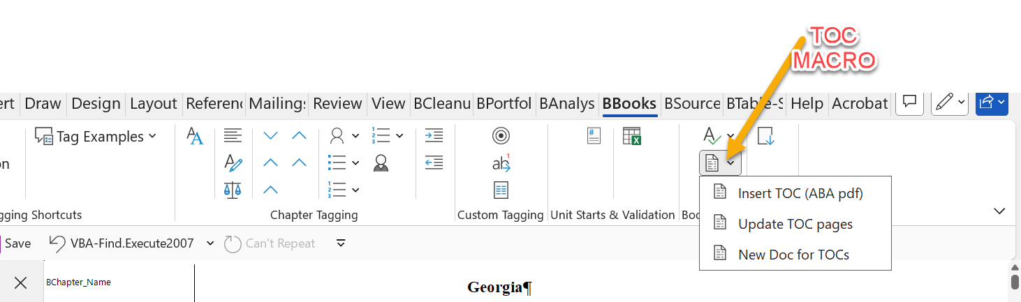

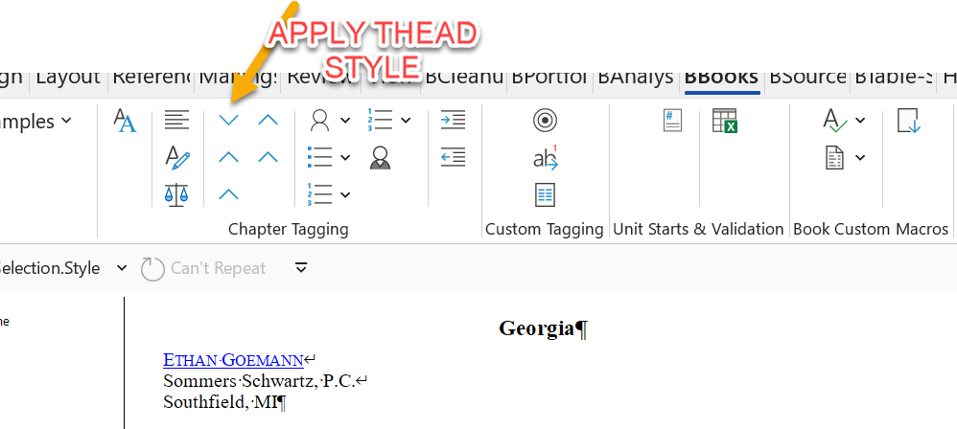

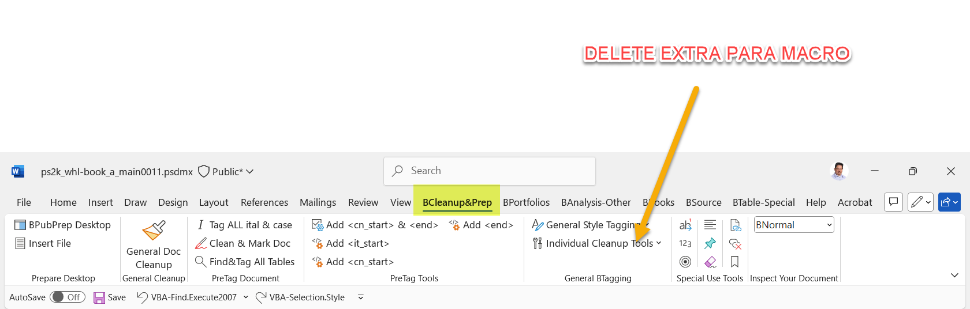

Getting rid of case name tagging

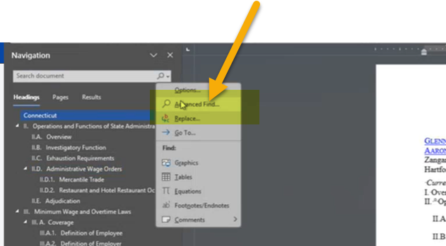

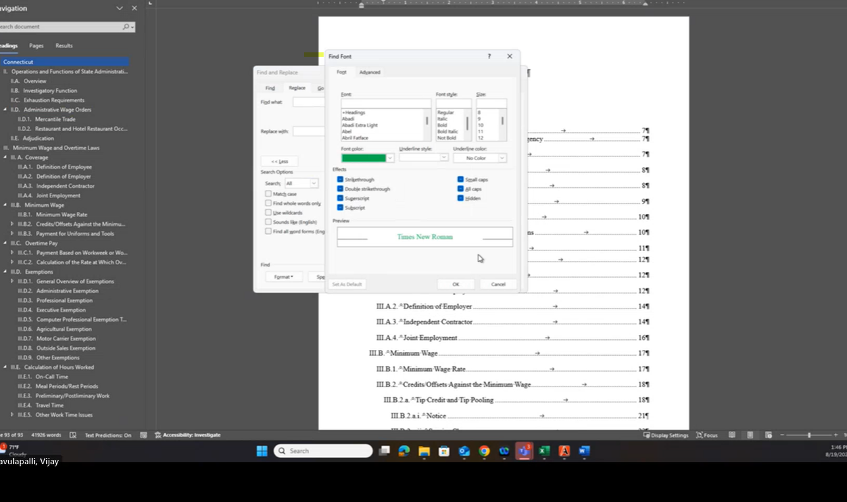

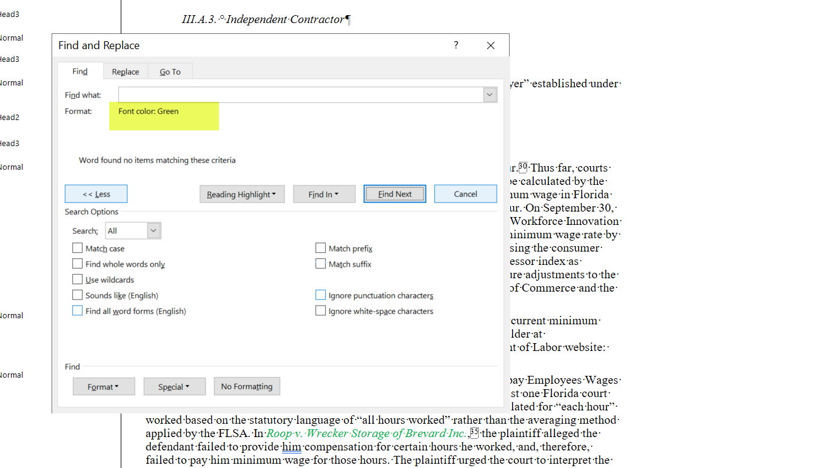

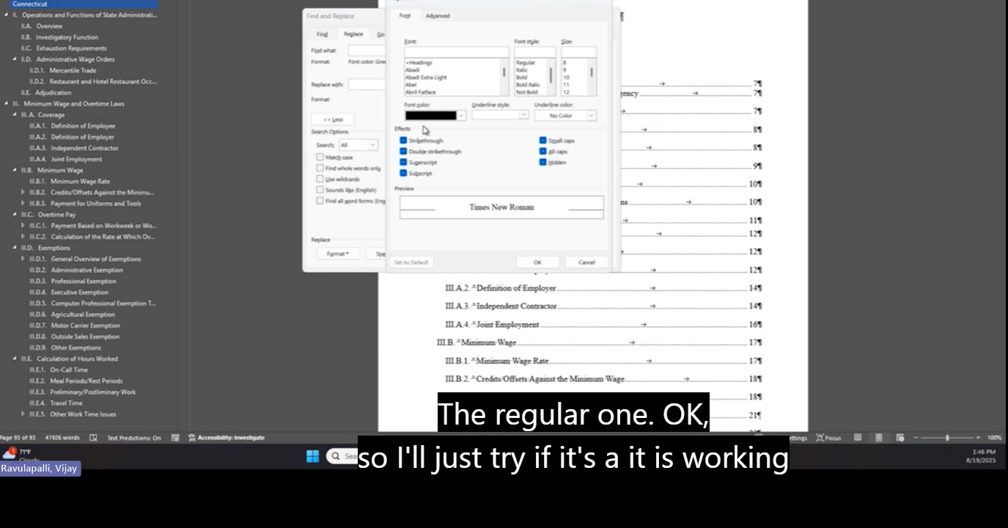

To Increse level of indents to bullet list use:
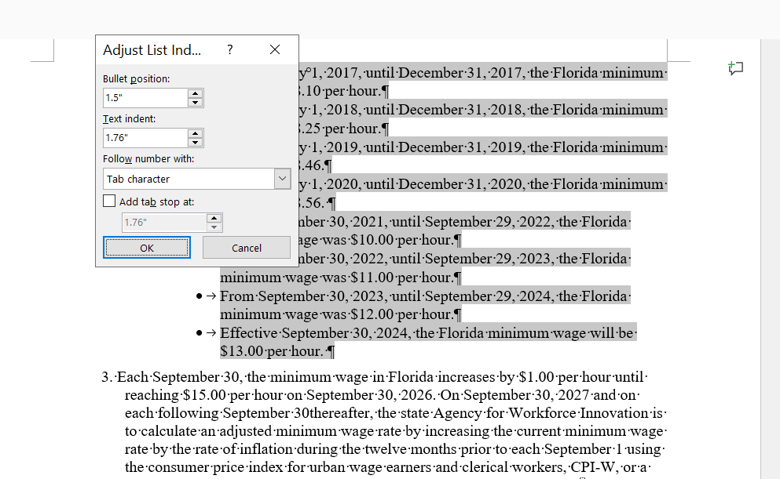

To increase level of Numbered or Lettered list us the Tab key

Show footnotes:
Reference>footnotes>Show footnotes: 