PG Tickets with questions:
Title with timeline but there is no title change do we change it
https://jira.bna.com/browse/ECO-249191 -Prod ticket
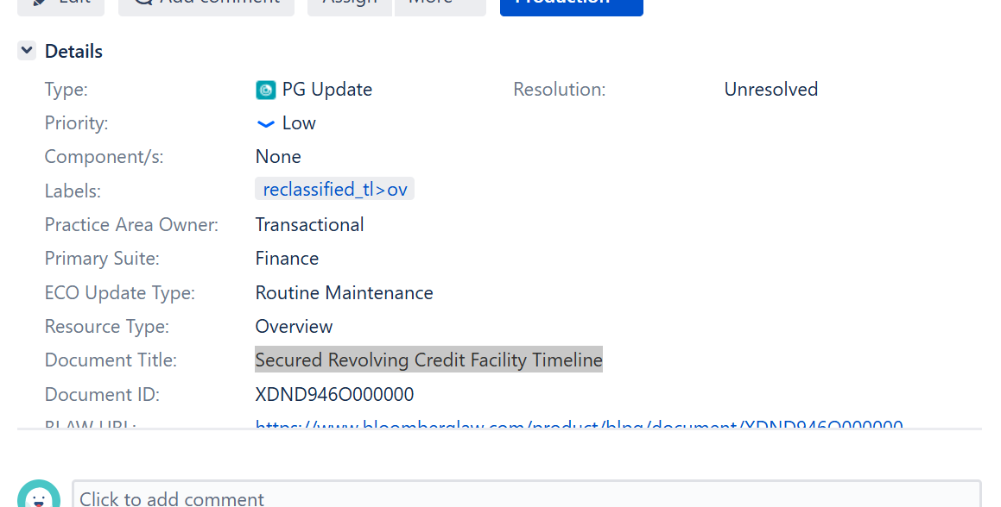

Annotated in the title but there is no title change do we get rid of the (Annotated)
Do we need to change the title in the ex-paywall ticket if it’s different from the Reclassification ticket
https://jira.bna.com/browse/ECO-187202 ex-paywall ticket
https://jira.bna.com/browse/ECO-249470- AutoComplete ticket

In instances where there are differences in the title in the tickets, copy title from Reclassify tickets. Leave titles that have Timeline on it as is if there is no title change.

*****************Title not showing in Anthology*************************
https://jira.bna.com/browse/ECO-249195
