Mapping to I: Instructions
In Citrix open Standard Desktop then:

- Open file Explorer
- Right click on the mouse (this PC)
- Select “Map network drive”
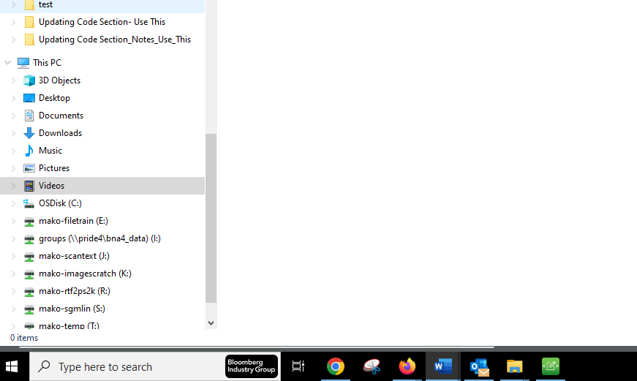

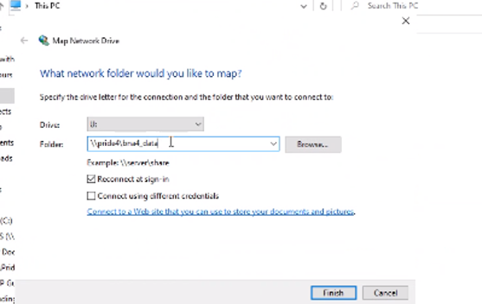
5. On Folder type
\\pride4\bna4_data\GROUPS\Tax&Accounting\Operations\
Production\Books\Federal\Tax Prep Guide
4. On Drive type
I:

