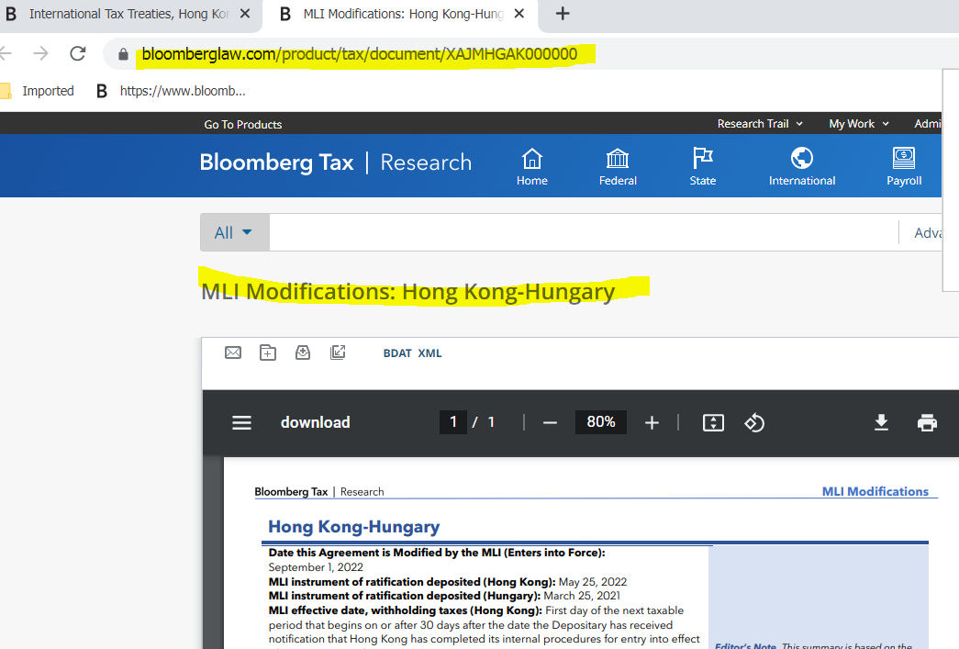

- Load file to BDMS to obtain bdms id
Use this sample for Document Title: MLI Modifications: Austria-Bulgaria
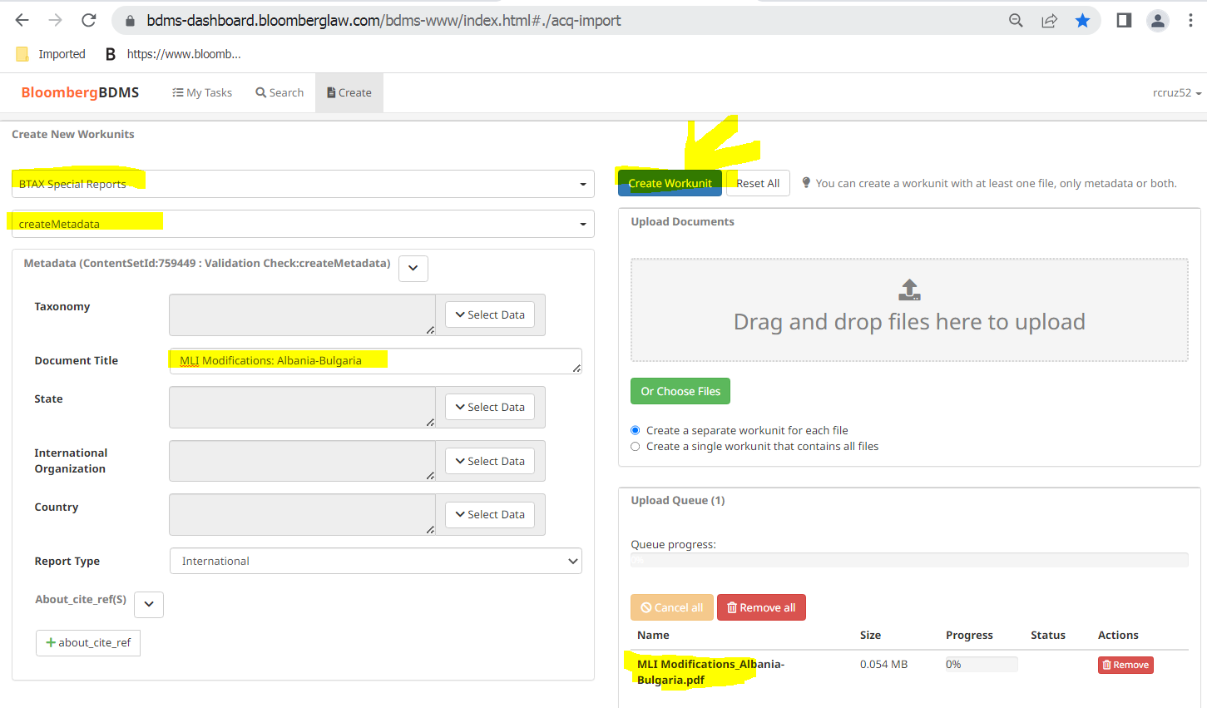

- Search using the bdms id
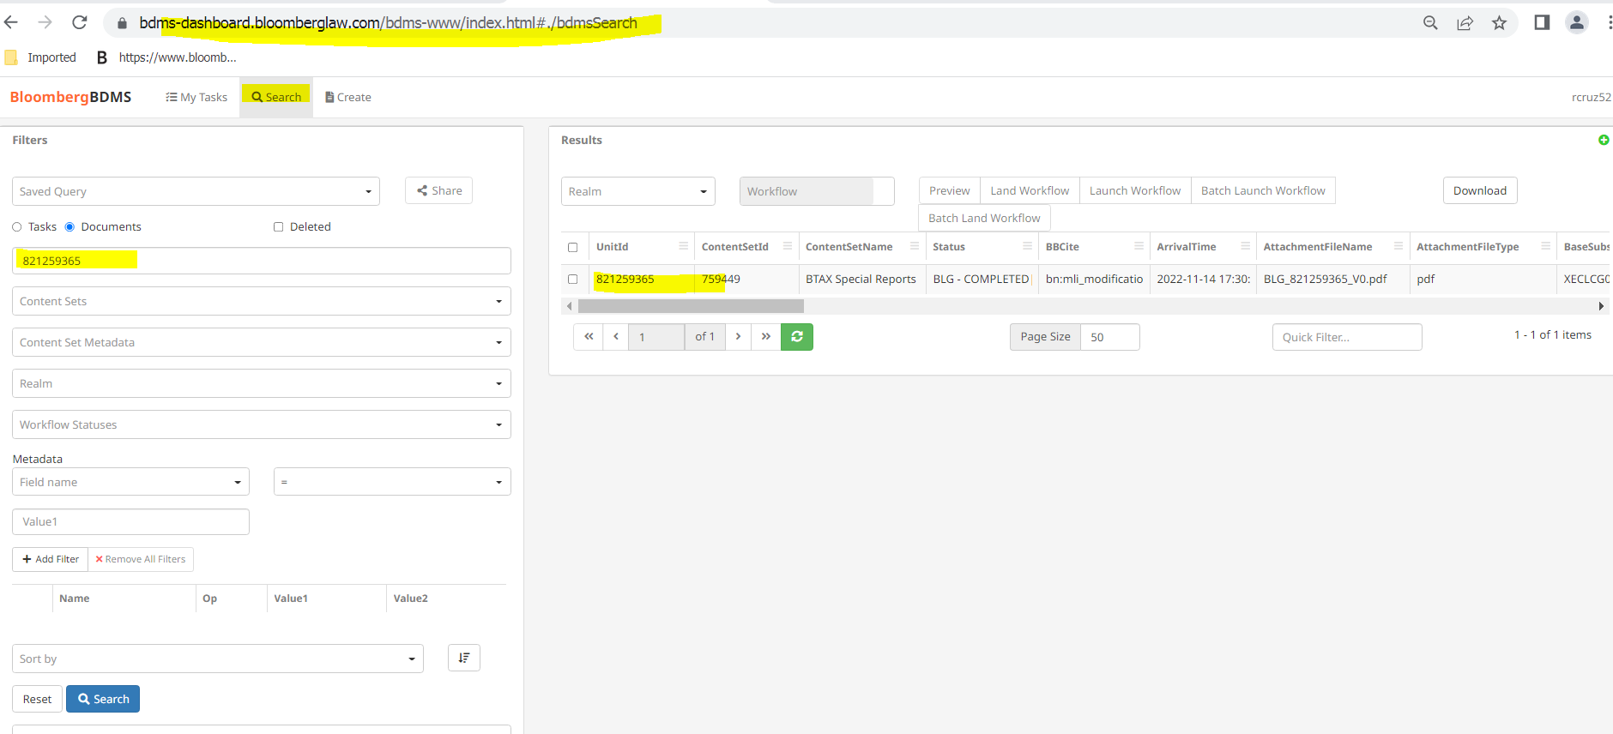

3. Use the BBLS id for the link
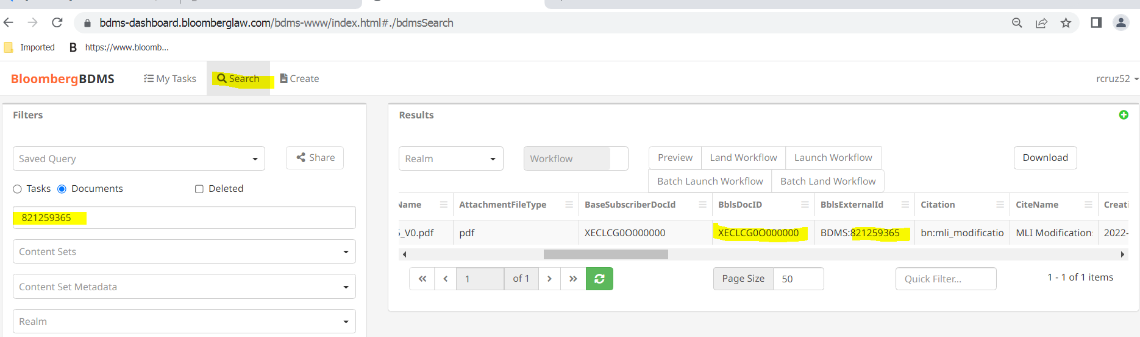

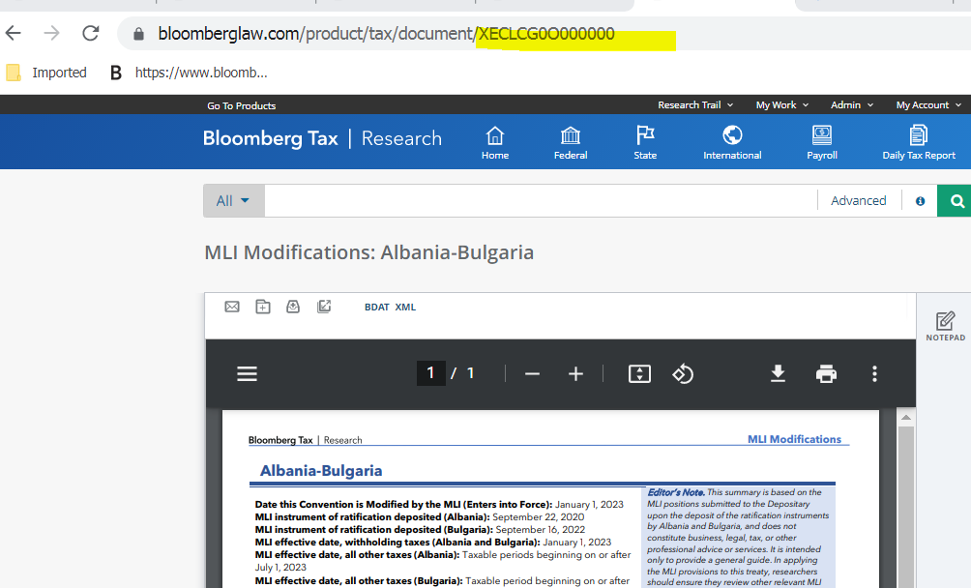

TO SEARCH FOR MLI FILES

- 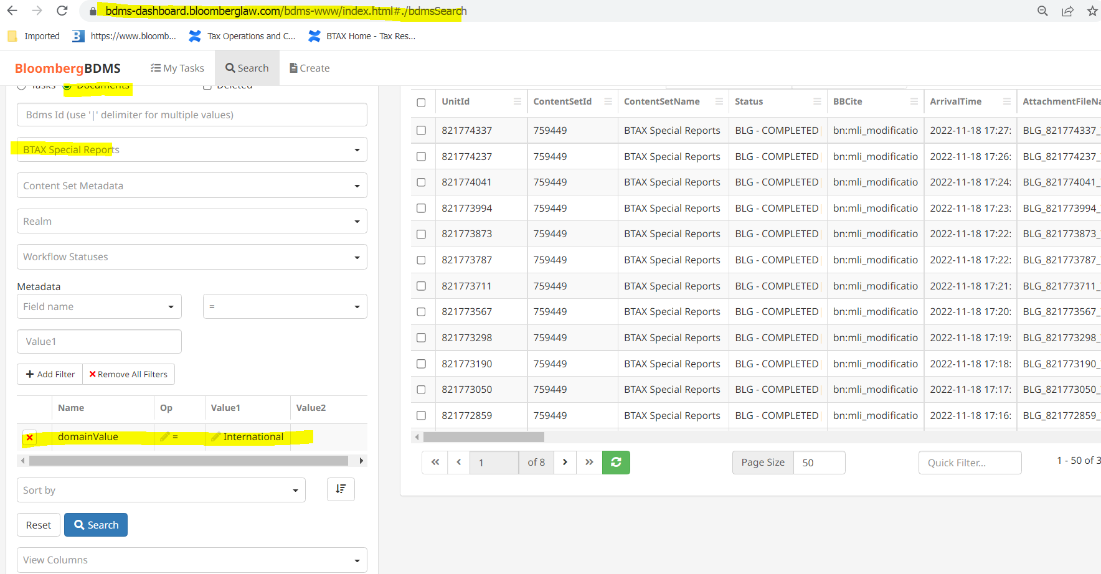

Or

2.
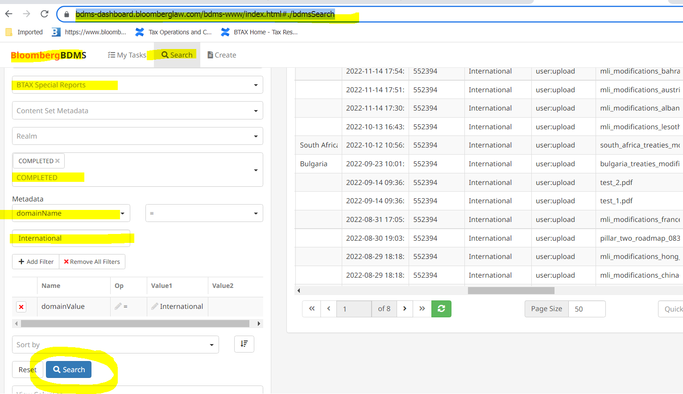

Inserting BBLS Ids to MLI files in BWIP

Go to BWIP and from the search in BDMS copy BBLs id to individual files in BWIP:

- 

 