Revised MLI Instructions for Infocon
Summary

- Send to Infocon:
- MLI Box Word files (retrieve files in I:\Analysis & Content\International\MLI\MLI Treaty Notes for CTAs)

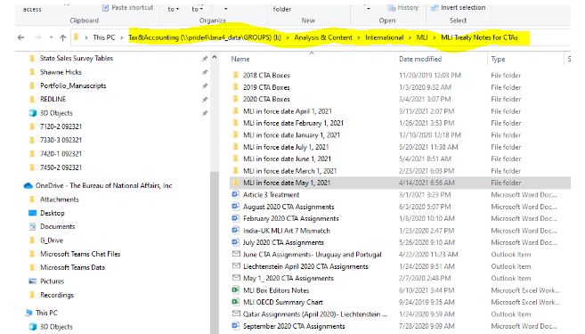

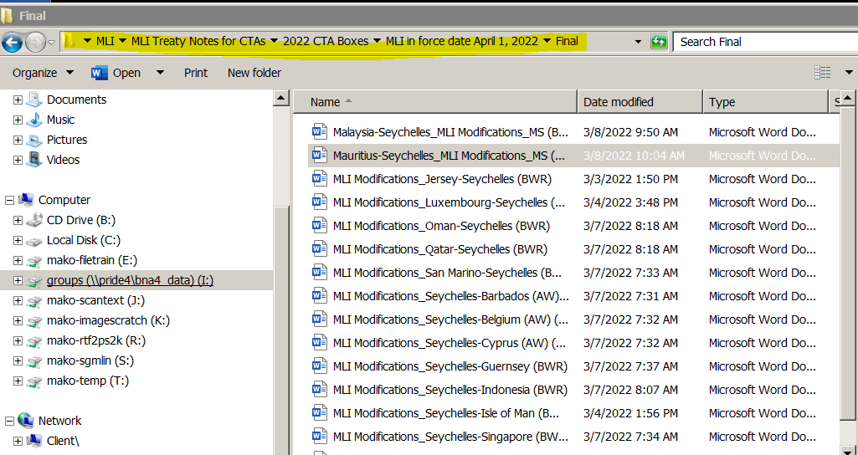

- SGML files to insert the MLI Boxes, Editors Notes and URLS (SGML files are exported from BWIP)

List of files to be checked out are in:

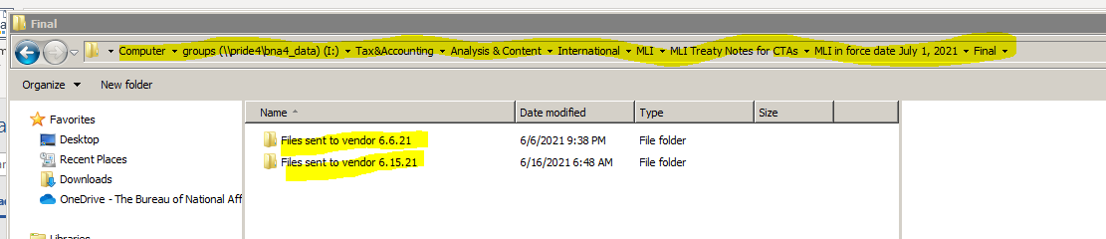

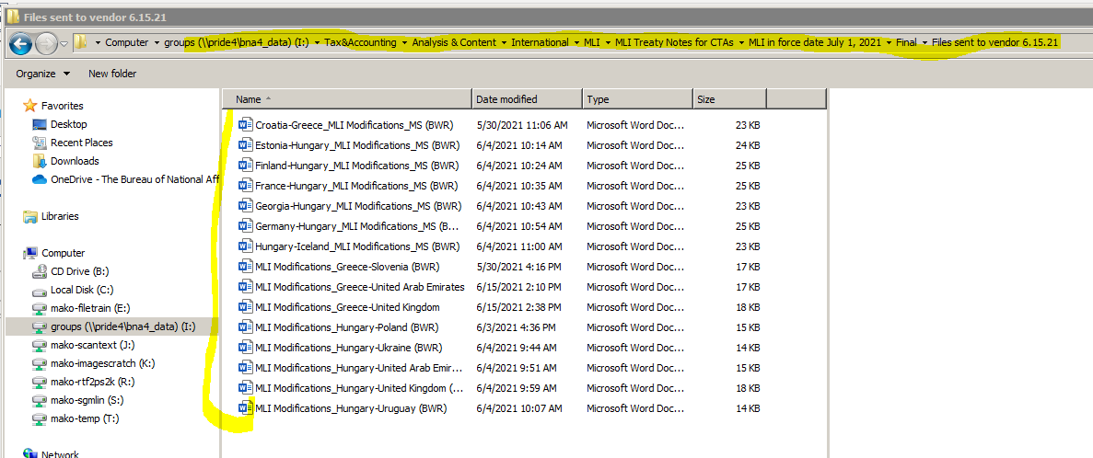

Or

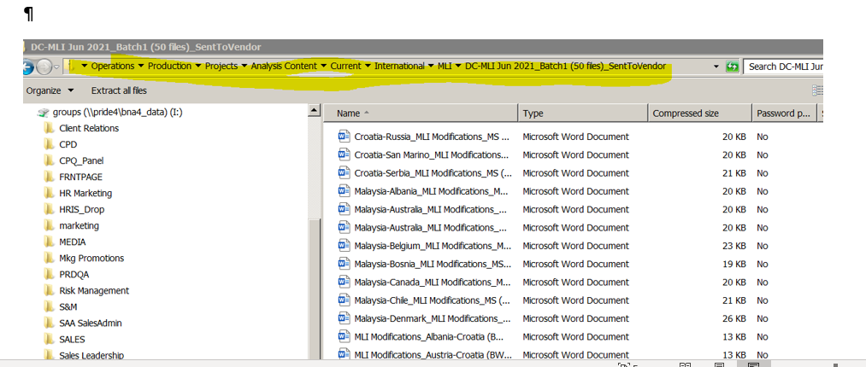

To get the filename Country abbreviation/filename go to the Excel sheet and click on the link which goes to BTAX then go to BDAT then citation

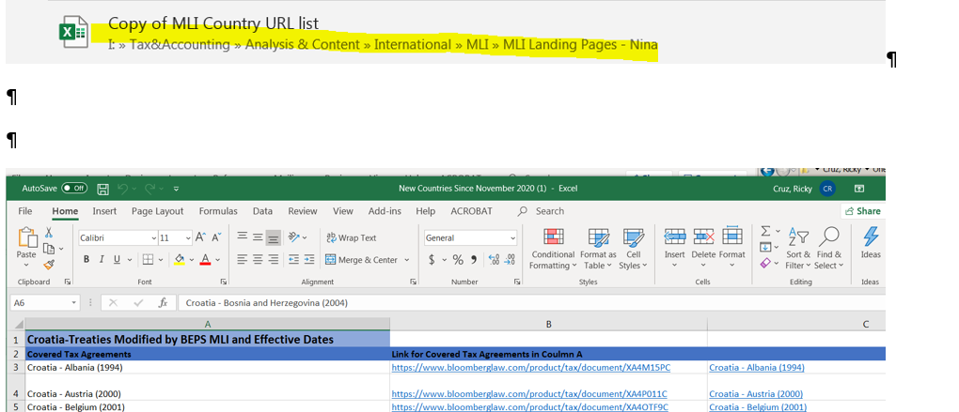

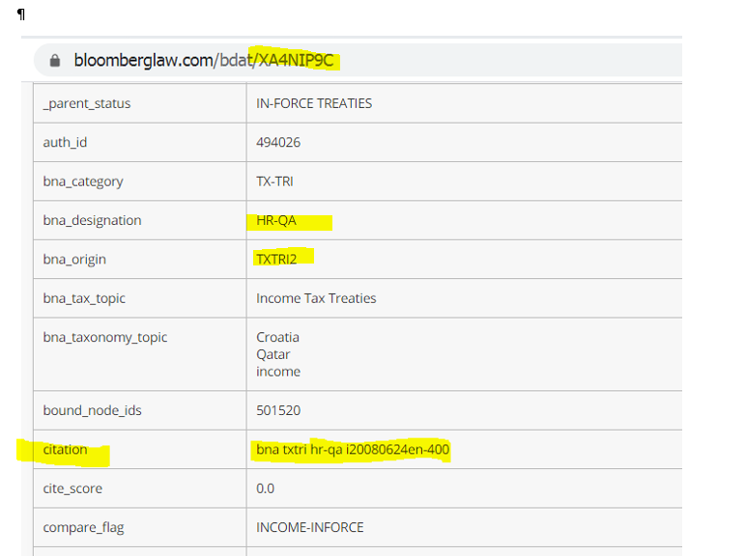

Search for files in BWIP using either the class code (gives multiple files)

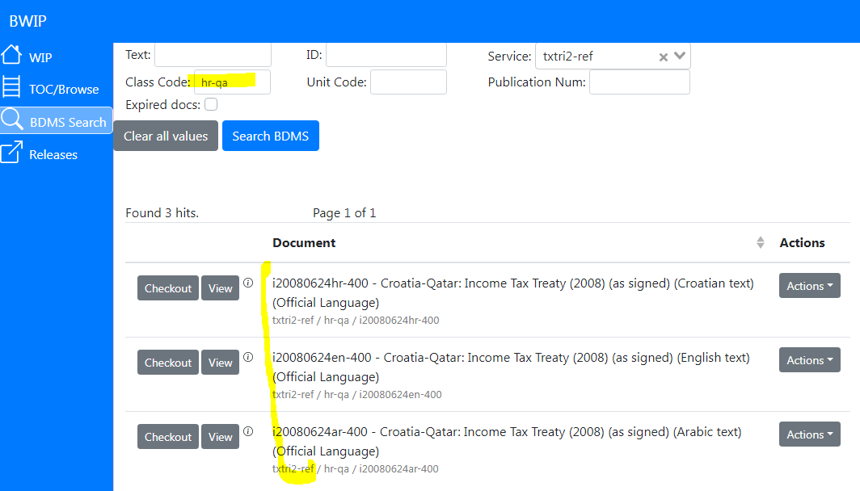

or the unit code (gives the exact file)

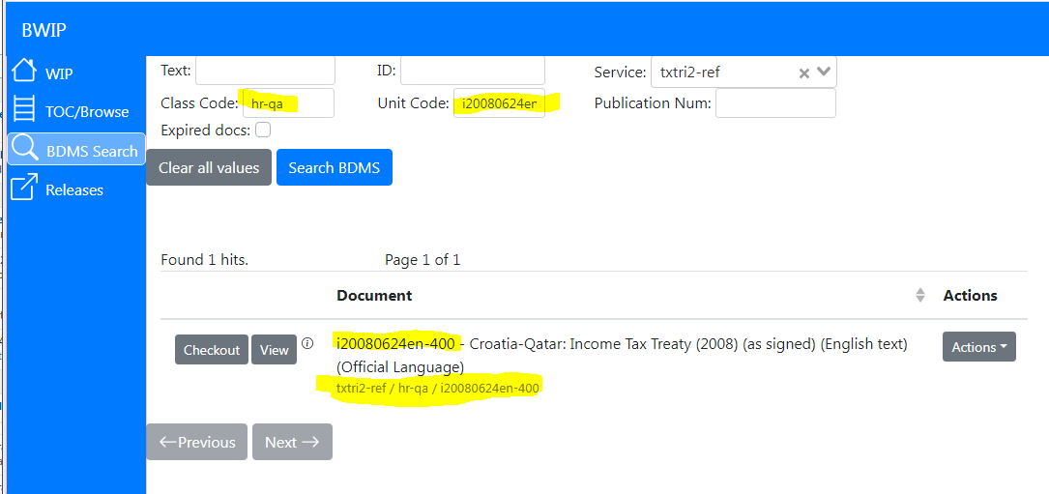

c. Excel file containing the URLS.

Copy url from Excel sheet

