Revised MLI BOX Workflow

Send Word files to Infocon to convert to formatted Word & SGML files (Make sure to rename the files using the naming convention below:

Pls. use the revised instructions below in processing the MLI SGML snippets going forward.

The new naming convention:
"bn:mli_modifications_1st country name-2nd country name"
example:
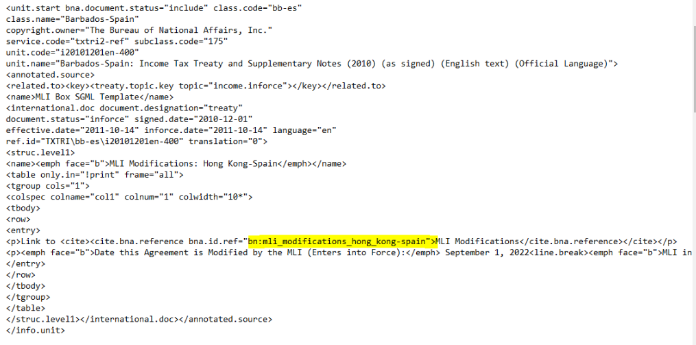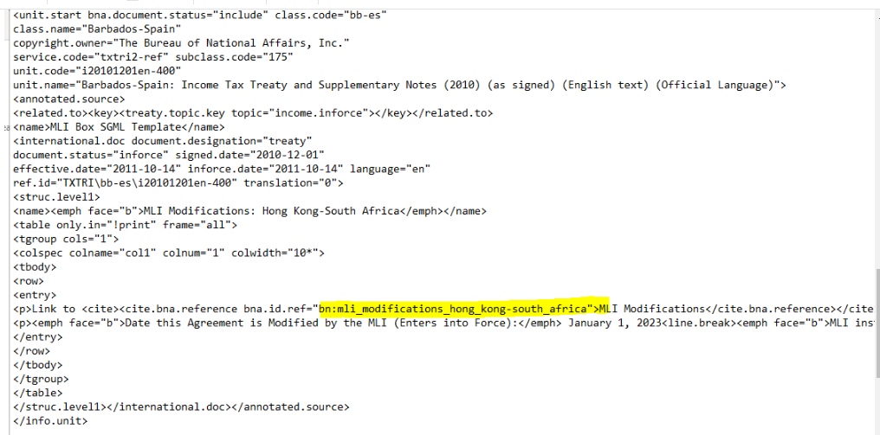

NOTE:
1. Country names should be in lower case
2. Underscore ( _ ) should be used in place of spaces between words
3. Dash should only appear between the 2 country names:
ex. romania-spain, thailand-russia, bulgaria-russia
4. Undescore ( _ ) should be used instead of dash (-) on country names
ex. 1. south-africa should be south_africa
2. hong-kong should be hong_kong
3. south-korea should be south_korea
5. There should also be no extraneous blank spaces between words, dashes, or underscores.
6. Going forward this naming convention should be used for the cite reference tag id refs in the sgml files. Any deviation from the naming convention will cause the link to fail.

- Copy returned documents from Infocon to respective folders in the I drive

- Insert SGML files to checked out files from BWIP

- Post files in BWIP to publish in BTAX.

Sample XML table inside XML file in Oxygen(Note: linebreak tag =<line.break/>:
