Steps to replace MLI PDF under the NEW workflow
- Rename filename using citation format (Analysts should be informed to follow this requirement to name future MLI PDF files)
-Example. from Bulgaria-India_MLI Modifications_MS(BWR).docx to mli_modifications_bulgaria-india_ms_(bwr).docx

- Log in to BDMS (Prod): https://bbe.bloomberg.com and click on the “Search” Tab
- Click on the hamburger sign to select “Acquisition”, “ACQ-Create Workunits:

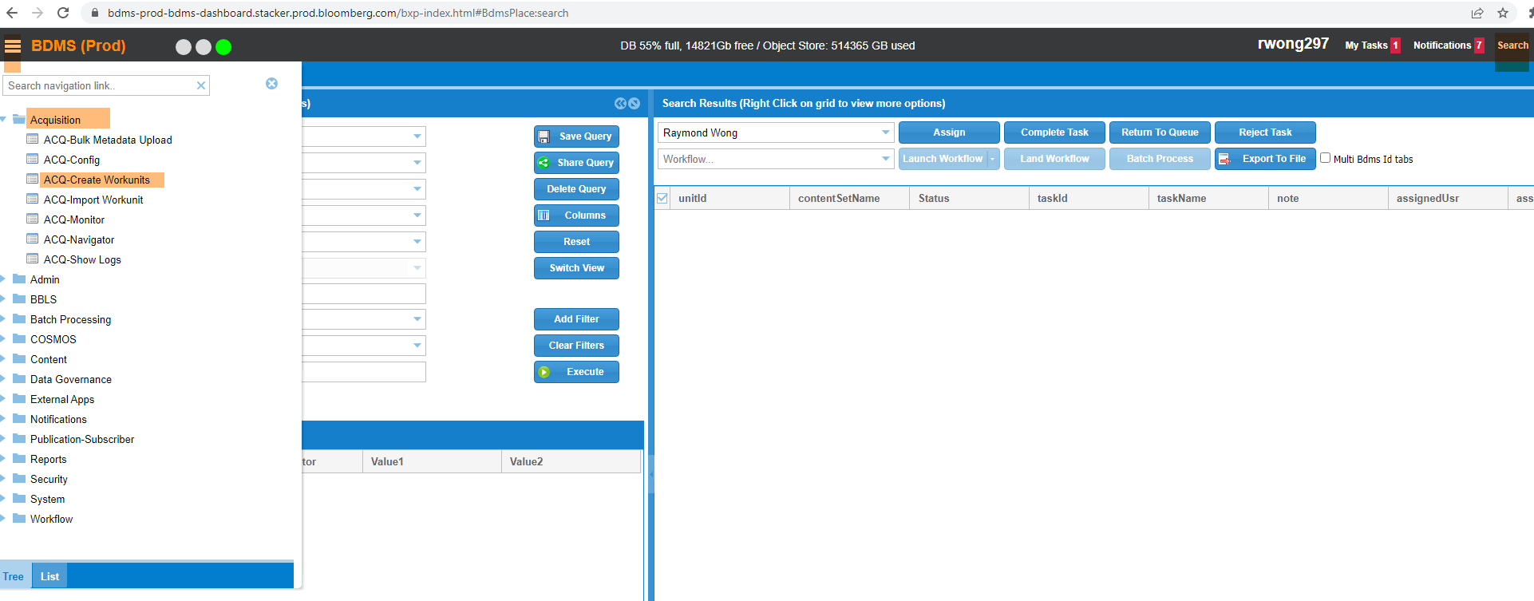
- Under “Create New Workunits”
-type in “BTAX Special Reports” on “Select Content Set (Required)”
-select “metaEdit” on “Select Metadata Group” pull down menu:
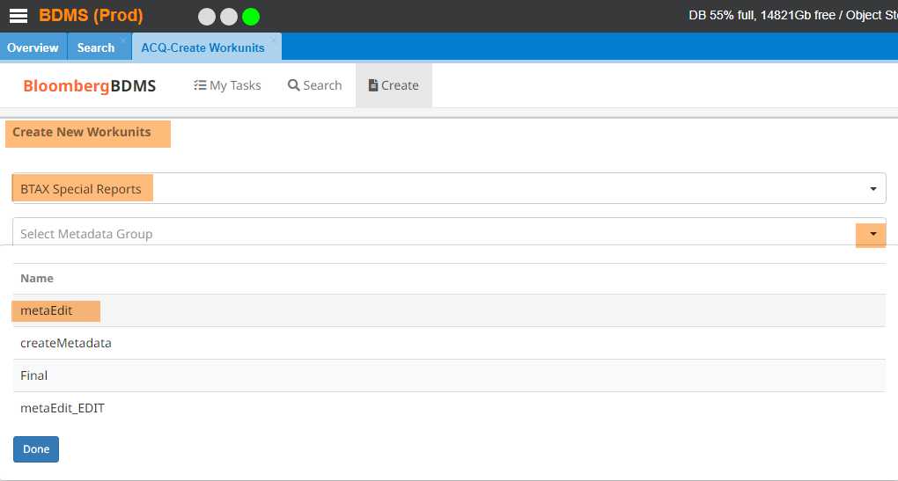

- When the “Create New Workunits” dialogue box appears (send the files to your personal email Login to Microsoft Outlook Username: rcuz@bna.com then login using company username and Password ex. rc3974 pw Bianca-5XX and load each pdf individually (do not drop & drag or as batch as this attaches a file with 0 size or empty):

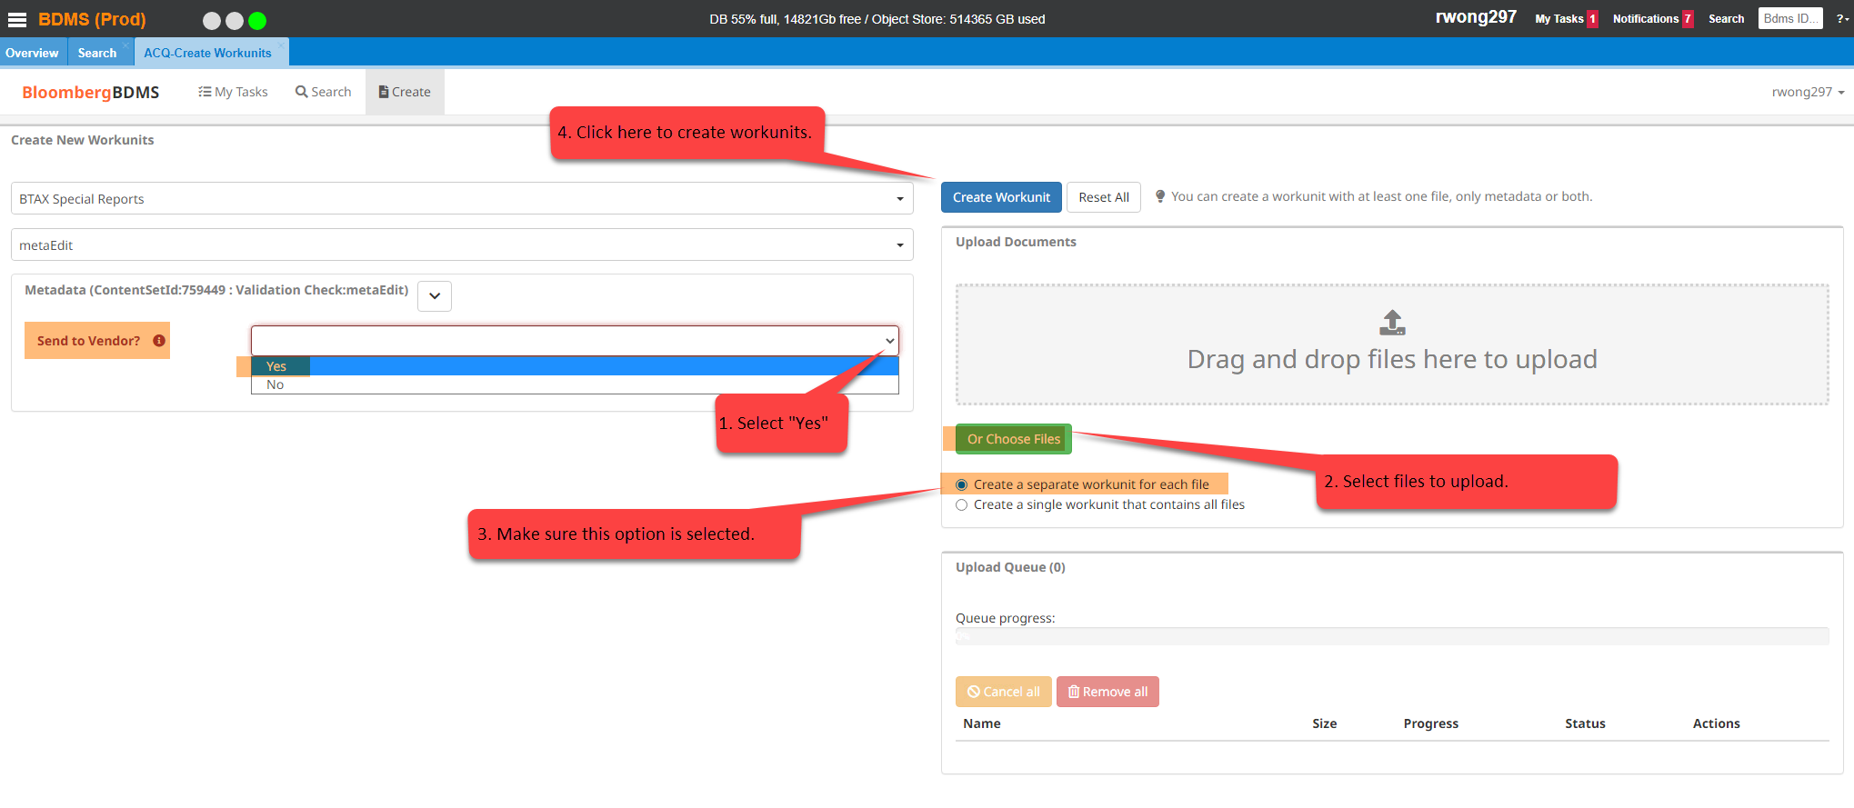
- BDMS receives PDF files and generates work unitIds
- BDMS starts vendor task
- Infocon converts Word file to MLI box Word layout and save it in PDF format (Infocon will return this PDF to BDMS for publishing- (automatically but mention in JIRA ticket) (generated automatically when Pdfs are loaded to BDMS by TPQA – step 5).
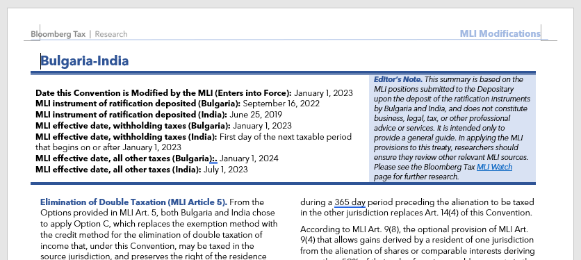11

- Infocon creates SGML snippet with link to PDF filename (in citation format):
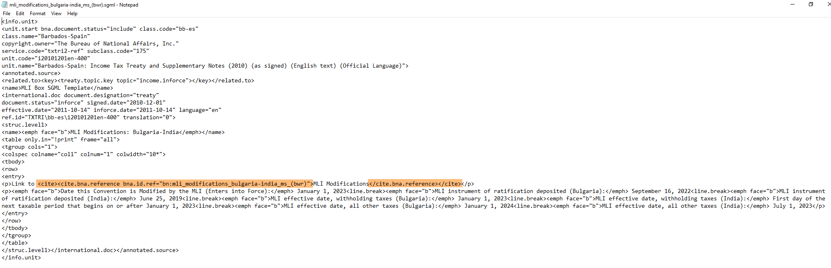
GD will SFTP this SGML snippet to BBNASCRIPTS@bfm1-sftp.bloomberg.com. (generated automatically when Pdfs are loaded to BDMS by TPQA- Step 5)
- Use the SGML snippet to replace the corresponding SGML file in BWIP.
- Release the SGML file in BWIP.
- BDMs will then update the record and publish it to BTAX.
- Check in BTAX to confirm the correct MLI box is published.

IF the Batch load doesn’t work load the pdfs to BDMS individually. No need to change the link to cite URL. The link will work as long as the BBCITE in the MLI box is the same as what is published in BDMS.

- Copy a file in WEBQ and rename to MLI_country name1_-country name 2
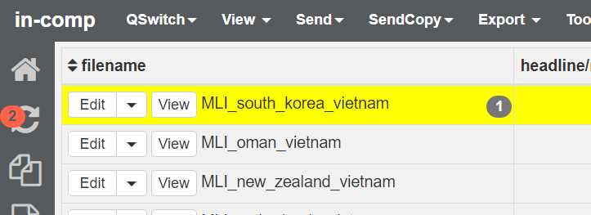

- Insert completed Sgml file from Infocon to the created file in WEBQ and insert eins

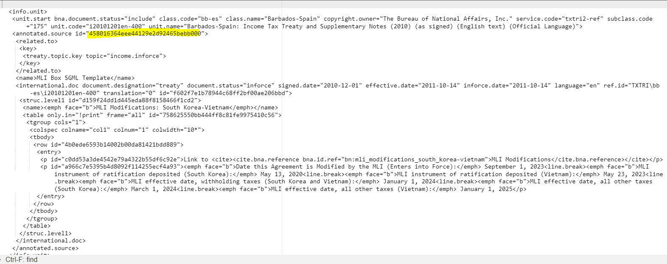

- Save the file and open in OXYGEN and click on edit as xml

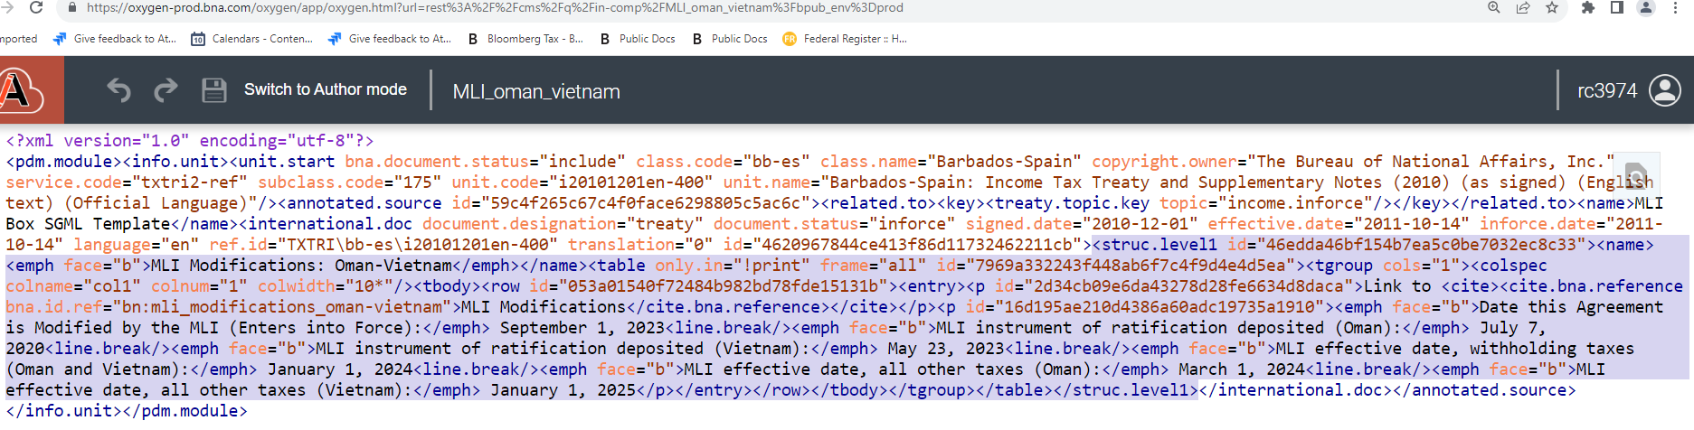
End highlight here
Look for name tag and start highlight from struct level-usually the 5th line
- Highlight contents of MLI box and paste inside the corresponding MLI Treaties file in BWIP
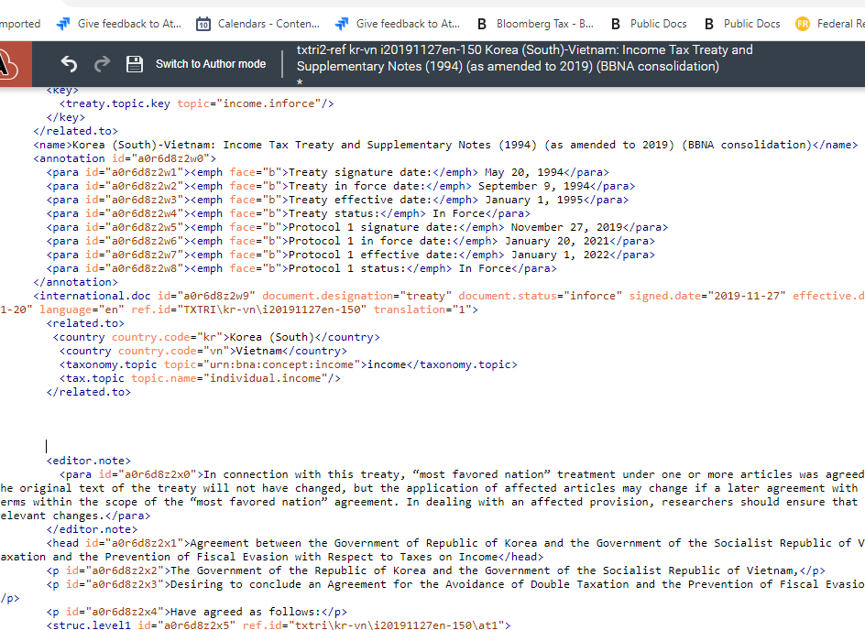
Insert Box here
Insert

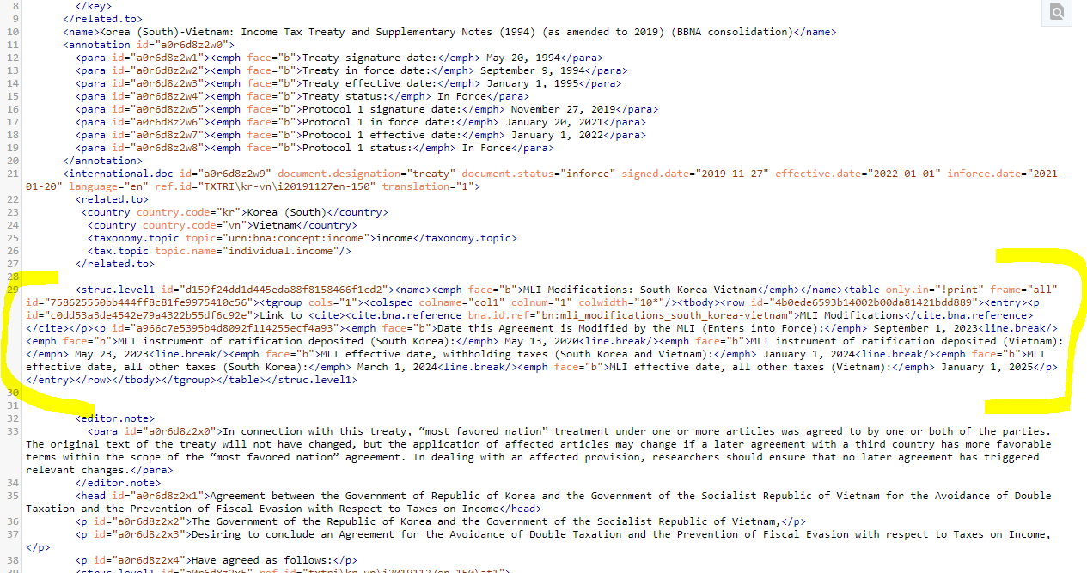
Make sure the link is the same as the bbcite in BDMS (add [1] if tht is what is indicated in BDMS log

Note: Make sure Colspec and line break have “/>”
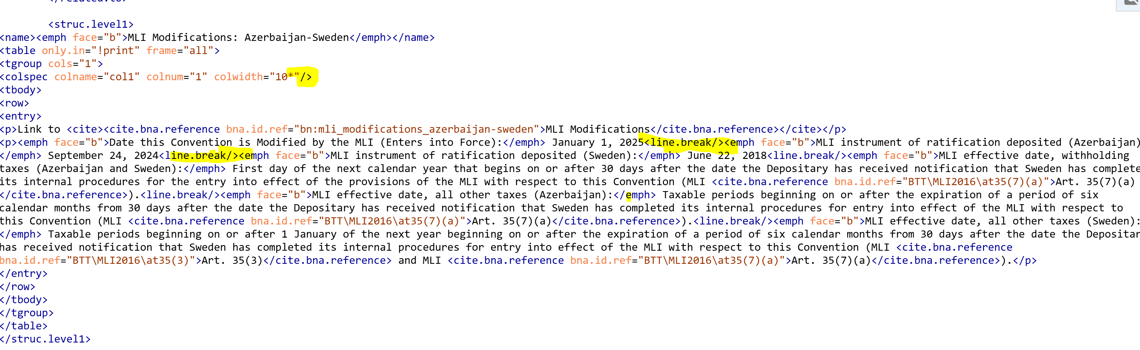
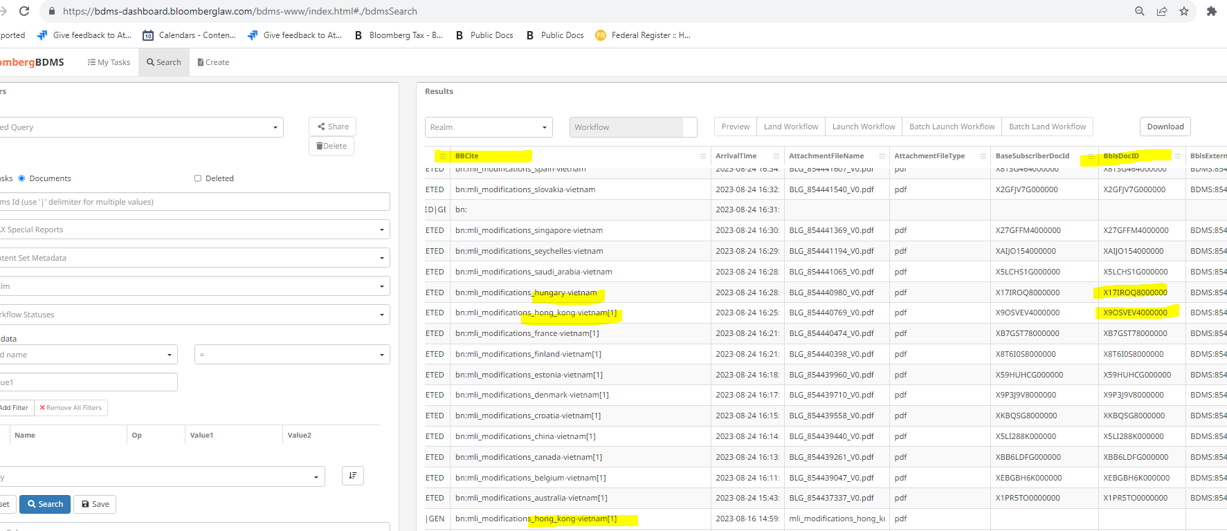

- After saving the file1 error (2 or more errors you need to check by sending a copy to WEBq and parse the file) will show but just ignore and release.
The error will disappear in the main view in BWIP when you save the file before releasing.

