Steps to replace MLI PDF under the NEW workflow
- Rename filename using citation format (Analysts should be informed to follow this requirement to name future MLI PDF files)
-Example. from Bulgaria-India_MLI Modifications_MS(BWR).docx to mli_modifications_bulgaria-india_ms_(bwr).docx

- Log in to BDMS (Prod): https://bbe.bloomberg.com and click on the “Search” Tab
- Click on the hamburger sign to select “Acquisition”, “ACQ-Create Workunits:

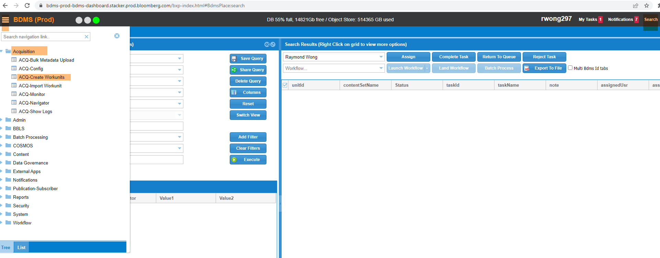
- Under “Create New Workunits”
-type in “BTAX Special Reports” on “Select Content Set (Required)”
-select “metaEdit” on “Select Metadata Group” pull down menu:
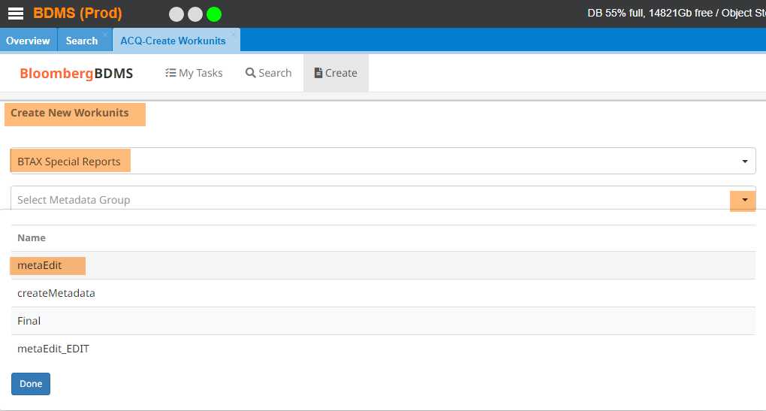

- When the “Create New Workunits” dialogue box appears:
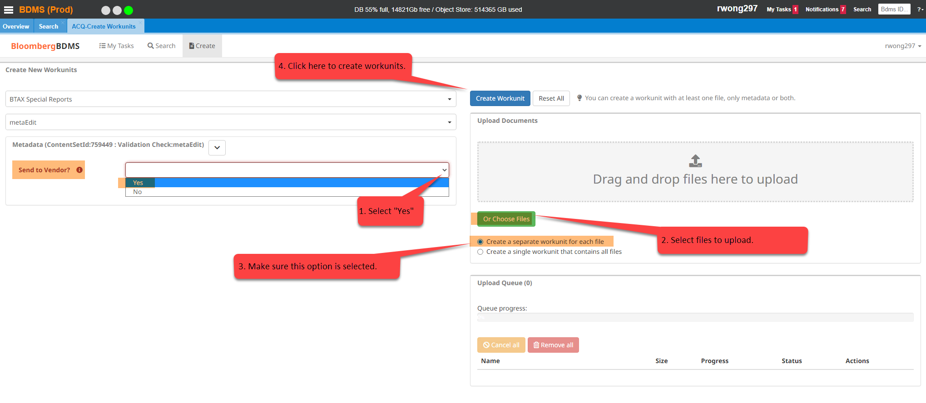
- BDMS receives PDF files and generates work unitIds
- BDMS starts vendor task
- Infocon converts Word file to MLI box Word layout and save it in PDF format (Infocon will return this PDF to BDMS for publishing- (automatically but mention in JIRA ticket) (generated automatically when Pdfs are loaded to BDMS by TPQA – step 5).
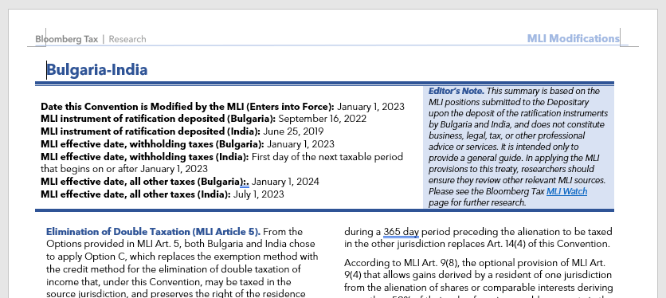11

- Infocon creates SGML snippet with link to PDF filename (in citation format):
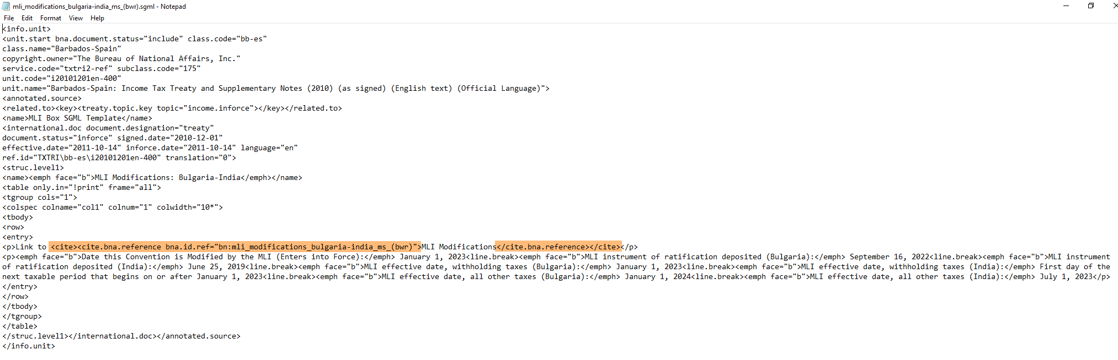
GD will SFTP this SGML snippet to BBNASCRIPTS@bfm1-sftp.bloomberg.com. (generated automatically when Pdfs are loaded to BDMS by TPQA- Step 5)
- Use the SGML snippet to replace the corresponding SGML file in BWIP.
- Release the SGML file in BWIP.
- BDMs will then update the record and publish it to BTAX.
- Check in BTAX to confirm the correct MLI box is published.

