Project Overview: Adding MLI Notes
Summary:
- Edits in Word files need to be integrated into XML files which you will retrieve in BWIP.
The XML files in BWIP are named after the country treaty “pairs” – i.e., for each set of countries (e.g., Albania and Belgium), there are two XML files, one in which Albania is the source country, and the other in which Belgium is the source country.
The XML filenames are based upon the international country code for each country. The official list of country codes can be found here: https://www.nationsonline.org/oneworld/country_code_list.htm#C
- Each Word file will contain edits to two XML files. There will be ~440 total Word files and, thus 880 XML files to be edited.
E.g. the “Albania-Belgium MLI Notes Final.docx” file contains edits to the XML files for Albania-Belgium and for Belgium-Albania.
- Each TPQA ticket will have approximately ~50 Word files attached (.zip’d). We expect to have about 9-12 total TPQA tickets for the entire project.
- After edits from each .docx file are incorporated into corresponding XML files, mark XML files as “Ready for Review” in BWIP.

Doing the Work:
- Check out files in BWIP.
In BWIP, use BDMS Search function to locate and check out the files.
- Service Code: tmiwt2-ref
- Class Code: 200
- Country codes (Unit Code): see list
E.g, For the “Albania-Belgium MLI Notes Final” draft, checkout two files: (1) using Unit Code: al-be (Albania as “source” country) and (2) using Unit Code: be-al (Belgium as “source” country). Below is Albania-Belgium:
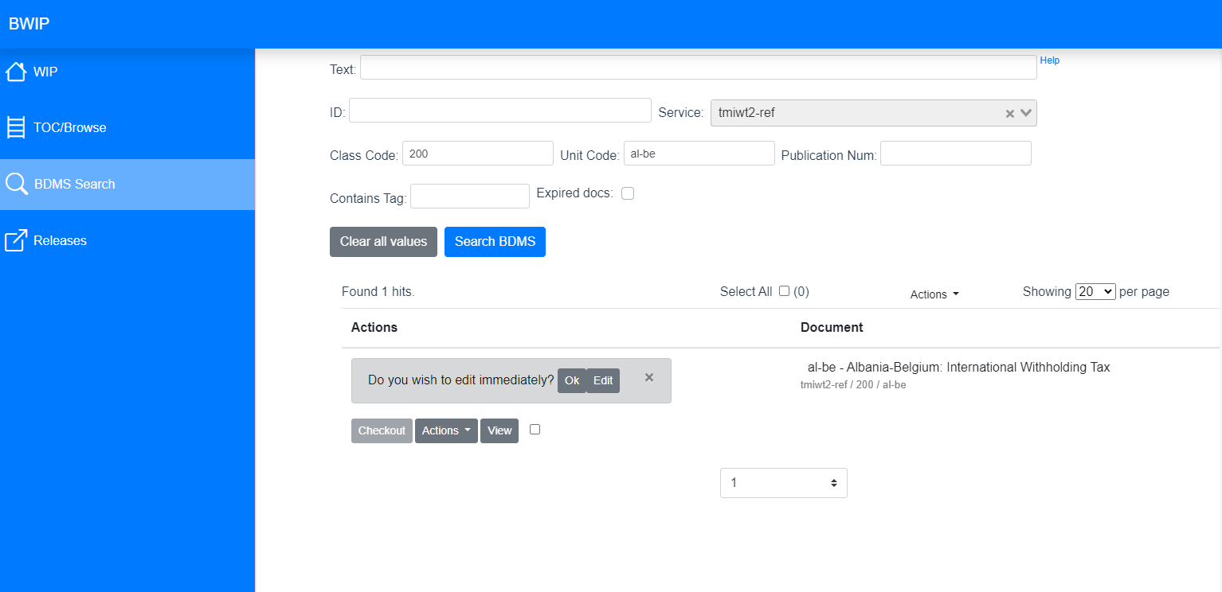
And Belgium-Albania:
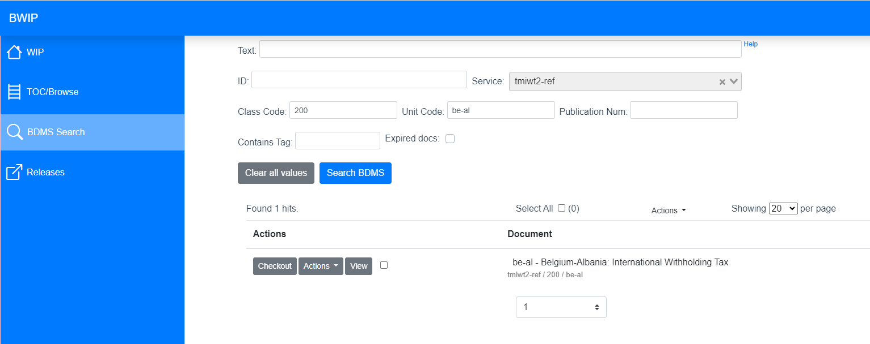

- Open Word file containing edits.
The first edits in the Albania-Belgium Word file highlighted below.
Note that the first set of changes are for the Albania-Belgium file (i.e., “al-be”), where Albania is the source country.
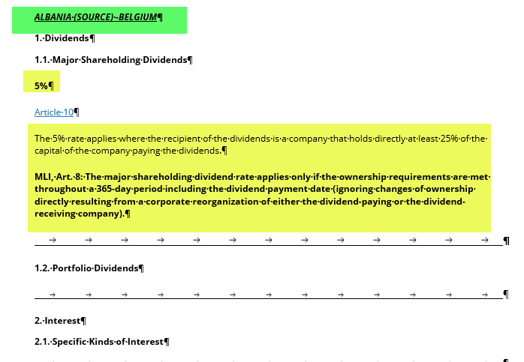
- Entering the edits
Click edit for the Albania-Belgium file in BWIP to open Oxygen.

Part 1 – First source country
  - Rates
Highlight the rate , replacing it with the updated number from Word file. The rate should always be BOLD.

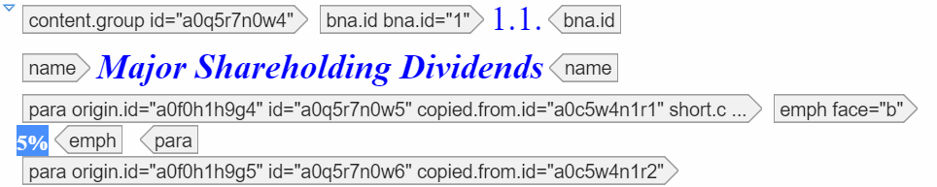

  - Articles
Highlight Article text from Word file, paste it into Oxygen. Do not delete the cite tag.

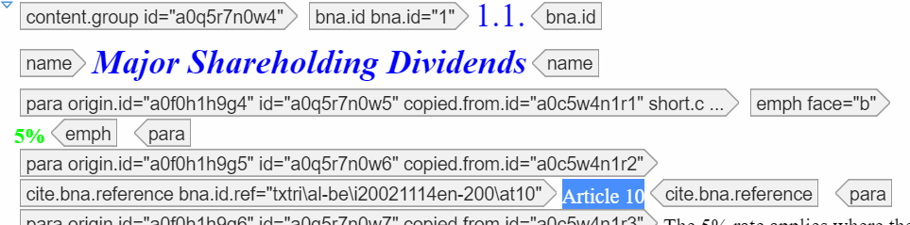

  - Analysis
Copy entire Analysis section from Word file, including MLI note.
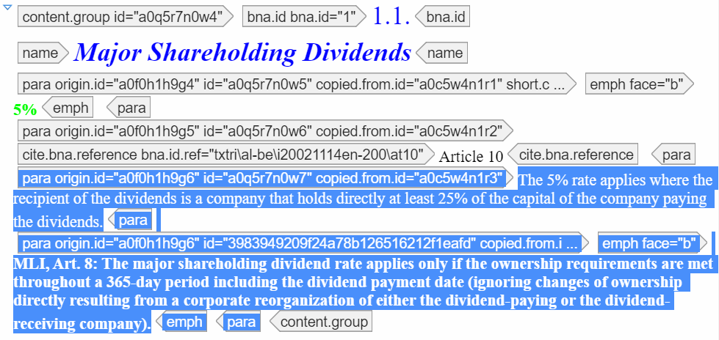
Note: One way to do this in Oxygen is:
- Delete text starting from para origin tag after Article.
- After clearing, press enter in Oxygen and select New Para. There will now be a para id beside your cursor.
- Paste in new analysis text using CTRL+Shift+V
- Find MLI Note in Analysis text, place cursor at beginning. Press enter and select split para.
This creates two separate paragraphs in Oxygen. If there’s a list it will need to be formatted with the list tag in Oxygen.
- Bold MLI note text.

- When finished, Save and mark file as Ready For Approval in BWIP.

Part 2-second source country
Midway through same Word file is update text for the other source country (in the example, this would be text for Belgium as the source country, as shown below).
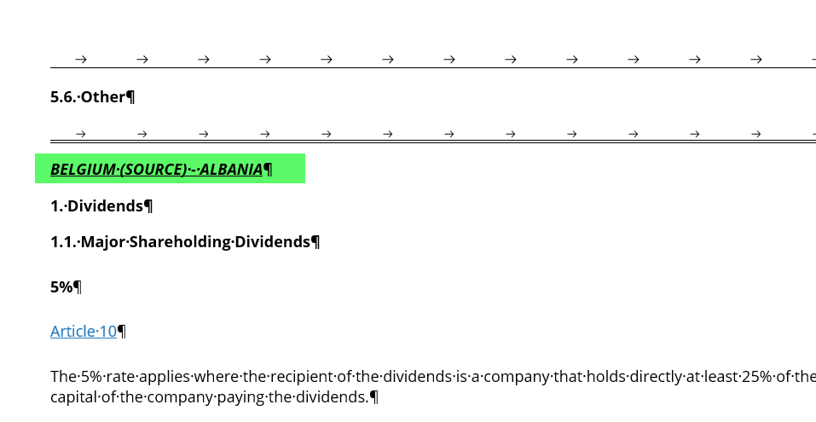
Find Belgium-Albania file in BWIP, and open in Oxygen. Follow same steps for updating as described above.

When finished, Save and mark file as Ready For Approval in BWIP.

