MLI Modifications Bulk Upload Steps
- Email the upload ready file from \\pride4\bna4_data\GROUPS\Tax&Accounting\Operations\Production\Projects\Analysis Content\Current\International\MLI\MLI Boxes June 1\Ready for upload” to yourself as attachment via Outlook.
- Log in to BLP Citrix Generic Desktop via: https://bbe.bloomberg.com/Auth/Logout?reason=Timeout
- Open a Web browser within the BLP Generic Desktop and open BDMS (prod) via: https://bdms-prod-bdms-dashboard.stacker.prod.bloomberg.com/bxp-index.html
- Log in to office 365 Outlook via: https://outlook.office365.com/mail paste & download in Chrome inside the generic desktop
- Look for the email and attachments you sent to yourself.
- Download the attachments to the Download directory in the BLP Citrix desktop.
- Navigate to BDMS (prod):
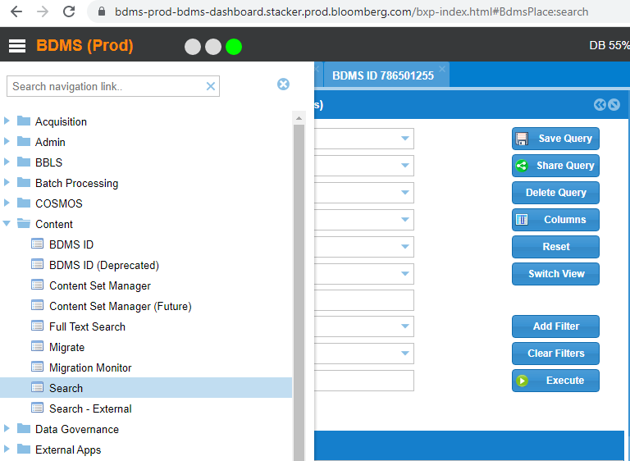
- Click on Hamburger then Click on “Acquisition”, “ACQ-Create Workunits”: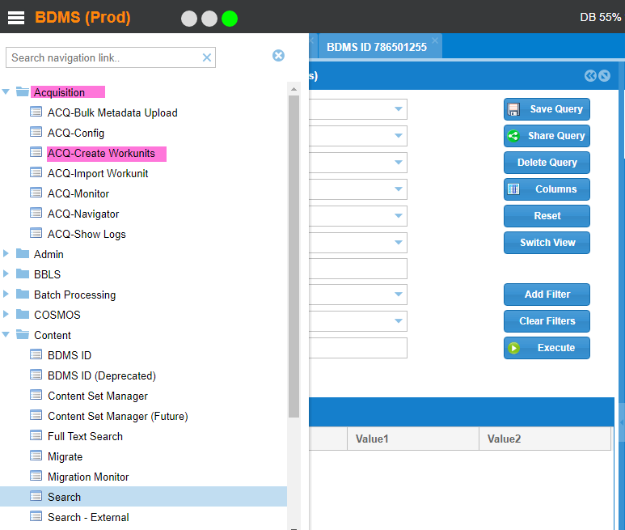Click on ham
- Display the “Create New Workunits” dialogue box:
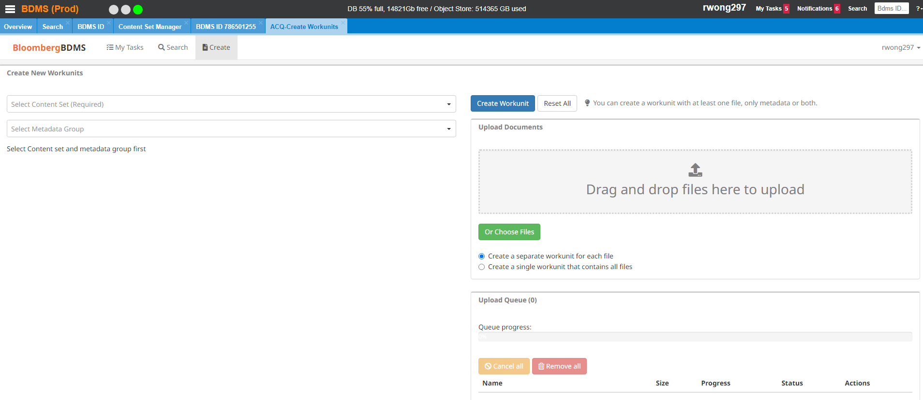

- Type in “BTAX Special Reports” content set or (select in drop down menu):
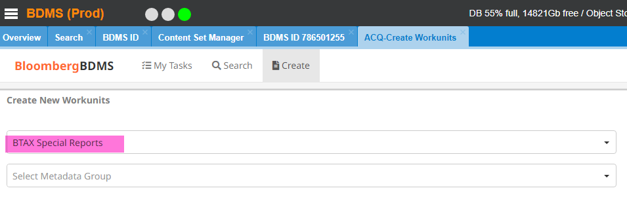

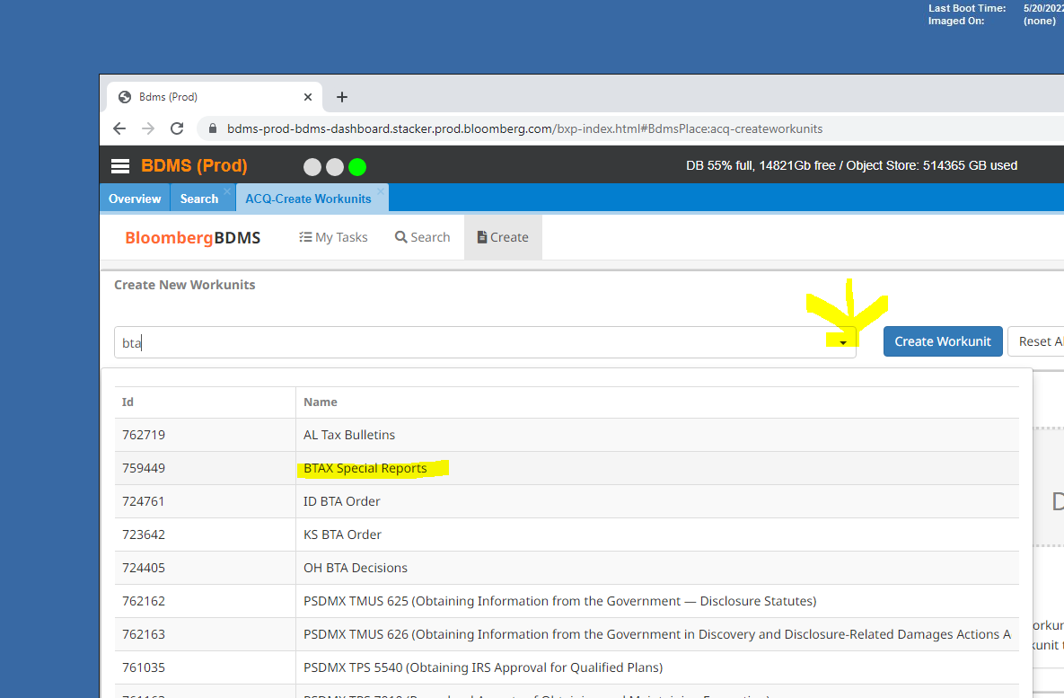

- Choose file/s to upload:
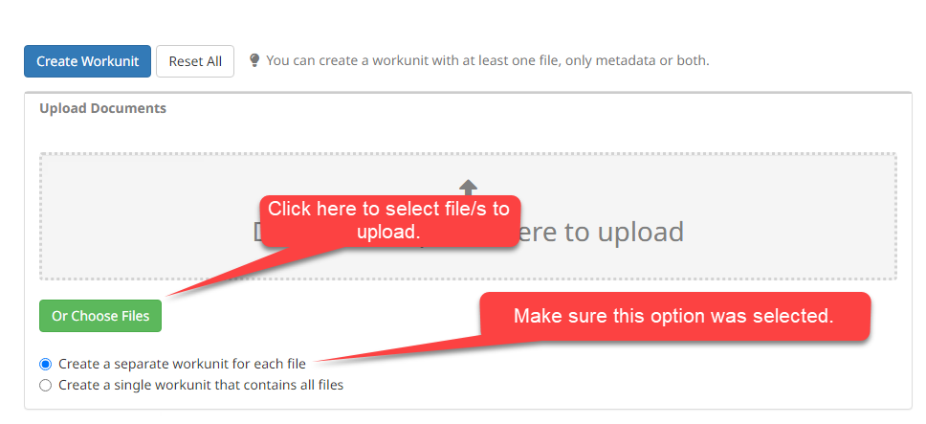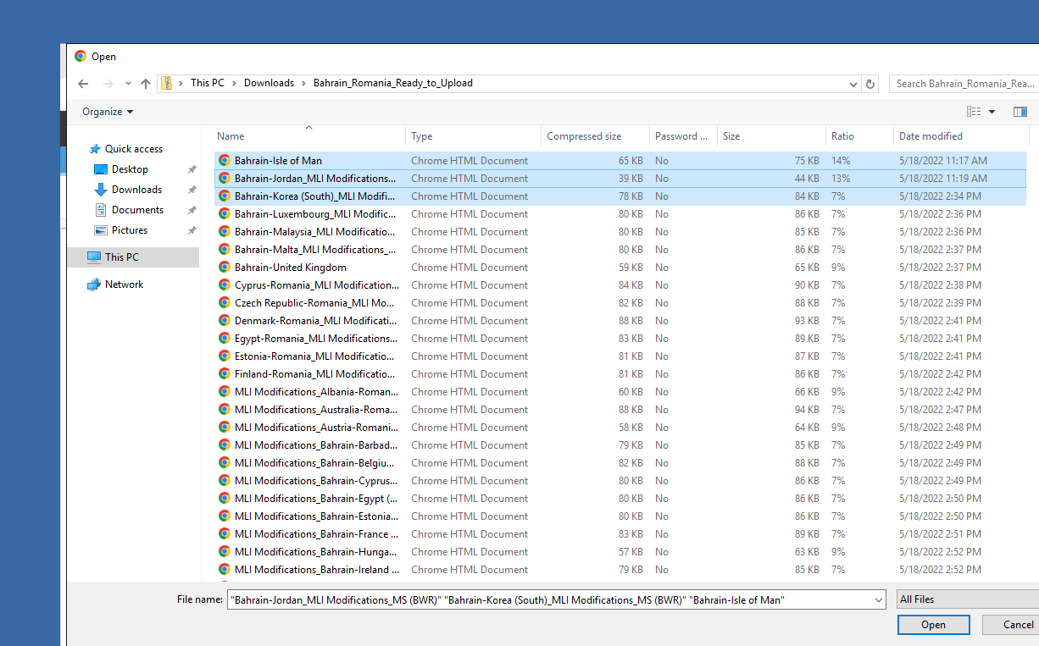

Use the first level to download files (make sure all files that are saved are in the first level and no special characters dash or underscores)
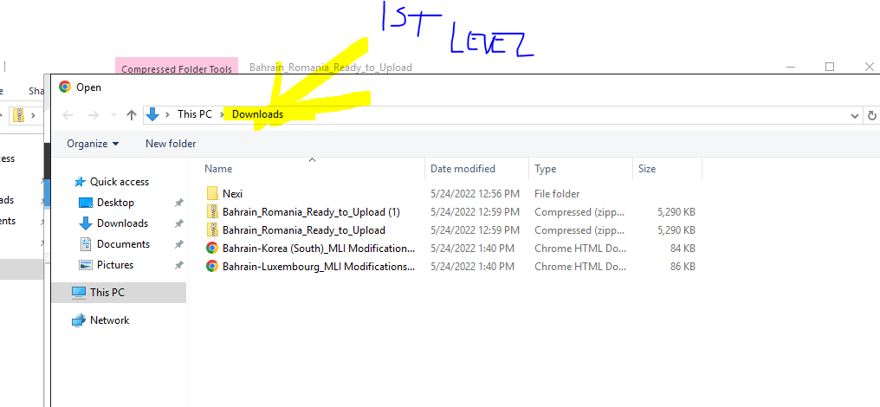

Drag & drop the files: 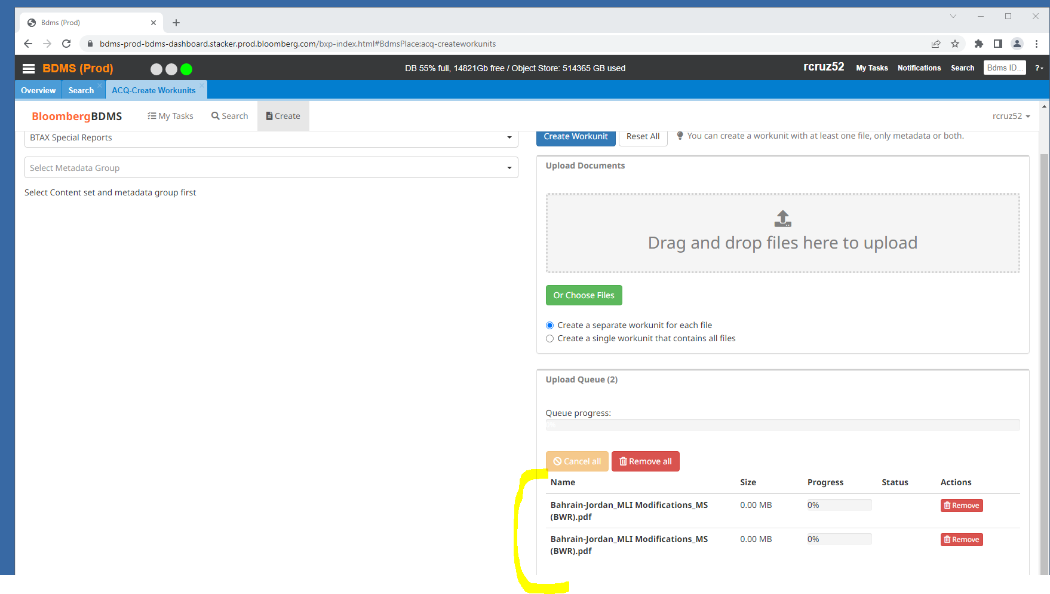

- Click on “Create Workunit” to create BDMS ID/s:
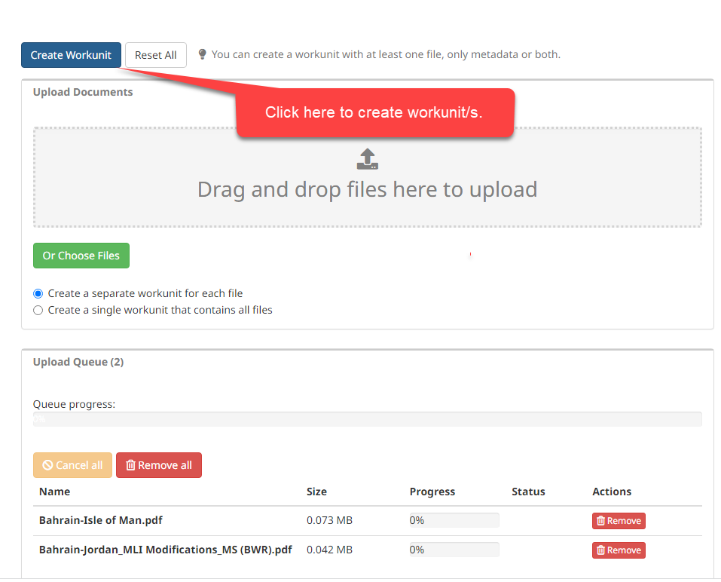
- Click “Yes” to view the workunits on the “Search screen”:
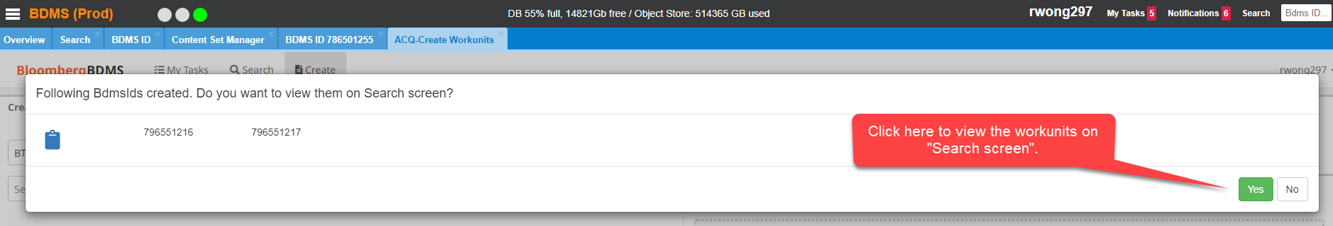
- Switch to “Task View”, select “BLG”, and “missing metadata” from the pulldown menu:
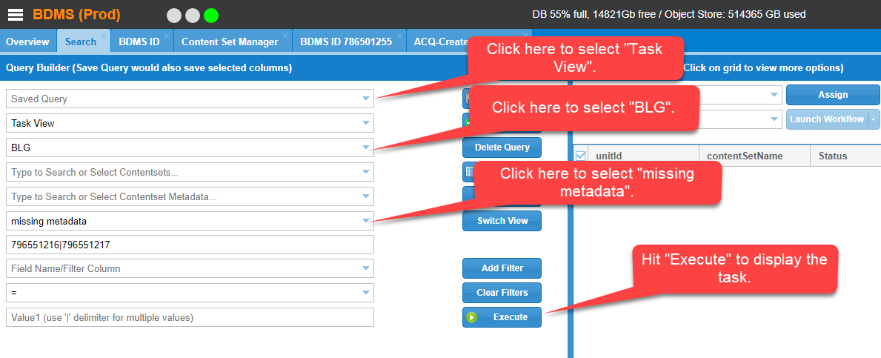
- Select the “unitId/s” and “Assign” to yourself:
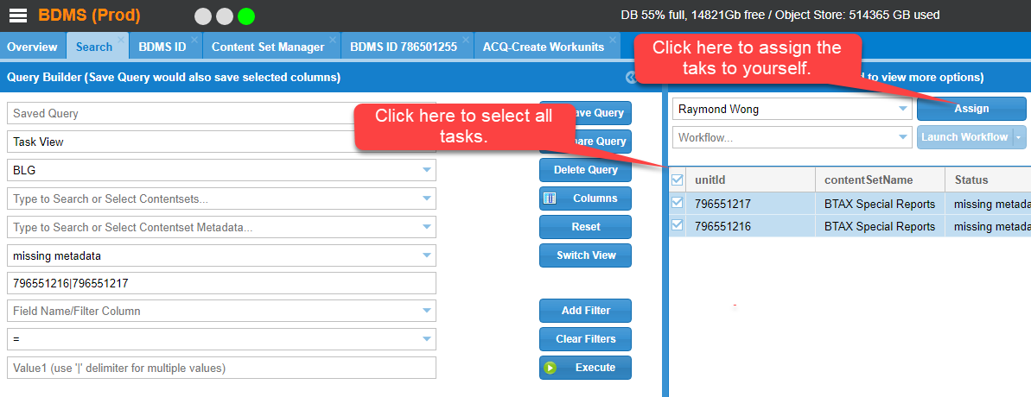
- Make sure the tasks are assigned to yourself:
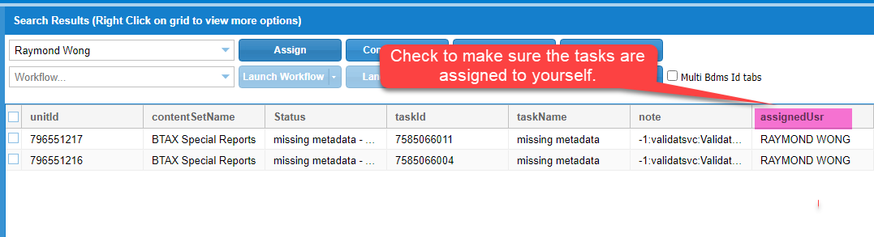
- Export the records to Excel:
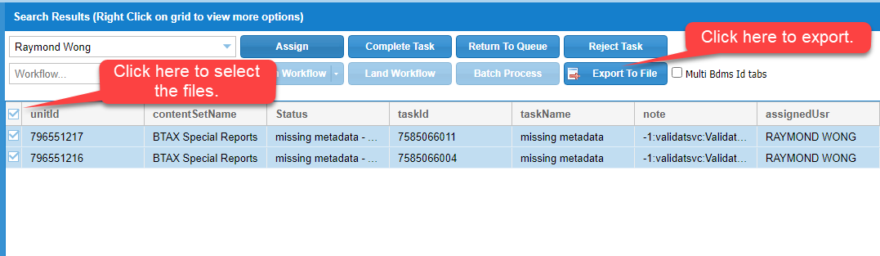
- Open the exported file:
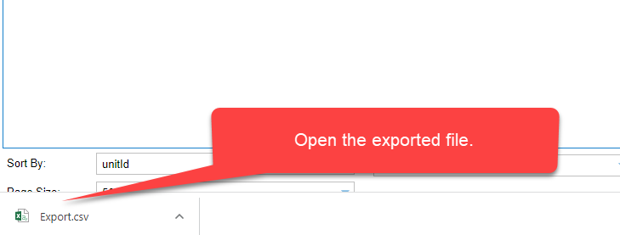
- The file will be opened in “Excel”.
- Modify the Spreadsheet headings to include: (Make sure V I caps in domain Value in spreadsheet
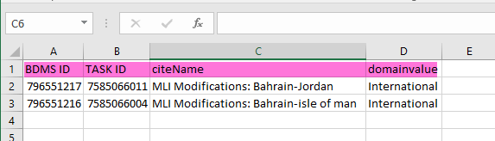
- Save the Spreadsheet in your BLP Citrix Generic Desktop Personal Directory in CSV (MS-DOS) format: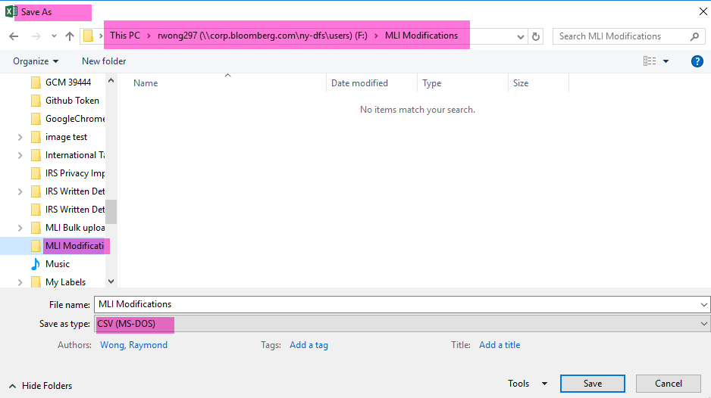

- Go to “Acquisition”, “ACQ-Bulk Metadata Upload”:
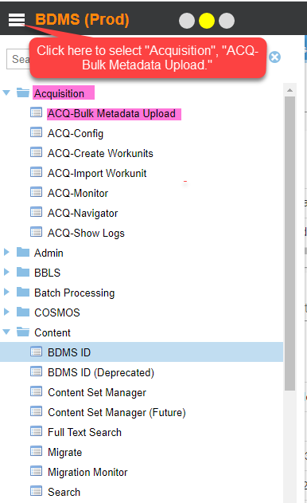

- Under the “ACQ-Bulk Metadata Upload” Tab, select “BLG” on “Realm”, and “Create Metadata” on “Workflow”:
- Select the spread sheet you want to upload to BDMS.25. 25. Upla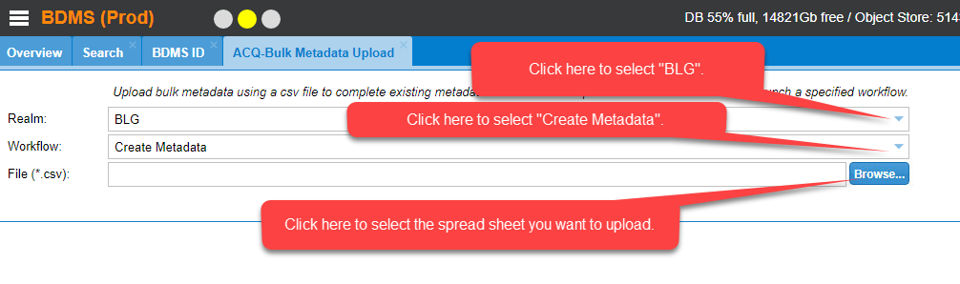
- Execute the command by clicking “Open”:
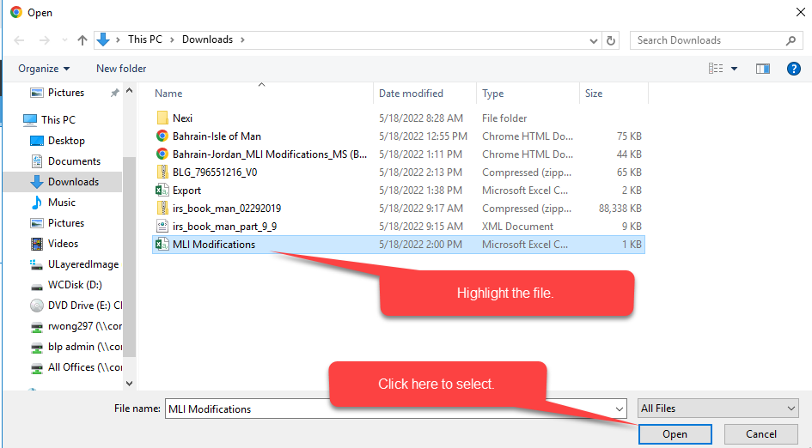
- Click on “Submit” to upload the spreadsheet:
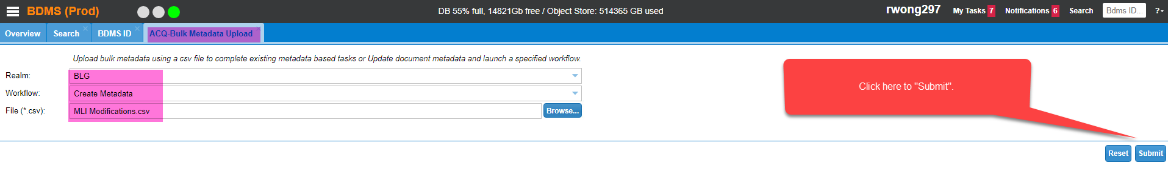
- Click “OK” to close the dialogue box:
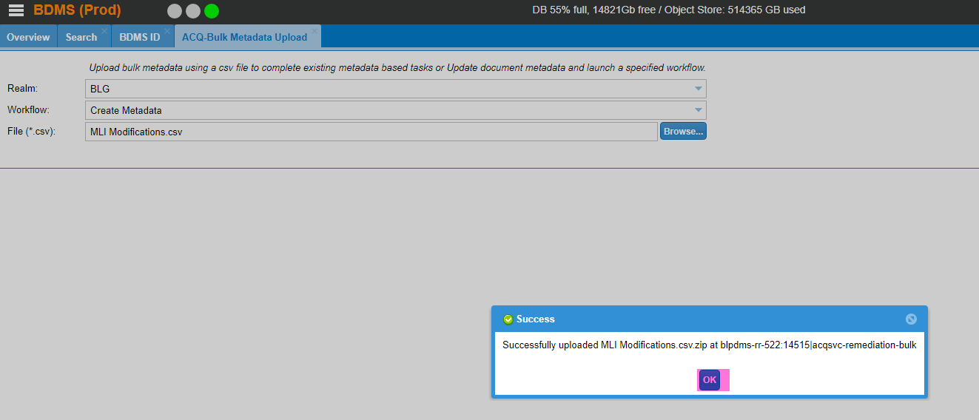

- Click on the “Search” Tab to go back to the “Task View”:
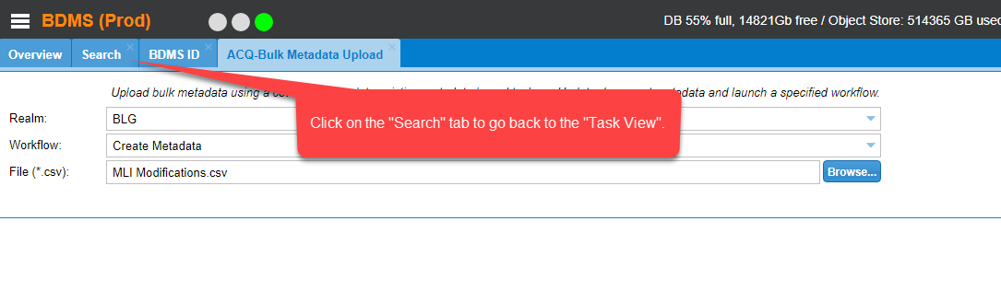

- Click on the “refresh” button to refresh the screen:
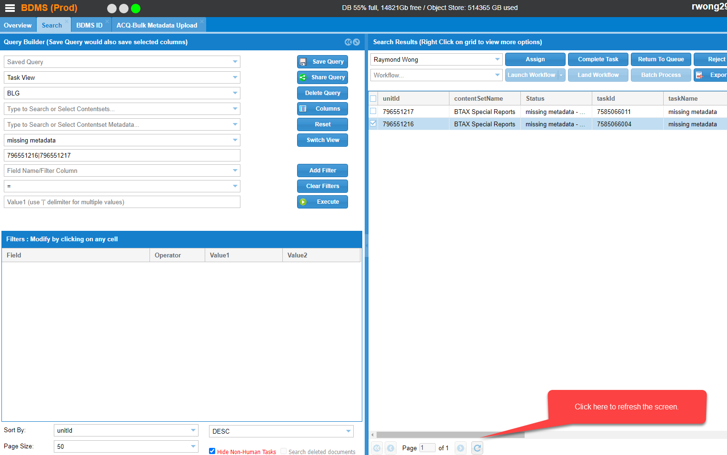
- If there are “No records found” after you hit the “refresh” button that means you successfully created the metadates for the Workunits:
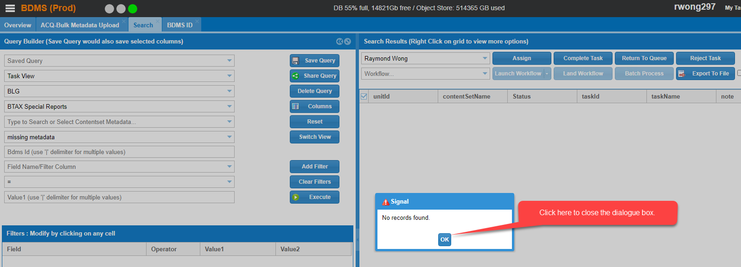
- Click “OK” to close the dialogue box.
- Go back to “Document View” and double clicks on the individual workunit to ensure the PDF was successfully uploaded:
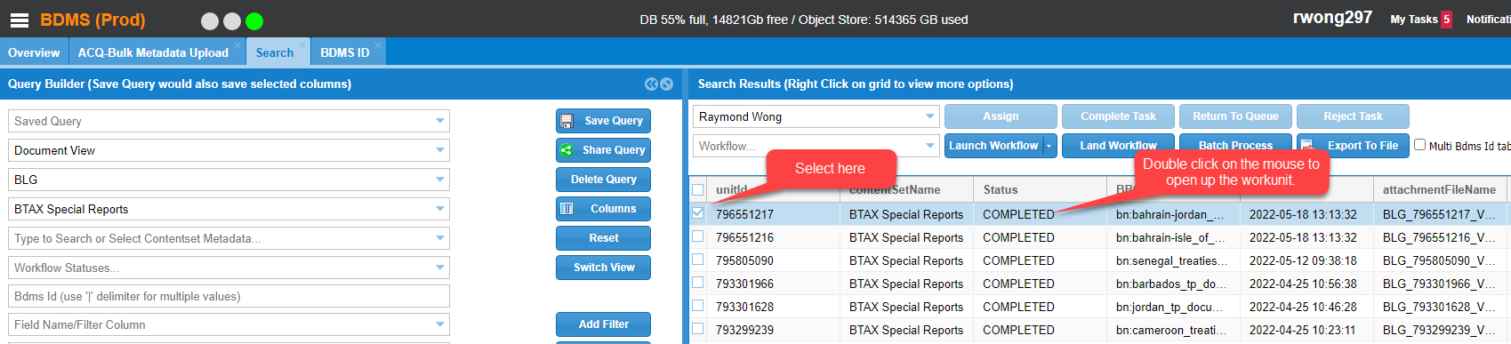
- Double clicks on the “bblsDocID” to ensure the PDF is fine:
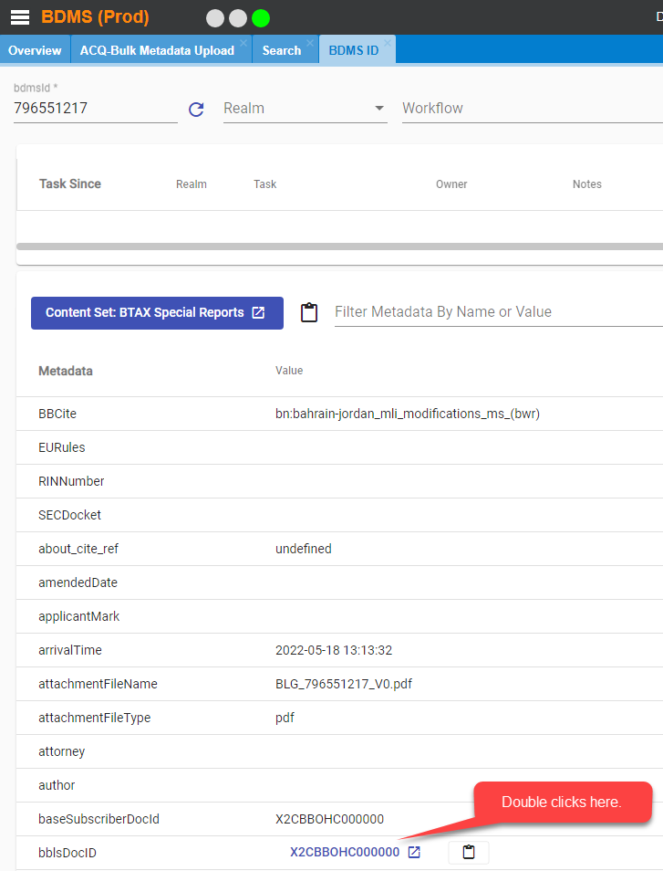
- The PDFl open up and looks fine. Your task was successfully completed:
