Loading Tax Prep Guide Placeholder files to BDMS
- Go to Pride4 and make a copy of the Placeholder pdf files then change the YEAR:
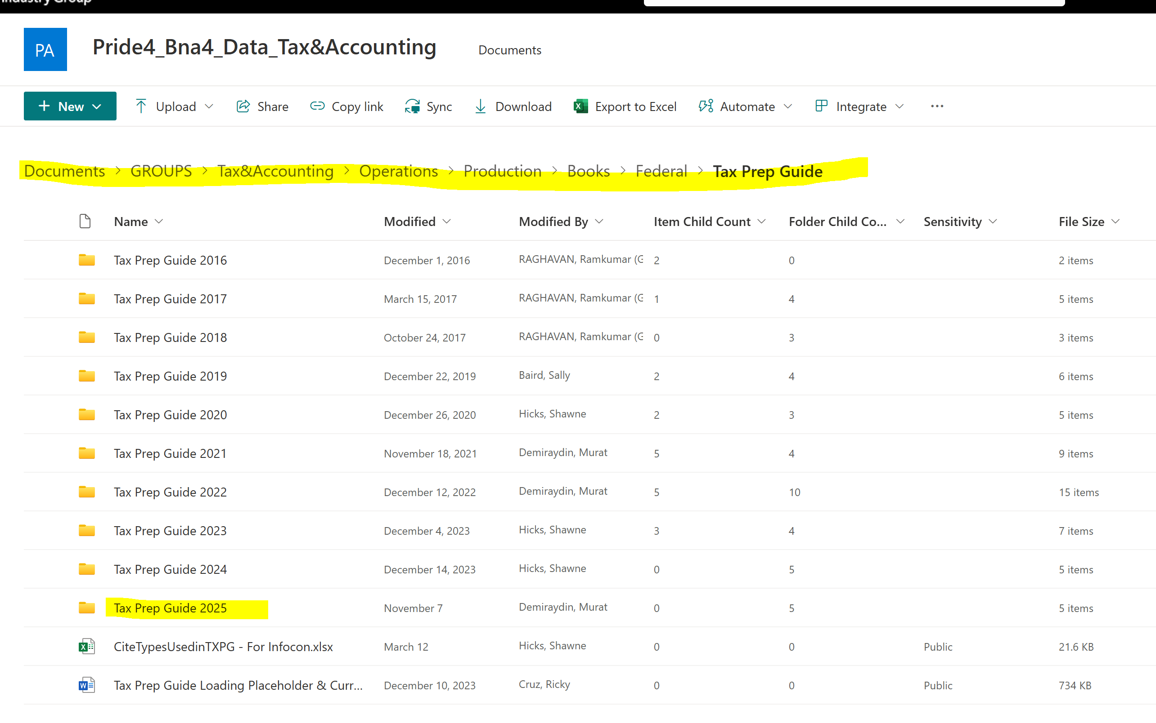

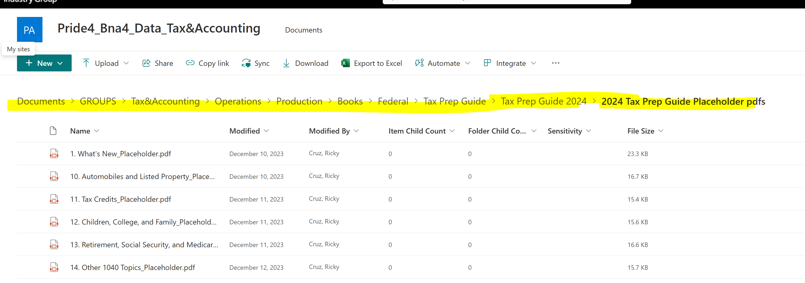

After changing the year attach copies of the files to Email and send to Outlook email in BDMS
Log in to BDMS and Log in and open Outlook in Chrome then Download attachments from email. In the Downloads folder copy files to Documents folder.

IN BDMS : Note: Copy title from the Placeholder file (exclude Placeholder text)
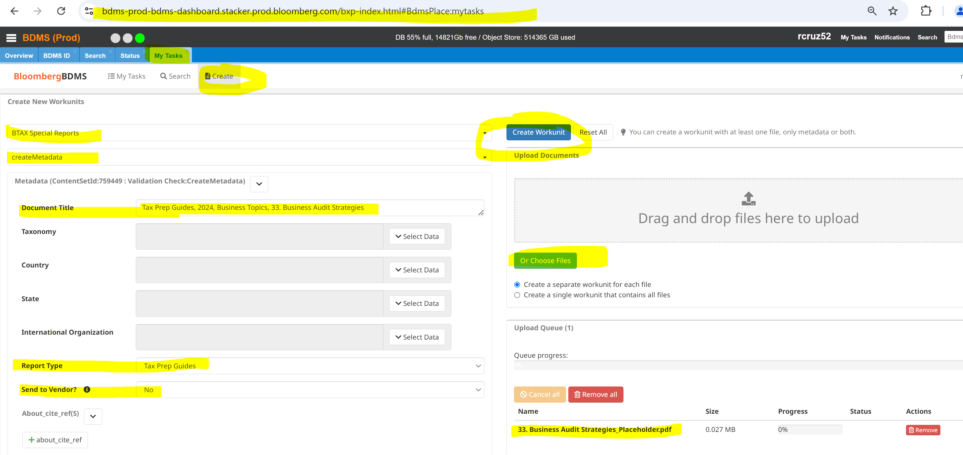

When the loading is successful:
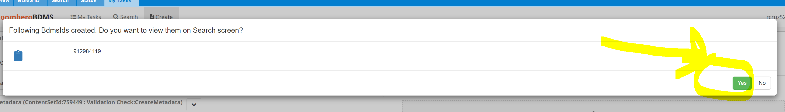

Click on MY Tasks then Search
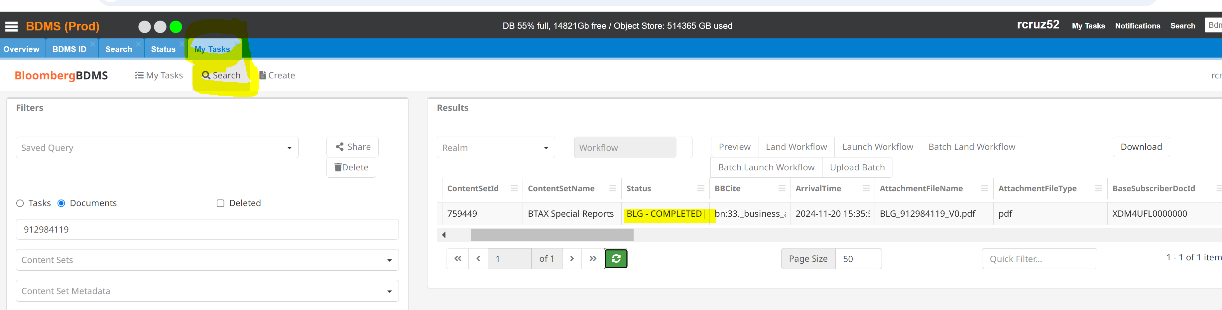

When the status is completed copy BBLS & BDMS IDS to TAX Prep Guide Tracker
To copy BBLS & BDMS IDS from BDMS, hold and highlight
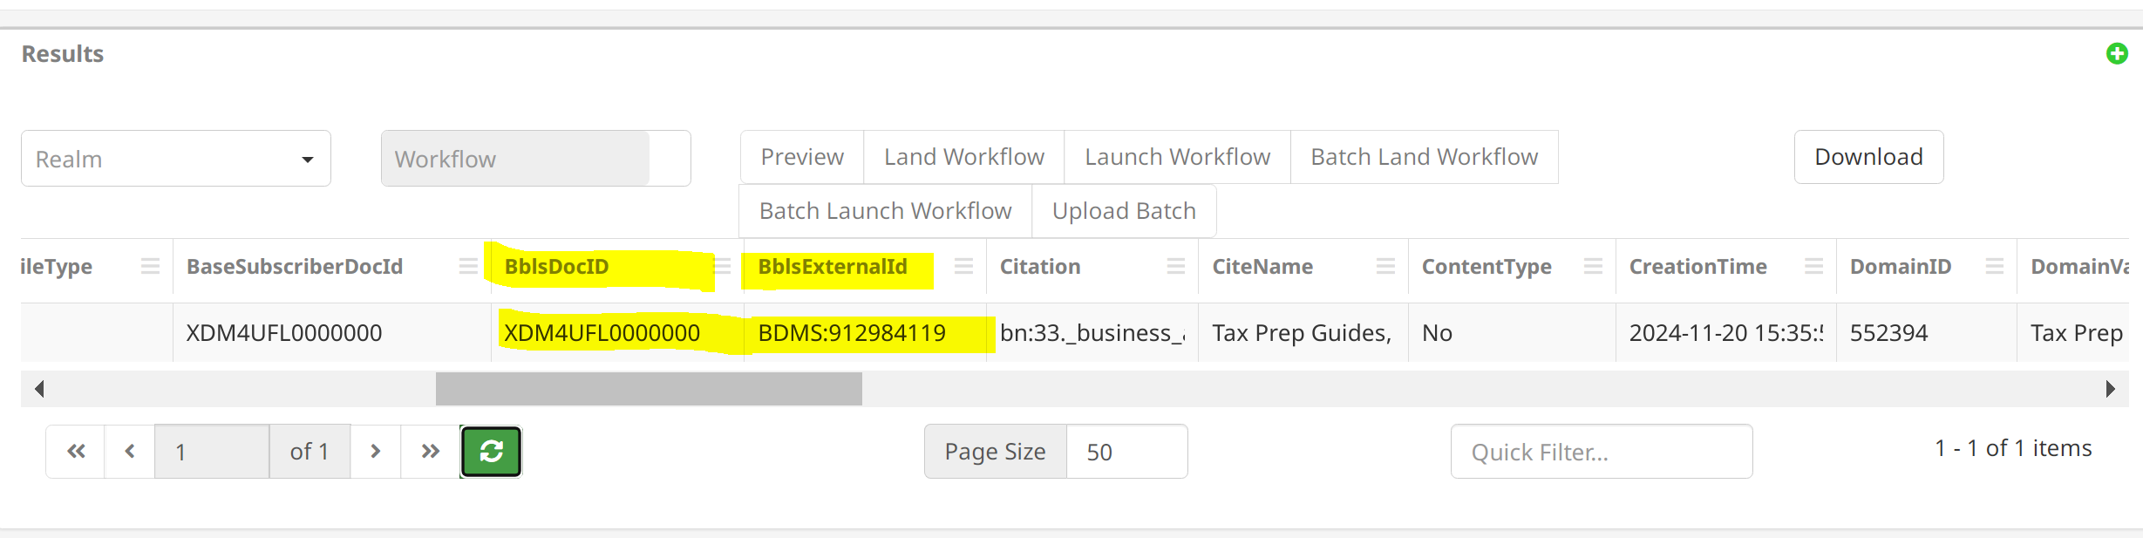

Tax Prep Guide Tracker: https://confluence.bna.com/pages/resumedraft.action?draftId=1756699298&draftShareId=3a7ad08a-bdbf-4498-b835-37272caa6f9a&

