TAX LEGISLATION (House Bill, Senate Bill, & Act Language), and Committee Reports

INTRODUCTION
We add to BTAX full text of House and Senate Bill language after it has passed the House or Senate (sometimes earlier if it’s a bill of interest). We add full text of House, Senate, JCT, and Conference committee reports as they are released (after we have added the bill language). We add full text of Act language once Congress has passed it (before it is signed by the President). Not every legislation will have committee reports. There are also times when the House Bill language, Senate bill language and Act language will be the same because there are no amendments as it moves through the legislative process. If the legislation has not been enacted (signed into law), it will appear on BTAX under the Proposed heading for that Congress. Once it has been enacted, Paula through JIRA requests that it be moved from the Proposed to the Enacted heading.
For new legislation, a new document needs to be created in BWIP (Service: leg-ref) under the appropriate Congress number (e.g., 117th,118th, currently 119 –119th Congress (2025-2026 )). The name should be the bill number (e.g., H4240 or S0391).

versions of a bill in their respective chambers

Here’s a breakdown of the differences between the enrolled, engrossed, and enacted versions of a bill or legislation in the U.S. legislative process:

1. Engrossed Bill
- When: After a bill is passed by one chamber (House or Senate).
- What: The official copy of the bill as amended and passed by that chamber.
- Purpose: Sent to the other chamber for consideration.
- Example: A bill passes the House with changes—those changes are incorporated, and the resulting document is the House Engrossed Bill, which is then sent to the Senate.

2. Enrolled Bill
- When: After a bill has passed both chambers in identical form.
- What: The final version of the bill agreed upon by both the House and the Senate.
- Purpose: Prepared for presentation to the President (federal level) or the governor (state level).
- Characteristics: It includes all final amendments and is signed by the leaders of both chambers before being sent for executive approval.

3. Enacted Bill (or Act)
- When: After the President (or governor) signs the enrolled bill into law, or if it becomes law without a signature (e.g., after a set period), or via a veto override.
- What: The bill is now law.
- Purpose: Becomes part of the statutory code (e.g., the U.S. Code).
- Title: It often gets a formal name or citation, such as Public Law No. 117-23.

Summary Table
Stage | Name | Meaning
Chamber Passed | Engrossed | Passed by one chamber, with all amendments included.
Bicameral Approval | Enrolled | Passed identically by both chambers, sent to President.
Signed into Law | Enacted (Act) | Officially becomes law.

1. Joint Committee Reports
- What They Are:
Reports issued by a Joint Committee of Congress—a committee composed of members from both the House and Senate.
- Purpose:
To investigate specific issues or oversee certain areas (e.g., taxation, the Library of Congress), not necessarily to resolve differences in legislation.
- Examples of Joint Committees:
  - Joint Economic Committee
  - Joint Committee on Taxation
  - Joint Committee on the Library
- Content:
  - Findings, studies, or recommendations on public policy issues.
  - Sometimes include legislative proposals, but these must still be introduced and processed through regular legislative channels.
- Key Point:
Joint Committee Reports are typically informational or advisory, not used to reconcile bill differences between House and Senate versions.

🧾 2. Conference Reports
- What They Are:
The final report issued by a Conference Committee, which is a temporary, bipartisan panel formed to reconcile differences between House and Senate versions of a specific bill.
- Purpose:
To create a single, agreed-upon version of a bill that has been passed in different forms by the two chambers.
- Process:
  - House and Senate each appoint conferees (members).
  - Conferees negotiate and agree on a compromise version.
  - A Conference Report is issued that:
    - Contains the final legislative text.
    - Explains how differences were resolved.
  - Both chambers must vote again to approve the conference version before it can go to the President.
- Key Point:
Conference Reports are binding and part of the legislative process for enacting laws.

Comparison Summary
Feature | Joint Committee Report | Conference Report
Purpose | Oversight, studies, or investigations | Resolve differences in House/Senate bill texts
Committee Type | Standing or permanent | Temporary, specific to a bill
Members | House and Senate members | House and Senate members
Legislative Impact | Informational; not binding | Binding; must be approved by both chambers
Associated with Bills | Rarely | Always

How a Bill Becomes a Law in the U.S. Congress
- Bill is Introduced
  - Introduced by a member of House or Senate.
  - Assigned a number (e.g., H.R. 123 or S. 456).
- Referred to Committee
  - Sent to a relevant committee for study.
  - May go to a subcommittee.
  - Hearings, markups, and revisions occur.
- Committee Action
  - The committee can:
    - Approve the bill.
    - Reject the bill.
    - Ignore the bill (often called “pigeonholing”).
- Floor Action in First Chamber (House or Senate)
  - Debate and amendments.
  - Vote (voice vote, division vote, or roll-call vote).
  - If passed, sent to the other chamber.
- Same Process in Second Chamber
  - The second chamber (House or Senate) repeats steps:
    - Committee review.
    - Debate and vote.
- Conference Committee (if needed)
  - If versions differ between House and Senate.
  - Members from both chambers form a conference committee.
  - Create a compromise bill.
- Final Approval
  - Both House and Senate vote on the compromise version.
- President's Desk
  - President can:
    - Sign the bill → Becomes law.
    - Veto the bill → Sent back to Congress.
    - Do nothing → Becomes law in 10 days if Congress is in session (or pocket veto if Congress is not in session).
- Congress Can Override Veto
  - Requires a 2/3 majority in both House and Senate.

File Location
In BWIP, the files are located under the Service: leg-ref. 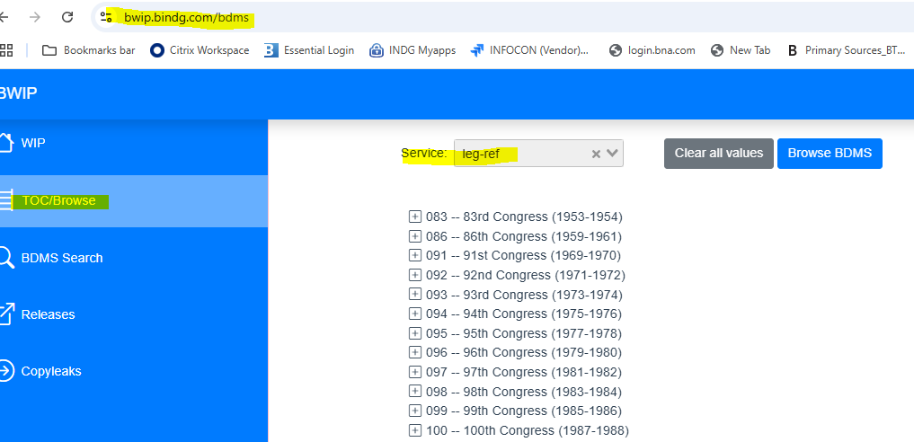

For BTAX, the collection is available at: https://go.bloombergtax.com/product/tax/page/federal_update_primary_sources
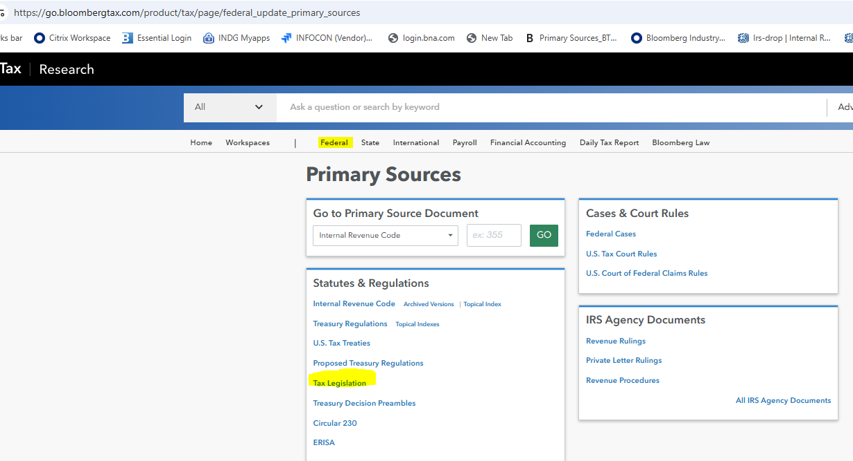

Posting Legislation to BTAX Process

- Review JIRA Ticket for Legislative Action Details
Open the JIRA ticket sent by Paula (to gather the necessary details regarding the legislative action or development. This may include milestones such as passage by the House or Senate (House Bill Language, Senate Bill Language, Committee Reports, or Joint Committee Explanation).
- Select and Prepare the Template
Based on the type of legislation, select the appropriate template. CLONE Legislation template in the leg-tmprod queue in BWIP to create your working file.

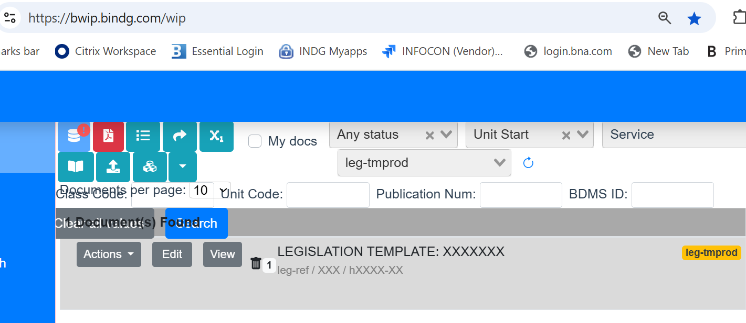

TEMPLATE

<pdm.module>
<info.unit>
<unit.start class.code="XXX" class.name="XXXth Congress (20XX-20YY)" copyright.owner="The Bureau of National Affairs, Inc." pdm.name="XXXX" service.code="leg-ref" subclass.code="XXXX" subclass.name="(TOC TITLE) XXXXX" unit.code="hXXXX-XX" unit.name="XXXXXX"/>
<annotated.source>
<name>LEGISLATION TEMPLATE: XXXXXXX</name>
<legislative.history day="XX" month="XX" year="20XX">
<related.to>
<tax.legislative.document legislative.category="Proposed or Enacted(Choose one)" legislative.resource="Source Documents"/>
</related.to>
<p id="58c4d8b573e24616864845f96697dd6e">Full <cite.url ref="xxxxxx">text</cite.url> of the _________, XXXX X, 20XX</p>
</legislative.history>
</annotated.source>
</info.unit>
</pdm.module>

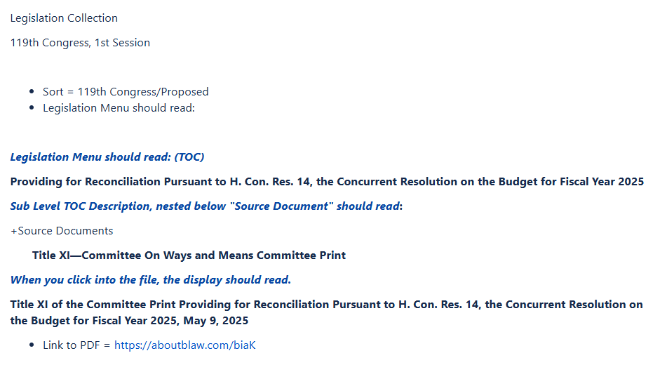
5
4
3
2
1

<pdm.module>
<info.unit>
1
<unit.start class.code="119" class.name="119th Congress (2025-2026)" copyright.owner="The Bureau of National Affairs, Inc." pdm.name="House_Lang" service.code="leg-ref" subclass.code="h14" subclass.name="One Big Beautiful Bill Act (Providing for Reconciliation Pursuant to H. Con. Res. 14, the Concurrent Resolution on the Budget for Fiscal Year 2025)" unit.code="h14-20" unit.name="House Bill Language"/>
3
<annotated.source id="1d0c3425a70346bda834ef0b3e7486e5">
4
<name>Title XI — Committee On Ways and Means Committee Print</name>
<legislative.history day="09" month="05" year="2025" id="bb96826161374670841d11cd82df97e3">
<related.to>
2
<tax.legislative.document legislative.category="Proposed" legislative.resource="Source Documents"/>
</related.to>
<p id="3e26617a715a402bb166e9e11d5ea5ad">Full <cite.url ref="https://aboutblaw.com/biaK">text</cite.url> of the Title XI of the Committee Print Providing for Reconciliation Pursuant to H. Con. Res. 14, the Concurrent Resolution on the Budget for Fiscal Year 2025, May 9, 2025</p>
5
</legislative.history>
</annotated.source>
</info.unit>
</pdm.module>

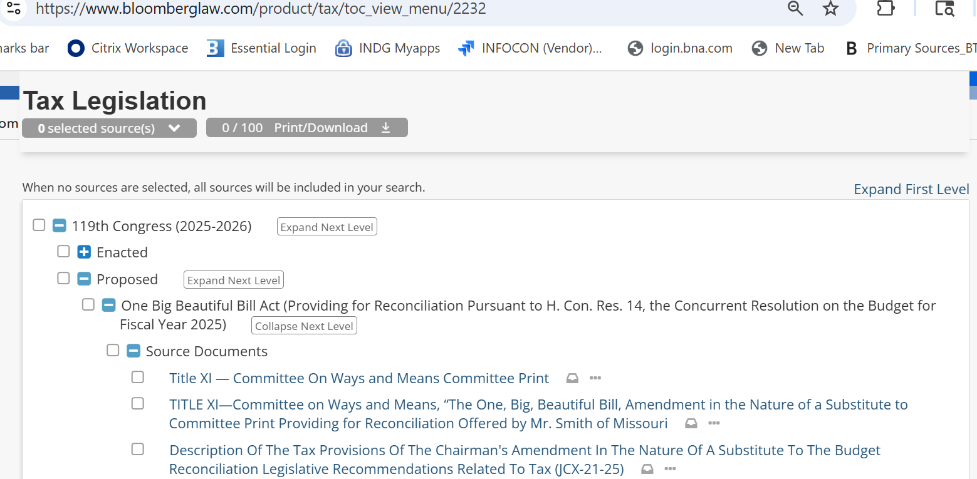
4
3
2
1

- Complete the Template Fields
Fill in all required fields, including:
  - unit.start.class.code, (Congress Number e.g,, 119 (Current), 118th)
  - class.name (XXXth Congress, (20XX-20YY) e.g,, 119th Congress (2025-2026)
  - pdm.name (Act, Lang, House_Lang, Senate_Lang, Comm_Rprt, JCT_Explan)
  - subclass.code (bill number e.g., hr14, s789)
3
  - subclass.name (TOC Title)
  - unit.code
4
  - unit.name (Title)
  - legislative.history date (day/month/year)
  - legislative.category (Proposed/Enacted)
  - cite.url ref (link to document pdf)
4
  - name (Title) LONE

Refer to the table below when entering values for pdm.name, unit.code, and unit.name.
pdm.name | unit.code series | unit.name
House_Lang | hxxxx-20 | House Bill Language
Senate_Lang | hxxxx-40 | Senate Bill Language
Act_Lang | hxxxx-02 | Act Language
Comm_Rprt | hxxxx-30 | Committee Report
JCT_Explan | hxxxx-10 | JCT Explanation

- Validate and Post
Once the file is complete, validate it and post to BTAX. Notify Paula to review the file in BTAX and provide feedback if any updates or corrections are needed.

In BWIP the files resides in Service: leg-ref

and in BTAX the collection can be found in:

