INSERTING MLI BOXES AND POSTING TO BDMS
- Send files to Infocon

Where to get files that are to be sent to Infocon
MLI Boxes Directory I:\Analysis & Content\International\MLI\MLI Treaty Notes for CTAs\2023 CTA Boxes\MLI in force date June 1, 2022\Final

Where to put files that are returned from Infocon

MLI Boxes path to returned from Infocon folder I:\Operations\Production\Projects\Analysis Content\Current\International\MLI\MLI Boxes\Returned from Infocon

Retuned files will be in 1. SGML & 2. PDF.

Attach files to be processed as zipped file if more than 1.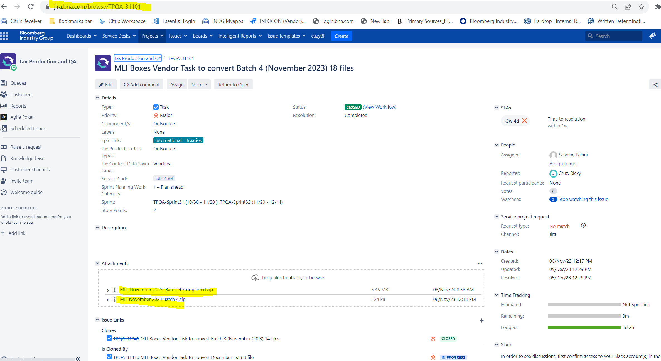

- Completed files (sgml & pdf) will be sent back and attached to the JIRA ticket
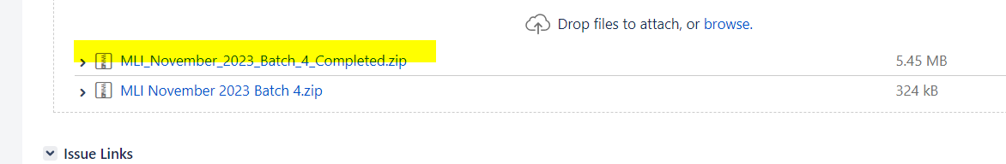

- Load pdf files to BDMS
Infocon converts Word file to MLI box Word layout and save it in PDF format (Infocon will return this PDF to BDMS for publishing- (automatically but mention in JIRA ticket) (generated automatically when Pdfs are loaded to BDMS by TPQA).

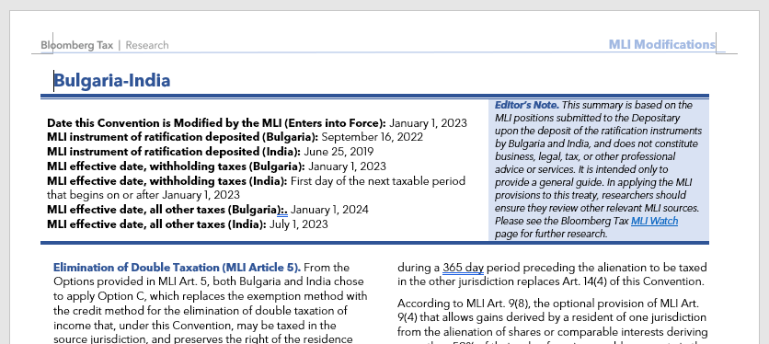

Log in to BDMS (Prod): https://bbe.bloomberg.com and click on the “Search” Tab
Click on the hamburger sign to select “Acquisition”, “ACQ-Create Workunits:

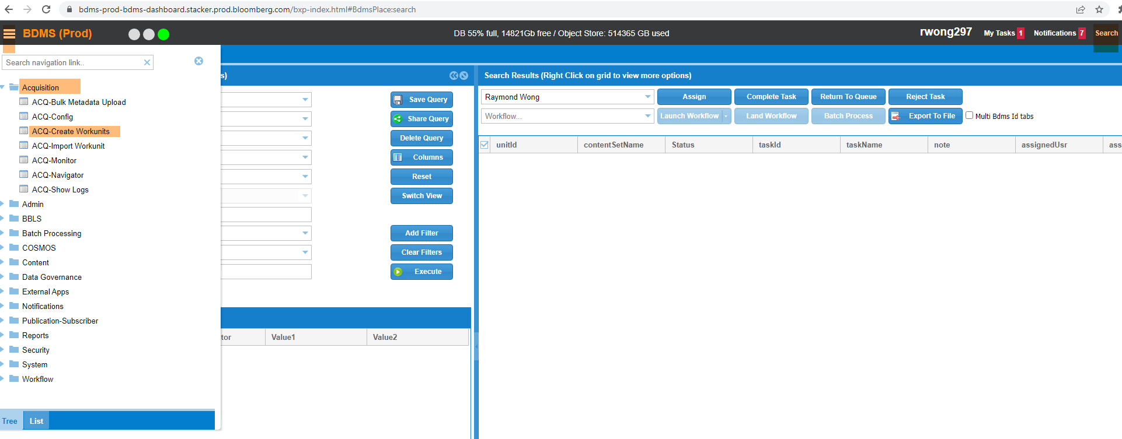
- Under “Create New Workunits”
-type in “BTAX Special Reports” on “Select Content Set (Required)”
-select “metaEdit” on “Select Metadata Group” pull down menu:
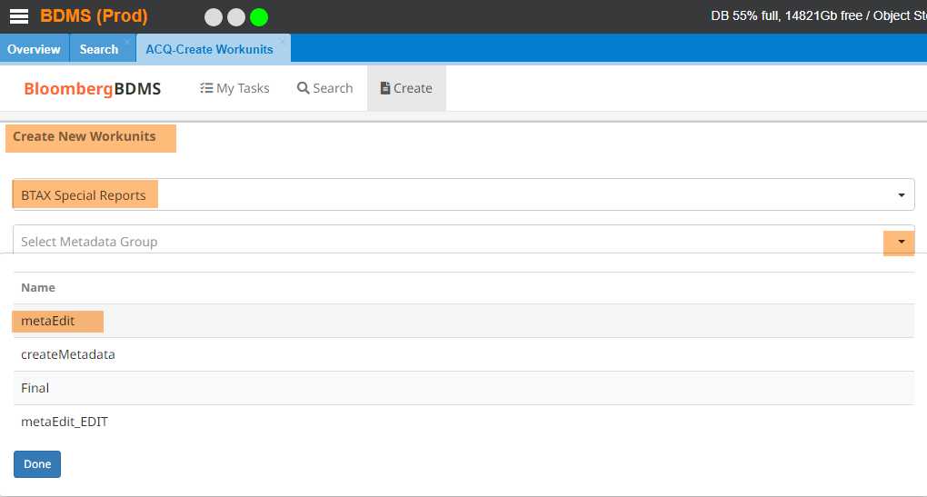
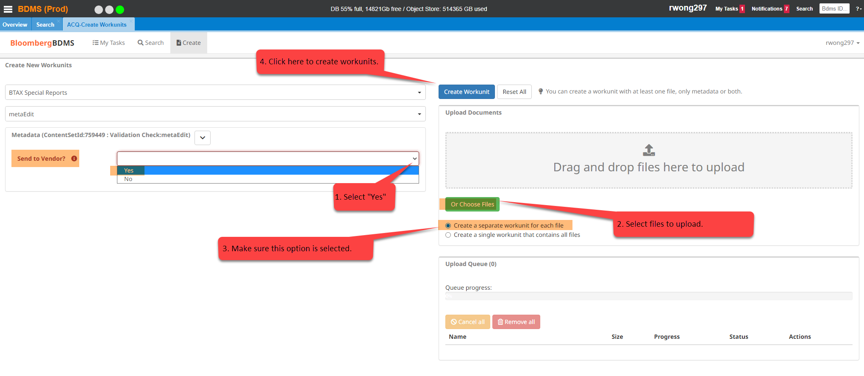

BDMS receives PDF files and generates work unitIds
BDMS starts vendor task

Infocon creates SGML snippet with link to PDF filename (in citation format):
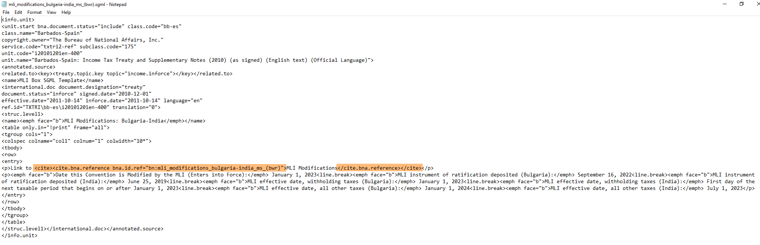

- Copy sgml file to Blank MLI template in WEBq and assign eins then save.

a.Copy a file in WEBQ and rename to MLI_country name1_-country name 2
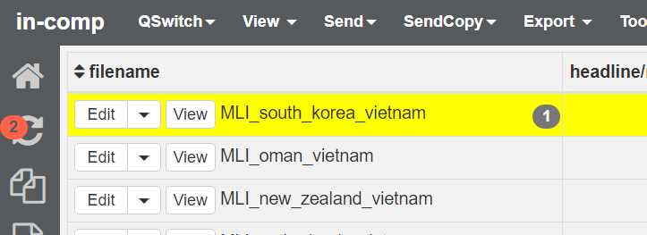

- Insert completed Sgml file from Infocon to the created file in WEBQ and insert eins

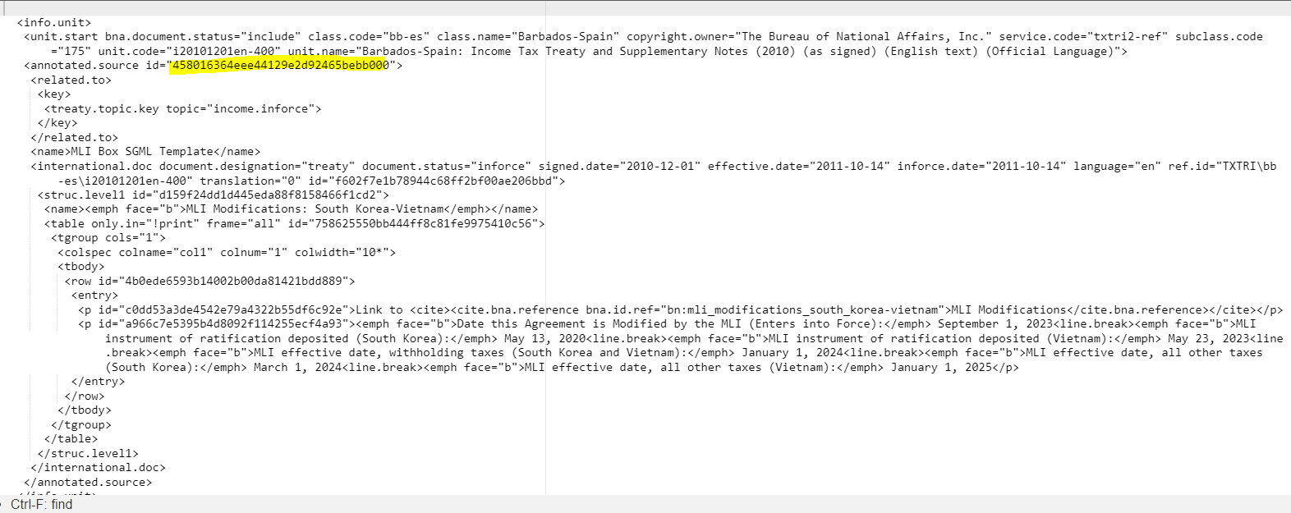

- Save the file and open in OXYGEN and click on edit as xml

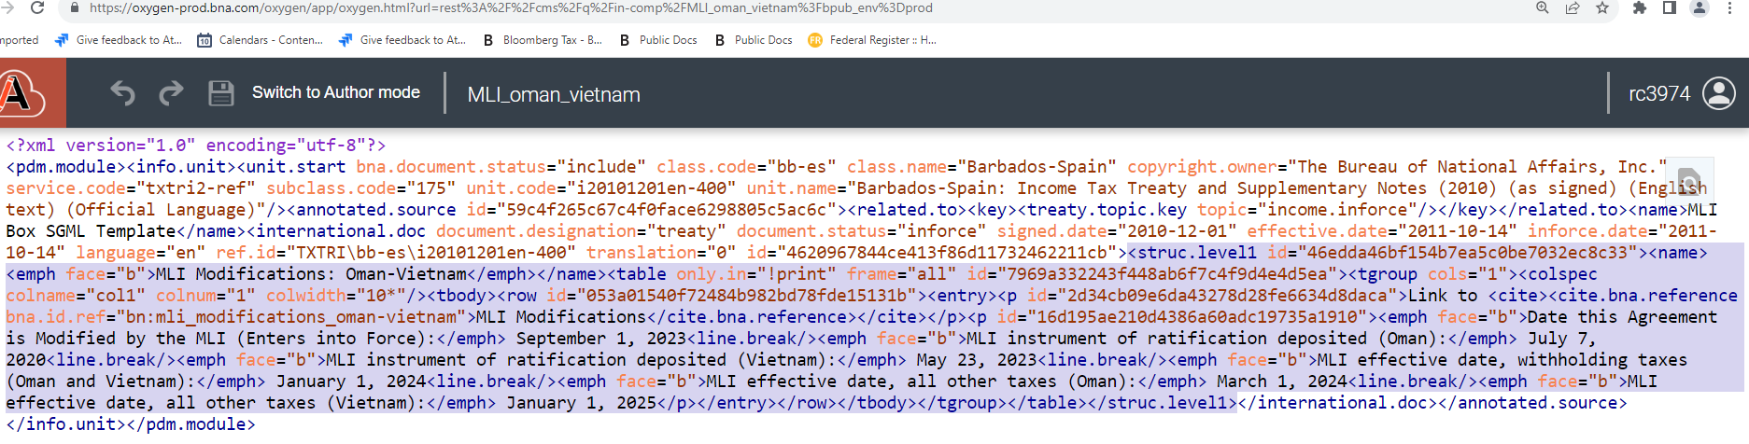
End highlight here
Look for name tag and start highlight from struct level-usually the 5th line
- Highlight contents of MLI box and paste inside the corresponding MLI Treaties file in BWIP
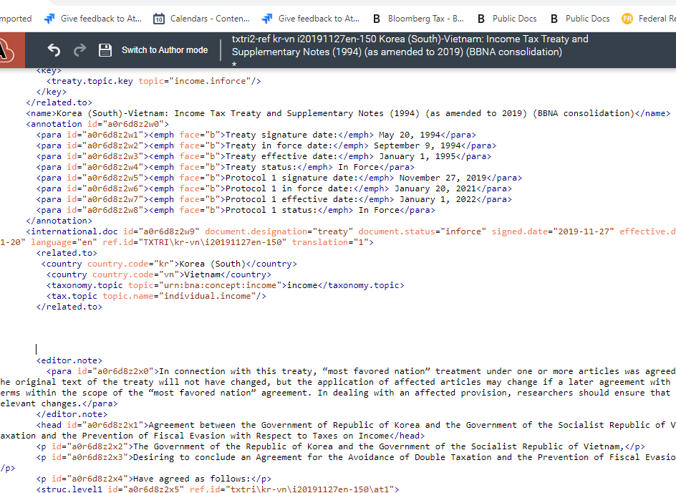
Insert Box here
Insert

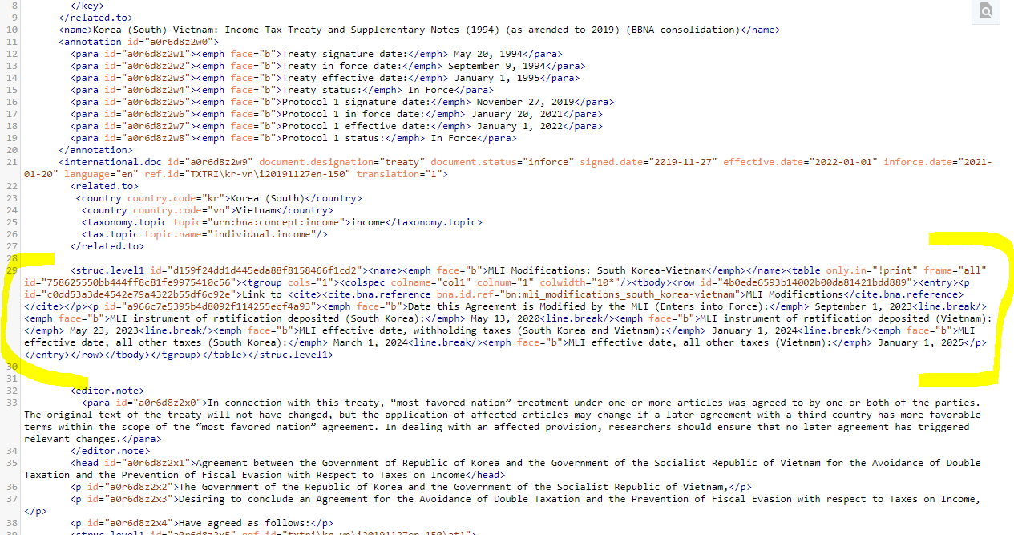
Make sure the link is the same as the bbcite in BDMS (add [1] if tht is what is indicated in BDMS log

After saving the file you can post.

NOTE: IF files in BDMS did not generate the BBLS and BDMS ids load the pdfs manually:

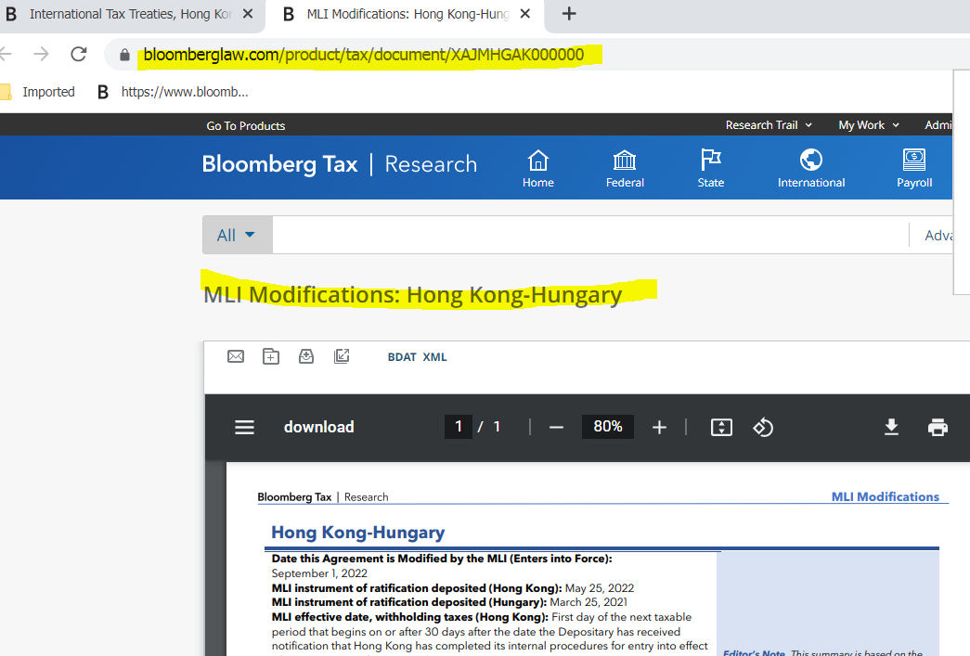

- Load file to BDMS to obtain bdms id
Use this sample for Document Title: MLI Modifications: Austria-Bulgaria
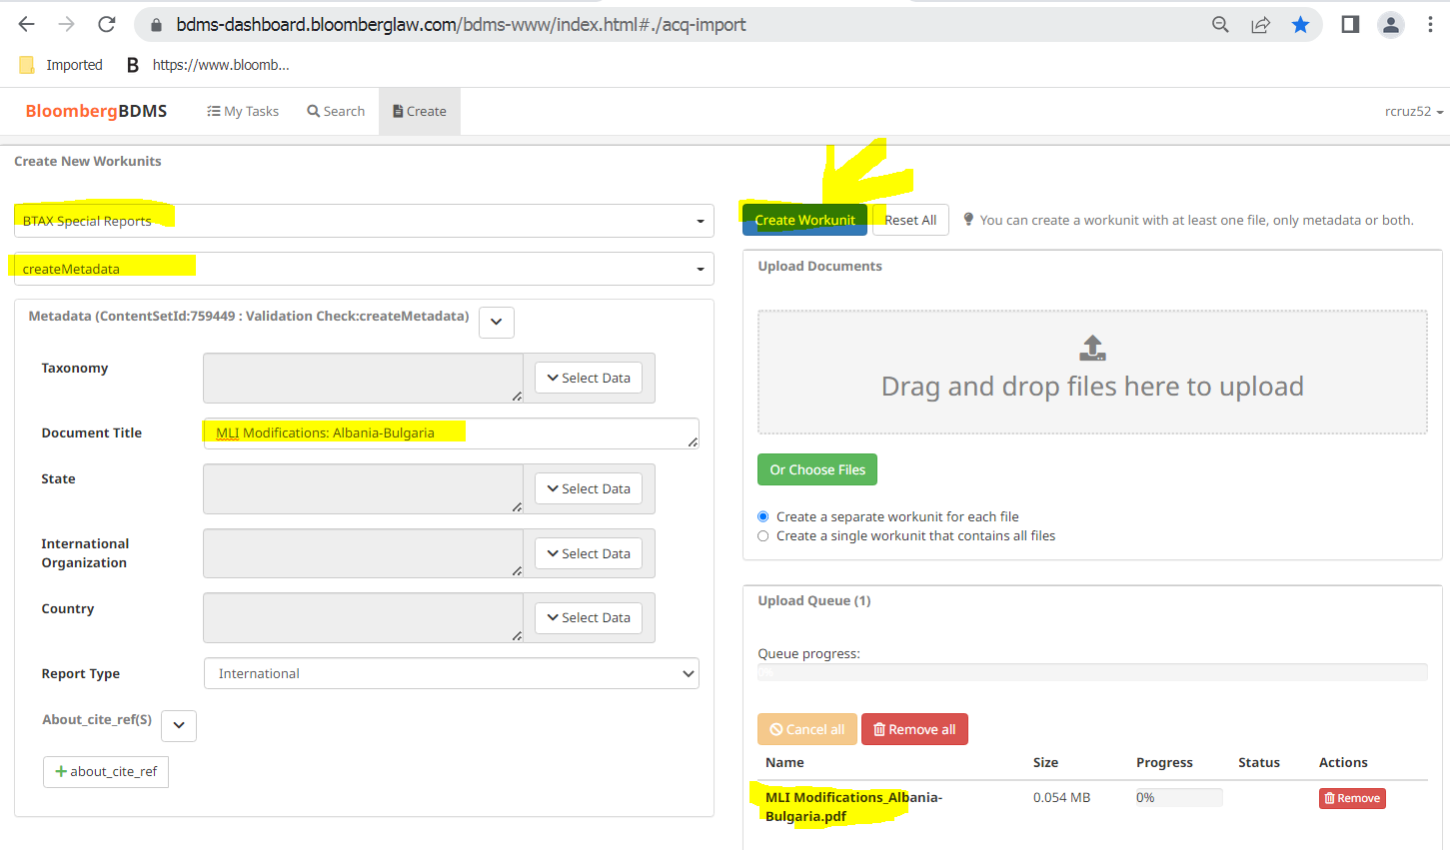

- Search using the bdms id
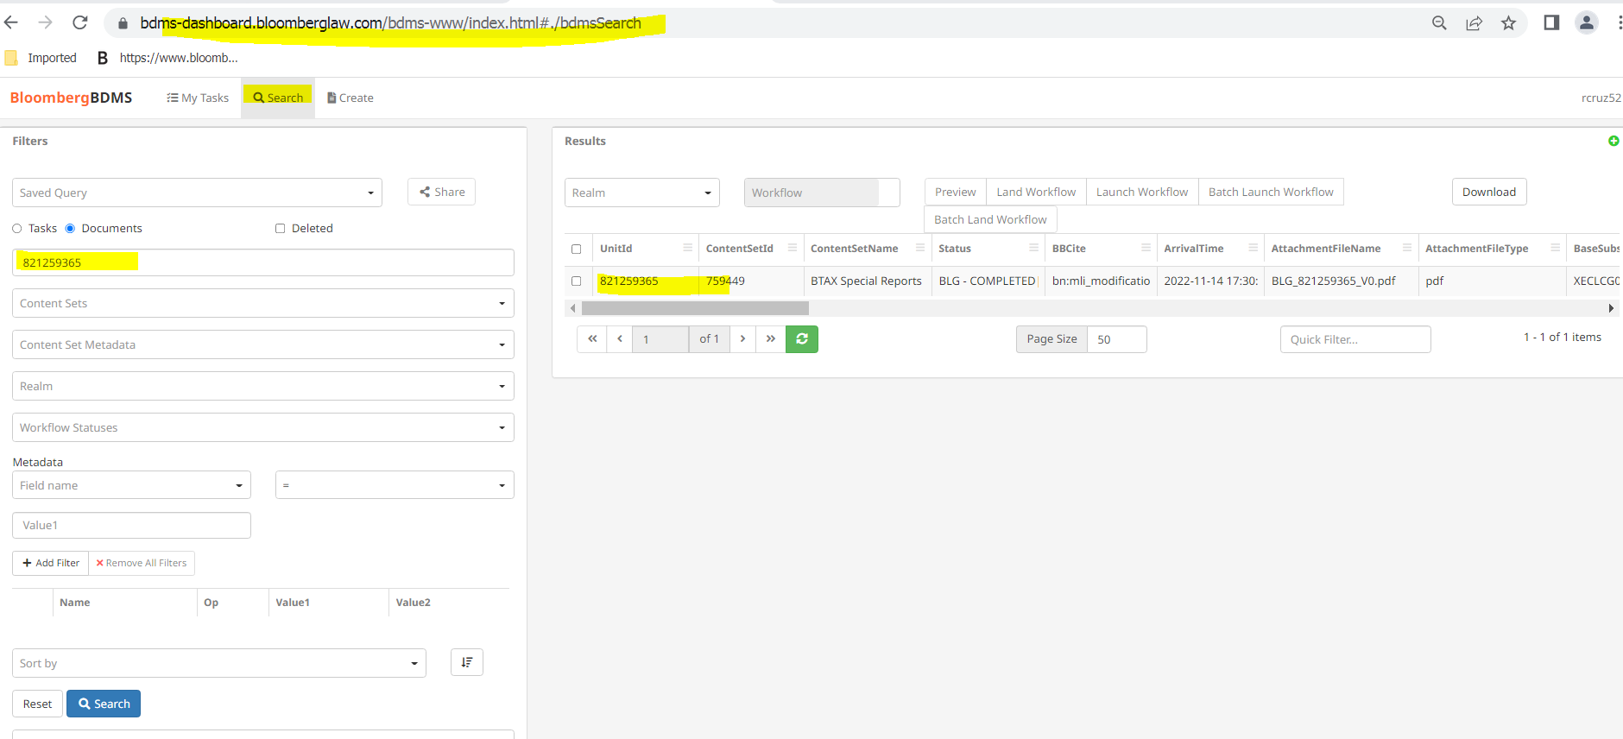

3. Use the BBLS id for the link
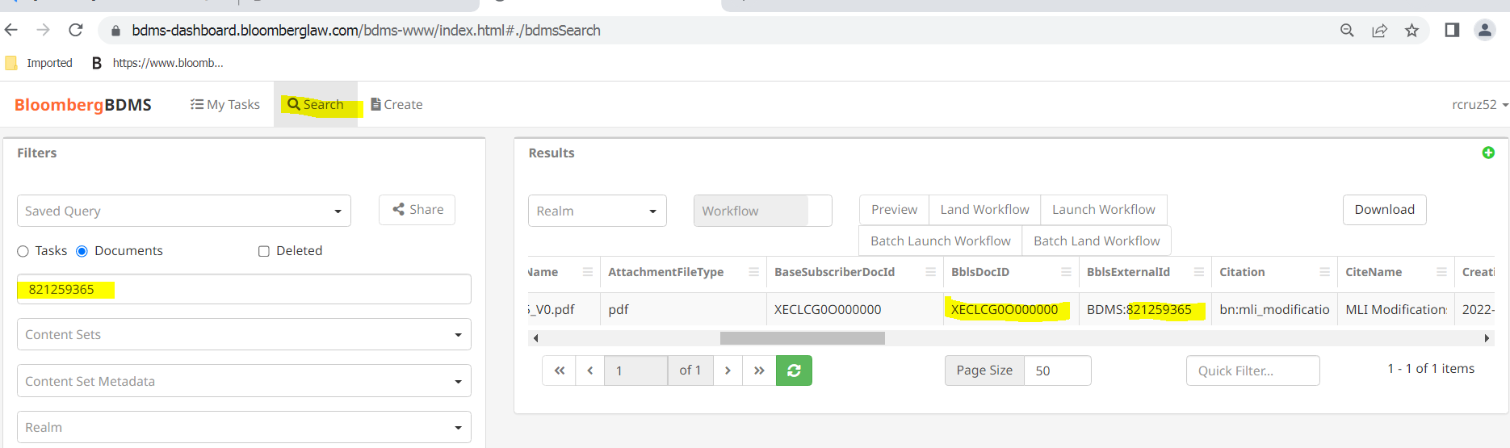

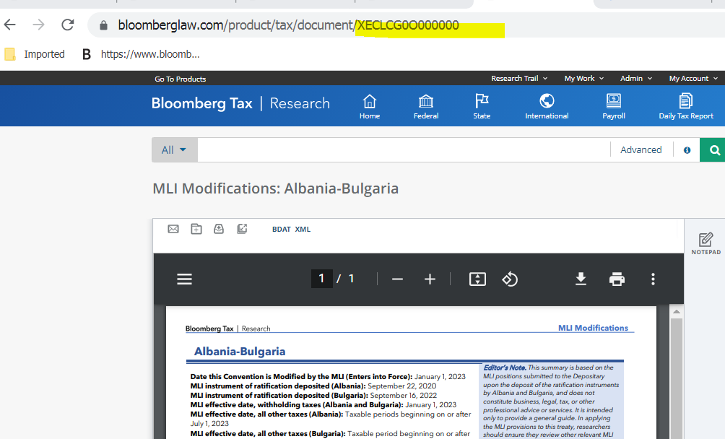

TO SEARCH FOR MLI FILES

- 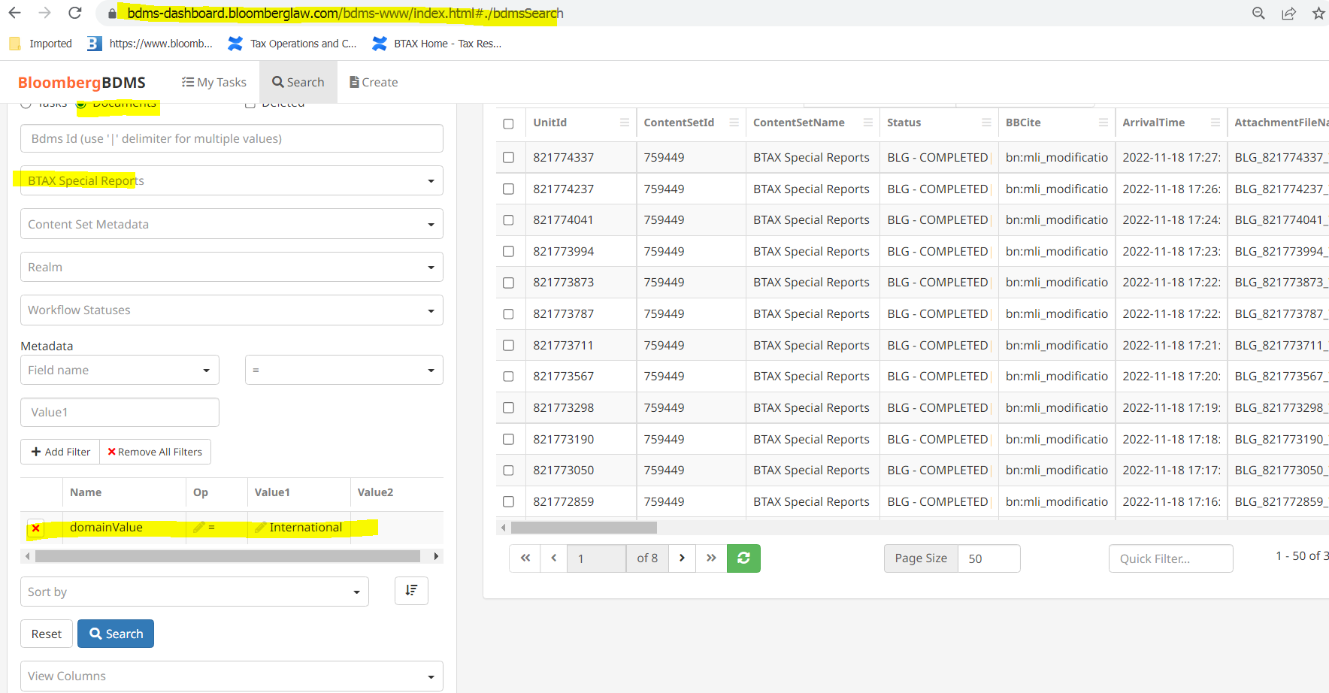

Or

2.
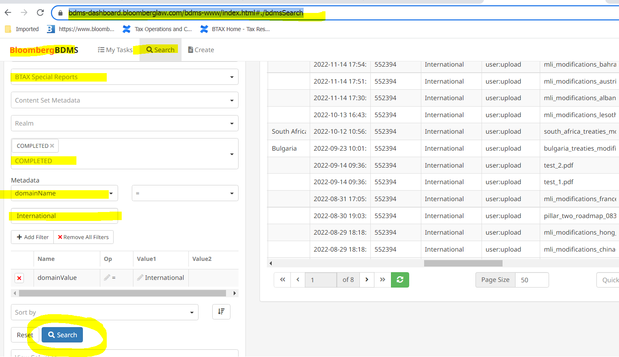

Inserting BBLS Ids to MLI files in BWIP

Go to BWIP and from the search in BDMS copy BBLs id to individual files in BWIP:

- 

 