Workflow of processing Portfolio documents

Download Source files from the Ticket
Create all chapters in WebQ

Convert source file as plain text for data cleanup (Phase I tagging)

Check the cleanup data and convert as xml

Copy converted xml file to WebQ for Phase II Auto tag execution

Download Phase II converted files from WebQ

Phase III tagging

A-Set
B-Set

File Compare

Tag balance

Citation checking

Check all TM references (Internal and External TM references) manually

If tables found in the file, need to check table content

Add related.to tags

QA

Validation

  - Copy validated files to WebQ
  - Send files from WebQ to BWIP
  - In BWIP renumbering of all footnotes

- Download Source files from the Ticket
- Create all chapters in WebQ
- Convert source file as plain text file to take for data cleanup (Phase I tagging). In cleanup process:
- Cleanup the text to match with source file;
Example (1):
We find errors in source file which needs to be corrected:
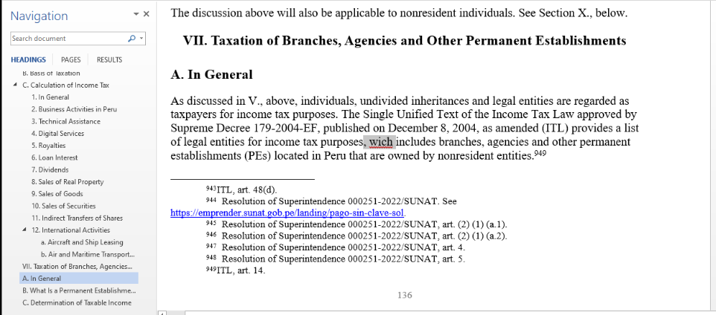
Example (2):
Highlighted text appears to be plain text in source file, for which link tags needs to be added:
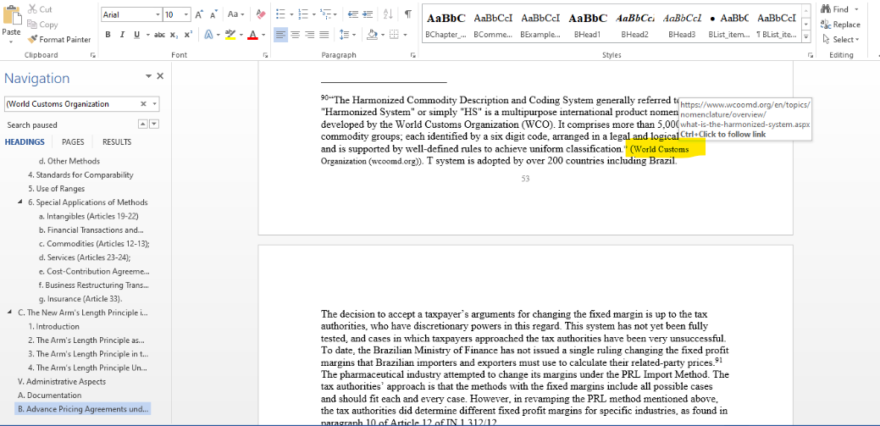

- Check and match all entity and emphasis tags;
- Match table text with source file;
- Tag all paragraphs like (<para>, <list.item>, <long.quote>, <example>, <note>, <case.name>); and
- Footnotes matching.
- Check the cleanup data and convert as xml:
- Necessary to add the metadata and info.unit attributes;
- Check all <list.item>, <long.quote>, <example>, <note> tags; and
- Convert the tables to cals table format.
- Copy the converted xml file to WebQ for Phase II Auto tag execution. In WebQ, execute auto tags for all chapters individually.
- Download Phase II converted files from WebQ to local system
- We check if any questions are raised by the team members. For clarification in the files, we check the previous version of the file on BWIP. If not clarified and still have doubt, we escalate the query to your team.
- Start process for Phase III tagging in two sets. It requires avoiding errors. Check, add and remove if needed, following tags:
- <cite.case.partial>
- <case.name>
- <cite.parallel>
- <decision.date
- <tribunal
- <procedural.info>
- <pin.point>
- Fed. Reg.
- T.D.
- T.M.
- USC & CFR sections
- Former
- Prior
- Pre & Post
- Repeal
- Proposed, Prop.
- Pub. L.
- Form
- Publication
- Notice
- Rev. Rul.
- Rev. Proc.
- CCA
- FSA
- PLR
- TAM
- REG-209054-87
- AOD
- Info. Letter
- Adv. Op.
- PMTA
- CC.Notice
- PRESS.RELEASE
- Statutes sections
- Regulations sections
- urls
- Compare the two sets of tagged files to identify differences. Once get the differences, have to match the source file and correct those errors.
- After comparing, will do the tag balance. In the tag balance match all citation tags. Opening and Closing tags should be matched.

In citation check process, we check all the citations and tables.
Example (1):
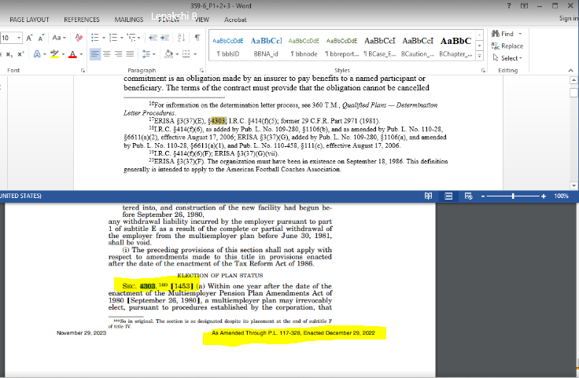
Here we have to search in the bill for adding the USC sections.

Example (2):
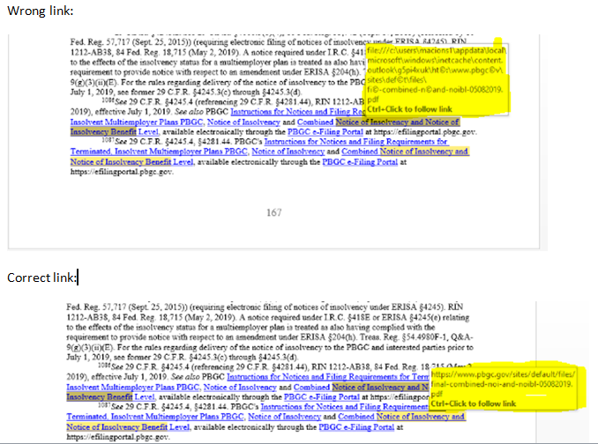

Example (3):
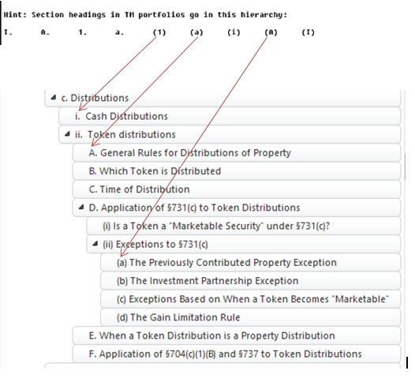
Here we have check heading levels as well as internal TM links.
Example (4):
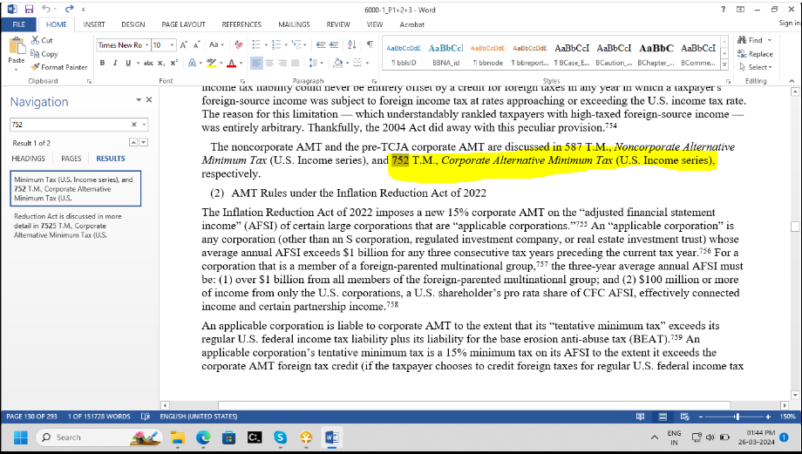
Here 752 T.M. should be 7525, we have to browse in google for correct number, or else search in whole file.

Example (5):
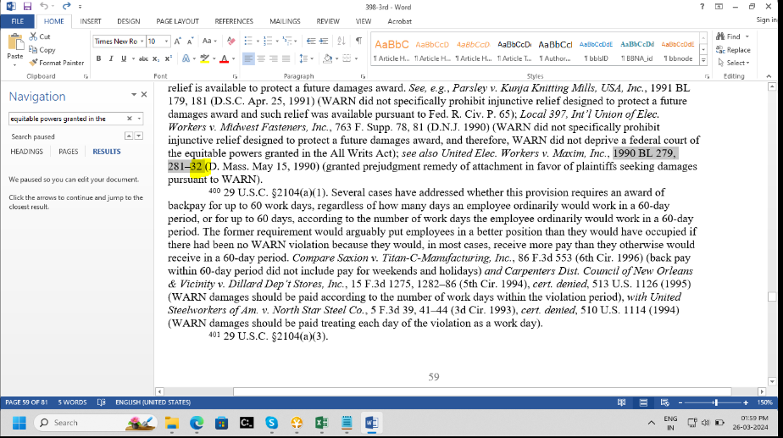
Here highlighted 32 should be 82.
Example (6):
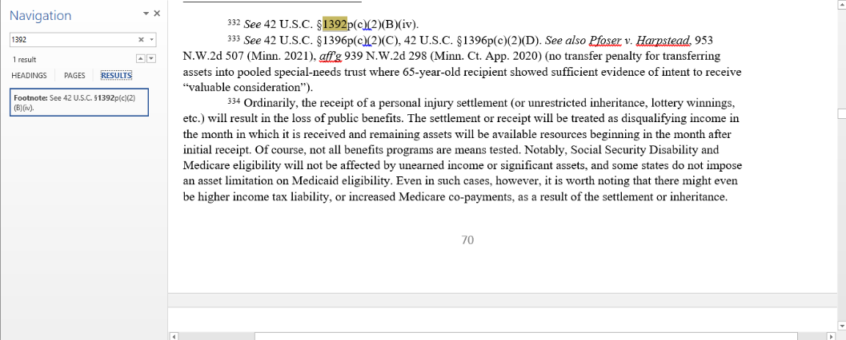
Wrong USC section number. Section 1392p should be 1396p.
- We check all TM references manually and one by one, like above, below, described, chapter in whole documents.

Example (1):
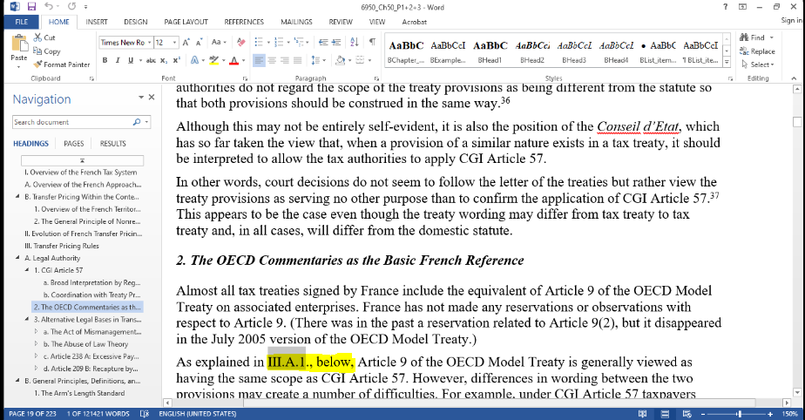
Example (2):
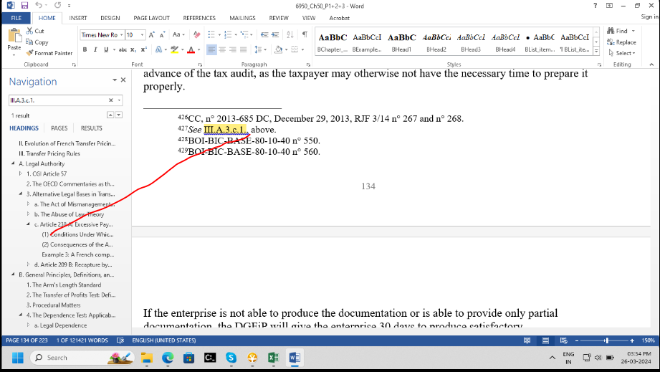

- Add the “related.to” and “highly.related="1”
- In Quality Check, check the all the <content.group> tags, Meta data attributes, Headings levels etc.
- Validate the file and clear any errors.
- Finally copy all chapters to BWIP.
- Copy validated files to WebQ;
- Send files from WebQ to BWIP; and
- Renumber all footnotes in BWIP.
- Notify completion of work and mention utilized man hours in the ticket.

