Image in Portfolio with Caption tags

- Open file in PDF
- Export file as a Powerpoint (pptx)
- Open file in Powerpoint & Export> Change file type>PNG
- Open png file in Paint
- Resize to 200%
- Load to Orca

<footnote id="b45f1473fd994989b8ade7a87f8017d9"><footnote.marker><superior>1558.1</superior></footnote.marker><footnote.text><para id="6e53df7a81724ddf929a3895768398eb">For a visual depiction of the formula in §163(j)(4)(C), see Formulas Illustrated, <cite.url ref="https://www.bloomberglaw.com/product/tax/document/XFRAAOIC000000"><emph>§163(j)(4)(C): Excess Taxable Income</emph></cite.url></para></footnote.text></footnote></para>

<para><include only.in="!print">
<image id="orcaxxxxx" horizontal.position="C" cd.display="inline" image.width="52" print.width="35">
<link.text/>
<caption><emph face="b">Notes and sources:</emph><line.break/><superior>a</superior><line.break/><superior>b</superior><line.break/><superior>c</superior><line.break/><superior>d</superior><line.break/><superior>e</superior></caption>
</image></include></para>

Use the tagging below to retain aspect ratio
Note: Image depth must be equal to “0” or else there will be validation error.


Try the dimensions of this first (leave print depth blank):

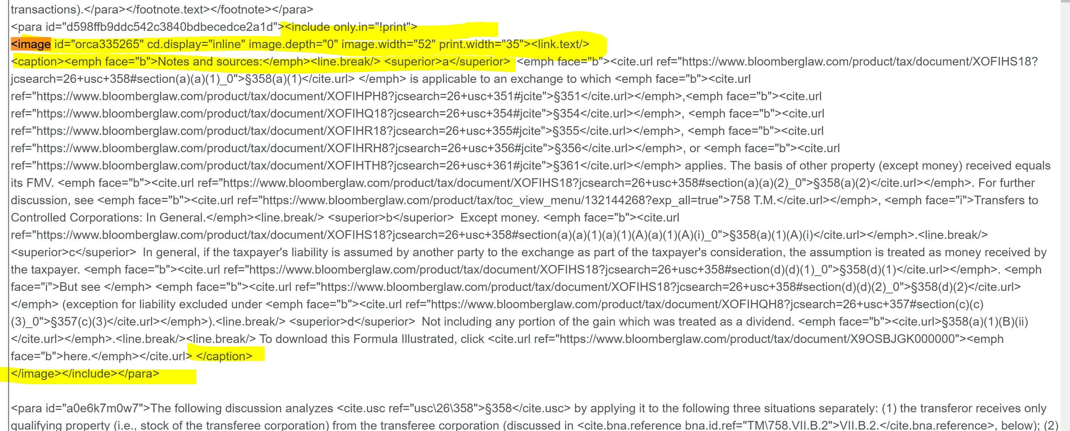

<para id="a0ec6baa2d6b4747bd52aa663b4946d3">
<include only.in="!print">
<image id="orca367831" cd.display="inline" image.width="52" print.width="35">
<link.text/>
<caption><emph face="b">Notes and sources:</emph><line.break/><superior>a</superior>§163(j)(4)(C); Reg. §1.163(j)-1(b)(17). For further discussion, see 536 T.M., Interest Expense Deductions, at V.E.8.<line.break/><superior>b</superior>§163(j)(4)(C); Reg. §1.163(j)-1(b)(17). For further discussion, see 536 T.M., Interest Expense Deductions, at V.E.8.<line.break/><superior>c</superior>Business interest expense means interest expense that is properly allocable to a non-excepted trade or business or that is floor plan financing interest expense. Business interest expense also includes disallowed business interest expense carryforwards. It does not include amounts of interest expense carried forward to the taxable year from a prior taxable year due to the application of the at-risk rules or the passive activity rules, which apply after the application of §163(j). Reg. §1.163(j)-1(b)(3). It does not include investment interest. §163(j)(5).<line.break/><superior>d</superior>Floor plan financing interest expense means interest paid or accrued on floor plan financing indebtedness. All floor plan financing interest expense is treated as business interest expense.Reg. §1.163(j)-1(b)(19).<line.break/><superior>e</superior>Business interest income is the amount of interest includible in the taxpayer’s gross income which is properly allocable to a non-excepted trade or business. It does not include investment
interest. §163(j)(6);Reg. §1.163(j)-1(b)(4).</caption>
</image></include></para>

