Hyperlinks/adjusting Rows to Pass Through Entity Tables

- To adjust depth of rows click on show paragraph marks to get rid of hidden hard returns.

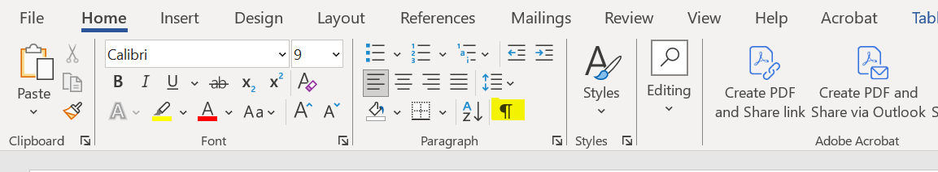

- For hyperlinks to Jump to State:
- Highlight name of State:
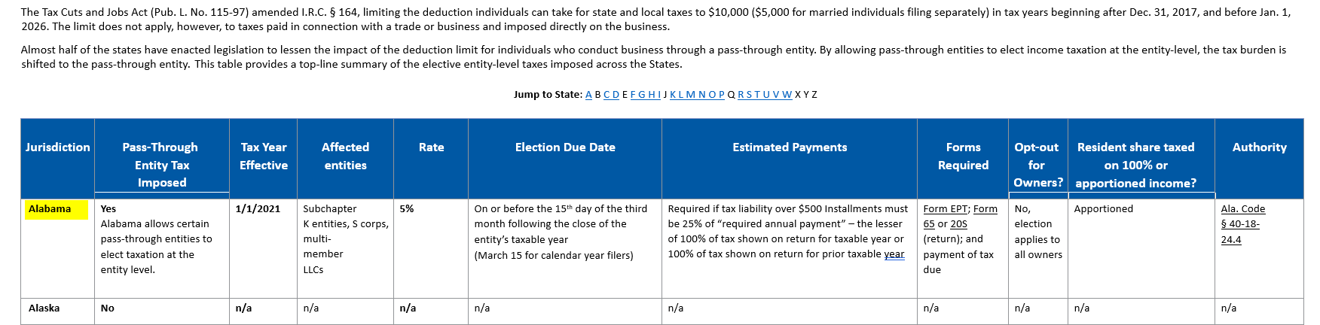
- Ckick on Bookmark on the Insert field: 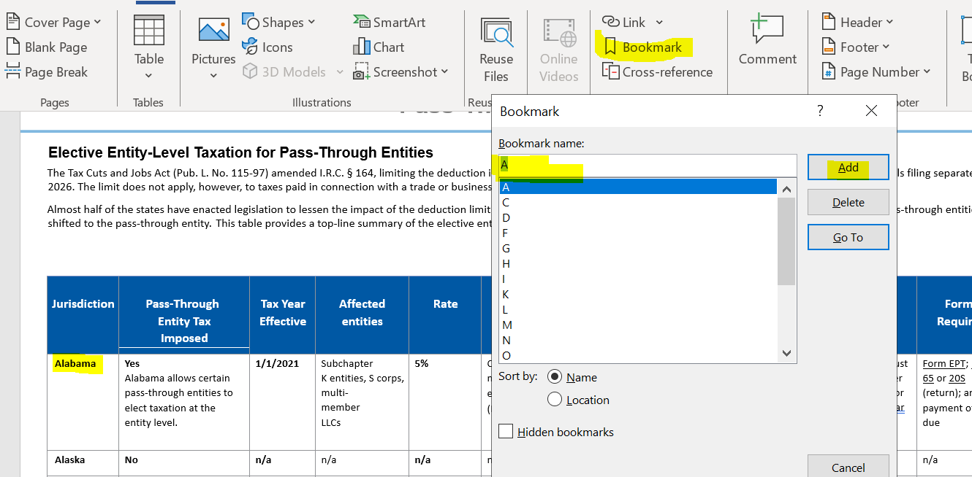
- Highlight letter A on the Jump to State line:
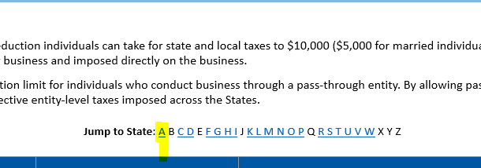

- Click on Link:
- 