How to filter JIRA tickets with Attachments only

To countries with multiple tickets – link tickets to an origin ticket

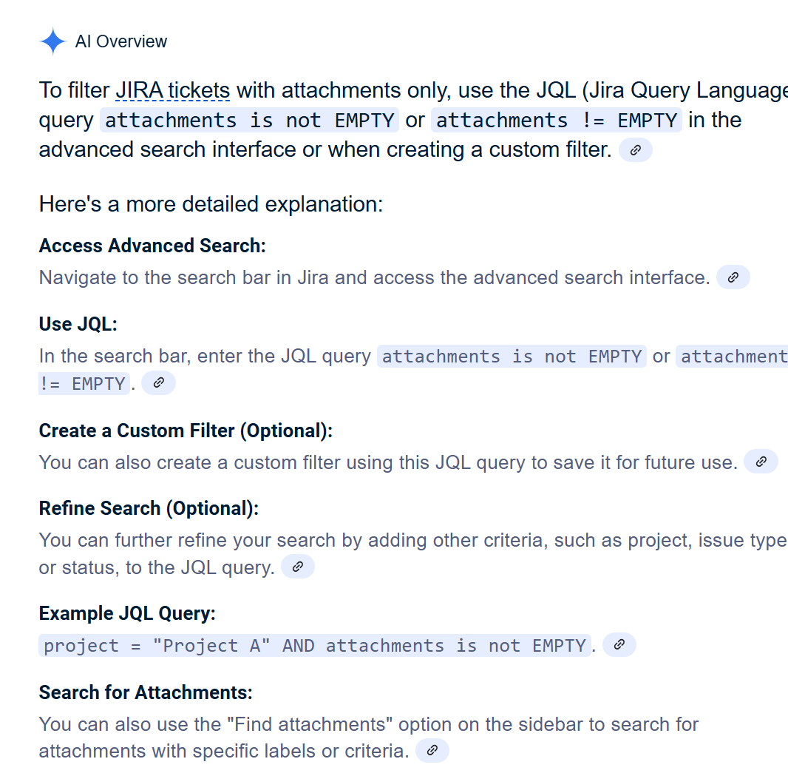

SAMPLE:

WITH ATTACHMENTS
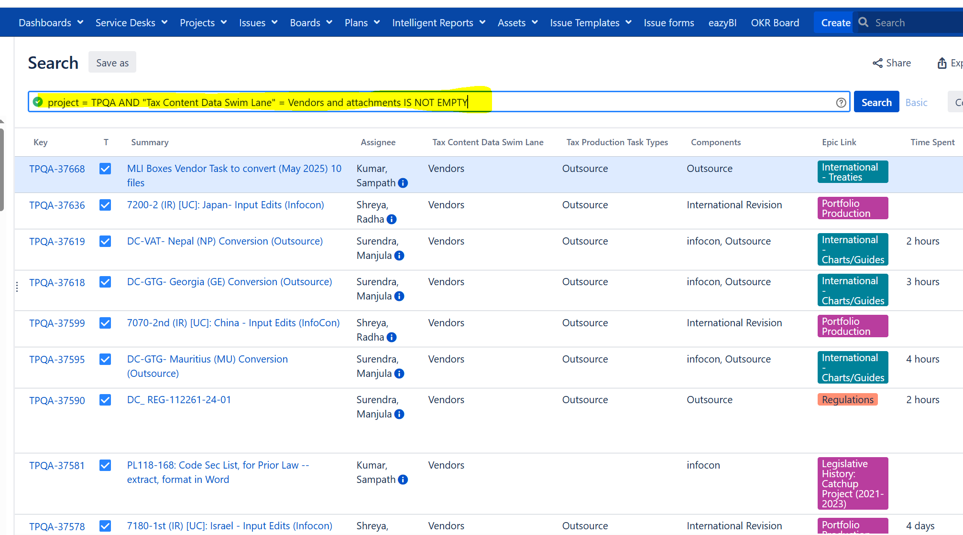

WITH NO ATTACHMENTS

