THow to add an article to the TPQA confluence page

- Click on Federal Documentation (if you want the topic to be under Federal Documentation, click on Tax Production and QA if you want it to be a sub section of TPQA)

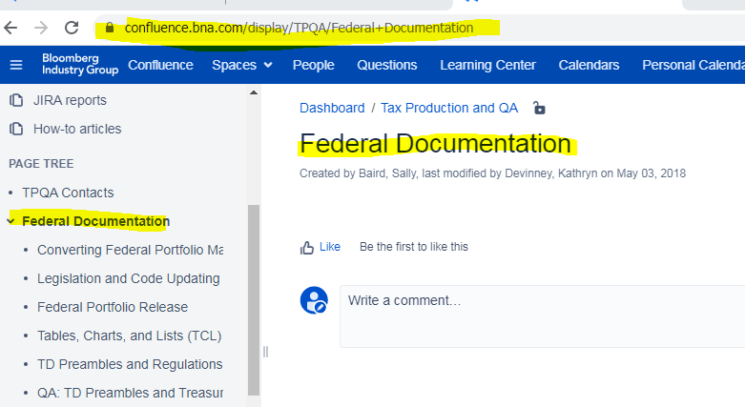

- Click on Create, fill in Page title, type details of the documentation (body)

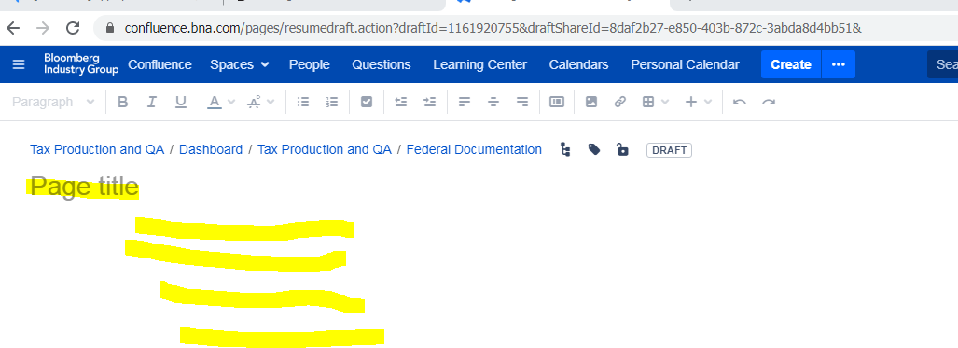

- Click on Publish
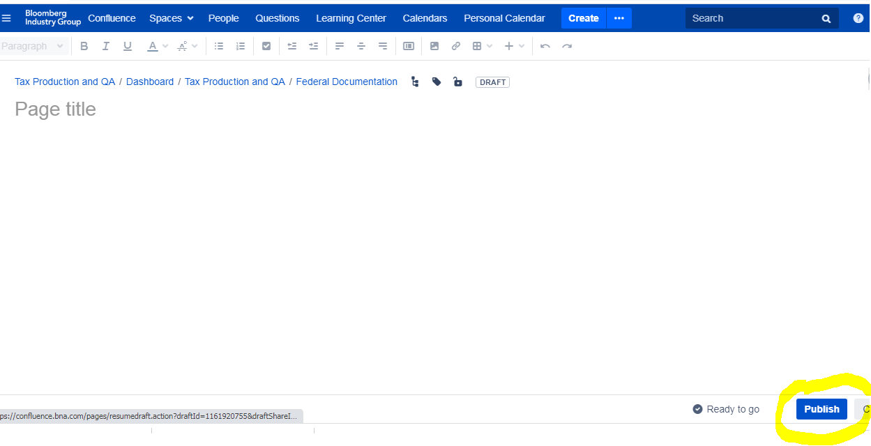

If you want to edit after being published, click on the article , then click on EDIT

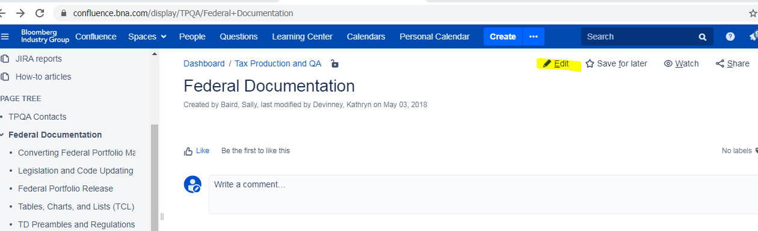

To insert task box:
