How To Create an Obsolete Cite Report with Worksheets for:
Obsolete Topic Cards, Obsolete IRC Cards,
Obsolete Cites Across BTAX, Metadata Worksheet & QA Worksheet

**Details for each Worksheet component are described in detail in documentation on Confluence. This document describes how to set up the Obsolete Cite Workbook.

Topic | Page
Primary Goal | 1-2
About BNA Topic Card Picks | 2
Basic Workflow Diagram | 4
Create Obsolete Cite Workbook for New Portfolio:  Detailed Steps 1-8 | 4-5
Additional Information:  5 Sample Worksheets | 5-10

- Primary Goal: When a new portfolio is published on BTAX, the Obsolete Cite Workbook is the foundation to report obsolete cites, obsolete pinpoint cites and issues identified during QA.
- Creating an Obsolete Cite Workbook is the FIRST STEP to do the obsolete cite processes.
- Each Workbook consists of (5) worksheets corresponding to the specific tasks of obsolete cite identification, reporting and updating.

- When each task is completed the Obsolete Cite Workbook is Uploaded to the TMTT Portfolio manuscript ticket for Analyst review and e-mailed to the Portfolio Production staff [Murat].

Trigger: Notification by Murat -or TPQA Portfolio Production --- of New Portfolio of release or pending release of a new portfolio.
An updated portfolio is classified as NEW, when its:
- completely brand new with no prior genesis.
- new edition of an existing portfolio, or
- renumbered.
- In the case of #2 and #3, the portfolio may also have a modified or new title.

Aliases: BNA Topic Card Picks are also referred to as Topic Baseball Cards or Simply Picks.
Applications: Excel to create Obsolete Cite Workbook.
Time Required:@1 hr.

Basic Workflow Diagram

First Step of Obsolete Cite Processes:
Create Obsolete Cite Workbook for New Portfolio + Detailed Steps 1-8

- Open a new Excel Workbook in Excel and name the Workbook:
Obsolete Cite Workbook for Portfolio XXX (replaces XXX) xxx= Portfolio number

- Add (5) worksheets with the following names: (XXX = Portfolio number)
- Topic Cards Obsolete Cites XXX
- IRC Card Obsolete Cites XXX
- XXX Obsolete Cites Across BTAX
- XXX Pick Metadata WKSHT
- QA Report XXX

- In the Top rows for each worksheet add the following information:
- Worksheet name
- Portfolio Title and edition
- Obsolete Portfolio Title and edition
- Emphasize title change if applicable

- On the Topic Card Obsolete Cite Worksheet, add columns:
- Topic Card Obsolete Cites
- Container Heading
- Container Name
- Cite
- TPQA Action
- Analyst Action
- Analyst Comments

- On the IRC Card Obsolete Cite Worksheet, add columns:
- IRC Card Obsolete Cites
- Container Heading
- Item Name
- Cite
- TPQA Action
- Analyst Action
- Analyst Comments

- On the Obsolete Cites Across BTAX Worksheet for XXX, add columns:
- Content group
- Citation
- TPQA Action
- Analyst Action

- On the Portfolio XXX Metadata Worksheet, add Columns:
- BNA Pick Name
- BNA Pick Heading
- Chapter I
- Chapter II
- Chapter III
- Chapter IV
- Chapter V
- Chapter VI. Continue adding Columns for Chapter VII -Chapter IX. If the Chapter has additional chapters, you can add columns as necessary.

- On the QA Report for XXX (replaces XXX) Worksheet, add Columns:
- Location/Chapter
- Issues
- TPQA Action
- Analyst Action

5 Sample Worksheets With Populated Findings.

- Sample: Topic Card Obsolete Worksheet
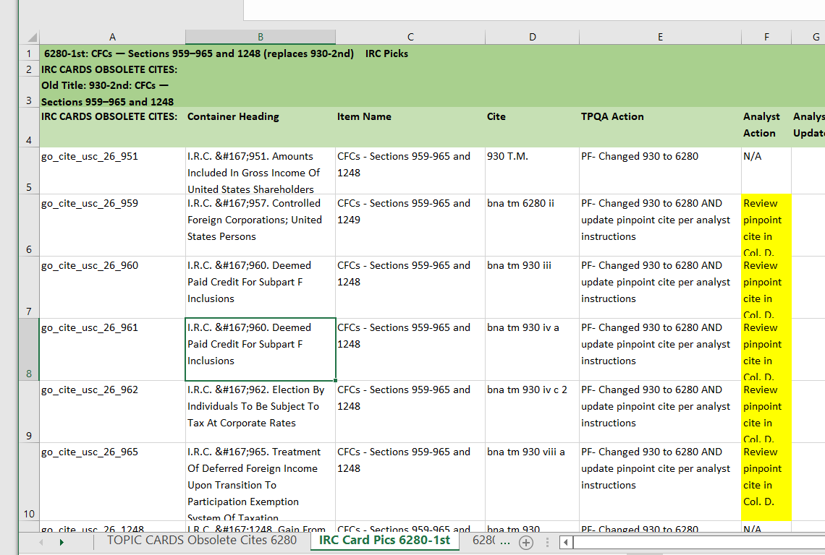

- Sample: IRC Card Obsolete Cite Worksheet:
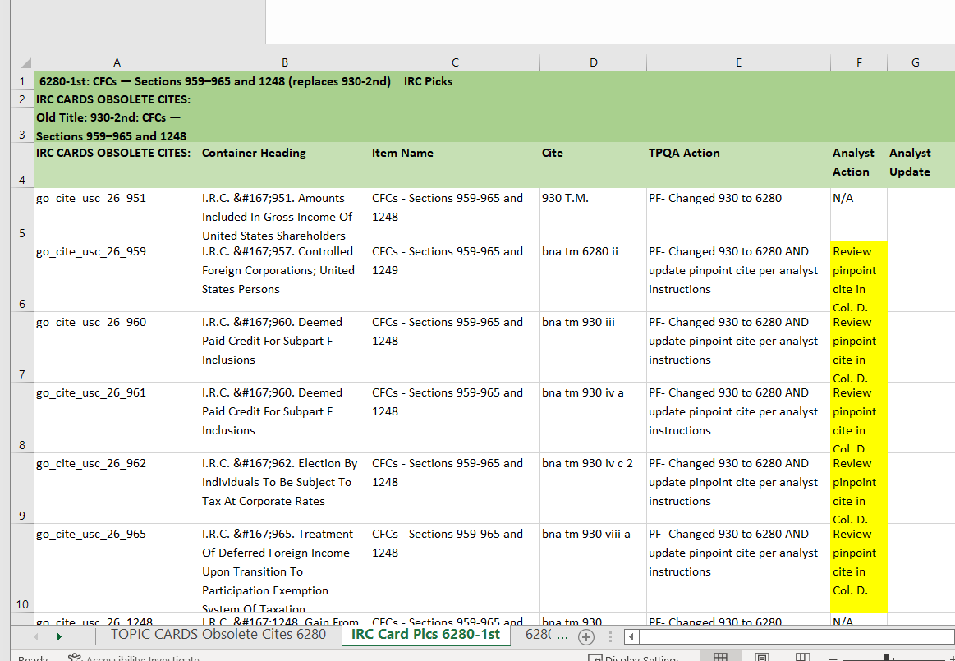

- Sample: Obsolete Cites Across BTAX Worksheet:
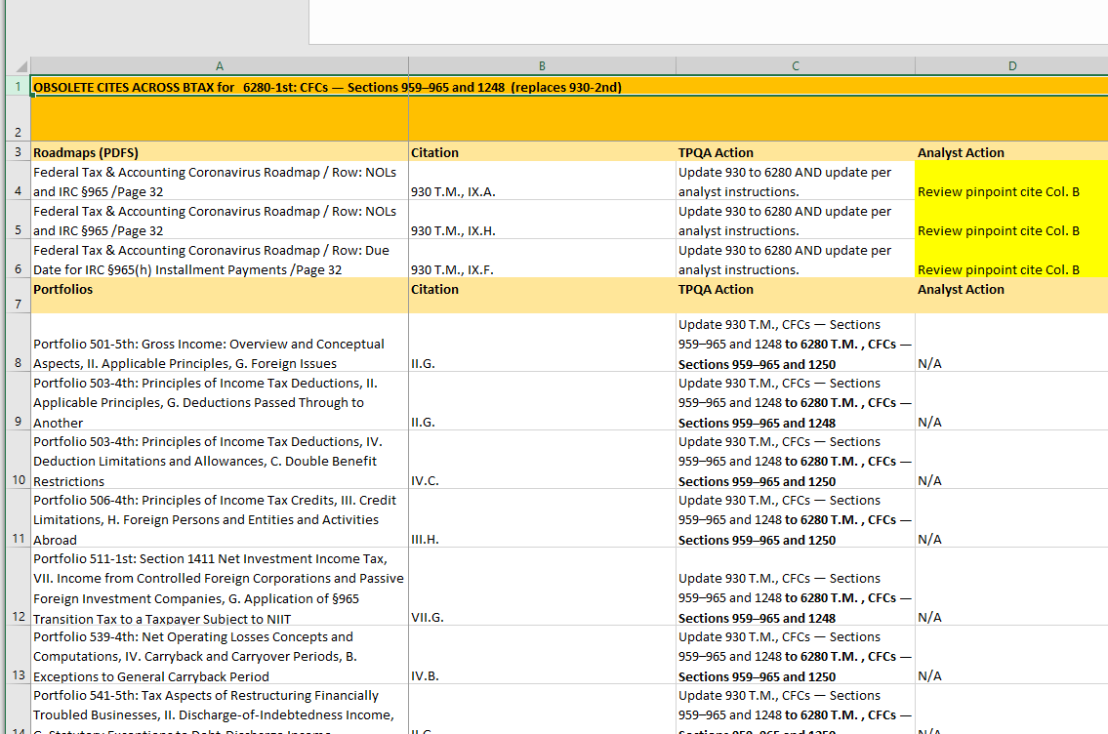

- Sample: Metadata Worksheet
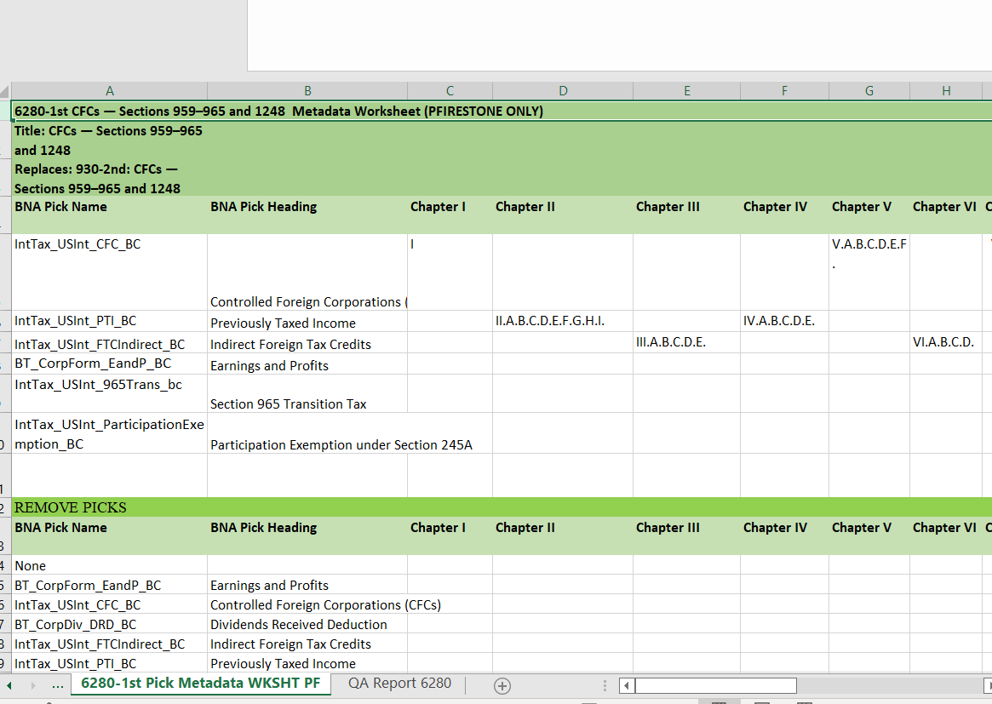

- Sample: QA Report Worksheet:
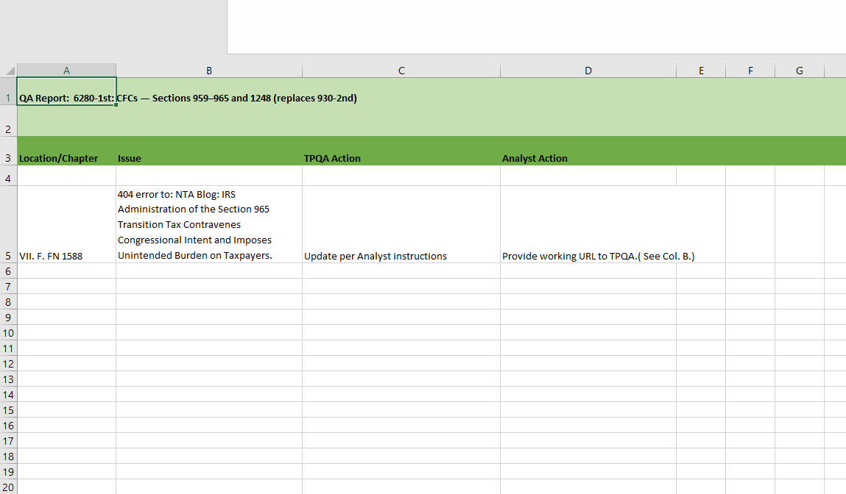

Created Nov. 10
Pfirestone@bloombergindustry.com
End

