- Open file in Paint (not paint 3D)
- Click on Select 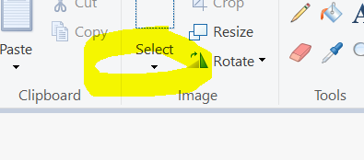

- Select Rectangular section on the Select tab
- Click on Crop
- Click on Resize (Resize and Scew)
- Unclick maintain Aspect ratio
- Click on Pixels
- Set Horizontal to 400 & Vertical to 480
- Save as tiff (tiff file when loaded to ORCA generates the other files while png does not)
- Load to ORCA (reserve an IM number and rename file)
- Copy renamed file with IM number to Filetrain 00080 Headshots
Fill up :
