Headshot Workflow
- Download the photo file to your computer.
Right click on image file in ticket. “Save link as” and place in designated folder.
- Right click on image file and “Open with” Photos. Check for size and quality. If the quality of the image is poor let the editor know that it would be better if they can send another file.
- 100kb or more preferred. Lower than 10kb will be poor quality.
- If the image is large but the person is a small part of the image, it may also be poor quality.
- Check for problems such as a blurry image or jpg artifacts.
- Click the edit tool. (upper left with highlight)
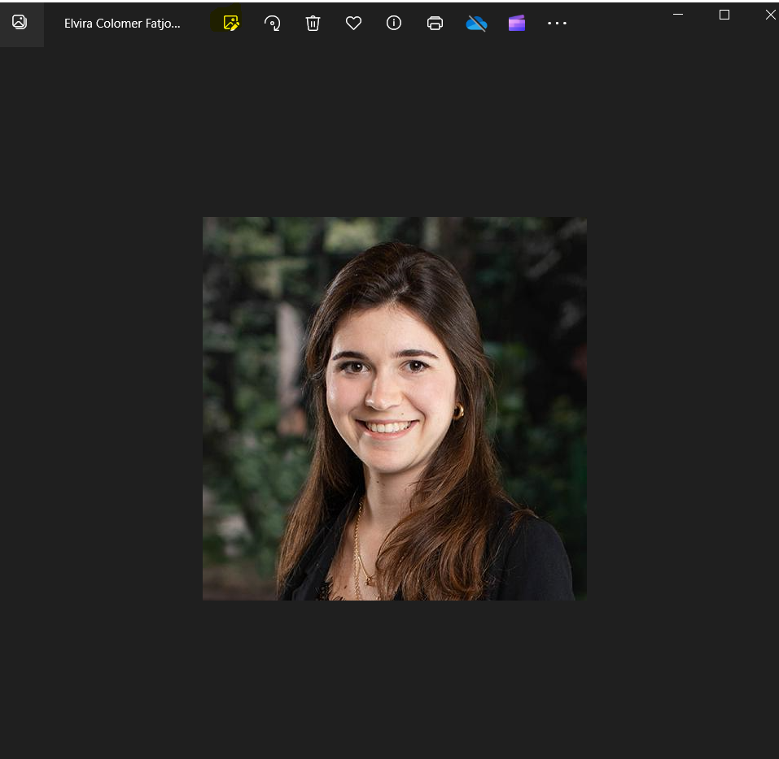

Use crop tool to adjust to a headshot format (approximately ½ in above the top of the head, 1 3/4 to 2 inches below the chin, and ½ to 3/4 inch from the side of the face) .
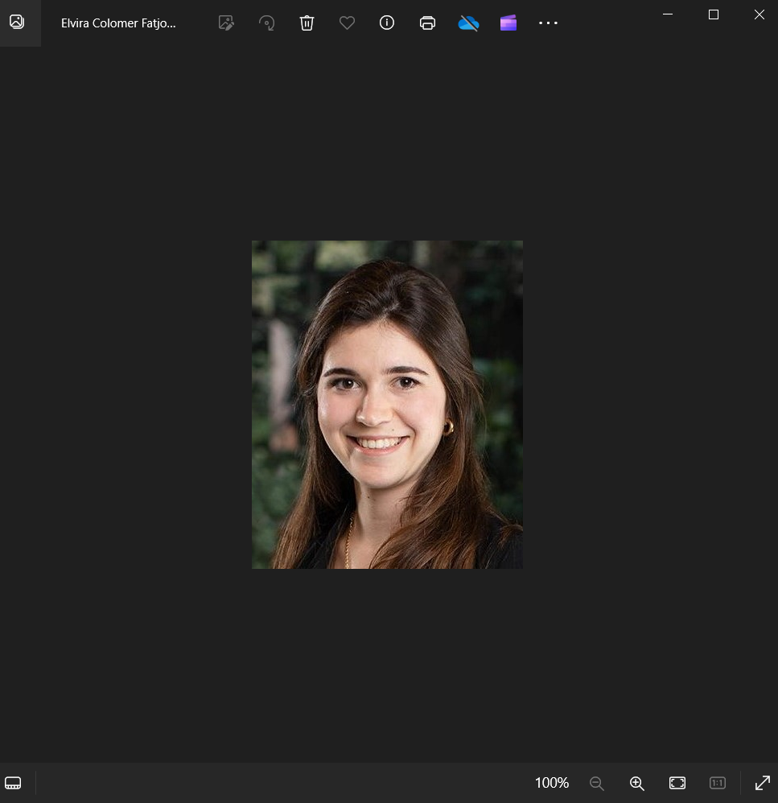
Click on save a copy. Save to drive add a “1” after the name so the original file stays the same. If you want to save the cropped image and over right the original then click on the drop down and click save.
Go to the toolbar and click on the three dots on the right.

Click on resize the image (this may take a couple of tries).
The width should be 400 pixels and the height is 480. (based on the photoshop canvas)
MS Photo adjusts the values based on the crop. Below is 480h x 396w. Add the height value of 480 and if the width is larger or smaller than 400 by 5 or 8 pixels then that is okay. If larger or smaller then recrop the original image so it is closer to 400. Click drop down to change file to png. Save the file with the name of the author.
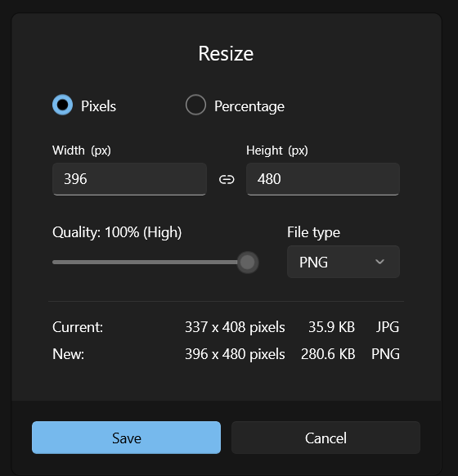
- Open Orca and go to Upload tab. Drag the png file created into Orca.

- Go to https://orca.bindg.com/

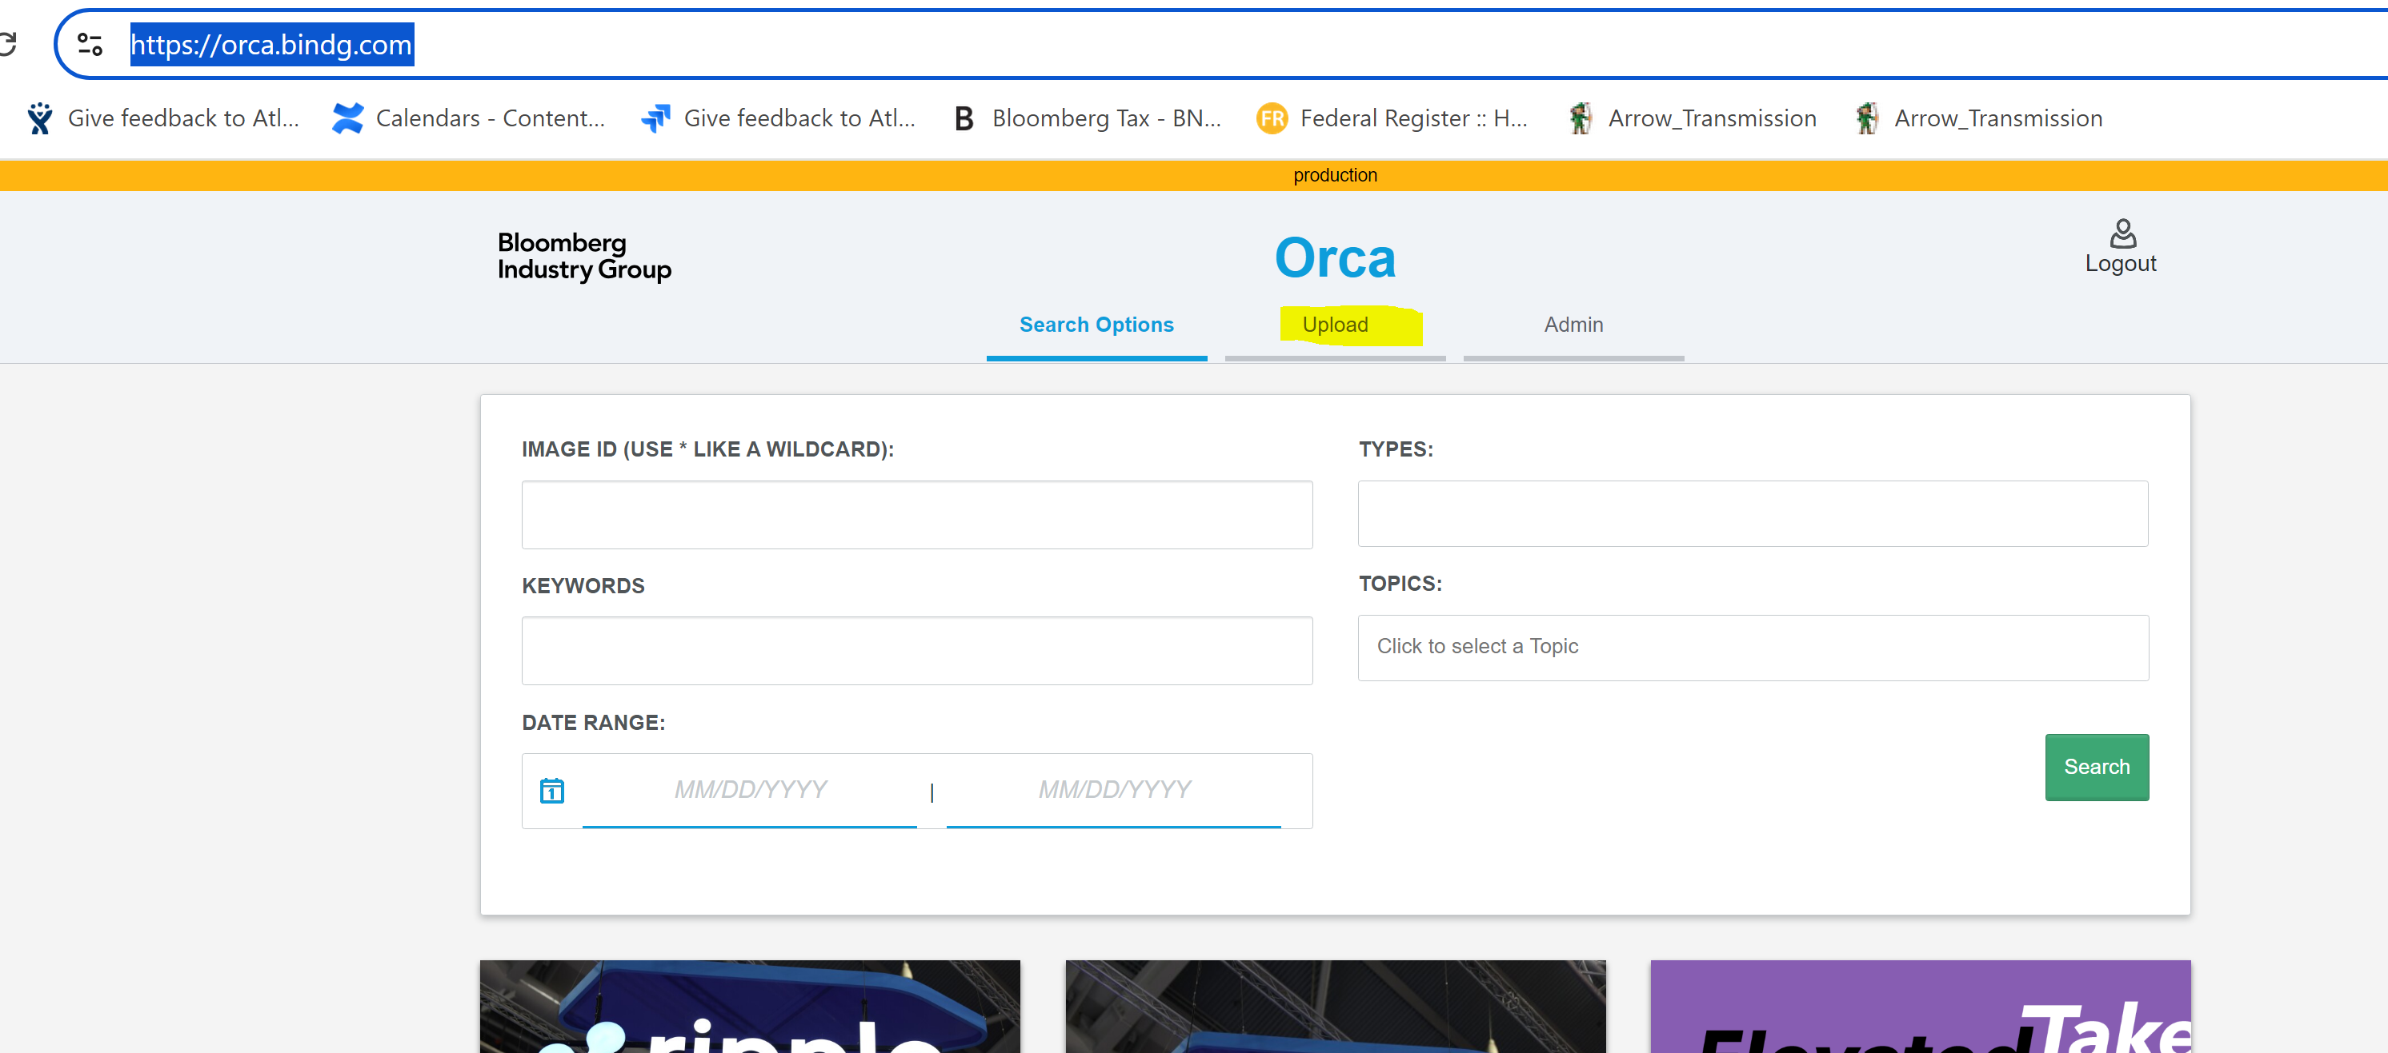

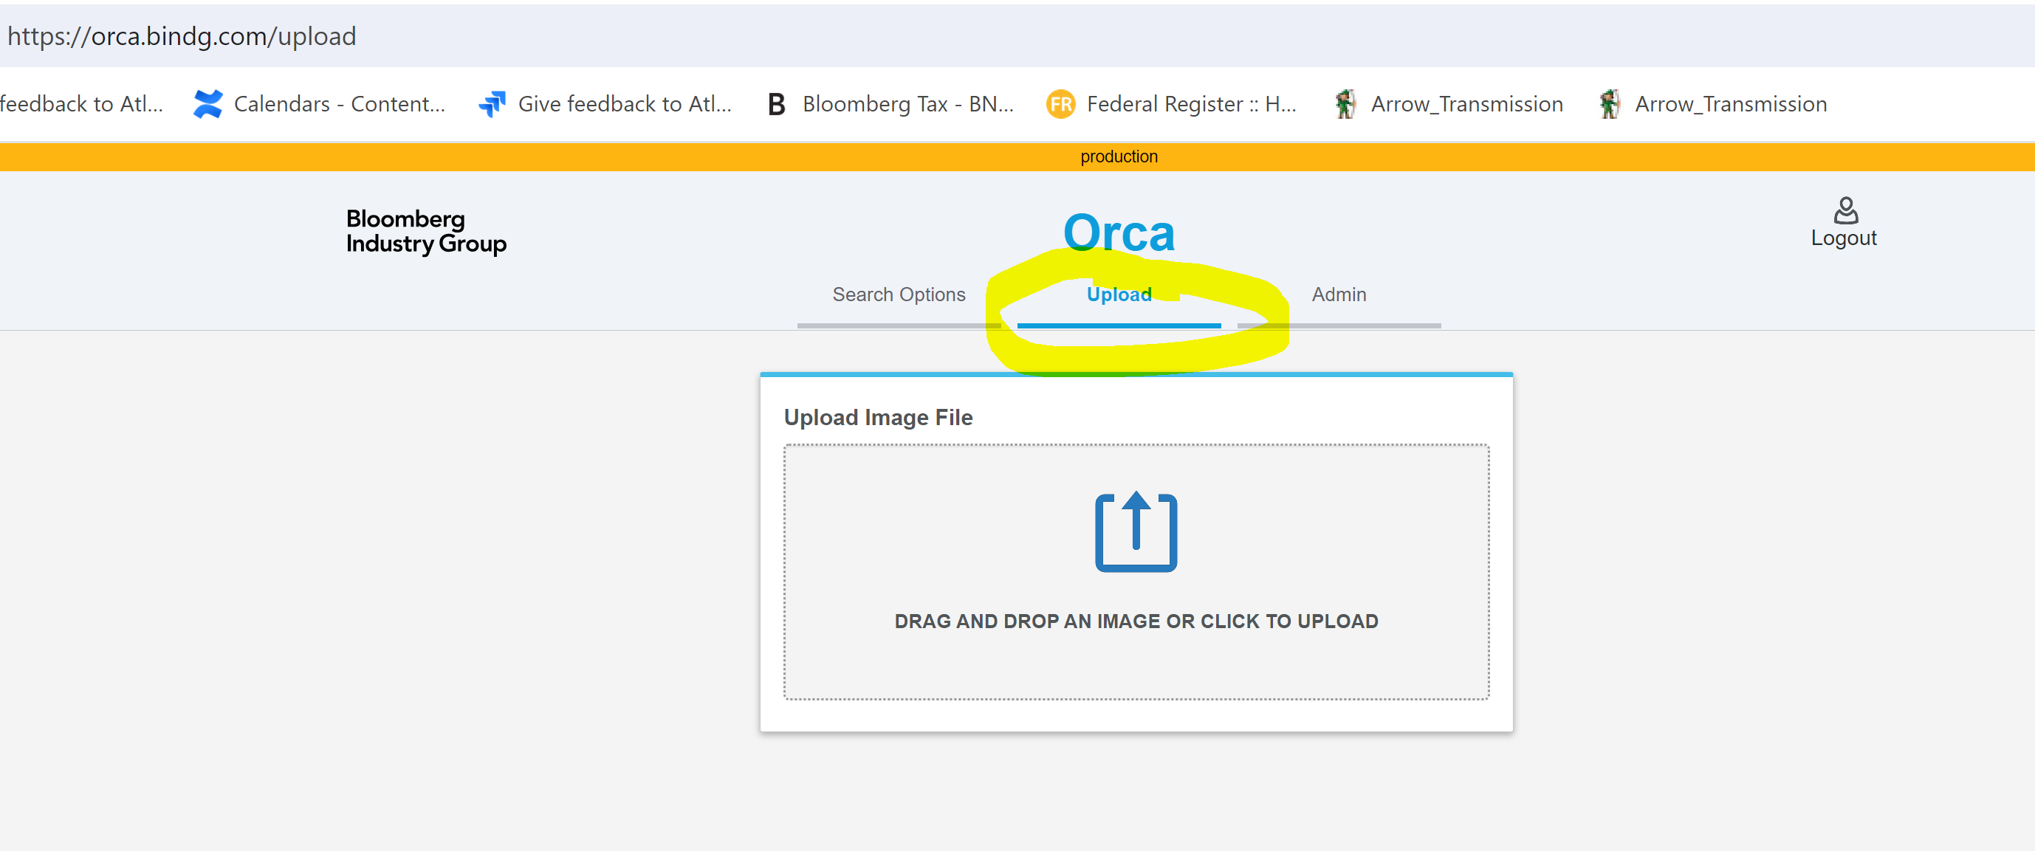

- Orca will generate the number and then fill in the fields.

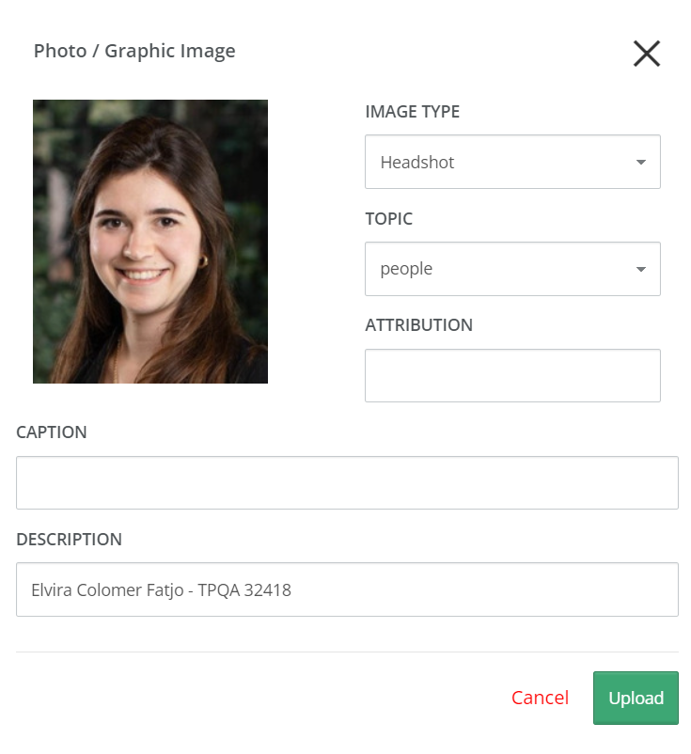
Image Type: Headshot
Topic: people
Description: Name of author and TPQA #
Click on Upload
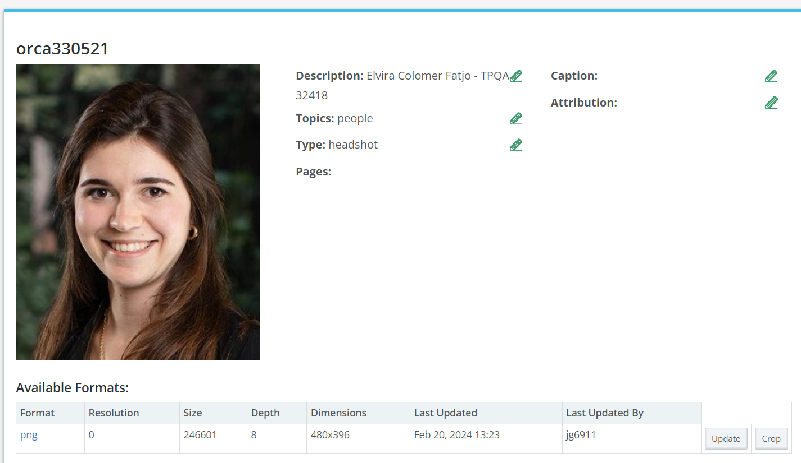
- ( No need to do this if you made the request) Go to ticket and add the orca number along with @ the requester’s name so they get all the info. Each image will need a number so if there are multiple images in the ticket add them:
orca330521 – Elvira Colomer Fatjo

