Headshot Workflow – Step by Step
- In Orca, search on the name under “Keywords” to see if the person is in the system. Often older entries are not marked as a “headshot” type, so don’t use that to search. Use the first or last name, because the original may not have a middle initial.
* We can't use wildcards to search any more. If searching on "William," you may need to check "Will" and "Bill."
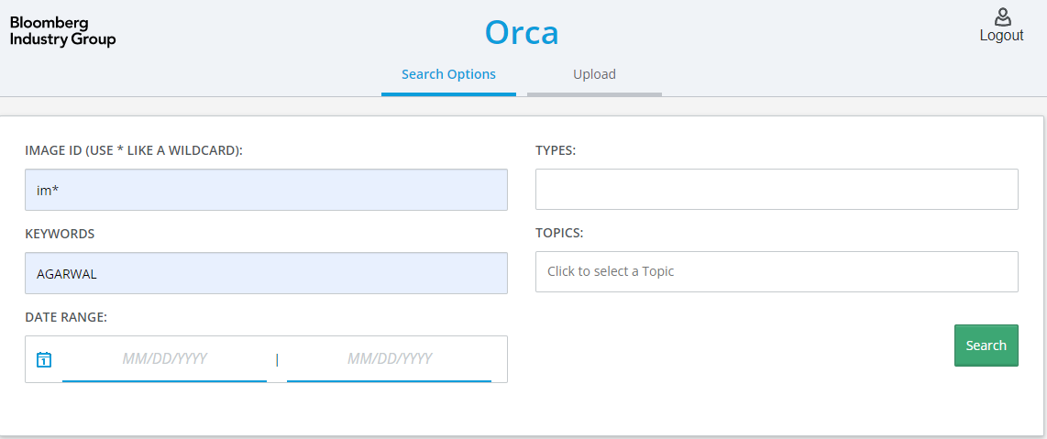
This search found five images, but the one provided by editor looked like im238324.
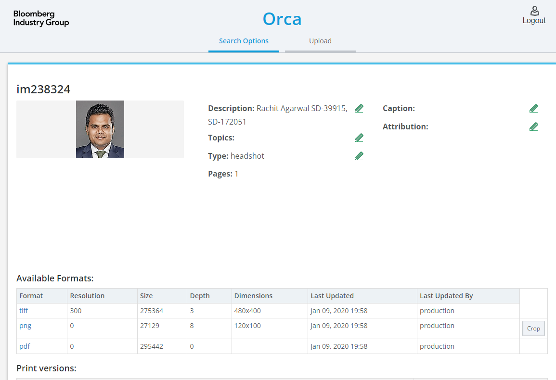
Under the description section click on the edit pencil and add the Jira number.
- If there is no old headshot, go under “Admin” in Orca and reserve the IM numbers needed.
Alphabetic Prefix: im and click on reserve. The new IM will appear in Generated IDs.
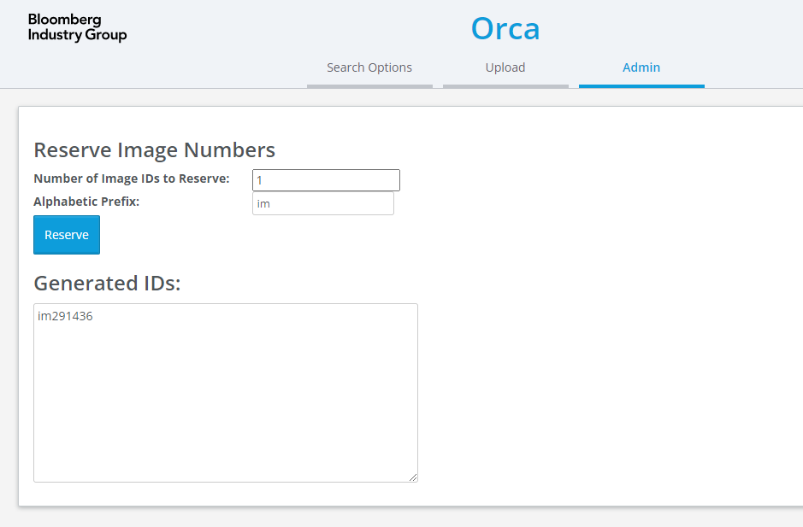
- In Orca search, look for the IM created. Set the “type” to “Headshot.” Put the person’s name and the Jira ticket number in the description box. If updating an old headshot, add the new Jira ticket number and be sure “Headshot” is set for the type.
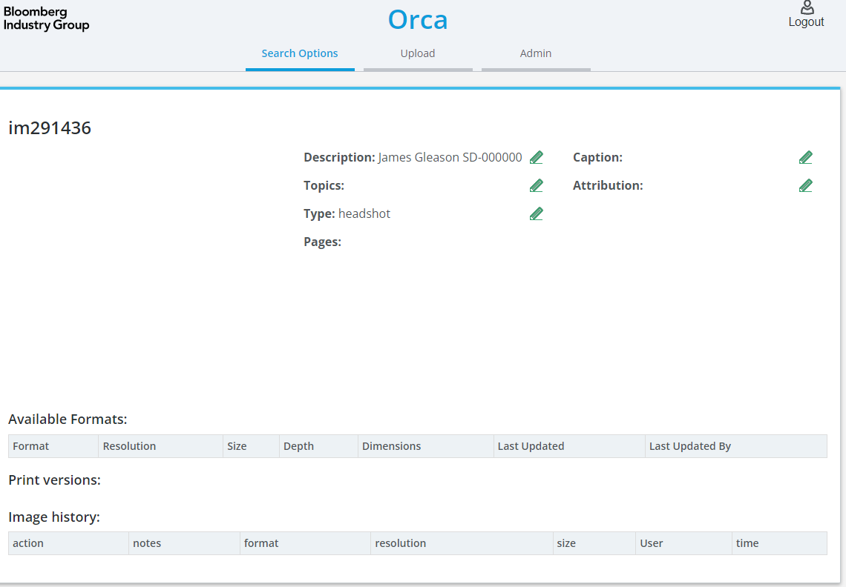
- Download the photo file to your computer. Right click on image file in ticket. “Save link as” and place in designated folder.
- Right click on image file and “Open with” Photos. Check for size and quality. If the quality of the image is poor let the editor know that it would be better if they can send another file.
  - 100kb or more preferred. Lower than 10kb will be poor quality.
  - If the image is large but the person is a small part of the image, it may also be poor quality.
  - Check for problems such as a blurry image or jpg artifacts.
- Click the edit tool. (upper left with highlight)
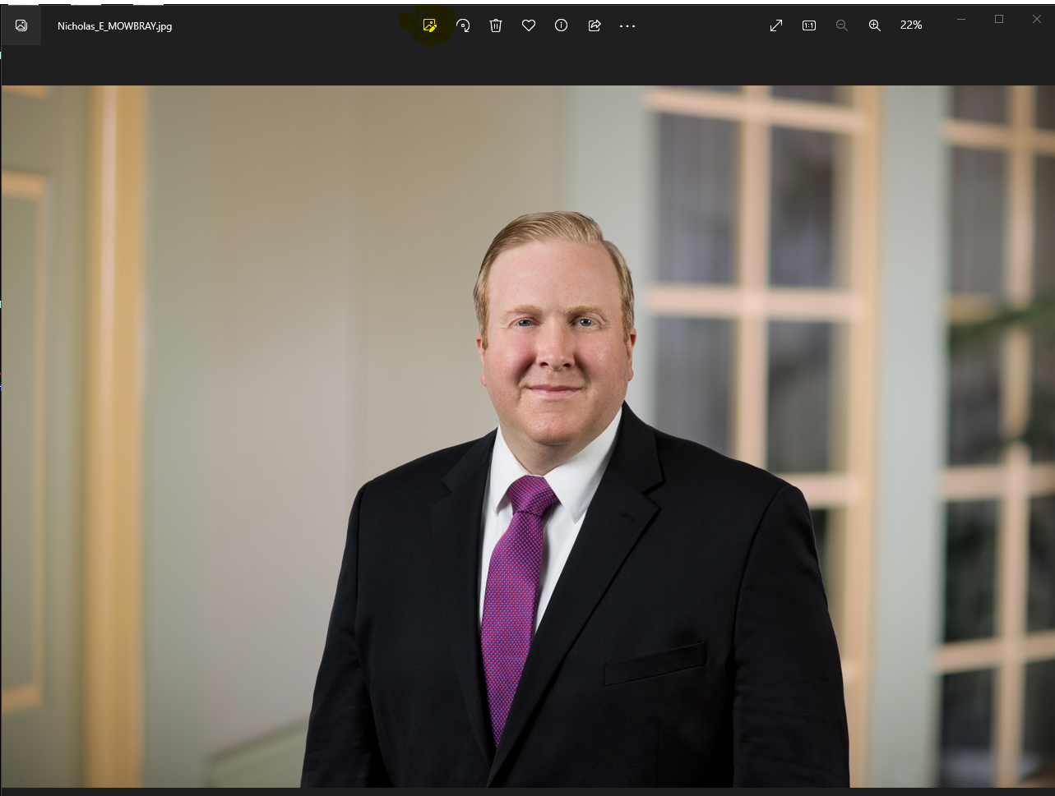
Use crop tool to adjust to a headshot format.
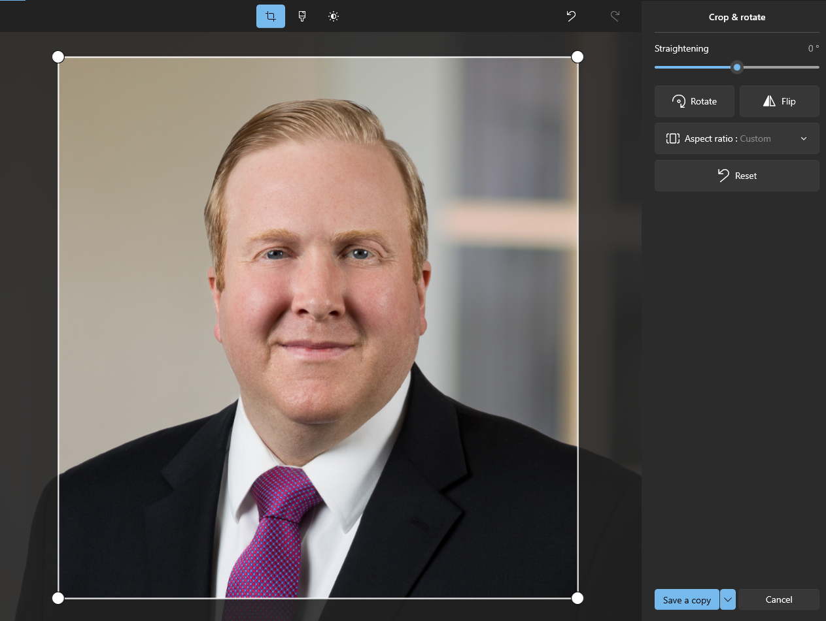
Click on save a copy. Save to drive add a “1” after the name so the original file stays the same. If you want to save the cropped image and over right the original then click on the drop down and click save.
Go to the toolbar and click on the three dots on the right.

Click on resize the image.
The width should be 400 pixels and the height is 480. (based on the photoshop canvas)
MS Photo adjusts the values based on the crop. Below is 480h x 400w. Add the height value of 480 and if the width is larger or smaller than 400 by 5 or 10 pixels then that is okay. If larger or smaller then recrop the original image so it is closer to 400. Click drop down to change file to tif. Save the file with the im number created in orca.
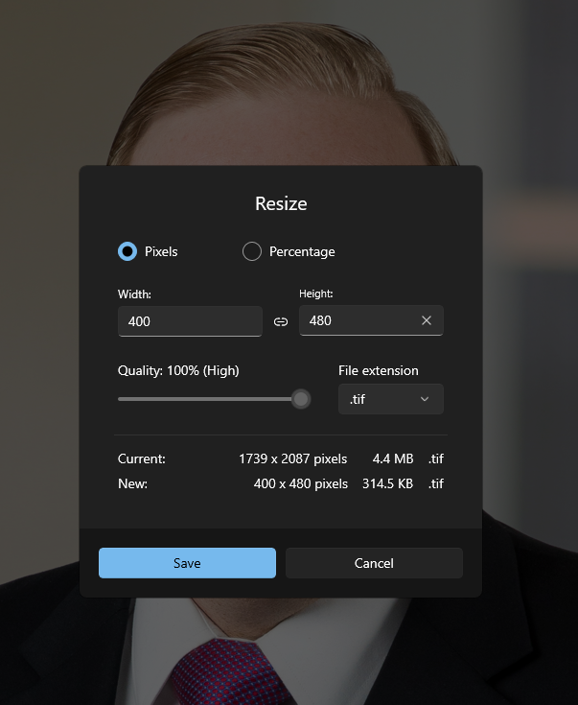

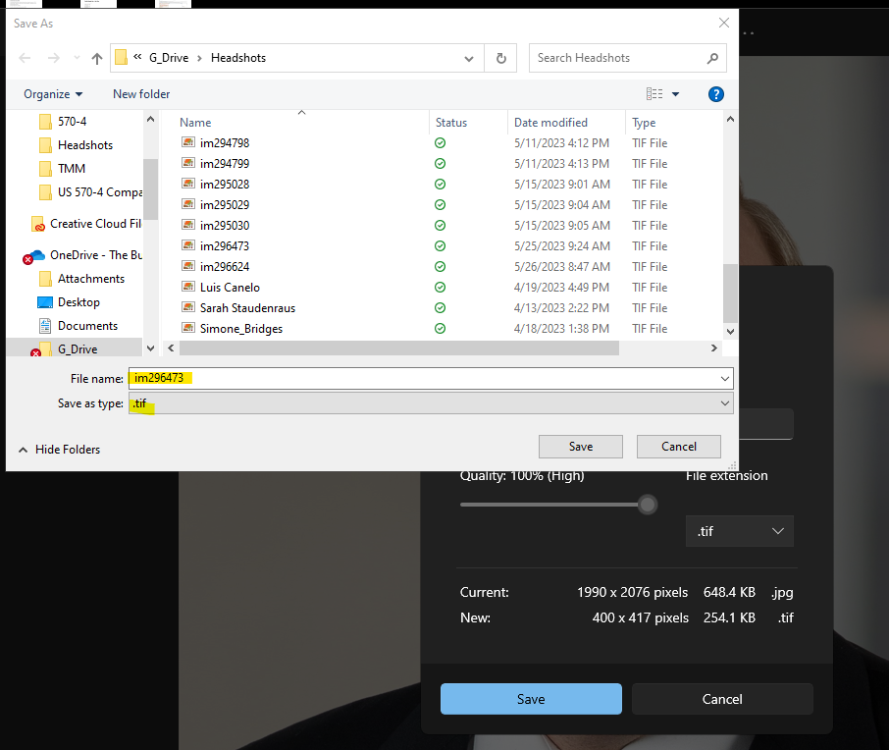
- Drag the tiff file created with im number into 00080-Headshots in filetrain.
- FileTrain will load the tiff into Orca and generate a pdf and png with the name.
- Once loaded, click on the refresh arrow to see the image in orca.
- Go to ticket and add the IM numbers along with @ the requester’s name so they get all the info. Each image will need a number if there are multiple images in the ticket:
im12345 Pat Jones
im12346 Chris Smith

