Obsolete Cites for a New BTAX Portfolio: INFOCON Instructions
Currency: August 29, 2024, 2PM
Goal: When notified of “New Portfolio: Obsolete Cites” via a JIRA ticket, INFOCON is responsible for:
- Generating an EXCEL spreadsheet of potential Obsolete Portfolio Cites across BTAX.
- Reviewing & Identifying potential Obsolete Portfolio Cites across BTAX using the EXCEL spreadsheet.
- Alerting TPQA and TMTT contacts of completed potential Obsolete Cites across BTAX.
- Updating Obsolete Cites in BWIP according to TPQA Content Oversight and INDG Analyst instructions.
- Providing Final Notification to TPQA and TMTT contacts when BWIP files are updated and ready to publish.

Background

Why is the Obsolete Cite task important?
A new portfolio (as defined below) contains structural and content changes that potentially “Obsolete” references across the BTAX platform.

What is a New Portfolio?
An updated Portfolio is classified as "New" when it's one or more of the following:
- Brand-new portfolio with no prior genesis; or,
- New/modified title and/or
- New edition number

- Note: Even the slightest title change – such as punctuation or capitalization modification – is considered a "New Portfolio title”.

TOPIC | PAGE
Goal | 1
Background | 1
Obsolete Portfolio Cite Format Reference Guide | 2
High Level Workflow | 3
Detailed Steps: GENERATE Obsolete Cites | 4-8
Detailed Steps: REVIEW & IDENTIFY Obsolete Cites | 9-10
Pinpoint Cite Procedures | 11-12
General Cite Procedures | 10
Portfolio Change to Title/Number Procedures | 10
Practice Guide Pinpoint & General Cite Procedures | 11-14
Detailed Steps:  ALERT TMTT Analyst & TPQA CO | 13
Detailed Steps: UPDATE Obsolete Cites | 13-14
Detailed Steps:  FINAL NOTIFICATION | 15
Contacts | 16
Useful Links | 16

`

Obsolete Portfolio Cite Format Reference Guide:
Obsolete Portfolio Citations will be either: 1.) General Cite format or 2.) Pinpoint Cite format.

- General cite: Portfolio references that are non-specific in nature: May or may not include the Portfolio title. Examples:
- “850 T.M.”
- “850 T.M., Generation-skipping Transfer Tax (Chapter 13)”
- “Corporate Bankruptcy, 791 T.M.”
- “791 T.M., Corporate Bankruptcy”
*Note: Number change refers to the portfolio number --- e.g., T.M. 850 T.M., 6140 T.M. -- and not the Edition.

- Pinpoint cite: Portfolio references are specific portfolio references, citing to a defined location in BTAX analysis. Examples:
- “850 T.M. IV.”
- “850 T.M., Generation-skipping Transfer Tax (Chapter 13), IV.A.iii.8.”

High-Level Workflow:
- Run General Search for Portfolio Number using General Search Bar set to “ALL” on BTAX.
- [Search format = “XXX T.M.”]

- Generate a CSV spreadsheet for the following analyst related collections:
- Portfolios; Additional Analysis; Practice Tools; On Points and Federal Tax Guide.
- Omit: News Archives, Law Reports & Journals.
- Omit: Primary Sources collections such as Code, Regulations and Agency Documents.
- Omit: Dated Content: We only need current year and 1-year prior. Ex: Federal Tax Guide 2024 and 2023 versions.

- Clean data and combine all generated CSV spreadsheets into (1) single EXCEL Worksheet to enable review of each potential obsolete cite in context or -- in the case of Practice Guides -- by using BDAT data.
  - Completed EXCEL spreadsheet is used by INFOCON to document the update required by INFOCON (e.g. title/number change);
  - for the TMTT analyst to review the potential obsolete portfolio cites and provide update instructions provided for INFOCON.

- Review each section identified on the EXCEL spreadsheet in context on BTAX, except for Practice Guides where BDAT data is used and cites are not reviewed in context. (Reference Detailed Steps section, below)
  - Indicate all obsolete pinpoint cite locations for Analyst to review under the TMTT Analyst Action column.
  - If the New edition has a portfolio name change, or portfolio number change note the reference in the spreadsheet under the INFOCON Update column.

- Attach the single Excel Worksheet to the JIRA Ticket and notify TPQA Content Oversight contact and responsible TMTT Analyst.

- TPQA Content Oversight reviews spreadsheet and “checks out” BWIP files for INFOCON to update.

- Analyst adds update instructions (for the pinpoint cites flagged to their attention) directly in the EXCEL spreadsheet.

- When given the “proceed” alert in the JIRA ticket, INFOCON updates Oxygen files in BWIP:
  - Based on Analyst Feedback for pinpoint cites.
  - Updates any general cites for portfolio name or portfolio number change.

- Mark Completed BWIP files as “Do Not Release” and notify Content Oversight.

- INFOCON task is complete.

- Mark the JIRA ticket as complete and Record task time in ticket.

- Content Oversight publishes completed files to BTAX.

Detailed Steps: GENERATE Obsolete Cites Across BTAX
- Search for the Obsolete Portfolio number on BTAX using the general search bar at the top of the screen and select “All” to search Federal, State, International and Payroll areas.
  - Use “New Search” not “Classic Search”.
  - Use the format: “XXX T.M.” [xxx = portfolio number sans edition]



- Search results* will display all BTAX collections that reference the obsolete portfolio.


*Use “New Search” not “Classic Search”.

Based on the generated search results for “850 T.M.” -- as highlighted in the screenshot above, INFOCON will search for the obsolete portfolio number [“XXX T.M.”] in all collections returned except “News Archive, Law Reports & Journals” and “Law Report Issues”.

- We only need potential obsolete cites for returned hits in analysis and tools collections.
- Omit: News Archives, Law Reports & Journals, Law Report Issues.
- Omit: Primary Sources collections such as Cases, Code, Regulations and Agency Documents.
- Omit: Dated Content: We only need current year and 1-year prior. Ex: Federal Tax Guide 2024 and 2023 versions.

- INFOCON will Download a CSV results spreadsheet for each collection returned (except primary source and news/journals as stated above); clean and sort the data, then combine all results into a single EXCEL Worksheet.

- Select a collection (content group) generated by the obsolete portfolio cite search.
- When the content displays, mouse over the “Download” icon in the top banner.
- Select CSV results as shown below.
- Open CSV file via Downloads or Downloads folder.

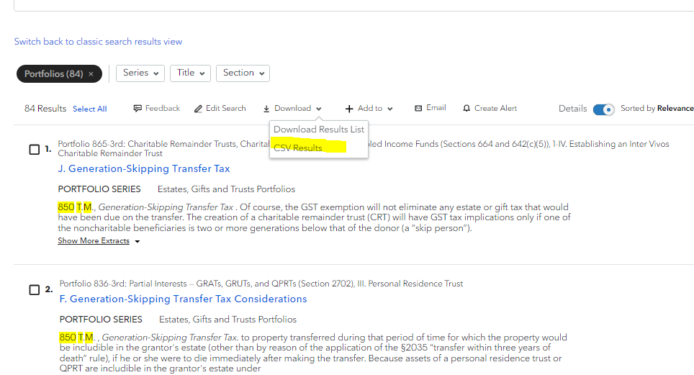

- For each CSV results page, clean the data.
- Delete “Search_id” column, leaving ID and Title.
- Remove any duplicate entries.
- Delete any references to the searched portfolio. Example: If INFOCON is identifying obsolete cites for 767 T.M., delete any references to 767 T.M. in the CSV spreadsheet.
- If it’s a Practice Guide, remove all references to archive years. We only update cites in the current year and (1) year prior. (Ex. 2024 and 2023).
- Expand columns to a readable width.
- Wrap “title” text.
- Sort “A to Z”.

- An example of a CSV download prior to the clean-up. Note, the only data points required are “id” and “title”.
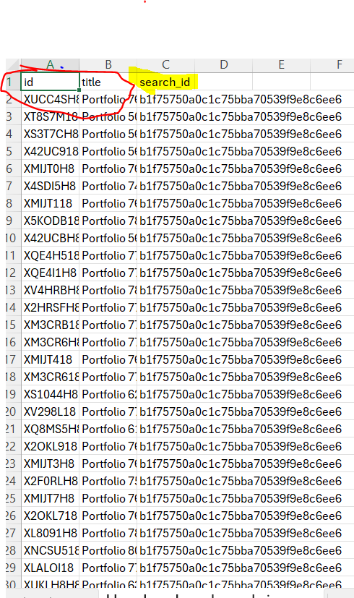

- Repeat above steps 3a. through 3e. for each collection identified by the General Search for the obsolete portfolio.

- When INFOCON has clean CSV worksheets - representing each search result collection - combine [copy/paste] CSV worksheets into a single EXCEL spreadsheet.

- To create a useful spreadsheet for reviewing obsolete cites in BTAX, further refine the data:

- Add a 3rd Column to the right of “title” B-column and title LOCATION.
- In this new LOCATION C-column, use EXCEL’s flash fill feature to extract the chapter and section information of the Obsolete cite. When flash fill doesn’t succeed, manually enter the chapter and section data in Col. C, using the provided data in the Title column.
- The spreadsheet must have the ID, Document title, Chapter and Section to facilitate locating each cite on BTAX and for updating the Oxygen files in BWIP.
- Add a Col. D titled, INFOCON UPDATE.
- Add a Col. E titled, TMTT Analyst Action.
- Add a Col. F, titled TMTT Update Instructions for INFOCON.
- Separate the content under title banners to match collections: Portfolios, Additional Analysis, Practice Tools etc...

Understand Importance of EXCEL Spreadsheet
Provides a guide to follow for reviewing & tracking each potential obsolete cite on BTAX.
- Provides the potential obsolete cite data points & location to enable INFOCON to review cites in context, in the named document; Or, by using BDAT data (Indicated by referencing the id, document name and cite location within document. (Cols. A, B, C)).
- Provides for the update INFOCON will make during the update process. (Indicated by the INFOCON Update column (Col. D)).
- Provides for TMTT Analyst review of pinpoint cites. (Indicated by the TMTT Analyst Action column (Col. E)).
- Provides for the update instructions following Analyst review. (Indicated by the TMTT Update Instructions for INFOCON (Col. F)).

- Sample of an EXCEL spreadsheet after extracting the chapter and section into a 3rd Col. (Illustration of 850 Obsolete Portfolio Cites Across BTAX worksheet for the Portfolios section.)

*Note: The heading Location contains additional Location value information added here for instructional purposes.
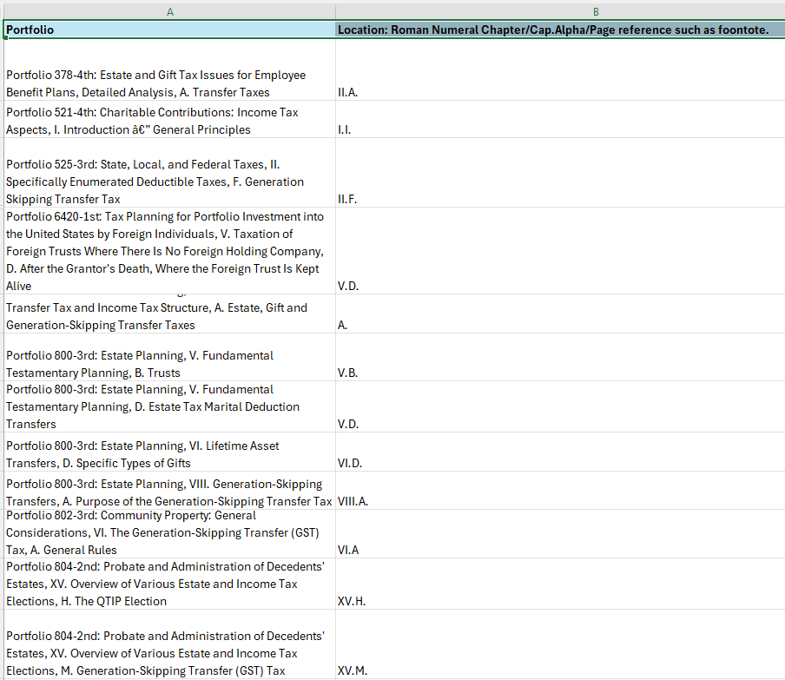

- Sample of completed EXCEL spreadsheet with all columns added [Illustration reflects portfolio content area.]
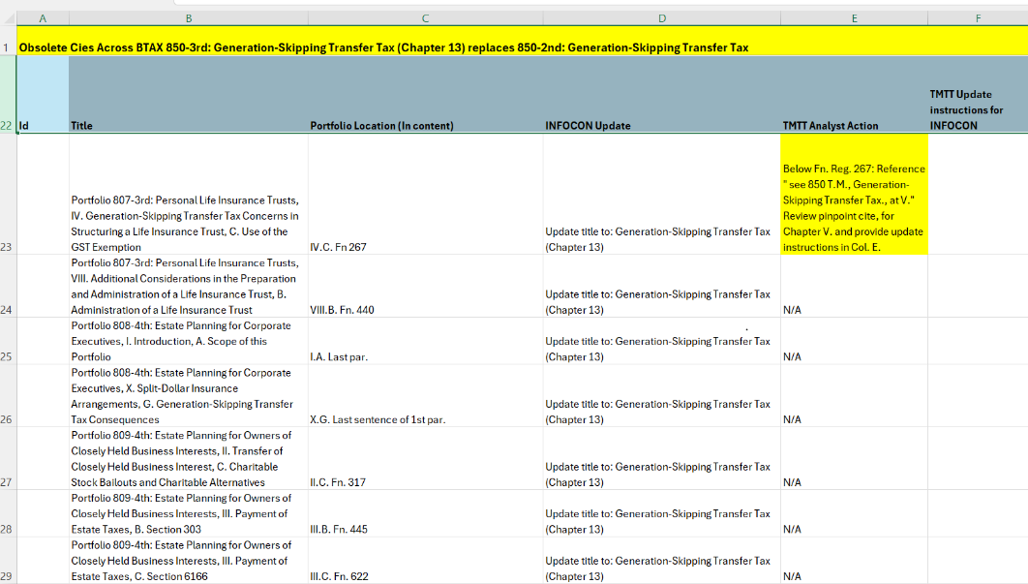

- Sample of the same competed EXCEL spreadsheet with all columns added [Illustration reflects Additional Analysis content area.]

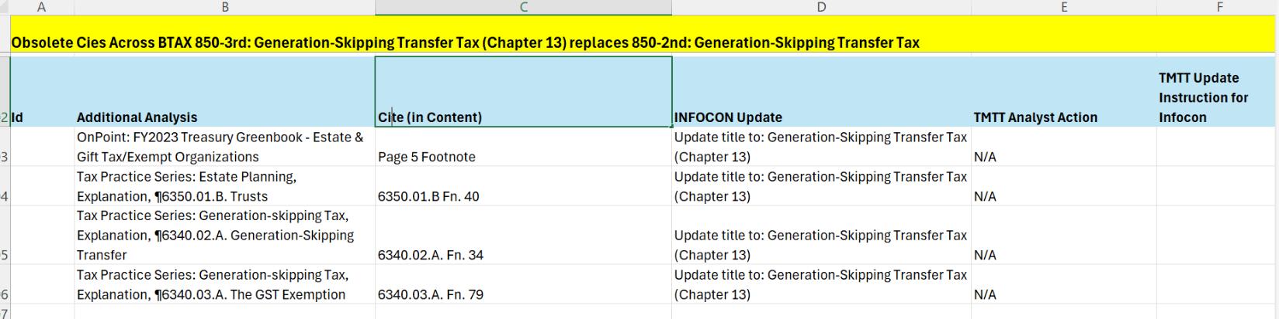

Detailed Steps: REVIEW & IDENTIFY Obsolete Cites
When INFOCON has generated a single EXCEL spreadsheet ---- that’s clean, sorted A-Z and represents the location of each potential Obsolete Portfolio cites across the BTAX platform (except Primary Sources, News and Journals) ---INFOCON is set to dive in and review each portfolio cite to determine if the cite requires updating for relevancy in the new portfolio edition.
In order to determine the obsolete cite type -- and if it needs updating per specifications in the JIRA ticket --- ask the following questions?
- Is it a Pinpoint cite that may not be relevant in the new portfolio edition?
- Is it a General cite? (Generally, no update is needed unless there’s a portfolio title or number change. [Refers to portfolio number change and not edition change.]
- Is there a Portfolio Title/Number change as indicated in the JIRA ticket?

PINPOINT CITES PROCEDURE
- Note: Treatment of Practice Guide cites deviates from these guidelines. Refer to details under the Practice Guide Section.
- Methodically review each section indicated in the Excel spreadsheet on BTAX.
- There are several ways to accomplish this task. Content Oversight has found the best navigation practices:
  - Search by Search ID using the id in the ID column. [Click into the collection content, and in the browser replace the SPA id (at the end of the URL) with the id provided in the spreadsheet.
  - Or navigate to the portfolio using the title/chapter in the Location column.
  - Return to the original obsolete portfolio search and click into the content via the results.

- Use a method that you find is effective and efficient.

- If it’s a pinpoint cite, in the spreadsheet’s Col. C (Location) and following the existing chapter notation, add the section and specific cite location. The cite location is taken directly from the analysis, and is any unique value such as footnote ref, Comment, para number or another value that will better identify the cite when in the Oxygen files on BWIP and on BTAX. See sample below:
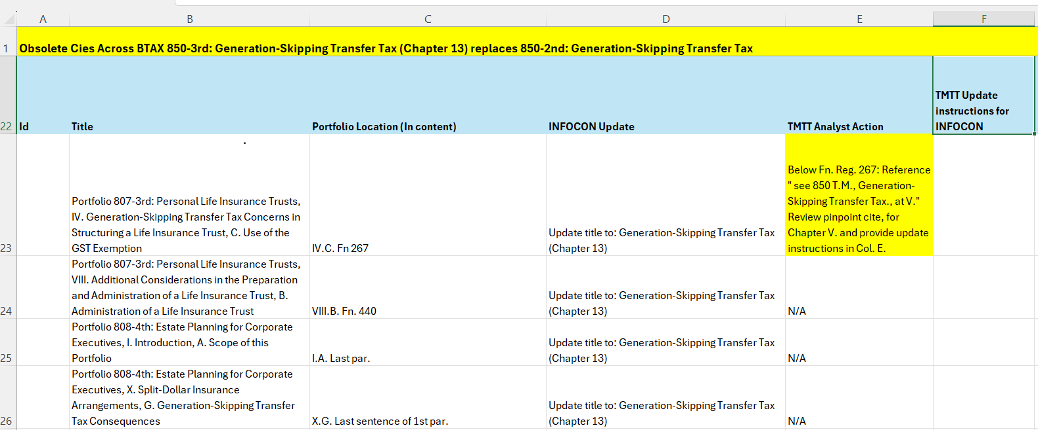

- In the appropriate cell under the “TMTT Analyst Action” column, indicate that the Analyst needs to review the obsolete cite in the provided location and highlight cell in YELLOW.

- During the update process, INFOCON will update each flagged pinpoint cite by following the instructions provided by the Analyst under the “TMTT Update Instructions for INFOCON” column.

GENERAL CITES PROCEDURE
- If it’s a general cite, which does not need updating, mark the cell under the TMTT Analyst Action column as “N/A”, and
- If it’s a general cite, which does not need updating, mark the cell under the INFOCON Update column as “N/A”.
- No further action -- by the Analyst or INFOCON -- is required for this cite type.

PORTFOLIO TITLE/PORTFOLIO NUMBER PROCEDURE
When the corresponding JIRA ticket indicates there’s a portfolio title or number change, methodically review each cite provided in the Excel spreadsheet on BTAX. (Note: Treatment of Practice Guide cites deviates from these guidelines. Refer to details under the Practice Guide Section.
- If it the cite references the portfolio name or portfolio number, in the spreadsheet’s Col. C (location) add the section and specific cite location. The cite location is taken directly from the analysis, and is any unique value such as footnote ref, Comment, para number or another value that will better identify the cite in BWIP and on BTAX. Use the sample illustration above as a guide.
- Note the corresponding cell under the INFOCON Update column as “Update title to: XXX” and/or “Number update”.
- INFOCON will update each title/number during the Update process.

PRACTICE GUIDES PROCEDURE FOR PINPOINT AND GENERAL CITES
If the potential Obsolete Cite lives in a Practice Guide or Checklist, INFOCON will use the BDAT Cite_Ref values in lieu of locating the cites within the analysis.
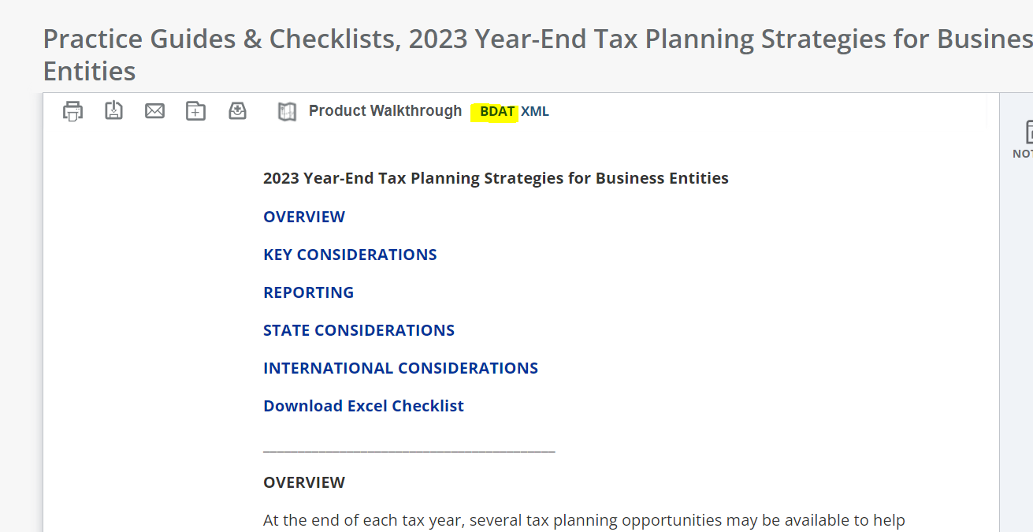

    - Select the Practice Guide or Checklist that corresponds to the item in the EXCEL spreadsheet.
    - Click on the BDAT icon at the top of the document.
    - The BDAT window will open in a separate browser window and will look like the screen shown below.
  - Under “Field Name” scroll to Cite_Ref.
  - Look to the right-pane, opposite of Cite_Ref, and scroll to the Obsolete Portfolio number.
  - Cut and paste all Obsolete Portfolio Cites into the “Location” cell on the Excel spreadsheet on the row corresponding to the Practice Guide or Checklist.
  - Continue this process until all BDAT cites have been added to the spreadsheet’s Practice Guide and Checklist rows.
  - As a rule, the Practice Guides and Checklists have the most potential Obsolete Cites of all services.
    - Unlike Analysis collections, INFOCON only needs to add the BDAT cites listed for the Portfolio.
    - Analyst will review all BDAT cites in context and provide INFOCON with the update instructions.

- Sample BDAT Cite_REF and Values for Obsolete Portfolio 335 T.M.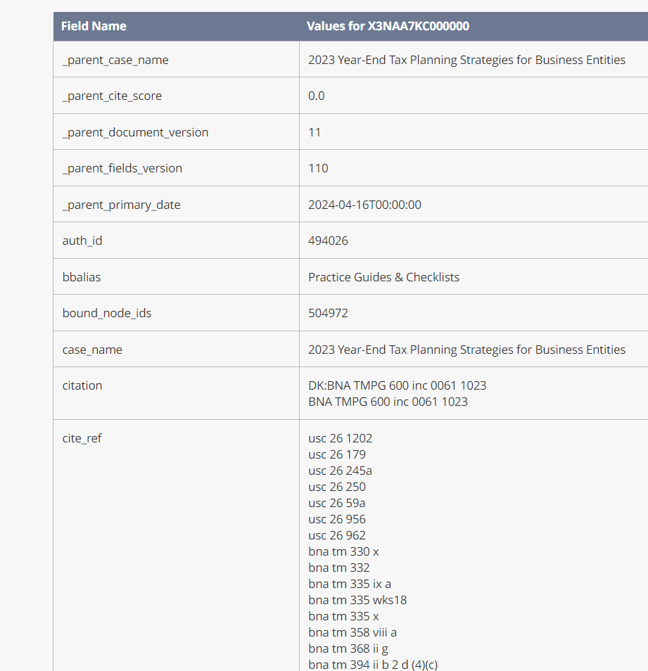

- Sample of completed Obsolete Cite EXCEL spreadsheet for 850 T.M. Practice Tools section:
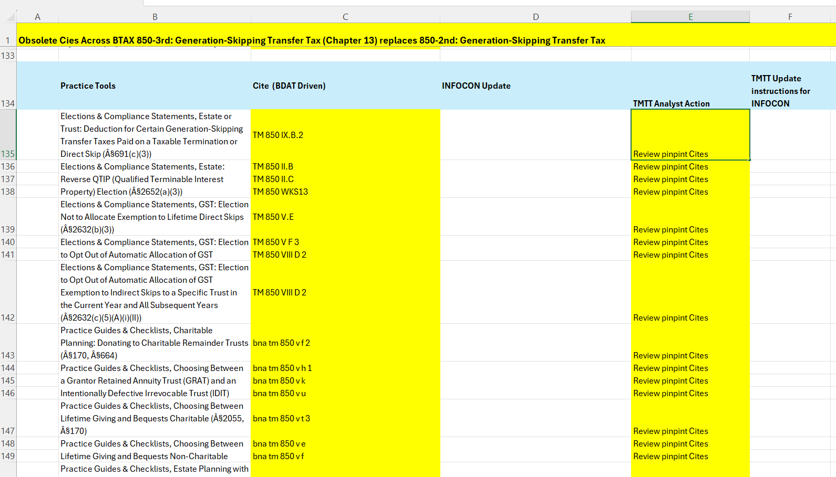

Detailed Steps: ALERT TMTT Analyst and Content Oversight of Obsolete Cites:
When INFOCON has reviewed each potential obsolete cite listed on the EXCEL spreadsheet and recorded the specific location of 1.) all pinpoint cites, and 2.) all general cites that require a new portfolio title and/or portfolio number – INFOCON is ready for the Alert Process.
- Name the Worksheet Obsolete Cites Across BTAX for Portfolio XXX. EX:

- Attach the completed Obsolete Cites Across BTAX Worksheet for Portfolio XXX to the JIRA Ticket.
- Flag and alert the stakeholders in the JIRA ticket.
  - In the comment flag the TMTT Analyst provided in the JIRA Ticket using the @ symbol.
  - In the comment flag the Content Oversight contact using the @ symbol.
    - The Content Oversight contact will be the “Reporter” on the ticket. Generally, Paula Firestone.
  - Alert the contacts that Obsolete Cites Across BTAX for Portfolio XXX are ready for review. To assist the Analyst, specify pinpoint cites are flagged in yellow and instruct the analyst to add the INFOCON update instructions under the Col. “TMTT Update Instructions for INFOCON”.

General Note about BNA Picks:
The right rail of Analysis often has a BNA Pick Topic Card with cites to content on the BTAX platform. Do not note these cites in the Obsolete Cite spreadsheet. Content Oversight has a separate workflow to capture and make any obsolete cite updates. A sample BNA Pick will look like this illustration: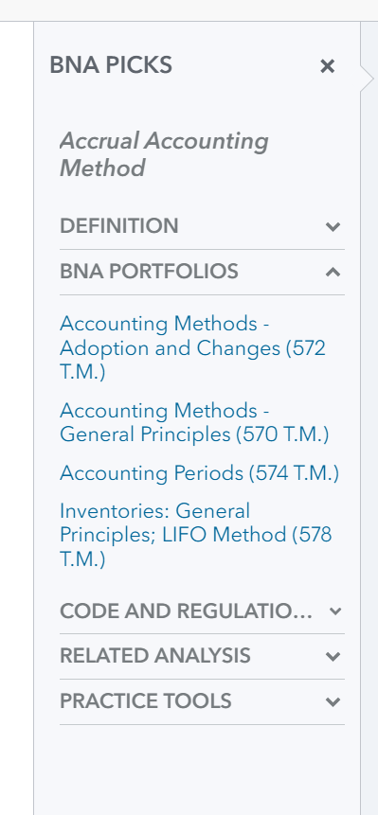

Detailed Steps: UPDATE Obsolete Cites
Next steps: BTAX review process is 2-steps:
    - Step 1: Based on the completed Obsolete Cites Across BTAX spreadsheet, Content Oversight will check out all files in BWIP for INFOCON review using Oxygen.
    - Step 2: TMTT Analyst will review their assigned sections for the obsolete cites and provide the update instruction directly in the worksheet under the TMTT Update Instructions for INFOCON column.

- When the files have been checked-out in BWIP, and ready for INFOCON to update files, Content Oversight will alert INFOCON via the JIRA ticket.
a, All files that need updating will be checked-out in BWIP (according to the submitted spreadsheet) and marked under the Content Oversight ID specified in the JIRA ticket. Generally,
“PF5147”. See sample BWIP screen, below.
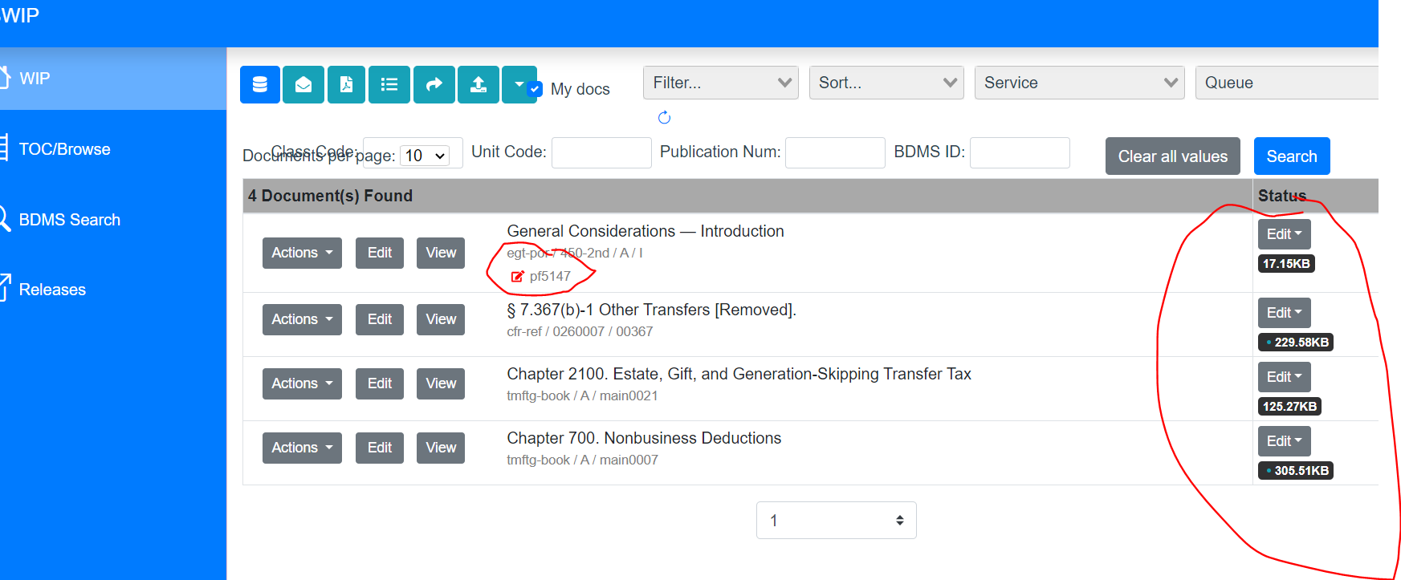

- Using the spreadsheet as a guide, edit each obsolete cite in the BWIP file for new portfolio name and/or new portfolio number where necessary. [Use INFOCON Update column data for this task.]

- Using the spreadsheet as a guide, edit each pinpoint obsolete cite in the BWIP file with the update instructions provided by the Analyst in the “TMTT Update Instructions for INFOCON” column. [Use TMTT Update Instructions for INFOCON column data for this task.]

- Keep track of your work: For each completed cite, note in the spreadsheet that INFOCON has completed the update.

- Change the status of each completed file as “Do Not Release”.

    - Sample of “Do Not Release” status
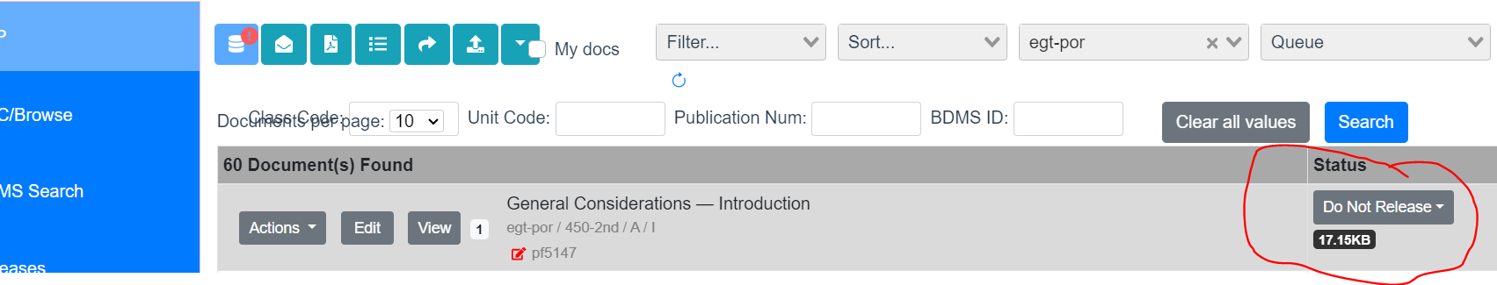

Detailed Steps: Final Notification:
When all the Oxygen files have been updated in BWIP and marked as “Do Not Release”, the Obsolete Cites Across BTAX task is complete.
- Notify the stakeholders in the JIRA Ticket that the task is complete and all Obsolete Cites Across BTAX have updated for the new portfolio.
- Record the time required to complete the task.
- Re-assign the ticket to the Content Oversight Contact, generally Paula Firestone.
- Note any issue or concern in the comments.
*That’s it!

Contact Information
If you have any questions, please contact:
Paula Firestone -Pfirestone@bloombergindustry.com

You may also contact:
Kenya Wortherly - kwortherly@bloombergindustry.com
Tan Nguyen - Thnguyen@bloombergindustry.com

SAMPLE DOCUMENTS & USEFUL LINKS

Link to Sample EXCEL Spreadsheet for 850-3rd (replacing 850-2nd) with title change.

Obsolete Cites Across BTAX for 850-3rd with title change.xlsx

JIRA Vendor Dashboard (for assigned INFOCON tickets)
https://jira.bna.com/secure/Dashboard.jspa?selectPageId=136031

Product Link:
BTAX Platform

Link to BWIP for file updating:
https://bwip.bindg.com/wip

END

