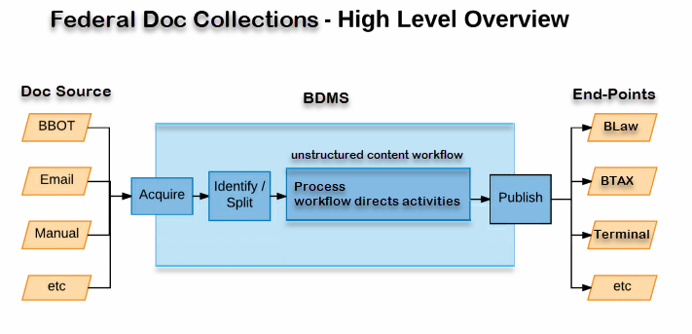

NOTES:
- Do not include Introduction (00) series in PLRs
So if there are 22 documents and 1 has a 00 (index) as the last digit indicate 21 only in the email
If there are multiple entries in the Written Doertmination page pertaining to one PLR consider them only as one
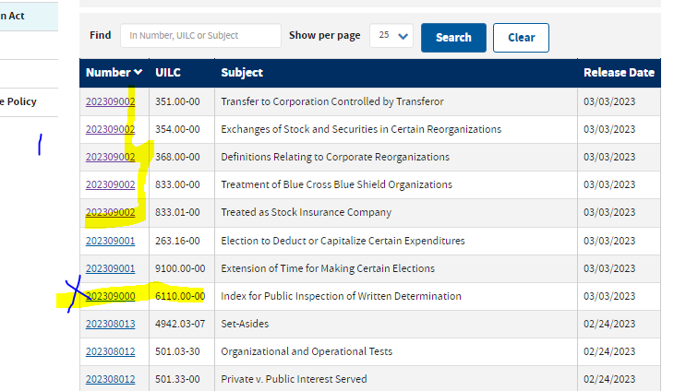

- Do not unclude AOD’s in the email
- Check IRS Drop site
- Check for Written Determination
- Check IRB and the documents mentioned (ex. AODS Notices, Revenue Rulings) if it’s been posted in BTAX (In 2 IRS sites & BTAX)
- If the contents of the IRB are not in BTAX you can post by extracting the file and posting in BTAX using metadata from previous files.
- No need to check Regulations & TDs mentioned in the IRB as they are handled by Paula.
- IRBs usually show in BTAX @ 8:45am up to 11:30 A.M. but show in BDMS earlier.
- AOD’s usually load to BDMS Mondays @ midnight on Published Date.
- Rev. Proc. ‘s load to BTAX @ 1:30 Friday so it’s best to wait before loading or creating a ticket.
- IR is News Release
- PLRs are under Written Determinations content set in BDMS

- Reg is Prop. Reg. & IRS Announcements go live in BTAX @ 1:00pm Friday, search using: 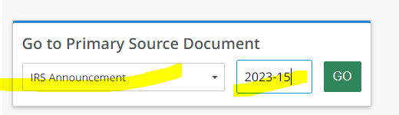
Instead of here: 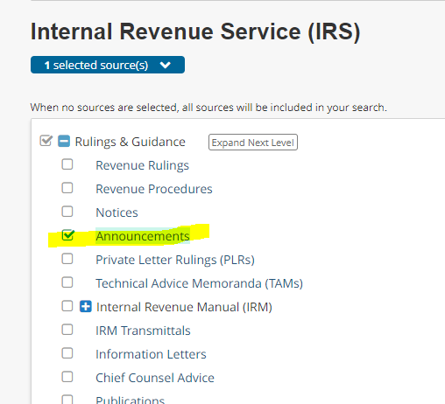
It usually appears later (Monday)

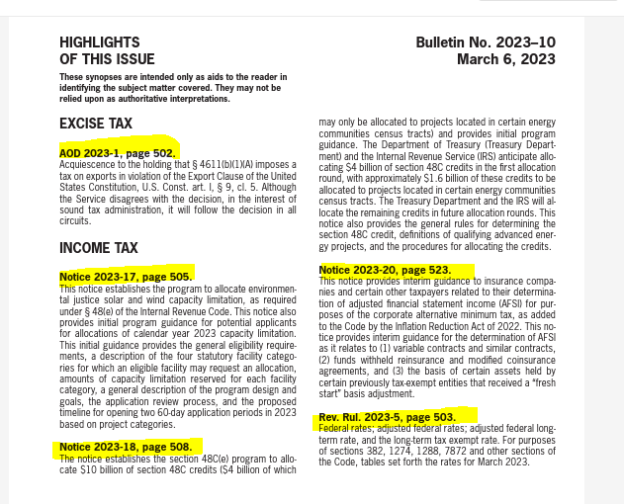
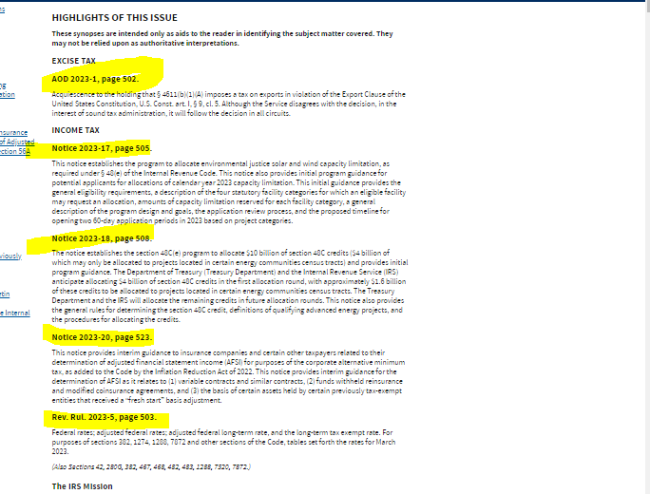
Search for the documents using their numbers.(PLR no, AOD no) then search by Date (Sometimes not in order, documents are listed on BTAX by the document date not published date)

CCA sample:
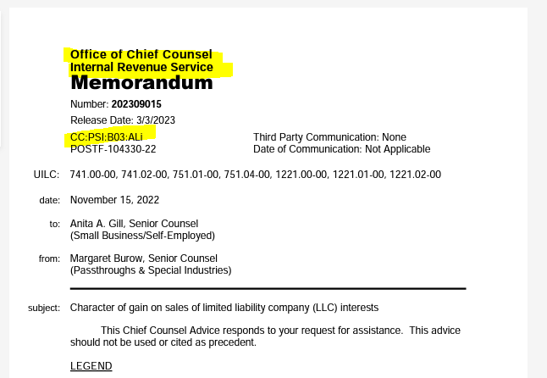

PLR Sample:
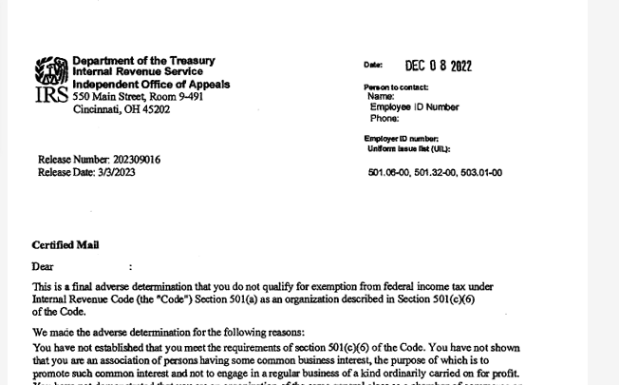

Doc Source
BOT (short for robot)
It is a computer program that:
-makes decisions for a user or other program
-simulates human activity
BBOT (ex. BBOT_SOURCEURL - https://www.irs.gov/written-determinations)
- it is a proprietary service developed by Bloomberg
-this service uses BOTs to scrape content from the web
-it can detect changes and deliver new content at a defined interval.
Email (ex. BBOT_EMAIL_FROM - IRS.Media.Relations@irs.gov)
-Data sent to these accounts is automatically forwarded to BDMS within 1 minute after it is received
Manual (ex. N-22-6.pdf)
-authorized BDMS users can manually deliver content to BDMS using the BDMS User Interface.
FTP/SFTP
-will be taken over by BBOT
BDMS/Unstructured Content Workflow
-a generic workflow that much, but not all, BDMS content flows through.
-it is currently a "one-stop-shop" for any treatment a document needs to be published.
-it provides validation, deduplication, auto-update, conversion, markup, and metadata edit steps.
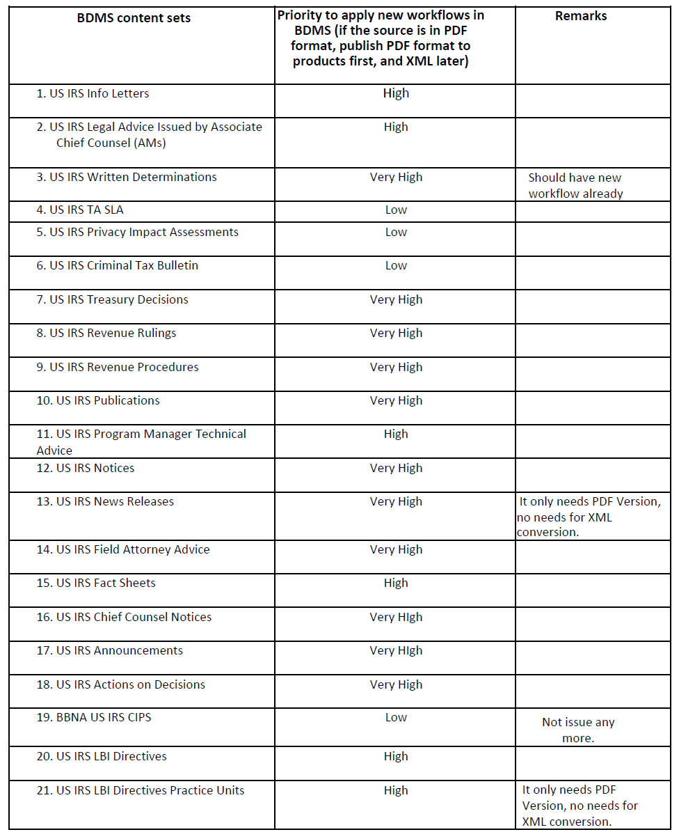
Time-sensitive/closely monitor IRS Content sets
-Revenue Rulings (usually released on Friday)
-Revenue Procedures (usually released on Friday)
-Notices (usually released on Friday)
-Announcements (usually released on Friday)
-Written Determinations (released on Friday)
-Technical Advice Memoranda (released on Friday)
-Chief Counsel Advice (released on Friday)
-Internal Revenue Bulletins (released on Friday, often include Notices, Rev. Procs., Rev. Ruls., Announcements,
Action on Decisions, T.D., and Proposed Regulations)
-Fact Sheets
-News Releasercrrcruz@bna.com
-Publications
-Action on Decisions
-Federal Register (Monitor by Paula Firestone)
-Treasury Decisions (Monitor by Paula Firestone)
-Prop. Regulations (Monitor by Paula Firestone)
-Field Attorney Advice

Other IRS related Content sets
-General Counsel Memoranda
-Field Service Advice Memoranda
-LB&I Industry Director Guidance
-MSSP Audit Guides
-Program Manager Technical Advice

IRS Source links:
-Notice, Rev. Proc., Rev. Rul., Announcements, T.D., and Prop. Regs. Irs-drop | Internal Revenue Service
-Internal Revenue Bulletins www.irs.gov/irb
-Internal Revenue Bulletins IRB | Internal Revenue Service (irs.gov)
-Written Determinations Written Determinations | Internal Revenue Service (irs.gov)
-Federal Register Federal Register :: Reader Aids :: Using FederalRegister.Gov
-Forms and Publications https://apps.irs.gov/app/picklist/list/formsPublications.html

- Document drop-site Irs-drop | Internal Revenue Service
- PLR link Written Determinations | Internal Revenue Service (irs.gov)
- IRB link IRB | Internal Revenue SeIrvice (irs.gov)
- IRB link Internal Revenue Bulletins | Internal Revenue Service (irs.gov)

Check IRBs on the 2 IRS sites if available. Sometimes it is not available on one site but already live on the other.

Note: PLR’s Sample -Document type will show on top of 2nd page

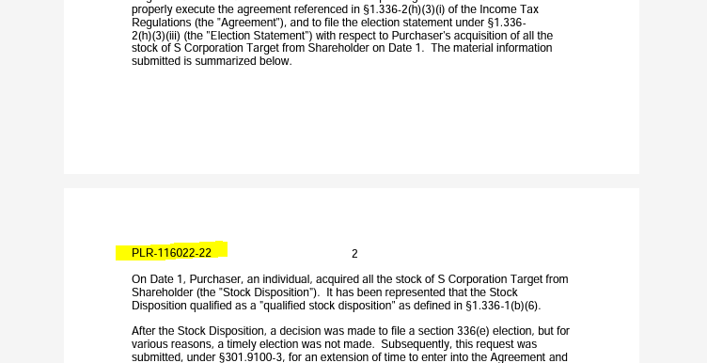

Daily checking routine:
- Check on the IRS drop site for new releases
-Irs-drop | Internal Revenue Service
2. Check on IRS Internal Revenue Bulletins for new release (on Friday)
-IRB | Internal Revenue Service (irs.gov)
3. Check on BTAX and BLAW to see if the new IRS updates are published
-https://www.bloomberglaw.com/product/tax/page/page_federal
-https://www.bloomberglaw.com/home
4. Check on BDMS Notifications for possible Alerts
https://bdms-prod-bdms-dashboard.stacker.prod.bloomberg.com/bxp-index.html#BdmsPlace:mynotifications
5. Follow “Ticket resolving time and CORC ticket” (below) to report unpublished documents
6. Monitor related CORC tickets to ensure the missing documents publish to BTAX and BLAW
https://pm.bloomberg.com/jira/secure/RapidBoard.jspa?rapidView=4729
Friday routine:
- Follow points 1-5 listed under “Daily checking routine.”
- Send an email to Frank, Larry (lfrank@bloombergindustry.com) and Manickam, Soni (smanickam@bloombergindustry.com) to let them know the status of the IRS updated.
Example: Total of 34 Written Determinations for Week 44, with 010 being CCA and the rest PLRs.
I.R.B. 2022-50 (Rev. 12-12-2022) (irs.gov) is on the IRS website but not yet on BTAX. I will let you know when it posts to BTAC.
Ticket resolving time and CORC ticket
- If the problem has already been assigned to a GD associate but is not solved, how long should I wait before escalating via CORC ticket?
- If you see that someone's on it, but 2-3 hours have passed without an update, definitely escalate. There is a general expectation to do these ASAP as a high priority, and anything after 2-3 hours should be raised.
- How long should a period of time elapse between when you see a problem in BDMS Notifications and when you report it? Especially early in the morning or before the long weekend?
- Wait until 10 am as the mark to Give GD time for Basic Tax data processing. GD associates come in between 7 am-8 am daily, which gives them 2-3 hours to assess what's going on that day across the board. If nothing has been spotted or communicated by 10 am, definitely raise it.

BDMS Notifications
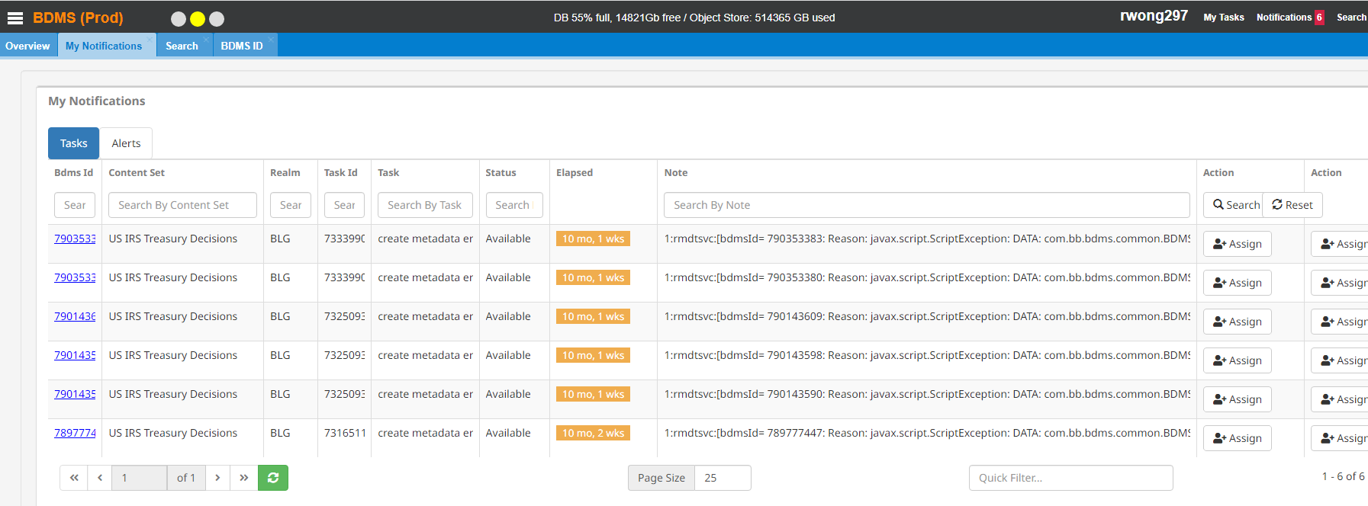
Example of CORC ticket (always assign the CORC ticket to Greg Cashel: gcashel1@bloomberg.net)
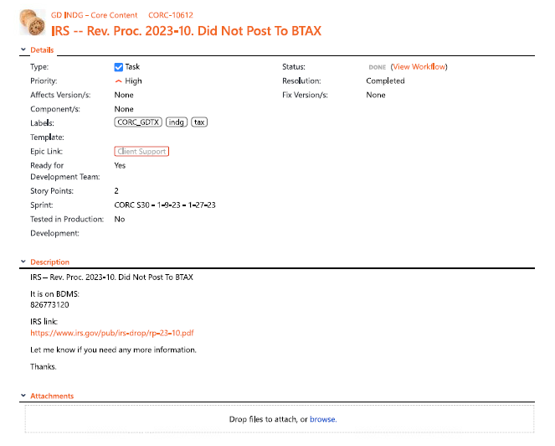
Link to GDTX Board
- To create and follow CORC tickets https://pm.bloomberg.com/jira/secure/RapidBoard.jspa?rapidView=4729
End-Points
BLaw:
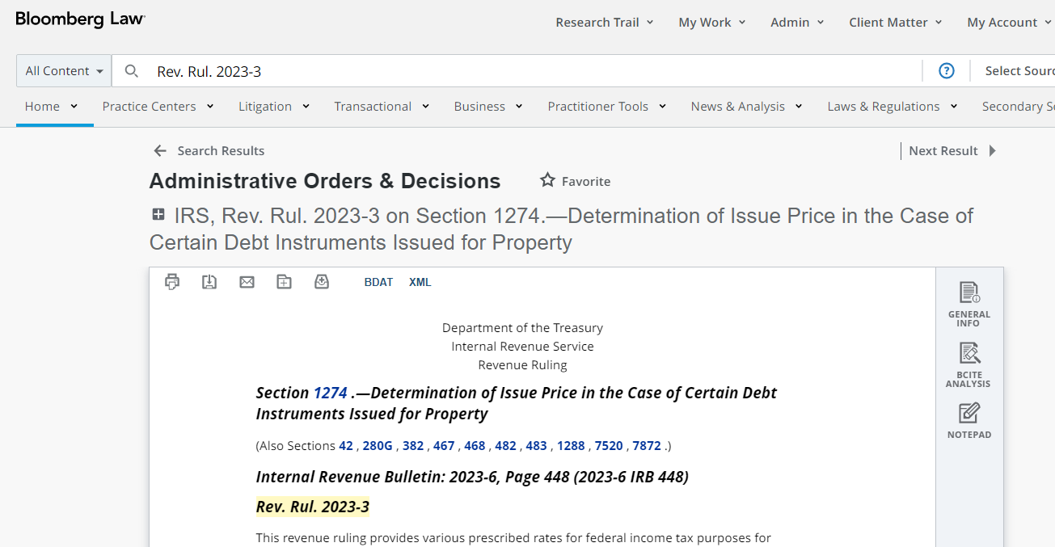
BTAX:
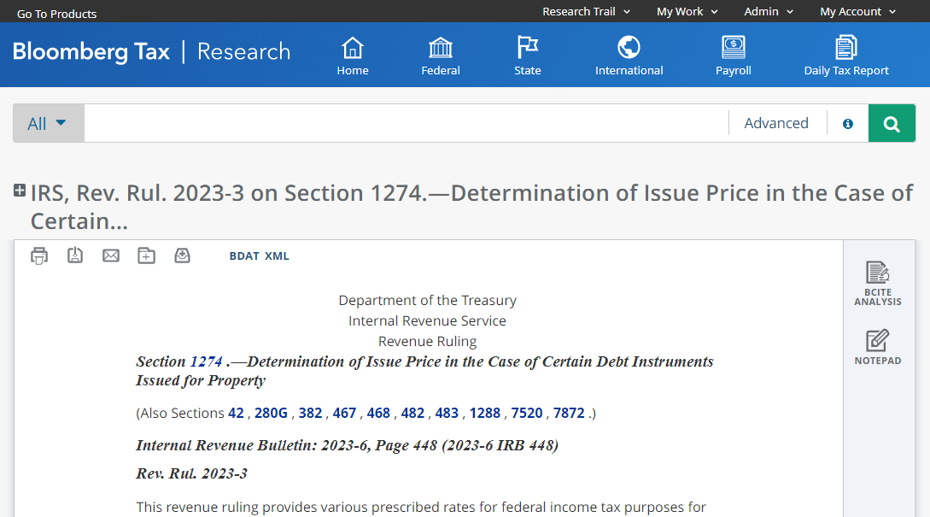

LOADING IRB TO BDMS METADATA

- If the file gets loaded at the same time with the bbot version the file will show when you search but there will be an error when you open and view. In this case crash the file that you loaded then replace the bbot version with the pdf you loaded. This will update the bbot version and will show in BTAX.
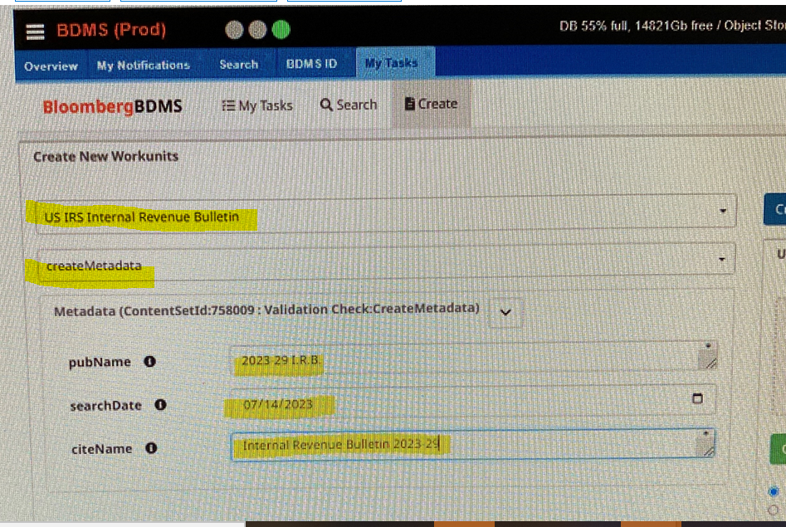

To Search for PLRS in BDMS
Use Written determinations as content set not Private Letter Rulings
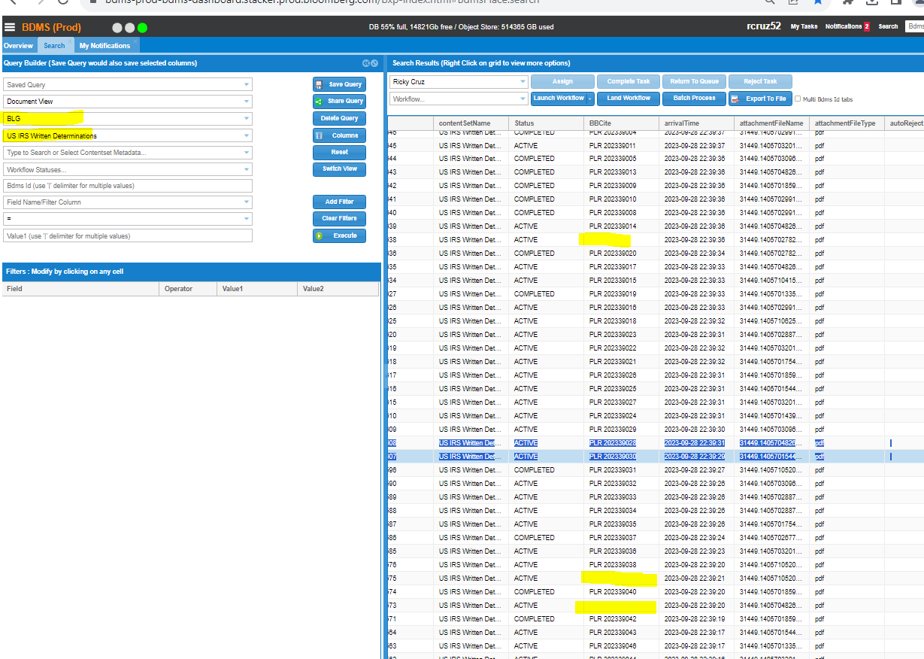

Rev. Proc.

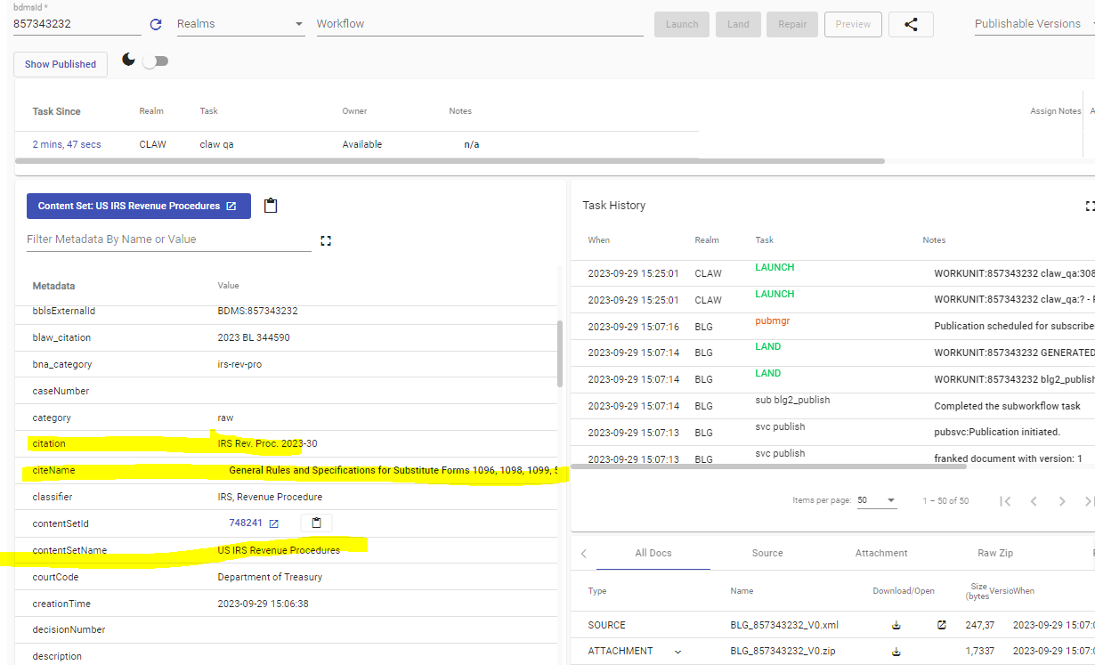
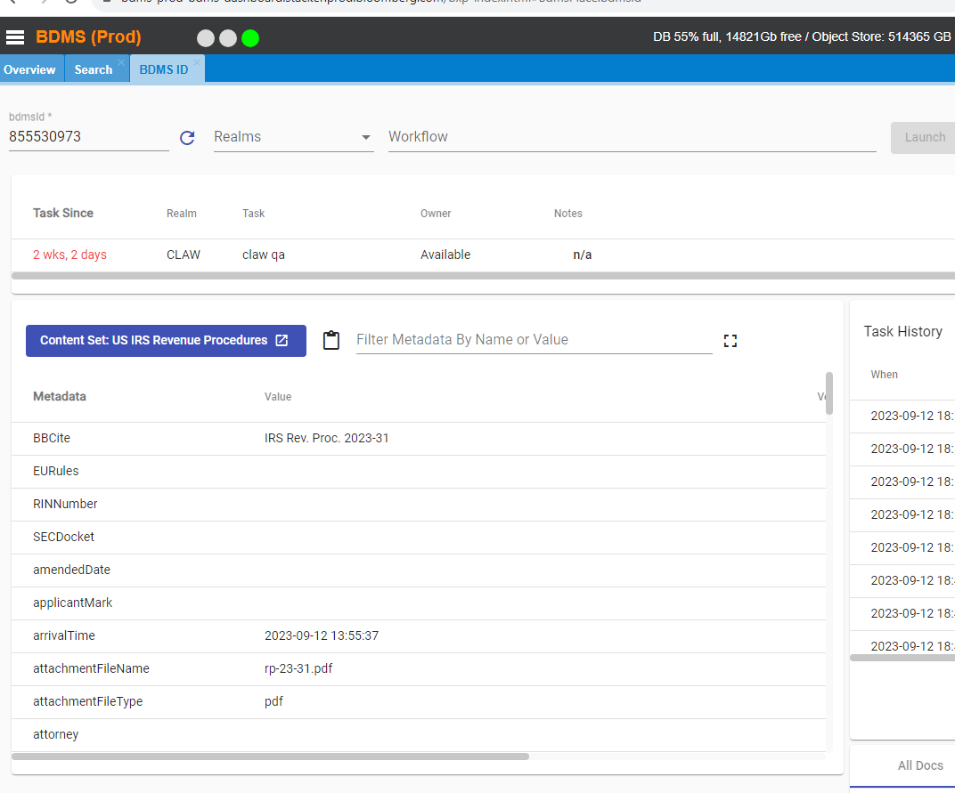

LOADING Announcements TO BDMS METADATA

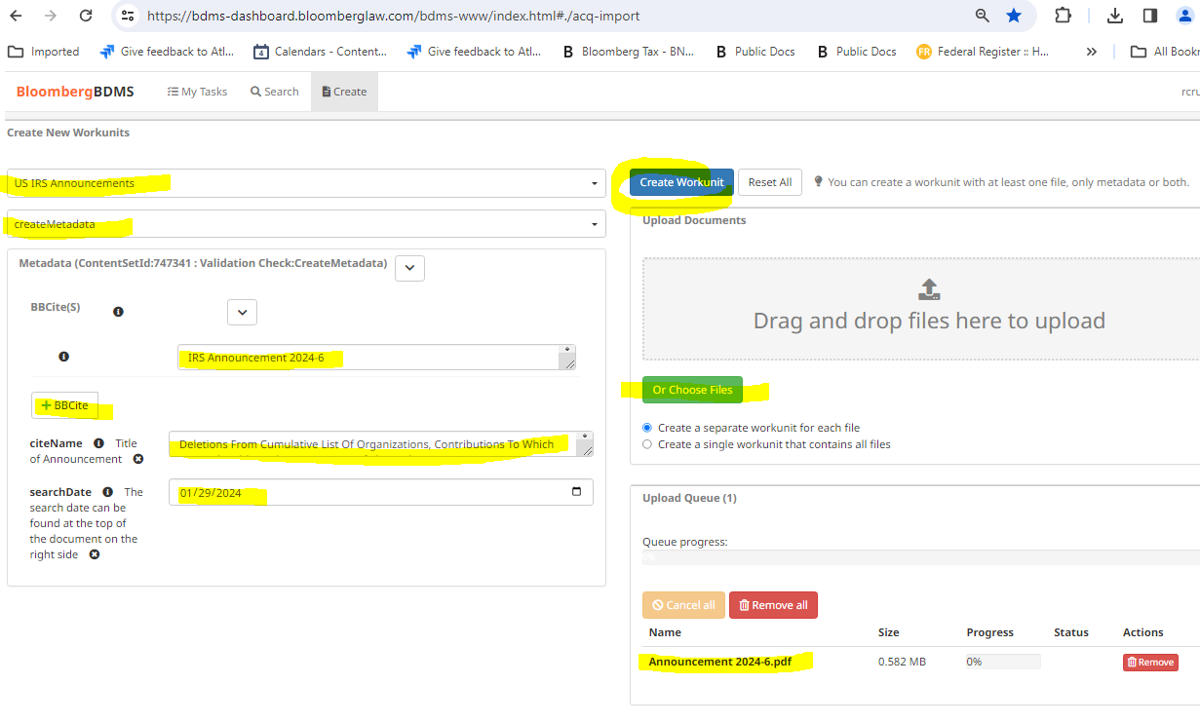

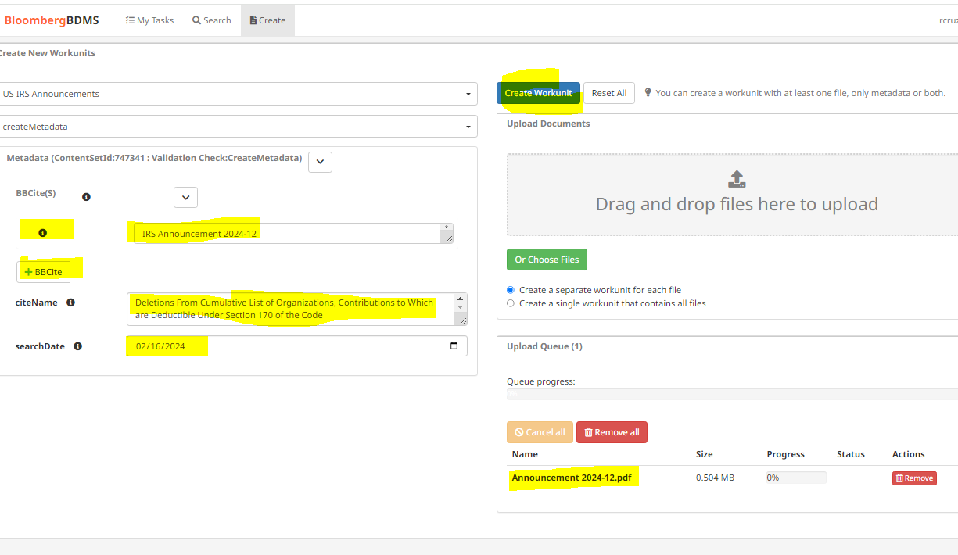

Note: When loading search Date should be the date the document is to be loaded or else it will not publish immediately. Wait till the status says BLG -Completed and Published indicates Y. Normally it will publish after one processing. You can use the BBLS id to check in bTAX.